

THE PRESIDENT’S OFFICE
REGIONAL ADMINISTRATION AND LOCAL GOVERNMENT
LONGIDO DISTRICT

FORM ONE ANNUAL EXAMINATION
041 BASIC MATHEMATICS
MARKING SCHEME NOVEMBER 2025

- (a) $=\frac{7}{8}÷\left(\frac{3}{2}×\frac{14}{9}\right)$…………………………………………………………………………….………….…..….01 mark.
$=\frac{7}{8}÷\frac{7}{3}$……………………………………………………………………………………….……………….01 mark
$=\frac{7}{8}×\frac{3}{7}$………………………………………………………………………………………….…….……….01 mark.
$=\frac{3}{8}$………………………………………………………………………………………………………………..02 marks
(b) $-6+2=-4$
01 mark
-1
-2
-9
-3
0
-10

-4
-5
-6
-7
-8
-6
Figure 1

01 mark
2
-4
01 mark

$∴$ $(-6)+2=(-4)$ ………………………………………………………………………………………..02 marks

- (a) i. $2.555555…=2.\dot{5}$………………………………………………………………………….…………$00\frac{1}{2}$ mark.
ii. $0.212121212…=0.\overline{21}$……………………………………………………………….…….……$00\frac{1}{2}$ mark.
iii. $1.15151515=1.\overline{15}$…………………………………………………………………………………$00\frac{1}{2}$ mark.
iv.$5.0000300003…=5.\overline{00003}$………………………………………………………..……..…..$00\frac{1}{2}$ mark.
(b) Let $m be 0.8\dot{3}$
$m=2.\dot{5}$ ……………………………………………………………………………………….……………..equation 1
$10m=2.\dot{5}×10=25.\dot{5}$ ………………………………………………………………………………equation 2
$-\left|\begin{matrix}10m=25.\dot{5} \\ m= 2.\dot{5}\end{matrix}\right.$
$9m=23$………………………………………………………………………………………………….……`01 mark.
$\frac{9m}{9}=\frac{23}{9}$
m$=\frac{23}{9}$……………………………………………………………………………………………….01 mark.
Let $y be 0.\overline{21}$
$y=$.$0.\overline{21}$………………………………………………………………………………………….equation 1
$100m=×0.\overline{21}×100=21.\overline{21}$ …………………………………………………………….equation 2
$-\left|\begin{matrix}100y=21.\overline{21} \\ y= 0.\overline{21} \end{matrix}\right.$
$99y=y=21$………………………………………………….………………………………………`01 mark.
$\frac{99y}{99}=\frac{21}{99}$
$=\frac{21}{99}=\frac{21÷3}{99÷3}=\frac{7}{33}$……………………………………………………………………..…….….01 mark.
$2.\dot{5}×0.\overline{21}=\frac{23}{9}×\frac{7}{33}=\frac{161}{297}$…………………………………………………………………………01 mark.
(c) i. 34.996 $≈35.00$………………………………………………………………………………………..…..01 mark.
ii. 35.0483 $≈35.0$……………………………………………………………………………………………..01 mark.

- (a) 20 192 + 18 800 + 23 468 +25 477 +18 991+260 060+ 22 645$=389 633$ ….$02\frac{1}{2}$ marks.
$389 633≈390 000$……………………………………………………………………………………..$02\frac{1}{2}$ mark.
Figure 2
(b)
-$5 <y$ $≤$ 2
3
2
-5
1
0
-1
-2
-3
-4

4. (a) $\begin{matrix}\frac{1}{2} \\ 1\end{matrix}\left|\begin{matrix}x+\frac{y}{2}=5 \\ \frac{x}{2}-\frac{y}{3}=\frac{1}{6}\end{matrix}\right.$
$\left|\begin{matrix}\frac{x}{2}+\frac{y}{4}=\frac{5}{2} \\ \frac{x}{2}-\frac{y}{4}=\frac{1}{6}\end{matrix}\right.$
$-\left|\begin{matrix}\frac{x}{2}+\frac{y}{4}=\frac{5}{2} \\ \frac{x}{2}-\frac{y}{3}=\frac{5}{2}\end{matrix}\right.$………………………………………………………………………………………………….01 mark.
$\frac{y}{4}+\frac{y}{3}=\frac{5}{2}-\frac{1}{6}$
$\frac{ 3y+4y}{12}=\frac{15-1}{6}$
$\frac{7y}{12}=\frac{14}{6}$……………………………………………………………………………………………….…..01 mark.
$y=\frac{14×12}{7×6}$
$x=4$…………………………………………………………………………………………….………..01 mark.
Substitute $4 for y in x+\frac{y}{4}=5$
$x+\frac{4}{2}=5$
$x+2=5$
$x=5-2$……………………………………………………………………………….…………..….01 mark.
$x=3$…………………………………………………………………………………………………..….01 mark.
(b) Total parts $=5+3+2=10$parts……………………………………………….……………….01 mark.
Difference in shares $=\left(\frac{5-2}{10}\right)×60 000$ shillings……………………………………….……01 mark.
$=\frac{3}{10}×60 000$ shillings………………………………………….…….01 mark.
$=18 000$ shillings………………………………………………………..02 marks.
5. (a) $m=\frac{y_{2}-y_{1}}{x_{2}-x_{1}}$………………………………………………………………………..……….……………..$00\frac{1}{2}$ mark.
$=\frac{4-2}{4+3}=\frac{2}{7}$………………………………………………………………..………………………...01 mark.
$\frac{2}{7}=\frac{y-2}{x+3}$……………………………………………………………………….………..……..$00\frac{1}{2}$ mark..
$2x+6=7y-14$
$2x+6+14=7y-14+14$
$2x+20=7y$
$\frac{7y}{7}=\frac{2x+20}{7} or 2x-7y+20=0$…………………………………………………..01 mark.
$y-intercept=c from y=mx+c$…………………………..…………………..01 mark.
Therefore $y-intercept=c=\frac{20}{7 }or \left(0,\frac{20}{7}\right)$…………………………………………..…………01 mark.
(b) $±\left(x-3\right)≤5$…………………………………………………………………………………………….……01 mark.
$x-3≤5$
$x-3+3≤5+3$
$x≤8$…………………………………………………………………………………………01 mark.
$or-\left(x-3\right)≤5$
$-x+3≤5$
$-x+3-3≤5-3$
$-x≤2$
$\frac{x}{-1}≥\frac{2}{-1}$
$x≥-2$……………………………………………………………………..………………….01 mark.
Figure 3
-$2 ≤x$ $≤$ 8
8
7
6
5
4
-3
3
2
1
-2
0
-1
9

- (a) $1m=100 cm$
$5m=y$
$y=\frac{5 m×100 cm}{1m}$
$y=500 cm$……………………………………………………………………………………………………01 mark.
$200 cm :5m=200 cm:500 cm$
$=\frac{200 cm}{500 cm}=\frac{2}{5}$……………………………………………………………………………02 marks.
$200 cm :5 m=2 :5$…………………………………………………………………………..…………..02 marks.

(b)
$$x$$ | $$-3$$ | $$-2$$ | $$-1$$ | 0 | 1 | 2 | 3
$$y$$ | 4 | 3 | 2 | 1 | 0 | $$-1$$ | $$-2$$
…………………………………………………………………………………………………………………...…05 marks.

- (a) i.$\frac{1}{q}\left(qz+4qz\right)=\frac{qz}{q}+\frac{4qz}{q}$………………………………………………………………………..…..$00\frac{1}{2}$ mark.
$=z+4z$…………………………………………………………..……………….01 mark.
$=5z$…………………………………………………………………..……….…….01 mark.
ii. $\frac{2}{x}+3-3=4-3$…………………………………………………………………………….$00\frac{1}{2}$ mark.
$\frac{2}{x}=1$………………………………………………………………….…….……….…01 mark.
$2=x$………………………………………………………………………….…….….01 mark.
(b) Let the numbers be $x and y$
$x+y=86$………………equation 1……………………………………..……….$00\frac{1}{2}$ mark.
$x-y=14$…….equation 2……………………………………………….…..…..$00\frac{1}{2}$ mark.
$+\left|\begin{matrix}x+y=86 \\ x-y=14\end{matrix}\right.$
$2x=100$………………………………………………………………..…………..….01 mark.
$\frac{2x}{2}=\frac{100}{2}$
$x=50$……………………………………………………………………….……..…….01 mark.
Substitute $50 for x in x-y=14$
$50-y=14$…………………………………………………………..…….….……..01 mark.
$y=50-14=36$…………………………………….……………………..01 mark.
Therefore, the numbers are 50 and 36
- (a)Using $x-intercept and y-intercept$
$2x+y=5$
$$x$$ | $$y$$
0 | 5
$$2\frac{1}{2}$$ | 0
$x+y=3$
$$x$$ | $$y$$
0 | 3
3 | 0
……………………………………………………………………………………………………………….02 marks.
Alternative: $y=-2x+5$
$$x$$ | $$-2$$ | $$-1$$ | 0 | 1 | 2
$$y$$ | 9 | 7 | 5 | 3 | 1

$y=-x+3$
$$x$$ | $$-2$$ | $$-1$$ | 0 | 1 | 2
$$y$$ | 5 | 4 | 3 | 2 | 1
…………………………………………………………………………………………………………….….02 mark.

Figure 5
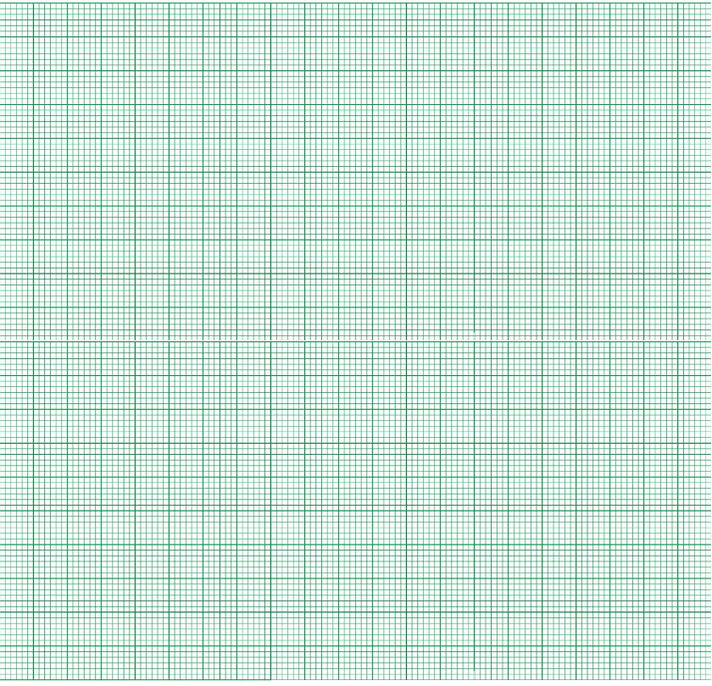
$$x$$

$$y$$

$$x=2$$
$$y=1$$
01 mark
$$∴$$
7

-3

5

-1

-2

2

3

4

5

6

$$2x+y=5$$
01 mark

$$x+y=3$$
01 mark
6

1

4

3

2

1

0

-1

(b) Multiples of 2 are 2, 4, 6, 8, 10, 12, 14, 16,… ……………………….……..……….…..01 mark.
Multiples 0f 7 are 7, 14, 21,……………………………………………………….…..………..…01 mark.
Common multiples is 14……………………………………………………….…….…..……….…01 mark.
Second multiple $=14×2=28$……………………………………………..……………….…01 mark.
Third multiple $=$14$×3=42$………………………………………………………….………….…01 mark.
Therefore, the common multiples of 2and 7 between0-50 are 14, 28, and 42
- (a) 206 $×206=42436$………………………………..…………………………………………………$02\frac{1}{2}$ marks.
Didit2 is at thousands place value or position……………………………………….$02\frac{1}{2}$ marks.
(b)Arithmetic: is the branch of Mathematics that deals with properties and manipulation of numbers by using basic Mathematical operations such as addition, subtraction, multiplication and division……………………………………………………………………………………………..……02 marks.
Algebra: is the branch of Mathematics in which arithmetic operations are applied to symbols rather than specific numbers………………………………………………………………………..$1\frac{1}{2}$ marks
Geometry: is the branch of Mathematics which deals with the study of the sizes, shapes, positions, angles and dimensions of different physical objects………………………………….……$1\frac{1}{2}$ marks.

- (a) $\frac{5}{100}×300 000=15 000$ ……………………………………………………………………………$1\frac{1}{2}$ marks.
$\frac{5}{100}×600 000=210 000$…………………………………………………..……………..…..$1\frac{1}{2}$ marks.
$210 000-15 000=195 000$……………………………..………………………………………..02 marks.
(b) $\left(-6 , n\right)→\left(x , y\right)$
$3\left(-6\right)-4\left(n\right)-6=0$……………………………………………………………………………….01 mark.
$-18-4n-6=0$
$-18-6-4n=0$
$-24-4n=0$………………………………………………………………………………..01 mark.
$-4n=24$………………………………………………………………….…..…….01 mark.
$\frac{-4n}{-4}=\frac{24}{-4}$
$n=-6$…………………………………………………………………..…………01 mark.

