

THE PRIME MINISTER’S OFFICE
REGIONAL ADMINISTRATION AND LOCAL GOVERNMENT
LONGIDO DISTRICT MID TERM EXAMINATION

FORM ONE MID-TERM EXAMINATION
043 MATHEMATICS
MARKING SCHEME AUGUST 2026

- (a) Prime numbers are: 2, 3, 5, 7.........................................................................01 mark.
The number formed in ascending order is 2357...........................................01 mark.
Square numbers are 1, 4 and 9.....................................................................01 mark.
The number formed in descending order is 941............................................01 mark.
$M−N=2357−941=1 416$...................................................................01mark.
(b) $=125−3\left(−2\right)+16$....................................................................................01 mark.
$=125+6+16$............................................................................................01 mark.
$=125+22$....................................................................................................01 mark.
$=147$...........................................................................................................02 marks.

- (a) Total ratios$=6+8+10=24$ parts............................01 mark.
Difference between the largest and smallest $=\left(\frac{10−6}{24}\right)×288 cm$..............01 mark.
$=\frac{4}{24}×288 cm$......................01 mark.
$=48 cm$ .......................... ....02 marks.
(b) David : Amina $=7:3$
David : Nuru$=4:5$
Let the oranges received by Nuru be $x$
Therefore $x:x+21=4:5$............................................................................01 mark.
$\frac{x}{x+21}=\frac{4}{5}$..............................................................................................01 mark.
$5x=4x+8$
$5x−4x=84$
$x=84$............................................................................................01 mark.
Let the number of oranges received by Nuru be $y$
$84 :y=7:3$
$\frac{84}{y}=\frac{7}{3}$..................................................................................................01 mark.
$y=\frac{3×84}{7}=36$
Therefore Amina received 36 oranges..........................................................01 mark.

- (a)
- 8 917 +201 392 +500 099 + 1 983$=$712 391....................................02 marks.
$712 391≈712 000$.........................................................................02 marks.
- 0.5021 +21. 1108 +0.00472+3. 079 $=24.69662$.............................02marks.
24.69662 $≈24.7$..............................................................................02 marks.
(b)
- 5.1825$×20=103.65 ≈103.6$.....................................................01 mark.
- 149.001 $÷8.99=16.574…≈20$..................................................01 mark.
- $\frac{1}{80}=0.0125≈0.01$........................................................................01 mark.
- $0.83×0.737=0.61171≈1$.........................................................01 mark.

- (a) let the cost of a pair of trouser be $x$
Let the cost of a pair of trouser be $y$
$\left. \begin{aligned}3x+4y =12000 \\ 7x+12y=32000\end{aligned}\right\}$………………………………………………………………..........…….01mark
$\left\{\begin{aligned}3x+y =12000 \\ 7x+12y=32000\end{aligned}\right.$
$\begin{aligned} 9x+12y =36000 \\ 7x+12y=32000\end{aligned}$
$−\left|\begin{aligned}9x+12y=36000 \\ 7x+12y=32000\end{aligned}\right.$
$2x=4000$
$\frac{2x}{2}=\frac{4000}{2}$
$x= 2 000$ …………………………………………………………………………..01 mark.
Substitute 2000 for x in $3x+4y=12000$
3 $×2000+4y=12000$
6000 $+ 4y$=12000
$4y=12000−6000$
4$y=6000$ ………………………………………………………………………………………...01 mark.
$y=\frac{6000}{4}$
$y=1500$ ……………………………………………………………………………..…………...01 mark.
$∴$One pair of trouser costs Tsh. 2000 while a skirt costs Tsh 1500 …..……..01 mark.
(b) $\overline{AB}=\overline{BC}$ (Isoscles triangle)
$5x−3y=3x+2y+1$
$5x−3x−3y−2y=1$
$2x−5y=1$...................equation 1.....................................01 mark.
Perimeter$= \overline{AB}+\overline{BC}+\overline{AC}$
$29=5x−3y+3x+2y+1+x+2y$
$29−1=9x+y$
$28=9x+y$............equation 2.....................................................01 mark.
$\left\{\begin{aligned}2x−5y=1 \\ 9x+y=28\end{aligned}\right.$
By calculator $x=3 and y=1$..................................................................................02 marks.
$\overline{CA}=x+2y=3+2×1=5 cm$................................................... ......01 mark.

- (a)
- $2.5555…=2.\dot{5}$ ................................................................................$00\frac{1}{2}$ mark.
- $3.040404…=3.\dot{0}\dot{4}$.........................................................................$00\frac{1}{2}$ mark.
- $\frac{1}{12}=0.083333…=0.08\dot{3}$..................................................................01 mark.
- $2.141414…+0.83333…=2.9\dot{7}\dot{4}$....................................................01 mark.
(b) The largest decimal is $3.\dot{0}\dot{4}$............................................................................$01$ mark.
$let y=3.\dot{0}\dot{4}$
$y=3.\dot{0}\dot{4}$
$100y=3.\dot{0}\dot{4}×100=304.\dot{0}\dot{4 }$....................................................................$01$ mark.
- $\left|\begin{matrix}100y=304.\dot{0}\dot{4} \\ y=3.\dot{0}\dot{4}\end{matrix}\right.$
$99y=301$................................................................................... .............$01$ mark.
$\frac{99y}{99}=\frac{301}{99}$
$x=\frac{301}{99}$....................................................................................................01 mark.

(c) Mathematics in Geography for Personal Income (3 Marks)
- Map Making and Cartography: Using scale drawings, ratios, and coordinates to draw accurate local maps for businesses or tourists. Example: A student calculates accurate scale models to design and sell custom hiking or tourist maps of a local national park.
- Weather and Climate Data Analysis: Using statistics, percentages, and graphs to calculate average rainfall and temperatures for local farmers. Example: Charging a fee to help commercial farmers look at temperature graphs so they know exactly which weeks are best to plant crops.
- Surveying and Land Measurement: Using geometry, shapes, and basic trigonometry to measure land boundaries and calculate the exact area of building plots. Example: Working as an assistant surveyor to calculate the square metres of a plot of land before it is sold.

- (a) $=\frac{−17}{2}+\frac{1}{10}−\frac{23}{7}$
$=−8\frac{1}{2}+\frac{1}{10}−3\frac{2}{7}$
$=\left(−8−3\right)+\left(\frac{−1}{2}+\frac{1}{10}−\frac{2}{7}\right)$.......................................................................01 mark.
$=−11+\left(\frac{−1}{2}−\frac{2}{7}\right)+\frac{1}{10}$
$=−11+\left(\frac{−7−4}{14}\right)+\frac{1}{10}$
$=−11+\left(\frac{−11}{14}\right)+\frac{1}{10}$....................................................................................01 mark.
$=−11+\left(\frac{−55+7}{70}\right)$
$=−11−\frac{48}{70}$
$=−11− \frac{24}{34}$
$=−11\frac{24}{35}$....................................................................................................01 mark.
$\left|−11\frac{24}{35}\right|=11\frac{24}{35}$...........................................................................................02 marks.

(b)$±\left(\frac{−2}{3}x−4\right)<2$
$\frac{−2}{3}x−4+4<2+4$
$\frac{−2}{3}x<6$.....................................................................................$00\frac{1}{2}$ mark.
$\frac{−2}{3}x×\frac{3}{−2}>6×\frac{3}{−2}$
$x>−9$...................................................................................01 mark.
$or$
$\frac{2}{3}x+4<2$
$\frac{2}{3}x+4−4<2−4$
$\frac{2}{3} x <−2$......................................................................................00$\frac{1}{2}$ mark.
$\frac{2}{3}x×\frac{3}{2} <−2×\frac{3}{2}$
$x<−3$.........................................................................................01 mark.
….…2 marks
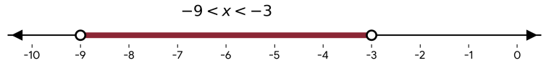
$$−9 < x < −3$$

- (a) $\frac{1}{\frac{8}{7}}=1÷\frac{8}{7}=1×\frac{7}{8}=\frac{7}{8}=0.875$..............................................................01 mark.
$40\%=\frac{40}{100}=0.4$............................................................................01 mark.
$0.5\dot{2}=0.5\dot{2}$......................................................................................01 mark.
$Therefore$ $40\%,0.5\dot{2} ,and\frac{1}{\frac{8}{7 } } are in ascending order…………...….02 marks.$
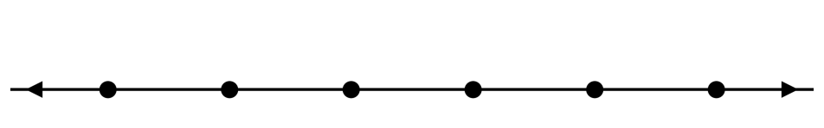
(b) i. Integers are $−4,−$ Graph here$3,−2,−1, 0$ ............................................................01 mark.
….…2 marks

-4
-3
-2
-1
0
1

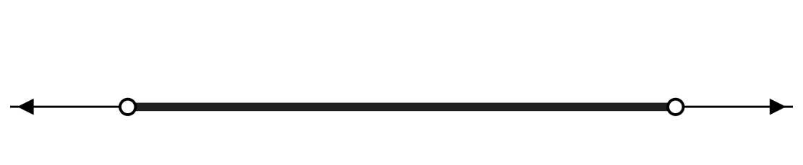
ii.
….…2 marks
2
-4
-3
-2
-1
0
1
-5

- (a) i. $\begin{matrix}1 \\ 2\end{matrix}\left|\begin{matrix}5x+2y=6 \\ 3x−y=8\end{matrix} \right.$
$\begin{matrix}5x+2y=6 \\ 6x−2y=16\end{matrix}$.............................................................................................0 mark.
$+\left|\begin{matrix}6x−2y=16 \\ 5x+y=6\end{matrix}\right.$............................................................................................01 mark.
$11x=22$
$\frac{11x}{11}=\frac{22}{11}$
$x=2$ ..............................................................................................01 mark.
Substitute 2 for $x in 3x−y=8$
$3×2−y=8$
$6−y=8$.........................................................................................................01 mark.
$6−8=y$
$−2=y$ .........................................................................................................01 mark.
(b) $\begin{matrix}5x+2y=6 \\ 3x−y=8\end{matrix}$

From $3x−y=8$
$y=3x−8$.........................................................................................................01 mark.
Substitute $3x−8 for y in5x+2y=8$
$5x+2\left(3x−8\right)=6$.......................................................................................01 mark.

$5x+6x−16=6$
$11x=22$
$\frac{11x}{11}=\frac{22}{11}$
$x=2$...........................................................................................01 mark.

Substitute 2 for $x in y=3x−8$
$y=3×2−8$.............................................................................01 mark.
$=6−8$
$=−2$.........................................................................................01 mark.

- (a) $x=6y$............................................................................................01 mark.
$4y+4=6y$
$4=6y−4y$

$4=2y$..............................................................................................01 mark.
$\frac{2y}{2}=\frac{4}{2}$
$y=2$.................................................................................................01 mark.
$x=6y=6 ×2=12$......................................................................02 marks.

(b) $=2 618 954+124×68−20243$..............................................01 mark.
$=2 618 954+8 432−20243$....................................................01 mark.
$=2 627 954−20243$...................................................................01 mark.
$=2607143$....................................................................................01 mark.
$2607143 ≈2 610 000$...................................................................................01 mark.

- (a)Time Management .........................................................................……….....05 marks.
- Planning Daily Schedule: We use addition and subtraction to divide our 24-hour day into different blocks for studying, sleeping, and playing. Example: Adding 2 hours of homework time to 4 hours of school activities to see how much of the evening is left.
- Meeting Deadlines: Explanation: We calculate the number of days or hours remaining before an exam or project is due so we can plan our preparation. Example: Subtracting today's date from the exam date to find out exactly how many days are left to revise.
- Travel and Punctuality: We calculate speed, distance, and time to know exactly what time we need to leave home to arrive at school or a meeting punctually. Example: Knowing that walking takes 20 minutes, so subtracting 20 minutes from the school start time to decide the departure time.
- Prioritising Tasks (Using Percentages/Ratios): We use fractions or percentages to decide how much total effort or time to give to a difficult subject compared to an easy one. Example: Spending 60% of study time on Mathematics and 40% on Geography.
- Measuring Efficiency and Speed: We count or time how long it takes to complete a single task to estimate how long a larger amount of work will take. Example: If it takes 5 minutes to read 1 page of a textbook, calculating that reading 10 pages will take 50 minutes.
(b) Budgeting ....................……………….....................................................……….....05 marks.
- Balancing Income and Expenses: We use basic addition to find total income and total expenses, then use subtraction to make sure we do not spend more money than we have. Example: Subtracting total shopping expenses from pocket money to ensure the balance is not below zero.
- Allocating Money to Categories: We use percentages or fractions to divide a total amount of money into specific groups like food, transport, and school supplies. Example: Setting aside 1/2 monthly pocket money for school snacks and 1/4 for bus fare.
- Calculating and Planning Savings: We use subtraction to find out what money is left over after buying needs, which can be saved for the future.
  - Example: Planning to save 1,000 shillings every week from pocket money to buy a new school bag after two months.
- Finding Best Prices (Comparison Shopping): We use division to find the unit price of items to see which shop offers the cheaper option or better discount. Example: Comparing if a pack of 3 pens for 1,500 shillings is cheaper per pen than a single pen sold for 600 shillings.
- Preventing Financial Debt: We use simple mathematical estimation and inequalities (greater than/less than symbols) to make sure our total wants do not cross our financial limit.Example: Keeping track of total costs while picking items in a shop so the final bill stays less than (<) the cash in hand.

