

THE PRIME MINISTER’S OFFICE
REGIONAL ADMINISTRATION AND LOCAL GOVERNMENT
LONGIDO DISTRICT MID TERM EXAMINATION

FORM ONE MID-TERM EXAMINATION
043 MATHEMATICS
Time: 2½ Hours Wednesday, 26th August 2026 a.m.

Instructions
- This paper consists of a total of 10 questions.
- Attempt all questions.
- Each question carries 10 marks.
- NECTA mathematical tables, non-programmable calculators, geometric instruments and graph papers may be allowed.
- Write your examination number on every page of your answer sheets

FOR EXAMINER’S USE ONLY
QUESTION  NUMBER | SCORE | EXAMINER’S INITIALS
1
2
3
4
5
6
7
8
9
10
TOTAL
CHECKER’S INITIALS

- (a) A number M is formed by using or writing all prime numbers between 0 $\text{−}$10 in ascending order while a number N is formed by writing all square numbers between 0$\text{−}$10 in descending order. Find the positive difference between M and N. (Each digit is used without repetition)

(b) Evaluate the following: ${\text{5}}^{\text{3}}\text{−3}\left(\text{18÷}\left(\text{−9}\right)\right)\text{+16}$.

- (a) The sides of a triangle are in the ratio of 6: 8: 10. If the perimeter of the triangle is 288 cm, find the difference between the longest side and the shortest side.

(b) David , Amina , and Nuru shared some oranges. The ratio of the number of oranges received by David and Amina was 7:3. The number of oranges David received to that of Nuru was in the ratio 4:5. If Nuru received 21 more oranges than David, find the number of oranges that Amina received.

- (a) Find the sum of the following numbers and give the answers correct to 3 significant figures
- 8 917, 201 392, 500 099, and 1 983

- 0.5021, 21. 1108, 0.00472, and 3.079

(b) Find the value of each of the following expressions. Write and correct to the given conditions in brackets:
- 5.1825 $\text{×20}$ (tenths).

- 149.001 $\text{÷}$8.99 (1 significant figure).

- $\frac{\text{1}}{\text{80}}$ (hundredths).

- $\text{0.83 ×0.737}$ ones)

- (a) The cost of buying 3 pairs of trousers and 4 skirts is 12 000 shillings, if there were 7 pairs of trousers and 12 skirts, it would have cost 20 000 shilling more. Find the cost of one pair of trousers and one skirt.

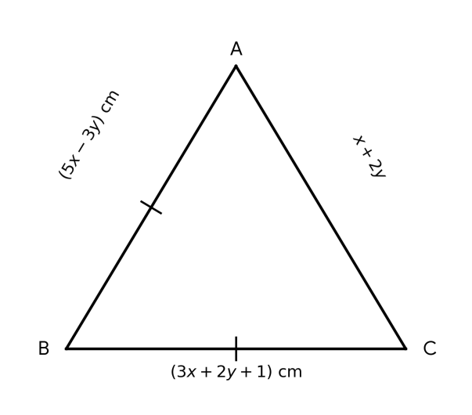
(b) Find the value of segment $\overline{\text{AC}}$ in the following triangle ABC whose distance around it is 29 cm.

- (a) Write each of the following in decimal notation:
- 2.555555…

- 3.040404…

- $\frac{\text{1}}{\text{12}}$

- $\left(\text{2.141414…+0.83333…}\right)$

(b) From 1 (a) convert the largest decimal into the simple fraction.

(c) Explain briefly with examples how Mathematics knowledge can be used in Geography field to generate personal income?

- (a)Find the absolute value of $\frac{−17}{2}+\frac{1}{10}−3\frac{2}{7}$.

(b) Graph the solution of $\left|−\frac{2}{3}x−4\right|<2$

- (a) Write the following numbers in ascending order: $\frac{1}{\frac{8}{7}},40\%, 0.5\dot{2}$

( b) Represent the following on a separate number line:
- $\text{−} \text{5} \text{<} \text{y} \text{<} \text{2,}$ where $\text{y}$is an integer

ii. $\text{ −5} \text{<} \text{y} \text{<} \text{2}$, where $\text{y}$ is a real number

- Given the following pairs of simultaneous equations:
$\left\{\begin{aligned}\text{5}\text{x}\text{+2}\text{y}\text{=6} \\ \text{3}\text{x}\text{−}\text{y}\text{=8}\end{aligned}\right.$
Solve by using:
- Elimination method.

- Substitution method.

- (a) If $\frac{x}{y}=6$ , find the values of $x and y if4\left(y+1\right)=x$

(b) Evaluate $2 618 954+\left(45 260÷365\right)×68−\left(1 614 312−1 594 069\right)$. Leave the answer to 3 significant figures.

- Explain how mathematics is used in the following:
- Time management.

- Budgeting:

