THE PRESIDENTS OFFICE
REGIONAL ADMINISTRATION AND LOCAL GOVERNMENT
NAMANGA SECONDARY SCHOOL
FORM ONE MATHEMATICS MID TERM EXAMINATION
TIME 2:30Hrs
INSTRUCTION
- DON’T COPY OTHERS WORK

- Write the place value of 6 from the following numbers
- 7689432
- 732∙1865
- Write the following numbers in words.
- 84040
- 111011
- You were provided with the following numbers.
83,81,85,80,82,84.
- Write the numbers in ascending order
- Write all even numbers
- Write all odd numbers
- Write all prime numbers.
- Factorize the following numbers into prime factors
- 250
- 729
- Work out the following
- 8975+967=
- 8224-986=
- 10-6∙79=
- 173∙43+1∙3=
- Evaluate the following integers by using number line
- (⁻7)+(⁻3)=
- (⁺8)+(⁻13)=
- (⁺4)+(⁻6)=
- -5+10

- Which of the following pairs of numbers is greater?
- ⁻1 and ⁻10
- ⁺2 and ⁺3
- Calculate the following
- (+12)$×$(-7)=
- (⁻15)$×\left(-10\right)=$
- (+3∙24)$×(+1∙2)$=
- (⁻4∙2)$×$(⁻100)=
- Work out;
- (⁺24)$÷$(⁻2)=
- (⁻2400)$÷$(⁻40)=
- (⁺5∙28)$÷$(⁻8)=
- (-2∙70)$÷$(-1∙5)=
- Arrange the following fractions from the smaller to the largest.
- $\frac{3}{8}$ ,$\frac{9}{12}$, $\frac{7}{16}$, $\frac{4}{18}$
- Find the missing number in the following equivalent fraction.
- $\frac{3}{4}$ =$\frac{}{20}$
- $\frac{}{50}=\frac{4}{5}$
- Work out the following fractions.
- 2$\frac{3}{5}$ +3$\frac{3}{4}$=
- 2$\frac{9}{7}$ $-$4$\frac{2}{11}$=
- 2$\frac{3}{4}$ - 3$\frac{1}{5}$=
- 4$\frac{1}{2}$ $÷$ 5$\frac{8}{12}$=
- In a class of 30 pupils, 18 are girls.
- What fraction are girls?
- What fraction are boys?
- How many weeks are there in 50400 minutes?
- Write down the fraction shown by the shaded part of the diagram.

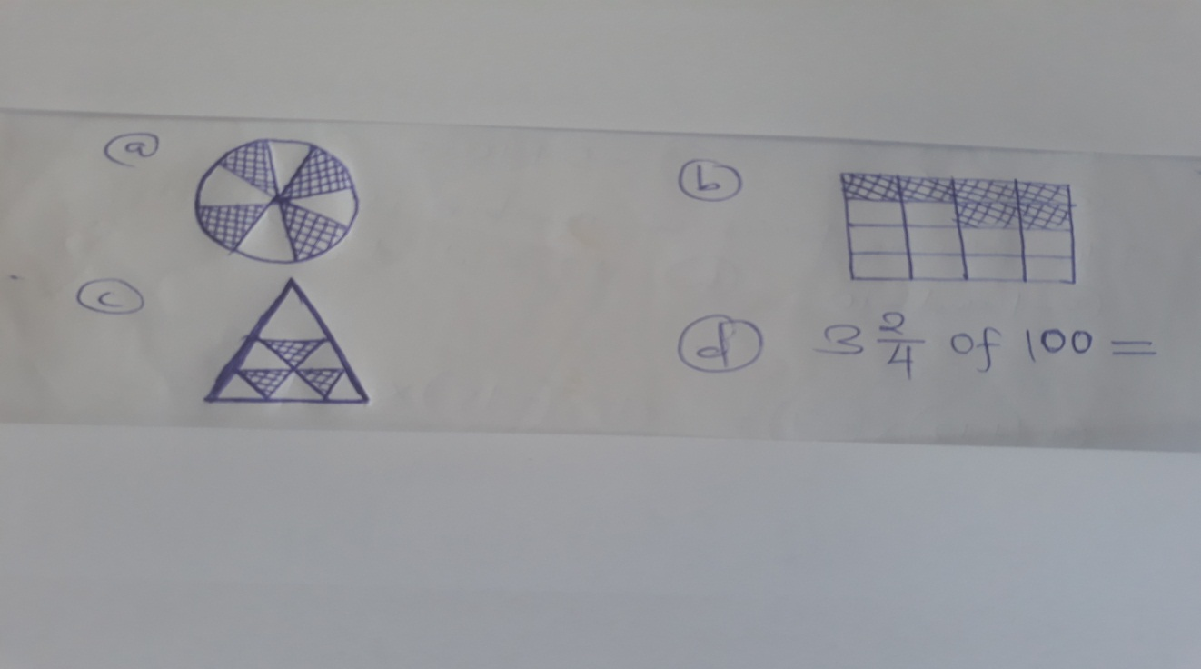

- Convert the following decimals into fractions
- 1∙2
- 1∙9
- 0∙54
- 0∙07
- 0∙431

