THE PRESIDENT’S OFFICE
MINISTRY OF EDUCATION, REGIONAL ADMINISTRATION AND LOCAL GOVERNMENT
CHEMISTRY MID TERM EXAMINATION
FORM ONE-2024
Time: 2:30Hours
Instructions.
- This paper consists of section A, B and C with a total of 10 questions
- Answer all questions in all sections
- Section A carries 15 marks, section B 70 marks and section C 15 marks
- All answers should be written in blue or black ink except for drawings which must be drawn by using pencil
- All communication devices, calculators and any unauthorized material are not allowed in examination room.
- Write your FULL NAMES on every page of your answer sheets
SECTION A (15 Marks)
Answer All questions in this section.
- For each of the items (i)-(x), choose the correct answer from the alternatives given.
- The following skills acquired through studying chemistry except;
- Careful observation
- Accurate reporting
- Testing hypothesis experimentally
- Map reading skills
- Chemistry is a scientific activity because;
- Chemistry is studied in schools
- Chemistry is interesting subject studied through data collection and analysis.
- Knowledge of chemistry is acquired through observation, experimentation and logical reasoning.
- It involves study of living and non-living things.
- The following are laboratory rules except;
- Turn off water and gas tap after use
- Test any un-labelled substance before using it in the laboratory.
- Put off flames which are not in use
- Remove obstacles from gang ways.
- Splints are among of the first aid kit equipment which of the following sentences set describes its use;
- Used to pick up and holding things
- Used for cutting bandages or pieces of clothes
- Used to support broken bones and is tied using bandages.
- Used for holding pieces of bandages or cloth together.
- The Bunsen burner is likely to contain soot when;
- The air hole is closed
- The air hole is open but not fully
- The air holes of Bunsen burner are completely open.
- The burner is not raised
- The gas supply is high
- Which of the following takes place in experimental stage?
- Rejection of hypothesis
- Acceptance of hypothesis
- Concluding the scientific findings
- Carry out investigations
- In scientific procedure, what would be the next step to follow after experiments?
- Data interpretation
- Conclusion
- Observation
- Investigation
- In her first experiment, Mwajuma dissolved sulphuric acid in water and heat was evolved. In her second experiment he dissolved sugar in water and no heat was evolved or absorbed she conducted that;
- Her first experiment was physical change
- Both of her experiments were physical change
- Her second experiment was chemical change
- Her first experiment was chemical change
- A person who studied chemistry in ancient time is called…………….
- Chemist
- Alchemist
- Both A and B
- dentist
- Which of the following method can be used to separate iron powder from sand
- magnetism
- magnetization
- magnet
- sublimation
2. (a) Match the items in List A with their correspondence items in List B.
LIST A | LIST B
- liquids that pass through the filter paper.  - Method of separating maize seeds from beans seeds  - A solid that is formed out of solution.  - Used to separate dyes  - Is the best method for separation of liquid mixtures. | - Emulsion paint  - Emulsion point  - Residue  - Filtrates  - Simple distillation  - Fractional distillation  - Evaporation  - Filtration  - Contaminated water  - Crystals  - Hand picking  - Chromatography

SECTION B (70 MARKS)
3 a) what is the meaning of metals and non-metals. Give example on each
(b) Fill the following gaps with the correct answer
- Mixture of solute and solvent…………………………………………
- A box for keeping items to be used for first Aid…………………………….
- Apparatus used to hold hot substances and apparatus is ……………………
- An apparatus used to measure fixed volume of a liquid………………..
- The smallest particle of matter…………………………………..
4 Juma went to the hospital for medical check-up and treatment in which he was given Medicine A and B. for medicine A he was asked to prepare a solution of glucose and water while medicine B were written “shake well before use”.
- The prepared medicine A and B are said to be …………………… and ………………………respectively
- For medicine A which component is a solute? Why?
- What are the four differences between medicine A and B
5 a) What is the meaning of physical and chemical change and give one example on each
b) Name the process of changing state of matter
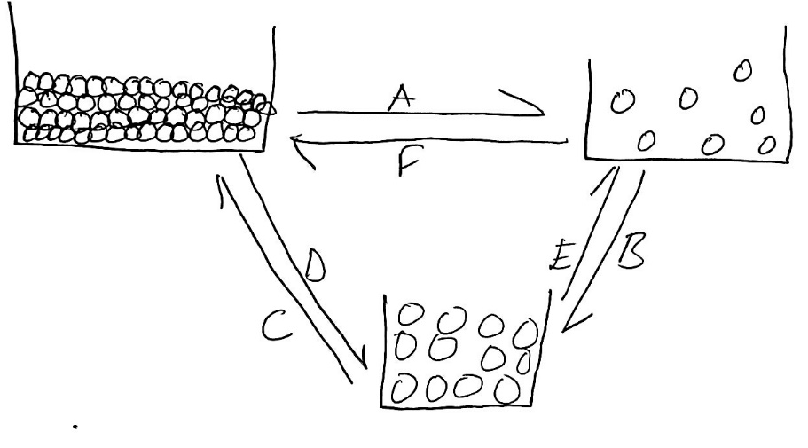

6. (a) What would you do if any kind of chemical splash into your eyes?
(b) What are the function(s) of:
I Antiseptics
ii Plasters
iii Antibiotics
iv Medical tape
v first aid manual
7 (a) Define the following terms and give one example in each case;
- A chemical symbol
- An element
- A compound
- Emulsion
(b) Write names of elements represented by the following symbols
i. Au ……………………………………
ii. Ag …………………………………….
iii. Hg ……………………………………..
iv. P ………………………………………..
v. Sn …………………………………………
8 (a) Mention and explain briefly any four warning signs found in chemical containers
giving one example in each case.
(b) Distinguish between the following;
i. Hypothesis against fact
9. Naomi was asked by her teacher, what are the properties of metals and she replied in five points as follows, metals are
- Ductile
- Malleable
- Sonorous
- Have high tensile strength
- Good conductors of heat
What did Naomi mean when she replied as mentioned above
SECTION C (15 MARKS)
10. Read the following diagram and answer question that follow in which A is a mixture of ethanol and water
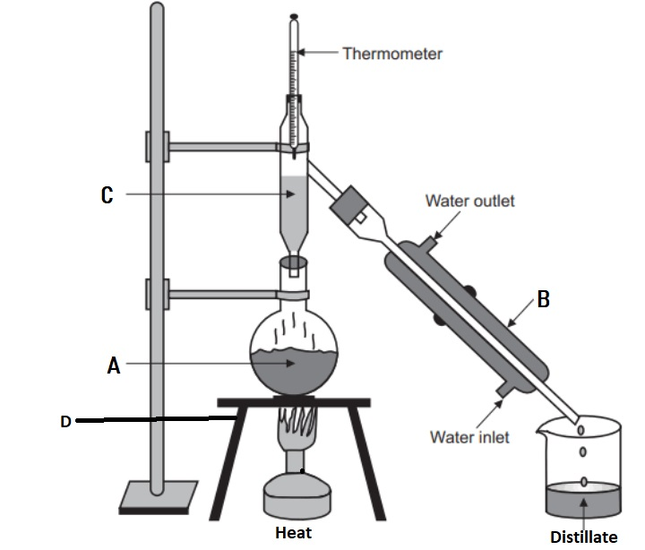

QUESTION
- Which method used to separate above components …………………………
- Define the method involved in separation
- Which liquid distills first and at what temperature
- Label parts A and D and state their functions
- Which liquid distills at the end of experiment? Why?
- Each collected component is known as

