PRESIDENT’S OFFICE – RALG
LONGIDO DISTRICT COUNCIL
FORM ONE MID- TERM EXAMINATION
TIME : 2 : 30 HRS CHEMISTRY MARCH , 2024
- i. The following apparatus is used to keep test tubes in the laboratory
A. Beaker B. Basin for test tubes C. Test tube rack D. Test tube holder
ii. A person at home can apply chemistry in:
A. Weighing cassava and maize B. Cooking food in a kitchen
C. Dusting a floor in a house D. Weeding flowers in a garden
iii. Which branch of chemistry deals with the study of carbon and its compounds?
A. Analytical chemistry B. Biochemistry C. Organic chemistry D. Inorganic chemistry
iv. Vaccines are chemical substances used to:
A Cure animals and human beings from disease
B. Protect animals and human beings from disease
C. Introduce vitamins and proteins in animals
D. Make animal grow faster than normal growing
v. Which of the following consists of home care products?
A. Paints, Air fresheners an petrol
B. Air fresheners, disinfectants and detergents
C. Yeast, plastic and disinfectant
D. Rubber, clothes and soap.
vi. After a practical session:
A. Clean up the equipments before you start experiment
B. Turn off any gas or water taps that are not in use
C. Turn off gas and water taps
D.Wash off any chemical spills on your skin or clothes with plenty of clean water
Vii. A person who provides immediately help to a sick person or victim is called:
- Chemist B. First aider C. Pharmacist D. First aid

- Showing small things more clearly
- Microscope B. Ammeter C. Bunsen burner D. A mirror
ix.A chemical substances that blasts easily
- Flammable B. Corrosive C. Explosive D. Health hazards
x. A person who deals with medicines is known as;
A. Doctor B. Nurse C. Store keeper D Pharmacist
i | ii | iii | iv | v | vi | vii | viii | ix | x

- Match the words in column A with their functions in column B
Column A | Column B
I.Grasping and lifting hot things | A. Bunsen burner
ii.Measuring temperature | B.Balance
iii.transferring samples of chemical from one container to another | C.scissor
iv.Cleaning apparatus | D. Tongs
v.An instrument for measuring mass | E. Thermometer
 | F.Cylinder
 | G.Brush
 | H.Spatula

LIST A | i | ii | iii | iv | v
LIST B

- a) Give the difference between laboratory and chemistry laboratory?
Laboratory | Chemistry laboratory
………………………………………………………  …………………………………………………….. | ………………………………………………………  ………………………………………………………

- Study the following picture and answer the questions that follow

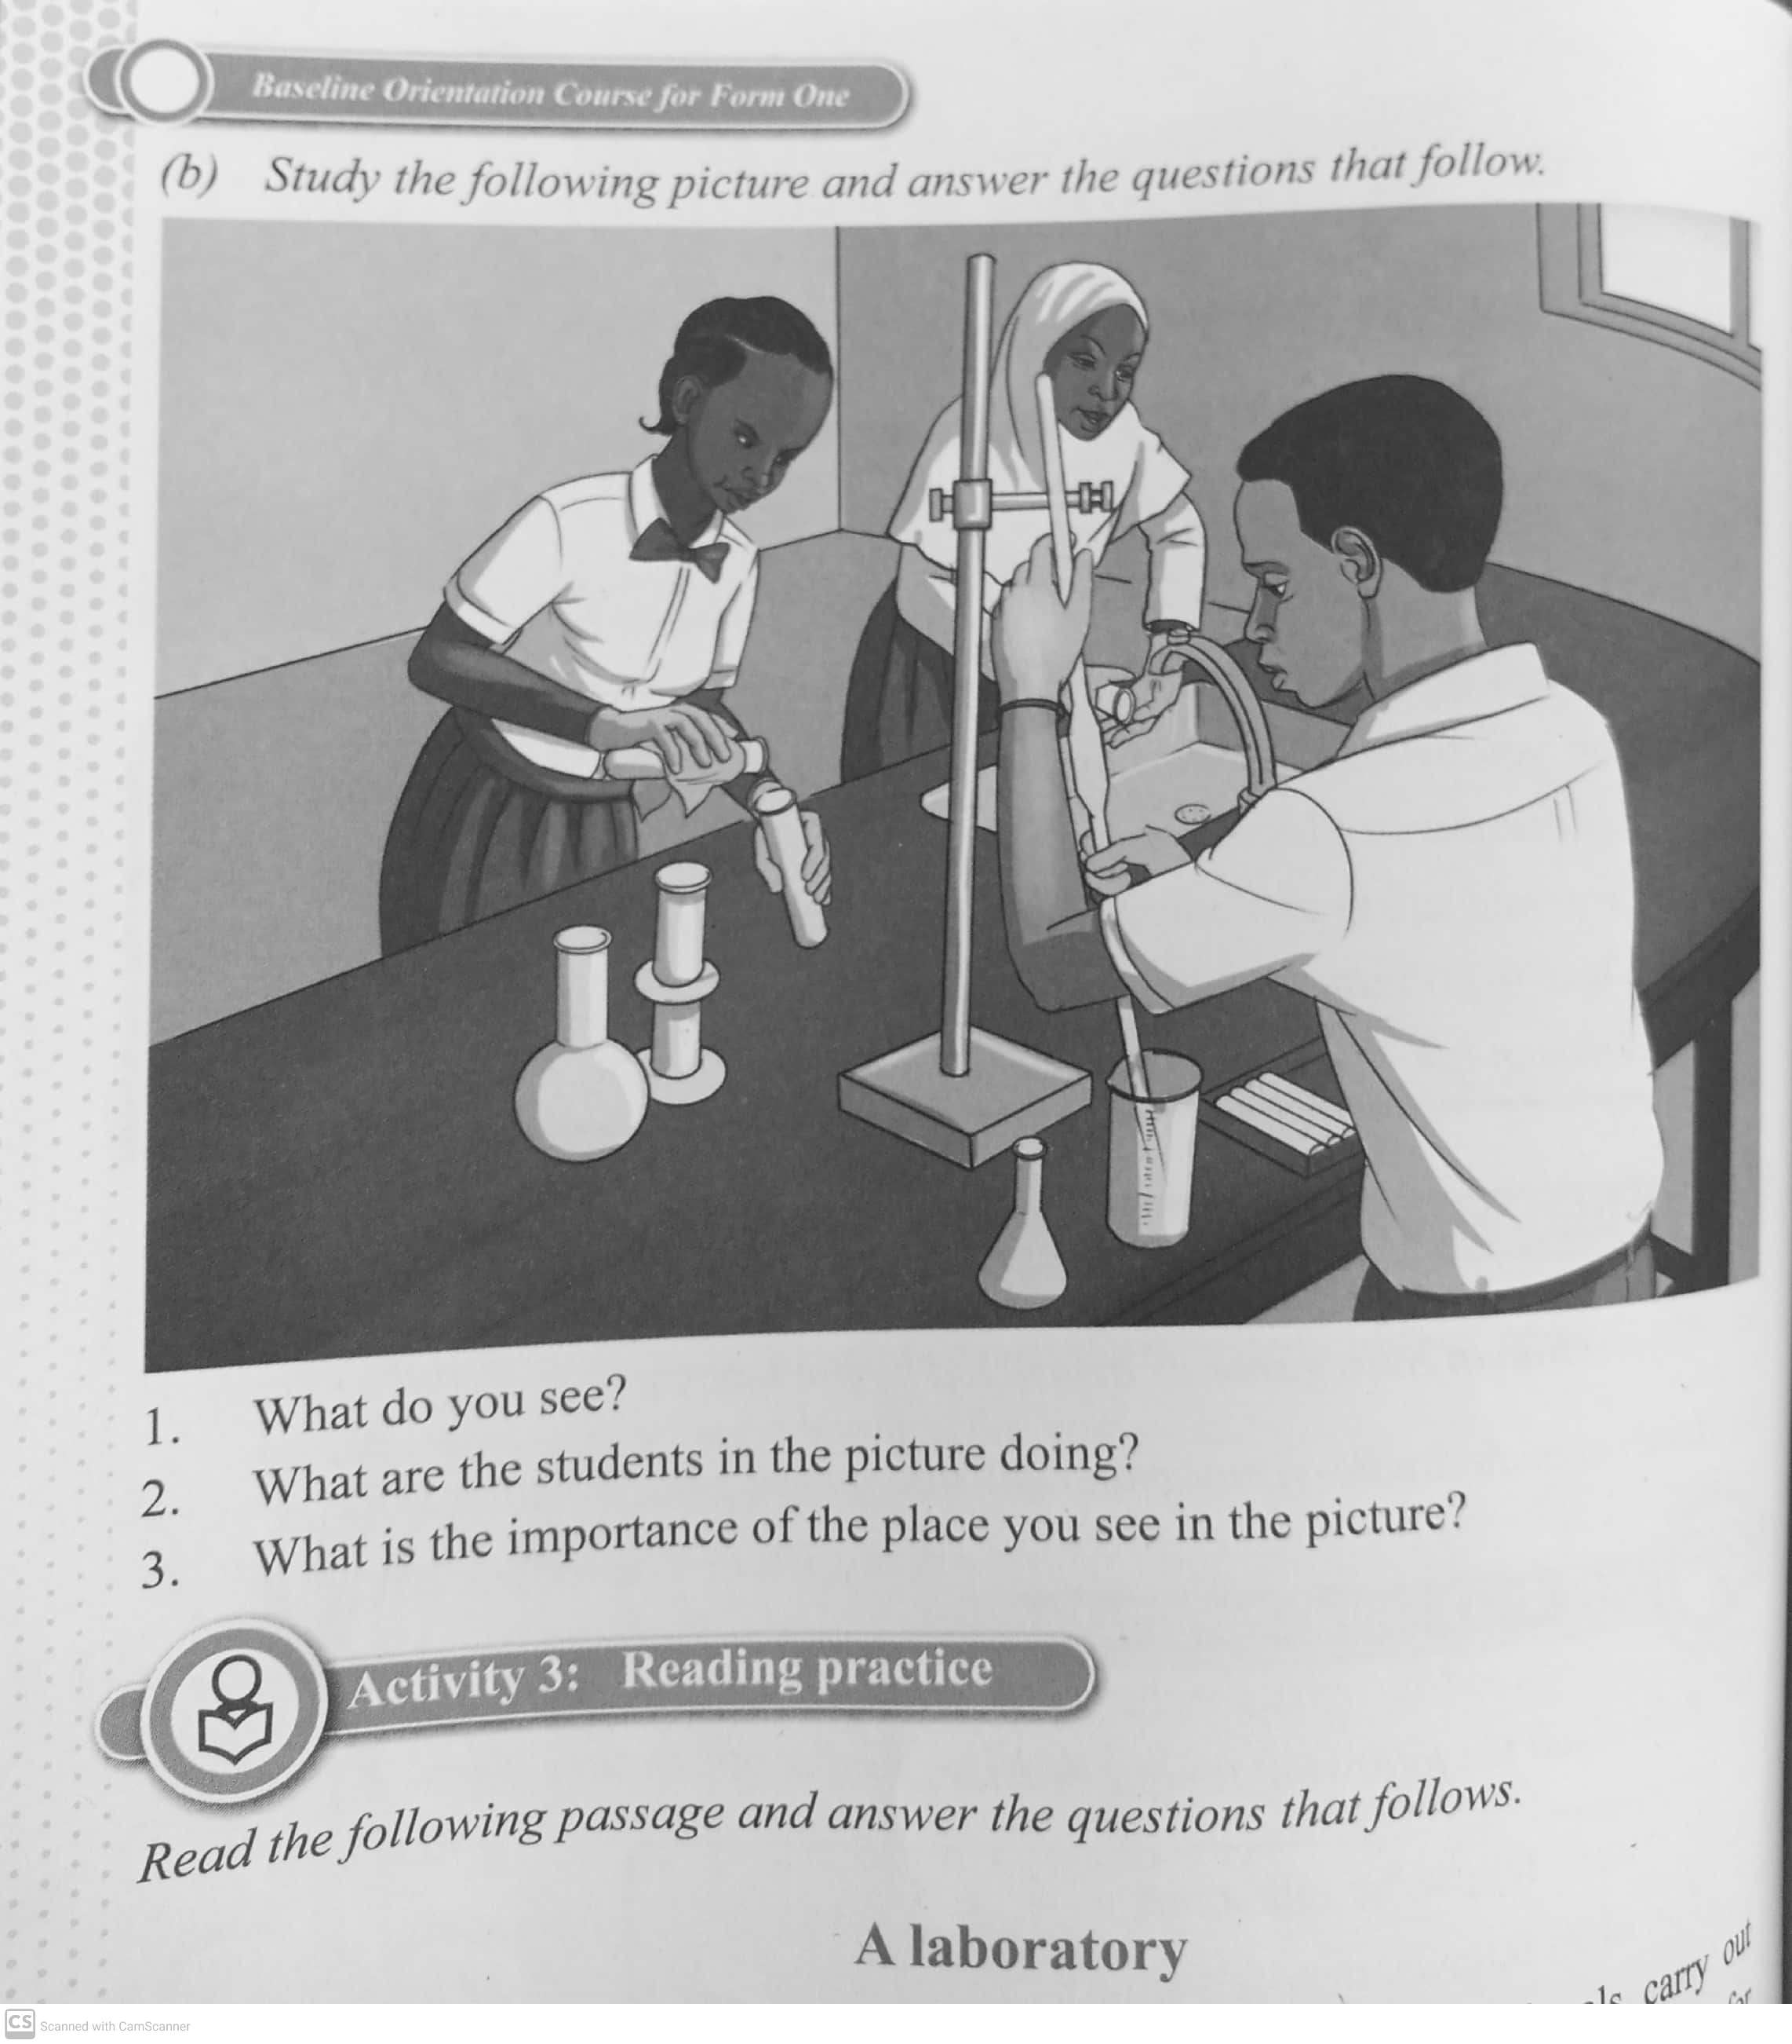
- What do you see ?
………………………………………………………………………………………………..…………….
- What are the students in the picture doing ?
……………………………………………………………………………………………………………..
- What is the two importance of the place you see in the picture?
……………………………………………………………………………………………………………...
4 a) Rearrange each of the following letters to form a word
- sapapartu ……………………………………………………………………….
- Sasm..…………………………………………………………………………..
- Muvole.…………………………………………………………………………
- orylaratob…...………………………………………………………………….
- etmi……………………………………………………………………………
- ii. Why do we need apparatus?
………………………………………………………………………………………………………..
iii. Mention any five apparatus you know
…………………………………………………………………………………………………………

iv What would you do if you are not sure of how to use an apparatus?
…………………………………………………………………………………………………………
5 i. Why should long hair be tied at the back?
……………………………………………………………………………………………………………
ii.What does the phrase "fooling around" mean?
…………………………………………………………………………………………………………
iii. Why is loose or floppy clothing not allowed in the laboratory?
………………………………………………………………………………………………………….
iv. Why safety equipment should never be blocked by any object
…………………………………………………………………………………………………………

6a) List down five laboratory rules which you should obey during practical activities
- ………………………………………………………………………………………..
- …………………………………………………………………………………………
- …………………………………………………………………………………………
- ………………………………………………………………………………………….
- ………………………………………………………………………………………….

- Read these descriptions of events in the laboratory and state which laboratory rule was violated.
i Some pieces of paper caught fire in the laboratory after the students went home.
……………………………………………………………………………………………………
Ii. Chimamy's long hair caught fire
……………………………………………………………………………………………………
- Domi and Dami are eating biscuits in the laboratory
……………………………………………………………………………………………….
- Tatu entered the laboratory alone and could not understand how to turn off the gas pipe. Half an hour later, she ran out of the laboratory but the laboratory and two more classrooms caught fire.
……………………………………………………………………………………………….
7i.Who is responsible to receive the report of all accidents which occur in the laboratory?
………………………………………………………………………………………………….
7ii. Mention any five causes of accident in the laboratory
…………………………………………………………………………………………………..
8. How would life be if there was no chemistry at all? Give five points
………………………………………………………………………………………………….
9. a) Fill in the following table by giving any two products
FIELDS | PRODUCTS
Textile industry
Agriculture
Transport
Food and beverage industry
Medicine

b) Give any five importance’s of chemistry in life.
- ……………………………………………………………………
- ……………………………………………………………………
- …………………………………………………………………..
- …………………………………………………………………..
- ………………………………………………………………….
10. a) Define the following terms as used in chemistry
i. First aid kit…………………………………………………………………………………………
………………………………………………………………………………………………………..
ii. First aid………………………………………………………………………………………….
……………………………………………………………………………………………………..
iii. First aider………………………………………………………………………………………..
………………………………………………………………………………………………………..
b) List five importance’s of giving First aid to victims of accidents
- ………………………………………………………………………………………………….
- …………………………………………………………………………………………………
- ………………………………………………………………………………………………..
- ……………………………………………………………………………………………….
- ……………………………………………………………………………………………….
- ………………………………………………………………………………………………..
c) List any five components of first aid kit and their uses
- ………………………………………………………………………………………
- ……………………………………………………………………………………….
- ………………………………………………………………………………………..
- ……………………………………………………………………………………….
- …………………………………………………………………………………………

