THE UNITED REPUBLIC OF TANZANIA
PRESIDENT’S OFFICE
REGIONAL ADMINISTRATION AND LOCAL GOVERNMENT
NAMANGA SECONDARY SCHOOL
FORM ONE TERMINAL EXAMINATION
CHEMISTRY
Time: 2 ½ Hours 2024

Instructions:
- This paper consists of sections A and B with a total of ten (10) questions.
- Answer ALL questions in the spaces provided.
- All writing must be in blue or black ink, except drawing, which must be in pencil.
- Cellular phones and any unauthorized materials are not allowed in the examination room.
- Write your Examination Number at the top right corner of every page.

SECTION A (15 Marks)
Answer all questions
- Choose the most correct answer among the given alternatives and write down the answer in the space given.
  - Which of the following apparatus would you use for keeping stored chemicals dry?
A. A reagent bottle B. Beaker C. Desiccator D. Crucible

  - Which of the following statements are true about the non-luminous flame of the Bunsen burner?
- It is sooty and obtained when the air hole of the Bunsen Buner is open.
- It is steady and obtained when the air hole of the Bunsen Buner is closed.
- It is noisy and obtained when the air hole of the Bunsen Buner is open.
- It is quite and obtained when the air hole of the Bunsen Buner is open

  - The most common source of heat used in laboratory is
    - Spirit lamp
    - Bunsen burner
    - Liquefied petroleum gas burner
    - Charcoal burner

  - The part of the Bunsen burner that controls the amount of air entering the burner is called:
    - Air hole
    - Collar
    - Base
    - Chimney

  - Candle and kerosene lamp produce…
    - No light
    - Luminous flame
    - Non luminous flame
    - No heat

  - Which one of the following sets of laboratory apparatus are used for measuring volume?
- Crucible, U-tube and volumetric flask
- Test tubes, beakers and glass jar
- Thistle funnel, separating funnel and beaker
- Burette, pipette and measuring cylinder

  - What is the use of liniment found in the first aid kit?
- Killing harmful germs
- It acts as an antibiotic
- Reducing muscle pain
- Soften up burns and cuts

  - Loose or floppy clothing is not allowing in the laboratory. Why?
- It may catch fire or cause one to fall
- Movement has to be fast.
- It will get wet when water splashes.
- It causes poor ventilation in the body

  - Teacher Palm wants to grind the granules of a certain chemicals to be fine powder. The apparatus he will use include
    - Pestle and filter paper
    - Motor and pestle
    - Burette and dish
    - Test tube and pipette

  - Chemistry is a scientific activity because
- Chemistry is studied in schools
- Knowledge of chemistry is acquired through observations, experimentation and logical reasoning.
- It is an interesting subject
- It involves the study of non-living things

ANSWERS
List A | (i) | (ii) | (iii) | (iv) | (v) | (vi) | (vii) | (viii) | (ix) | (x)
List B

- Match the mixtures in list A with the correct separation method in list B.
LIST A | LIST B
- Apparatus for taking measurements  - Apparatus for heating substances  - Apparatus for grinding  - Apparatus for storage  - Apparatus for safety | - Mortar and pestle  - Goggles and hand gloves  - Beaker, tongs and spatula  - Thermometer, beam balance, and stop watch.  - Reagent bottles and wash bottle.  - Test tubes, droppers and thistle funnel  - Filter paper, filter funnel and cotton wool  - Pipe-clay triangle, crucible and lid, and wire gauze

ANSWERS
List A | (i) | (ii) | (iii) | (iv) | (v)
List B

SECTION B (70 Marks)
- (a) Define the following
- First Aid …………………………………………………………………………………………………………….
- First aid kit ………………………………………………………………………………………………………
        - State four importance of First Aid:
- …………………………………………………………………………………………………………………………………………………………………………………
- ……………………………………….....................................................................................
- …………………………………………………………………………………………………
- …………………………………………………………………………………………………

- (a) Draw a well labeled diagram of a luminous flame.

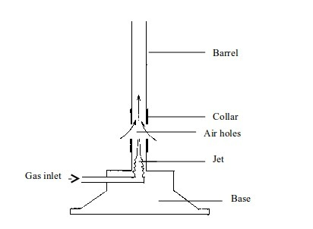
(b) Below is a diagram of a Bunsen burner: Give the names of the parts labeled a, b, c, and d, and then state the function of each of the parts a, b , c, d.

a

b
c

d

Part | Name | Function
a
b
c
d

- State five laboratory safety measures to obey in order to ensure a safe laboratory environment for yourself and the people you may be working
- .…………………………………………………………………………………………………………………………
- …………………………………………………………………………………………………..
- ………………………………………………………………………………………………………..
- ………………………………………………………………………………………………….
- …………………………………………………………………………………………………..

- State the meaning of each of the following symbols and briefly describe the substances represented by the symbols.
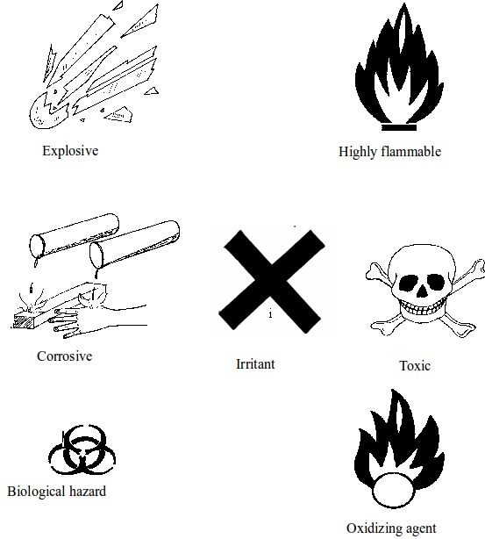

(i)

………………………………
……………………………………………………………………………………………
……

(ii)

…………………………………
……………………………………………………………………………………………..
…………

(iii)

…………………………………..
……………………………………………………………………………

(iv)

………………………………….
………………………………………………………………………………………
……….

……………………………….
………………………………………………………………………………………………………

- a) A muscle cramp is an involuntarily and forcibly contracted muscle that does not relax. Briefly explain any two causes of the muscle cramp and what should be done to the victim of muscle cramp.
Causes:
          - ……………………………………………………………………………………………………………………………………………………
          - ………………………………………………………………………………………………………..
b)

Actions to be taken when somebody suffers a muscle cramp
  - …………………………………………………………………………………………………
  - …………………………………………………………………………………………………
  - ………………………………………………………………………………………………………

- (a) (i) What is Chemistry?
…………………………………………………………………………………………………………………………………
(ii) Define matter
…………………………………………………………………………………………………………….
(b) (i) Briefly explain three other fields where Chemistry is applied. ………………………………………………………………………………………………………………………………………………………………………………………………………………………………………………………………………………………………
(ii) Outline any the three materials or products made by using the knowledge of Chemistry.……………………………………………………………………………………………………………………………………………………………………………………………………………………………………………………………………………

- (a) What are flames?
………………………………………………………………………………………………………………………
(b) Flames are very important due to their usefulness in our daily life. Briefly explain four of their uses:
  - …………………………………………………………........................................................................................................................................................................................

  - ……………………………………………………………………………………………………………………………………………………………………………………

  - ……………………………………………………………………………………………………………………………………………………………………………………

  - ……………………………………………………………………………………………………………………………………………………………………………………

SECTION C (15 MARKS)
- The knowledge of chemistry is considered to be very important in life. Briefly explain this in five points.
……………………………………………………………………………………………………………………………………………………………………………………………..
………………………………………………………………………………………………………………………………………………………………………………………………….
……………………………………………………………………………………………………………………………………………………………………………………………………………………………………………………………………………………………………..
……………………………………………………………………………………………………………………………………………………………………………………………..
……………………………………………………………………………………………………………………………………………………………………………………………..
………………………………………………………………………………………………………………………………………………………………………………………………….
……………………………………………………………………………………………………………………………………………………………………………………………………………………………………………………………………………………………………..
……………………………………………………………………………………………………………………………………………………………………………………………..
……………………………………………………………………………………………………………………………………………………………………………………………..
………………………………………………………………………………………………………………………………………………………………………………………………….
……………………………………………………………………………………………………………………………………………………………………………………………………………………………………………………………………………………………………..
……………………………………………………………………………………………………………………………………………………………………………………………..
……………………………………………………………………………………………………………………………………………………………………………………………..
………………………………………………………………………………………………………………………………………………………………………………………………….
……………………………………………………………………………………………………………………………………………………………………………………………………………………………………………………………………………………………………..
……………………………………………………………………………………………………………………………………………………………………………………………..

