
TANZANIA HEADS OF SECONDARY SCHOOLS ASSOCIATION (TAHOSSA)
SIMIYU REGION
MEATU DISTRICT COUNCIL
FORM ONE DISTRICT JOINT TERMINAL EXAMS, MAY - 2019

032 CHEMISTRY
Time: 2:30 Hours. Wednesday, 29th May 2019 a.m. ____________________________________________________________________________________________________

Instructions:
- This paper consists of section A, B and C.
- Attempt ALL questions in all sections.
- Write your examination number on every page of your answer sheet(s) provided.

SECTION A: (20 Marks)
Answer all questions from this section.
- For each of the items (i) – (x), choose the correct answer among the given alternatives and write its letter in the box provided.
- The branch of science that deals with composition and decomposition of matter is called ………………….
A. Atechemistry B. Chemist
C. chemistry D. Alchemist
- The first step in scientific procedures
A. Data analysis B. Problem identification
C. Hypothesis formulation D. Data interpretation
- Heat, fuel and ……………. are the three components of fire triangle.
A. Carbon B. Oxygen
C. Hydrogen D. Nitrogen
- Technicians prefer to use blue flame in welding because;
A. It is bright and non-sooty B. It is light and non-sooty
C. It is very hot and large D. It is very hot and non-sooty.
- Milk is a mixture of water and fats. This types is called ……………………..
A. Suspension B. Emulsion
C. Solution D. Precipitate
- The ………… of matter are closely packed in solid state and further a part in the gaseous state
A. Pesticides B. Fertilizer
C. Weak killer D. Particles
- A chemist should acquire the following skills, except
A. Problem identification B. Experimentation
C. Observation D. Survey
- In salt and water mixture, the water is ……………….
A. Solute B. Solvent
C. Suspension D. Solution
- What type of fire is associated with electric equipments?
A. Class D B. Class C
C. Class B D. Class E
- Which of the following is the characteristic of solid?
- It is packed together but do not have definite size.
- It is compact packed and have definite shape and size.
- It is loosely packed with irregular order.
- It is loosely packed with uniform shape.

2. Match the item in List A with the correct responses in List B by writing its letter beside the
number of corresponding items in the table below.
LIST A | LIST B
- Sour milk  - Ice melt to form water  - Parts of Bunsen burner  - Conditions for rust to occur.  - It exists in three states of matter.  - Method of separating coloured compounds  - Used for grinding solid materials  - A person who study chemistry  - A burn which is caused by hot liquid or vapour  - Forms about 21% by volume of the air | - Tripod stand  - Chromatography  - Physical change  - Magnetization  - Air, iron and moisture  - Nitrogen  - Water  - Mortar and pestle  - Oxygen  - Base, jet and collar  - Engineer  - Liquid ,Solid and gases  - Chemical change  - Scald  - Chemist  - Wire gauze

SECTION B: (60 Marks)
Answer ALL questions from this section.
3. (a) Define the following as applied in chemistry
- Fire fighting
- Air
- Combustion
(b) Is air a mixture or compound? Give three reasons for your answer.
4. (a) Explain the followings;
- Flame
- Bunsen burner
(b) Draw a well labeled diagram for Bunsen burner.
5. (a) Write short notes on the following.
- First Aid
- First Aid kit
(b) List four components of First Aid Kit and its uses
6. (a) Give the meaning of the following terms;
(i) Matter
(ii) Condensation
(iii) Boiling point
(b) Give one common substance which exists the three states of matter.
(c) Write the names of the following processes of changing matter from one state to another
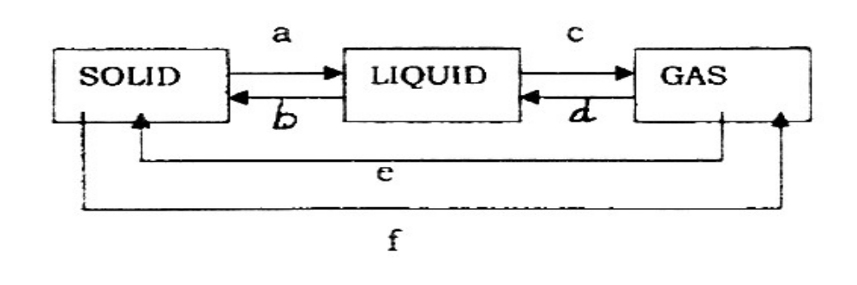
(i) a is ………………… (ii) b is …………………… (iii) c is ….………………
(iv) d is ………………… (v) e is …………………… (vi) f is ………………….

7. (a) Explain the following methods of separating mixtures;
- Layer separation
- Evaporation
- Decantation
- Solvent extraction
- Fractional distillation
(b) Mention the appropriate method used to separate each of the following mixtures;
- Cooking oil and water ………………………
- Oil from groundnuts ……………………….
- Alcohol and water ………………………….
- Iron fillings and sulphur powder …………………………
8. (a) Define the following terms
- Element
- Compound
- Mixture
(b) Write four (4) differences between mixture and compound.

SECTION C: (20 Marks)
9. (a) Define the following terms.
    - Rust
- Rusting
(b) Briefly explain four (4) methods through which rusting can be prevented.
10. (a) Explain the role of Chemistry in the following field.
- Agriculture
- Human health
- Industry
- Transport and Communication
(b) Differentiate between Luminous Flame and Non- Luminous Flame by giving four (4)
differences.

************** Best Wishes **************

