MARKING SCHEME - CHEMISTRY FORM 1
TERMINAL EXAMINATION MAY 2026
SECTION A.
1. (10) marks
(i) | (ii) | (iii) | (iv) | (v) | (vi) | (vii) | (viii) | (ix) | (x)
C | C | B | C | B | B | C | B | B | B

2.
(a) | (b) | (c) | (d) | (e)
(iii) | (v) | (i) | (vi) | (vii)
(05) Marks
SECTION B
3.(a) .Improves blood circulation
.Prevent fainting
.Reduce the risk of organ failure.
.Buys time until medical help arrives. (01)Mark @
(b)Precautions:
(i)It help prevent accidents and injuries. (01) Mark
(ii)Ensure accurate experimental results (01) mark
(iii)Protect others and environment. (02)Marks
(iv)Promote proper use of laboratory apparatus. (02) Marks
Q4.(a)(i)Toxic-the substance is poisonous and can cause serious harm or death.
(ii)Flammable-The substance can catch fire easily.
(iii)Corrosive - The chemical can burn skin and table top
(iv)Explosive-The substance can explode if heated, shocked or mishandled (01) marks @
(b)(i)Students and teachers would not know the dangers of certain chemical substances.
(ii)It would increase the chances of serious accidents.
(iii)Emergency response would be slower and less effective.
(c)(i)Hospitals and clinics (ii) Factories and industries (iii) Construction sites
(iv)Roads and Highways (v) Public places (vi) Fuel station. Any 3 places. (01) Mark
Q5.(a) (i)Large windows and good ventilation
(ii)Water supply.
(iii)Gas supply
(iv)Electric supply.
(v)Preparation room, cupboards. Any 5. (01) Mark @
(b) (i)Follow laboratory rules.
(ii)Wear protective gear.
(iii)Handle chemicals carefully.
(iv) Follow instruction.
(v) Avoid unsafe behaviors. (01) Mark @
Q6.(a) Five Careers from learning chemistry are:
(i)Medical Doctor, (ii) Pharmacist (iii) Chemical Engineer (iv) Laboratory technician (v) Chemistry teacher (01) Mark @
(b)Five accidents that may occur in the laboratory:
(i)Chemical spills (ii) Fire outbreak (iii) Cuts from broken glass
(iv)Chemical burns (v) Inhalation of toxic fumes. (01) Mark@
Q7.(a)Reasons:
(i)It is transparent.
(ii)It can withstand heat.
(iii)It does not react easily with chemicals.
(iv)It is easy to clean. (01) Mark @
(b)Wire gauze-Spread heat evenly and prevent glass from cracking. (02) Marks
(c)Significances of First Aid:
(i)It reduce the like hood of death.
(ii)Shorten the recovery time.
(iii)Prevent permanent disability.
(iv)Reduce pain and suffering. (01) Mark @
Q8.(a)(i)Good ventilation and reduce accumulation of dangerous gases in the laboratory.
(ii)To understand the procedures correctly, To avoid accidents, To reduce confusion.
(iii)It leads to incorrect results, Causes contaminations
(iv)Prevent accidents and protect apparatus.
(v)Avoid flooding and water wastage and to prevents accidents (01)Mark @

(b)(i)Loose clothing around the neck and chest.
(ii)Let the victim sit with the head tipped slightly forward.
(iii)Let the victim pinch in the nose and ask him/her to breathe through the mouth for few minutes.
(iv)Place a wet piece of cloth at the back of the victim neck.
(v)When bleeding stops, clean the nostrils, if bleeding continue, take the victim to nearby health care facility. (01) Mark @
Q9.(a)(i)Fire is the state at which an ignited material combines with oxygen and give off light, heat and flame WHILE Firefighting is the act of extinguishing fire and eliminating their effects. (02) Marks.
(ii)Luminous flame is formed when the air hole of the Bunsen burner is closed while Non-luminous flame is formed when the air hole of the Bunsen burner are fully open. (02)Marks.
(iii)Fire triangle is formed by three components of fire: oxygen, heat and fuel while Fire extinguisher is a device used to extinguish fires. (02)Marks.
(b)Because it denies oxygen from air and water is used to remove heat. (02)Marks
(c)(i)Burning material- Combustible solid materials like papers, clothes, wood.
>Chemical composition- water
(ii)Class F- wet chemical
(iii)Burning material- Flammable gases.
Chemical composition- fine sodium bicarbonate.
(iv) Class B- Extinguisher is Dry powder, Foam or CO2 extinguisher. (001/2)mark @ Total=04marks.

SECTION C (15 Marks)
Q10. (a)
Luminous flame | Non- Luminous flame
1.Bright yellow in colour | .Blue in colour
2.It produce soot | .Does not produce soot
3.It is quite | .It is noisy
4.It is not so hot | .It is very hot
(04) Marks.
(b) Steps for extinguishing fire (4 points)
(i)Remove the safety pin.
(ii)Aim at the base of the fire.
(iii)Squeeze the top lever to release the extinguishing agent.
(iv)Sweep from side to side until the fire extinguished. (01)Mark @

(c) Good labelled diagram of Bunsen burner----- (04) marks
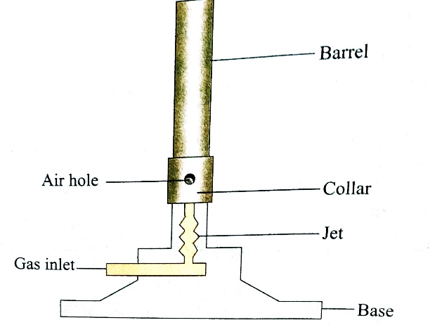

(d)Luminous flame- (i) For lighting (01) Mark
Non- Luminous flame- (i) Heating (ii) Flame test (02) Mark

END.

