PRESIDENT’S OFFICE
REGIONAL ADMINISTRATION AND LOCAL GOVERNMENT
JOINT INSPIRING EXAMINATIONS FOR PRIVATE SECONDARY SCHOOLS


(JIEPSS)
FORM THREE JOINT TERMINAL EXAMINATION
CODE 033 BIOLOGY


Time: 3 Hours May/ June 2025

Instructions:

- This paper consists of section A, B and C with a total of eleven (11) questions
- Answer all questions in sections A and B and two (2) questions from section C
- All writings must be written in blue or black pen except diagrams that must be drawn in pencil
- Write your name on every page of your booklet(s) provided.
- Cellular phones any unauthorized materials are not allowed in the examination room

SECTION A (16 MARKS)
Answer all questions from this section.

1. For items (i) – (x) choose the correct answer from among the alternatives given and write its letter beside the item number in the answer booklet(s) provided.

(i) Which of the following is not true about moss plant?
  - They have no true root, stems or leaves
  - They are true land plants
  - They do not have conducting tissue
  - They found growing in dump shady
  - They have true roots, stems or leaves

Page 1 of 6
St. Augustine Tagaste,Libermann Boys, St. Aloysius Girls SS

- Monica found an organism shaped like an umbrella in damping site. Which statement is true about the organisms?
    - It is mushroom and belongs to phylum Ascomycota
    - It is yeast and belongs to phylum Basidiomycota C. It is mushroom and belongs to phylum Basidiomycota
D. It is mucor and belongs to Ascomycota.

- In the human body kidneys act as.
    - Blood filters
    - Water reservoirs
    - Blood stores
    - Blood pumps

- Air is warmed and humidified in nasal passages. This help to;
  - Presence of mitochondria
  - Presence of vacuole
  - Presence of cell wall
  - Presence of cell membrane
  - Presence of cytoplasm

- Jumanne ate a meal consisting of protein. Where did the digestion of the meal begun?
    - Mouth
    - Duodenum
    - Stomach
    - Small intestine

- John debarked a plant for the purpose of making it dry. Unfortunately, the plant did not wilt. Which cells were not destroyed?
    - Xylem
    - Phloem
    - Cambium
    - Epidermis

- The part of light microscope which helps to reflect and direct light to stage containing specimen.
    - Diaphragm
    - Ocular tube
    - Mirror
    - Condenser Page of 6

- A boy climbed a coconut tree to harvest coconuts. Unfortunately, he fell down and broken his upper arm. Which bone was broken?
    - Ulna
    - Humerus
    - Femus
    - Radius

- The sheet or band of tough, fibrous tissue connecting bones or cartilage at a joint or supporting an organ is a
    - Tendon
    - Muscle
    - Joint
    - Ligament
(x) Normal urine contains the following dissolved substance.
- Ammonia
- Glucose
- Uric acid
- Urea

2. Match the items in List A with the response in List B by writing the letter of the correct response in the space provided

LIST A | LIST B
i. Convert starch to maltose in the mouth. ii. Convert protein to peptide in the duodenum. iii. Change lipid to fatty acid and glycerol. iv. Change peptide to amino acids. v. Emulsifies fats and oils into tiny droplets. vi. Composed by fructose and glucose. | - Maltase  - Rennin  - Bile  - Peptidase  - Pepsin  - Sucrose  - Salivary amylase  - Pancreatic amylase  - Trypsin  - Pancreatic lipase.

Page of 6

SECTION B (54 Marks)

Answer all questions from this section

- (a) With the aid of well labelled diagrams explain three types of neurones
  - Coordination in animals can be accomplished through a set of signals channeled into a series of nerve cell. Use the figure below to answer the following questions:

P

Q

Stimulus
feedback

Response

M

    - Name three (3) components of coordination labeled letter Q, P and M above.
    - Give two (2) examples of parts labelled M.

- (a) Define the following term:
    - Tendon
    - Ligament
    - Muscle
  - Identify three (3) types of muscles you know
  - Grasp the muscle of your left upper arm using your hand. Do not grip too tightly. While grasping your left upper arm in this way let it bend and streghthen it. What happened to the muscle of the arm during bending and straightening
(c) The bending and straightening of the arm are brought by two sets of muscles located inside and outside the hinge joint. Name the two muscles.

- (a) Similar types of three animal cell were placed in 3 different solutions, namely A, B and
C. after some time, the cell in solutionPageA bursted,of 6 the cell in solution B shrank and
shriveled and the cell in solution C did not change.
i. Which types of solutions were A, B and C ii. Explain the reasons for such observation

  - State the meaning of blood transfusion and explain two (2) advantages and two
(2) disadvantages of Blood Transfusion.

- (a) Distinguish between the following term Excretion and Secretion
  - Lomilo has observed his urine sometimes is pale yellow and the other time is colourless. State four factors which cause the changes in his urine concentration.
  - Figure below shows a section of a mammalian kidney.
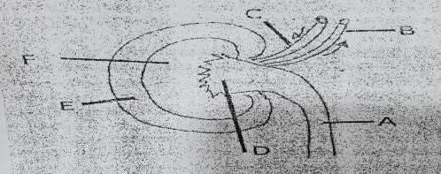

(i) Name the parts labelled A, B, C, D, and F (ii) Give the function of part A, B and C

- (a) In what ways does plant cell differ from an animal cell? Mention three points.
  - Sketch a diagram of an animal cell and from it label the structure responsible for:
      - Energy synthesis
      - Passage of material in and out of the cell (iii) Control all life processes

- The diagram in figure 1 is the alimentary canal of a human being. Study the diagram and then answer the questions that follow.

Page of 6
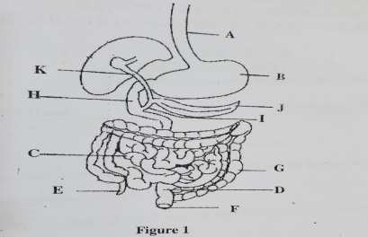

- Name the parts labeled A – K
- (i) Name the digestive juice which produced in organ labelled B
(ii) Mention the substance contained in the digestive juice named in (b) (i) above and state their roles.

SECTION C (30 marks)
Answer two (2) Question from this section. Question 9 is compulsory

- With the aid of a well labelled diagram, describe the urinary system and explain the process of urine formation in human beings

- Write an essay on photosynthesis under the following guidelines:
  - Meaning of photosynthesis
  - Raw materials of photosynthesis
  - Products of photosynthesis
  - Stages of photosynthesis
  - Importance of photosynthesis

- Food guide pyramid is not universal for all groups of people, it depends on the needs and health status of the people. By using examples of food for each case prove this statement with reference of the following:
  - Elders
  - Pregnancy and expectant mother
  - Sedentary workers
  - Manual workers
  - Sick persons

Page of 6

