THE UNITED REPUBLIC OF TANZANIA
PRESIDENT’S OFFICE
REGIONAL ADMINISTRATION AND LOCAL GOVERNMENT
LONGIDO AND NAMANGA SECONDARY SCHOOLS


FORM THREE TERMINAL EXAMINATION
BIOLOGY
MARKING SCHEME 2024

SECTION A (16 Marks)

(i) | (ii) | (iii) | (iv) | (v) | (vi) | (vii) | (viii) | (ix) | (x)
B | B | E | C | B | D | B | C | D | A
01@ = 10 marks

LIST A | (i) | (ii) | (iii) | (iv) | (v) | (vi)
LIST B | E | B | F | I | G | D
01@ = 06 marks

SECTION B (60 Marks)
- Basic Principle of Waste Disposal (Principles of Waste Management)

The basic principles of waste management are reduction, re-use and recycling.

Reduction

Reduction involves uses of alternatives in order to prevent or reduce waste generation; for example, using a basket for shopping instead of using disposable plastic bags.

Re-use

Re-use involves the use of waste (used material) for other useful activities; for example, using a margarine container for storing sugar instead of throwing it away.
(03 @ = 09 marks)

Recycling

Recycling involves the conversion of waste in other useful materials. Recycling include the sending back of plastic bottles to the factory for manufacturing of new plastic bottles, sending back of broken glass to the factory for manufacturing of new glass, refurbishment of broken down computers, and using organic waste to produce bio gas.

- (a)The vertical dimension represents feeding relations and the horizontal dimension represents the abundance or biomass at each level.
(3 marks)

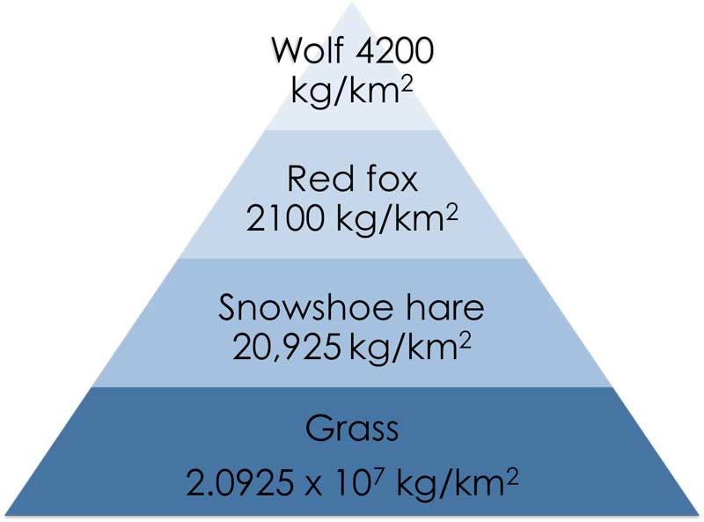

(01½ marks)

Pyramid of biomass

- Trophic pyramids can be categorized as: (1) pyramid of numbers (numeric pyramid), (2) pyramid of biomass, and (3) pyramid of energy.
- The pyramid of numbers depicts the number of individual organisms at different trophic levels of food chain.
(01½ marks)

- The pyramid of biomass depicts the total weight of organisms at different trophic levels of food chain.
(01½ marks)

- The pyramid of energy indicates the amount of energy flow at each level and the actual role the various organisms play in the transfer of energy.
(01½ marks)

- Features of Class Monocotyledonae VS dicotyledones
- Monocots have one cotyledon (or one seed leaf) while dicots have two cotyledons (or two seed leaves).
- Monocots have broad leaves with parallel venation while dicots have net venation.
- Monocots have fibrous root systems while dicots have tap root system.
- The floral parts in monocots occur in threes, or multiple of three while . Dicots floral parts occur in fours and fives and multiple of four or five.
- Monocots lack cambium secondary growth while dicots floral parts occur in fours and fives and multiple of four or five.
- Monocots have scattered vascular bundles in their stems while dicots have vascular bundles arranged into a ring
(01½@ = 09 marks)

- Mr. Seyplam: Hypermatropia: … the light rays of a near object converge at a point behind the retina because the eye ball is too short. Near object appear blurred.
(01½ marks)

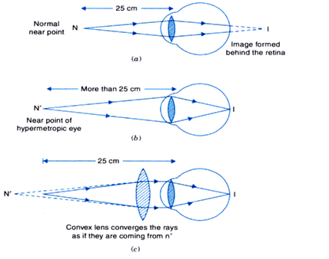
Hypermetropia is corrected by spectacles with convex (converging) lenses. Convex lenses converge the light rays before they reach the eye and enabling them to eventually be focused on the retina.
(01½ marks)

(01½ marks)

Mrs. Seypalm: Myopia: … the light rays of a distant object converge at a point in-front of the retina because the eyeball is too long. Distant object appear blurred (not clear).
(01½ marks)

Myopia is corrected by concave (diverging) lenses. The lenses diverge the light rays before reaching the eye enabling them to be focused on the retina.
(01½ marks)

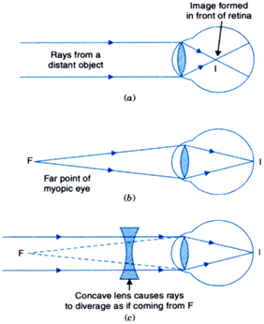

(01½ marks)

- (a) Skeletal muscles are voluntary…Cardiac muscles are involuntary
01½ @ = 04½ marks

Skeletal muscles are fatigued….cardiac muscles are not fatigued
Skeletal muscles are connected to the bones…cardiac muscles are located in the heart.
(b) Movement: the skeleton facilitate movement in cooperation with muscles….
Protection: the skeleton protects internal organs…
01½ @ = 04½ marks

Support: the skeleton support the body from collapsing…

- (a)
- Villus
(01 mark)

(00½ mark)

- Absorption…
(1½ marks)

- a= epithilium, b = Lacteal , and Blood capillaries.
(b)
(i) Starch and Protein.
(1½ marks)

(00½= 01@ mark)

(ii) Energy production, Growth and body repair …
- Excess starch is converted into glycogen and stored in the liver
(1½ marks)

Excess protein can not be stored, it is deaminated in the liver and excreted as urea through urine
(02 marks)

SECTION C (30 Marks)
- Natural barrier and the immune system defend the body against infections and diseases. Natural barrier form the first line of defense. The components of natural barrier include the skins, mucous membrane, cilia/hair, ear wax, sweat, tears, saliva, stomach acids and urine flow.
(Introduction 02 marks)

Components of the natural barriers:
The skin forms a physical barrier to pathogen by preventing them from entering inside of the body.
The mucous membrane also prevents pathogen from passing through into the tissues and organs.
The cilia are found along the respiratory tract and trap and prevent pathogen and dust particles from entering the system.
Earwax traps and therefore prevents dust and pathogen from entering the body through the ear.
Tears have antiseptic substance that kills germs and therefore preventing them from entering the body.
Saliva has enzymes that can destroy pathogen and therefore preventing them from entering the body.
Stomach acid is the acid found in the stomach; it is hydrochloric acid. The acid kill germs that have managed to enter in the stomach with food.
The components of the immune system:
(Any three, 02@ =06 marks)

The white blood cells attack and destroy pathogens.
The lymph nodes trap pathogens which are then destroyed by white blood cells in the lymph
Spleen filters blood by removing broken down cells.
(Any three, 02@ =06 marks)

The liver keeps the body safe by removing toxins.
The bone marrow produces the white blood cells.
(Conclusion 1 mark)

Tonsils and thymus also produce antibodies.
Total: 15 marks

Introduction: 1½ marks)

- The three layers of muscles of the stomach wall allows it to perform the vigorous churning motions essential for efficient mechanical digestion.
- The hydrochloric acid kills bacteria that had entered with food and provide acidic medium for the enzymes in the stomach to work.
- The mucus prevents the acids and enzymes to corrode the stomach walls.
Any five 02½ @ = 12½ marks

- The enzymes are pepsin and rennin, which break down proteins into peptides. Rennin acts specifically on milk protein.
With its muscular lining, the stomach is able to engage in peristalsis…
Total: 15 marks

(Conclusion 01 mark)

- Transpiration is the process in which plants loses water to the atmosphere in form of vapor through the leaves and other areal parts.
(Intro: 01½ marks)

The importance of transpiration
- it enables plant to absorb water and mineral salts from the soil
- it helps in cooling the plant
Any 4 brief explanations × 1½ =06 marks marksmarkmarks

- it helps to remove excess water from the plant
- it facilitates the movement of soil water
- It helps in exchange of gases such as up taking of carbon dioxide through stomatal opening
The adaptation of features which enable plants to reduce water loss
Any 3 brief explanations × 2 =06 marks marksmarkmarks

- Leaves reduced to spines: this reduces the surface area for evaporation
- Waxy leaf cuticle: impermeable to water
- Reduced number of stomata: this reduces the rate of transpiration…
- Rolled leaf, leaf hair and stomata sunk in pits: traps air and reduce movement/diffusion of water vapour…
Total: 15 marks

Conclusion;
(01½ mark)

