THE PRESIDENT’S OFFICE
REGIONAL ADMINISTRATION AND LOCAL GOVERNMENT
LONGIDO DISTRICT
MID-TERM TEST EXAMINATION
FORM THREE BIOLOGY-MARCH 2021
INSTRUCTIONS: TIME: 3 HRS
1. This paper consists of section A, B and C with total of 15 (fifteen) questions
2. Answer all questions in the section A and B AND two (2) questions from section C of which question 13 is compulsory
3. All writing should be in blue or black pen, except for diagrams that must be drawn in pencil
4. Write your NAME on every page of your answer booklets
SECTION A (15-MARKS)
1. For each of the items (i)-(x), choose the correct answer from among the given alternatives and write its letter beside the item number in the answer booklet provided
(i) Suppose you are provided with small sections of cells from different organism, which equipment will you use to identify them?
A. Test tube B. Watch glass C. Microscope D. Petri dish
(ii) Which of the following joints allow movement in one place only?
A. Ball and socket B. Hinge C. Glinding D. Immovable
(iii) Oxygen debt occurs when
A. Too much carbon dioxide is present in the body B. There is insufficient oxygen in the muscles tissues during strenuous exercise C. Alcohol is formed in tissues D. There is insufficient lactic acid in muscles tissues
(iv) If the magnifying power of the eye piece lens of the compound microscope is X10 and that of the high power objectives lens is X40, what is the magnification of a specimen under observation
A. X10 B. X400 C. X40 D. X50
(v) Rickets is a common feature in young children lacking one of the following vitamins
A. D B. C C. A D. K
(vi) Which of the following prevents surfaces of the articulating bones from being worm out by friction?
A. Capsule ligament B. Articular cartilage C. Synovial fluid D. Cerebrospinal fluid
(vii) Which of the following are the non-living parts of a cell?
A. Cell wall and nucleus B. Cell wall and vacuoles C. Vacuoles and nucleus D. Cytoplasm and ribosome
(viii) Which of the following substance is not the waste product in man”
A. Faeces B. Sweat C. Uric acid D. Urea
(ix) The phylum chordate includes all animals that have
A. Mammary glands B. Post anal tail C. A back bone D. Scales
(x) When students were conducting private study at night, light went off suddenly, which of the following changes occurred in the eyes of the students?
A. The pupil become larger B. The lens become thicker C. The ciliary muscles relaxed D. The ciliary muscles contract
Answer
i | ii | iii | iv | v | vi | vii | viii | ix | x
2. Match the items in LIST A with the responses in LIST B by writing the letter of the correct responses beside the item number

LIST A | LIST B
(i) Axial component which protects the delicate internal organs such as heart, kidney, liver and lungs  (ii) Axial component which protects the brain and provides area for attachment of the neck  (iii) Appendicular component which provides large surface area of muscle attachment and a base for articulation with hind limbs  (iv) Axial component which protects the spinal cord  (v) Axial cartilage which acts as a shock absorber | A. Pivot  B. Vertebral column  C. Lumbar  D. Pelvic girdles  E. Cervical  F. Rib cage  G. Skull  H. Pectoral girdles  I. Intervertebral disc

answer
i | ii | iii | iv | v

SECTION B (60-MARKS)
3. (a) (i) What is gaseous exchange
(ii) Arrange the following in the correct order
“Bronchi, Pharynx, Bronchioles, Nasal passages, Alveoli, Trachea”
(b) Name the structures concerned with gaseous exchange in
(i). A mammal (ii). A young tadpole (iii). An insect
(iv) An earthworm (v). A spider
(c) What is the differences between the function of a ligament and tendon?
4. (a) (i) Differentiate lymphocytes from phagocytes
(ii) State the functions of blood plasma
(b) (i) List the factors that increase blood pressure
(ii) Why is a person with blood group AB not always considered as a universal recipient?
5. (a) Define the following term
(i) classification (ii) movement (iii) coordination (iv) skeleton (v) joint
(b) Mention function of skeleton to an organism
(c) Mention type of skeleton
6. (a) (i) Define immunity
(ii) Distinguish between natural acquired immunity and artificial acquired immunity
(b) Name four diseases against which children are immunized
(c) Explain why it is (i) Not healthy to sleep in a closed room with many potted plants
(ii) Dangerous to sleep in a poorly ventilated room with a charcoal burner on
7. (a) Define the following words (i) Laboratory (ii) Apparatus
(b) Why should schools have a biology laboratory? Give reasons
(c) State six laboratory rules
8. (a) (i) With examples, state the meaning of abiotic and biotic factors of the environment
(ii) Name four different types of consumers found in natural ecosystem
(b) Consider the figure 1 below

E
DDD D
C
B
A
Fig. 1

(i) Place the following organism in their appropriate trophic level indicated by letter A-E
“Algae, large fish, human being, small fish and zooplankton”
(ii) Give the name of the highest trophic level in this pyramid
9. (a) (i) The kingdom plantae is divided into different division “mention them”
(ii) Give one example of the plants which are found in each division
(b) With the use of illustrations, differentiate between dicotyledonous and monocotyledonous in the following aspects (i) Venation (ii) Arrangement of vascular tissues in stem
10. (a) (i) What are the characteristics of viruses
(ii) How do viruses differ from bacteria A E
B
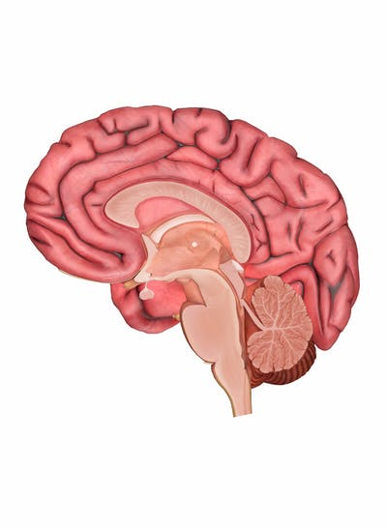
C D
(b) Study the figure 2 below, then answer the following questions
(i) what does figure 2 represent
(ii) Name the parts labelled A, B, C, D and E
(c) Arrange the following in the correct order for a simple reflex arc
“impulse travels in motor fiber, impulse travels in sensory fiber, effector organ is stimulated, receptor organ is stimulated and impulses crosses synapse”
11. (a) Give the meaning of the following terms as used in biology
(i) Blood transfusion (ii) Blood compatibility
(b) (i) State two advantages of blood transfusion
(ii) Outline four precautions to be taken during blood transfusion
12. (a) Define the following words
(i) Tissue (ii) Diseases
(b) (i) Mention types of diseases (ii) Name three animal and plant tissues
(c) State the structural differences between a cell wall and a cell membrane

SECTION C (25-MARKS)
Answer two questions from this section, where question number 13 is compulsory
13. Write an essay on cholera using the following guidelines
- Cause
- Symptoms
- Transmission
- Effects
- Prevention
14. Discuss how the knowledge of Biology is useful in agriculture and medicine
15. Give four common accidents at home and school for each case explain the causes and three prevention measure

