THE UNITED REPUBLIC OF TANZANIA
NAMANGA SECONDARY SCHOOL
ANNUAL BIOLOGY EXAMINATION FORM THREE 2025

033/1 BIOLOGY 1

Time: 3:00 Hours NOVEMBER: 2025

Instructions
- This paper consists of sections A, B and C with a total of eleven (11) questions.

- Answer all questions in sections A and B and two (2) questions from section C.

- Section A carries sixteen (16) marks, section B fifty four (54) marks and section C carries thirty (30) marks.

- Except for drawings which must be drawn in pencil, all writings must be in blue or black ink.

BIO
LOGY FORM4

PRE CSSC
2025

- Cellular phones and any unauthorized materials are not allowed in the examination room.

- Write your Name in Full on every page of your answersheet.



SECTION A (16 Marks)

Answer all questions in this section

- For each of the items (i) – (x), choose the correct answer from among the given alternatives and write its letter besides the item number in the answer booklet(s) provided.

  - Viruses are not living things.this is because:
    - They don’t have multicellular cells B they don’t reproduce outside the living cells
C they can move by using flagella D they are found in kingdom monera
E they are die body

  - The proper method of disposing biohazardous wastes is:
    - Burning B Incineration
C Recycling D Feeding animals
E Pit latrines

  - fertilization of the human zygote usually occurs in which of the following parts of human body?
    - Cervix B Uterus
C Ovary D Vagina
E Oviduct

  - Which of the following is not transmitted by sexual contact?
    - HIV/AIDS B Dysentery
C Hepatitis D Gonorrhea
E Candidiasis

  - Plants do not need elaborate excretory system like animals. This is because:
    - They moves by locomotion
    - They produce ammonia, uric acid and urea
    - They recycle most of the waste they produce
    - Their metabolic processes are too much fast
    - They store wastes in the soil where they are found

  - The hypothesis is usually verified during scientific studies by:
    - Collecting relevant data
    - Conducting experiment
    - Ensuring graphical analysis of data
    - Drawing sensible conclusion
    - Identifying the problem

  - When a fish is taken out of water can die because:
    - It has no legs for walking
    - Its mouth is small to get the food on land
    - Its gills are not able to exchange dry respiratory gases
    - There are many enemies on land than in water
    - The water on land flows faster than in rivers
  - Transpiration is the lost of water from plants during the day by different ways.this ways include:
    - Loss of water through palisade cells
    - Loss of water through stomata
    - Loss of water through phloem
    - Loss of water through root hairs
    - Loss of water through seeds
  - In which of the following mammalian blood vessel does deoxygenated blood flow away from the heart?
    - Aorta B Vena cava
C Ventricle D Pulmonary artery
E Pulmonary vein

  - The function of bile is to:
    - Soften food B Produce gall stones
C Deaminate protein D Digest fat
E Emulsify fats

- Match the description in List A with the respective items in List B by writing the letter of the correct response besides the item number in the answer booklet(s) provided.
LIST A |  | LIST B
- The cellular structure made up of lipids and proteins that covers the cell contents  - The house of hereditary materials inside the living cell  - Organisms with similar cell plan and can interbreed freely to produce viable offspring  - A particle that has no living status but is able to act as a living material inside the living cell  - A membrane that covers the vacuole of the plant cell  - Unicellular organism that is able to reproduce by binary fission and locomote by false feet | A  B C  D  E  F  G H | Euglena  Species  Tonoplast  Nucleus  Amoeba  Virus  Cell membrane  Golgi apparatus

SECTION B (54 Marks)

Answer all questions in this section

- (a) By using simple diagrams, describe what would be observed if your cells are placed in distilled water for a long time.
  - Outline four the adaptive features of the respiratory surfaces for gaseous exchange.
  - Give the definition of the followings
- Stimulus
- Coordinator
- Reflex Actions

- (a) Biology is more than the study of plants and animals. Justify this statement.
(b) What is pollination?
(c) Why is it not common for insects to visit wind pollinated flowers? Give three points.
- (a) Briefly explain why:
    - A decent person should have a handkerchief every time
    - Desert animals like camels have fewer glomeruli in their kidneys
    - The first aid kit should contain a medicated soap
    - Unused chemical should not be returned into its original container
(b) draw a large and well labeled diagram of the sperm.

- (a) Eminaomi usually experiences burning pain in the stomach, nausea and vomiting, heartburn and blood drops in the stool.
    - Which disease of the digestive system is she possibly suffering from?
    - Name the pathogen that is known to cause the disease above.
    - What can people do to avoid the problem faced by Eminaomi? Give two points.
  - Vaileth and Gladness visited Ngorongoro national park and observed many animals like antelopes, cheetah, foxes, gazelles and wild dogs moving here and there in the shrubs and grasses. There were also mushrooms on some wet places.
  - Why were the animals moving from one place to another? Explain three points.
  - Which two organisms observed by Vaileth and Gladness are herbivores?
  - Construct a food web that accommodates all organisms observed by Vaileth and Gladness.
  - Explain the relationship that exists between gazelles and cheetah

- Carefully study the specimen below and then answer the questions that follow:
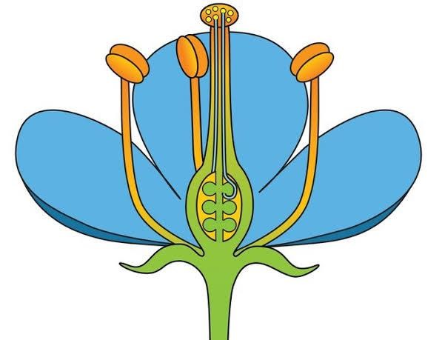.

P

Q

G

  - Give the common name of the specimen presented above.
  - Label the parts P and Q.
  - What is the main function of the part G?
  - It is very common to find insects on the specimen above. Identify three features of the given specimen that attract insects towards it.
(e) Give two differences between coniferophytes and the division of the specimen above

- (a) Explain briefly what would happen if the following occurs in your body:
    - The choroid layer of the eye gets severely damaged
    - Semi-circular canals are removed from the ear
    - Adrenal glands fail to function
    - Hypothalamus is removed from the brain
  - Movement is an inevitable process in living organisms. Justify.
  - Explain briefly three types of ribs.

SECTION C (30 Marks)

Answer two (2) questions in this section

- Endotherms are able to survive in different weather conditions without fluctuation of their body temperature. Explain the mechanisms that aid them to withstand cold and hot weather conditions.

- How can people maintain good health? Explain by giving six points.

- Why is it important for plants to carry out photosynthesis? Explain by giving four reasons.

God is The Master of All Wisdoms and Understandings! Men of God Know This! By Sir. Ephraim S. Joseph © 2025

