THE CATHOLIC DIOCESE OF SAME
KINDOROKO GIRLS’ SECONDARY SCHOOL
FORM THREE FIRST CONTINUOUS ASSESSMENT TEST; 2024

033/1 BIOLOGY 1 MARKING GUIDE

10 marks @1

S/N | (i) | (ii) | (iii) | (iv) | (v) | (vi) | (vii) | (viii) | (ix) | (x)
ANS | D | D | C | A | C | B | B | A | C | B

06 marks @1
LIST A | (i) | (ii) | (iii) | (iv) | (v) | (vi)
LIST B | F | D | G | E | A | C

- Six (6) consequences of poor waste disposal:
  - It leads to water and soil contamination
  - It leads to eruption of diseases
  - It leads to pollution
  - Leads to the loss of biodiversity
  - It destroys the natural beauty of the environment
  - It leads to occurrence of accidents
It attracts dangerous animals
It blocks the drainage channels
It can harm domestic animals and wildlife
It provides breeding site for vectors
It leads to unpleasant smell (9 Marks @1.5)

- (a) Four (4) importance of the skeleton in the human body:
    - It supports the weight of the body of the organism
    - It provides rigid framework which maintains the shape of the body
    - It provides the site for attachment of organs
    - It protects delicate internal organs against mechanical damage; e.g. cranium protects the brain
It provides the site for attachment of the muscles bringing about movement of the body
It is responsible for formation of red blood cells and white blood cells in the bone marrow
It is used to store mineral salts such as calcium salts (6 Marks @1.5)
  - Three (3) importance of saliva in food digestion:
    - It moistens the food and lubricate it for easy chewing and swallowing
    - It provides alkaline medium for efficient functioning of enzymes
    - It contains salivary amylase enzyme for digestion of cooked starch (3 Marks @1)

- (a) i) Platelets or thrombocytes
ii) Red blood cell
iii) White blood cell

b)
 | Artery | Vein
i | It thick, muscular and elastic | It thin, less elastic and less muscular
ii | It has small lumen | It has wide lumen
iii | Has high blood pressure | Has low blood pressure
iv | It does not has valves | It has valves
v | It carry blood away from the heart | It carry blood to the heart
vi | It located deep in the body | It found near the surface of the skin.

- ( i) Inorder to trap dust and microorganism entering through the nostrils. The mucus is also used to warm the inhaled air when it is cold

    - In order to keep live small animals like rats and birds
    - In order to kill germs contained in it to make it safe for drinking
    - In order to reduce water loss through transpiration during the day (6 Marks @1.5)
(b) Three (3) ways in to prevent Malaria:
    - Spraying oil in mosquito breeding sites
    - Cutting long grasses around the house
    - Draining stagnant water around the house
Sleeping under treated mosquito nets
Applying mosquito repellants
Using windows with mosquito-proof wire meshes
Wearing clothes that cover the whole body during the night (3 Marks @1)

- (a) (i) Anaerobic respiration
(ii) Lactic acid (3 Marks @1.5)
(b) Four (4) economic importance of anaerobic respiration:
  - It is used in baking industries.
  - It is used in brewery industry.
  - It is used for cigarette making.
  - It is used in dairy industry for making cheese, butter and yoghurt.
It is used for commercial acid production like vinegar (acetic acid), citric and oxalic acid
It is used in biogas production. (6 Marks @1.5)

- (a) (i) Artificial classification
(ii) This is a system of classifying organisms based on few observable features (2 Marks @1)

(b) (i) A food web

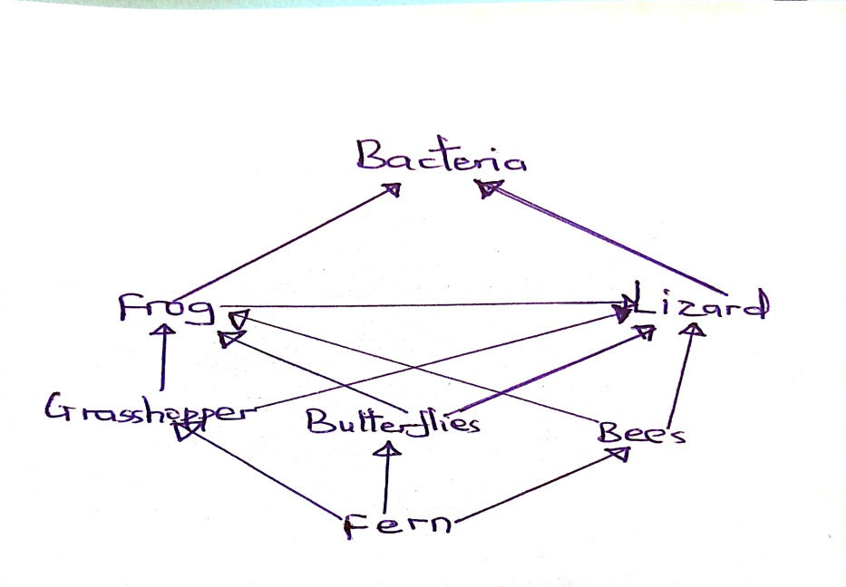
(3 Marks)

- Frogs and Lizards (1 Mark)
- Two (2) food chains:
  - FernsGrasshoppers Frogs Bacteria
  - Fern Grasshopper Lizards Bacteria (2 Marks @1)
- Because ferns are producers that converts solar energy into chemical energy to be utilized
by all other trophic levels. (1 Mark)

ESSAY QUESTIONS: Introduction: 02 Marks Main body: 12 marks @2 | Conclusion: 01 Mark

- Introduction: Meaning of angiosperms and its classes.
Main body:
- Differences between monocots and dicots

 | Monocots | Dicots
i | The have fibrous roots system | The have tape roots system
ii | The leaves have parallel veins | The leaves have net veins
iii | The have one cotyledon | The have two cotyledon
iv | Their vascular bundles are scattered in the stem | Their vascullar

- importance of angiosperms:
  - They are source of food to man and other organisms
  - They provide habitats for different organisms like insects
  - They provide fibres for textile industries like cotton
  - They form a ground cover to prevent soil erosion
  - They make the environment attractive, e.g. rose, lily and hibiscus
Three points
Conclusion: Any relevant

- Introduction 0.5 marks ( the concept of food preservation)
Main body
- Traditional methods of food preservation
- Smoking
- Salting
- Drying in the sun
- Cooking
- Curing
Any four points with explanation (02@=08marks)
- Advantages of traditional methods of food preservation
- Its simple and can be done by most people
- Its not costless because it local available materials
- Its save because there is no chemicals added to the food
- Some methods add distinctive flavor to the food
- Most methods do not destroyed nutrients in the food
Any three points with explanation (02@=06marks)
Conclusion 0.5 mark
TOTAL 15 MARKS

- Introduction: Meaning of gaseous exchange and the respiratory structure:
Gaseous exchange: Is the passive movement of gases across a respiratory surface.
The specialized organs for gaseous exchange are called respiratory surfaces.
The respiratory surface in humans is the alveolus (Plural: alveoli) found in lungs.
Main body: Description of the mechanism of gaseous exchange in the human lungs:
When we breathe in, air accumulates in the alveoli and increases the concentration of oxygen in the alveolus since the inhaled air contains more oxygen. Therefore, oxygen diffuses into the blood capillaries around the alveolus and combines with haemoglobin to form oxyhaemoglobin. Oxygen is transported to the body cells in this form and once in the cell oxyhaemoglobin breaks to release oxygen and haemoglobin.

During respiration, there is higher carbon dioxide in cells than in the blood capillaries, therefore carbon dioxide diffuses into the blood capillaries and combine with the free haemoglobin to form carbaminohaemoglobin. Carbon dioxide is transported in this form to the alveoli. This leads to higher concentration of carbon dioxide in blood capillaries around the alveolus than in the alveolus. Therefore, carbaminohaemoglobin breaks off and carbon dioxide diffuses from the blood capillary into the alveolus. It is then transported through the bronchioles, bronchi, trachea, glottis, pharynx and finally to nostrils into the atmosphere.
Conclusion: Any relevant

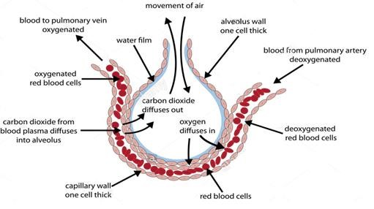
THE DIAGRAM
OF A
LVEOLUS

DESCRIPTION QUESTION:
Introduction: 02 Marks
Mechanism: 07 marks
Conclusion: 01 Marks

Diagram
Caption: | 01 Mark
Diagram: | 02 Marks
Labelling: | 02 Marks (Any 4 @0.5)

