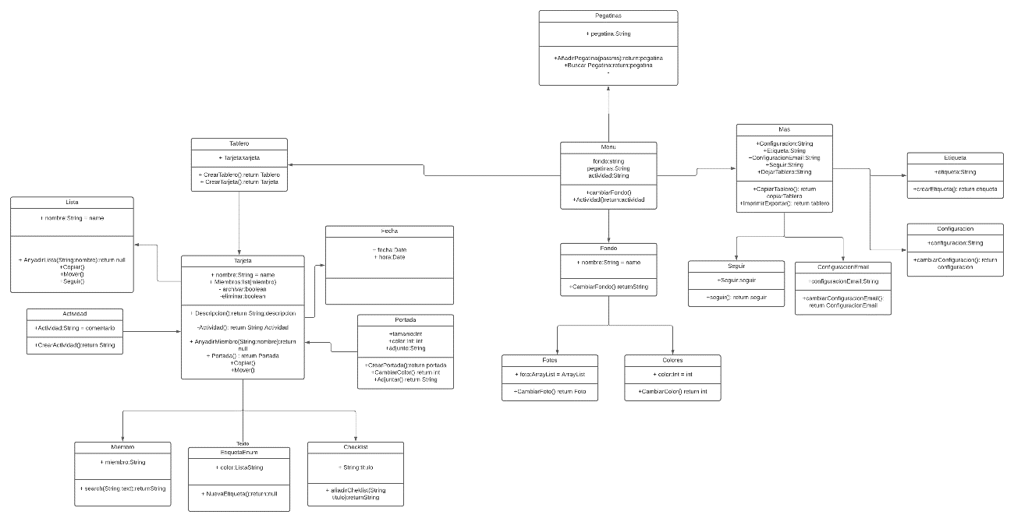

https://lucid.app/lucidchart/invitations/accept/bda3aa63-010d-4100-bc94-1d99894a6446