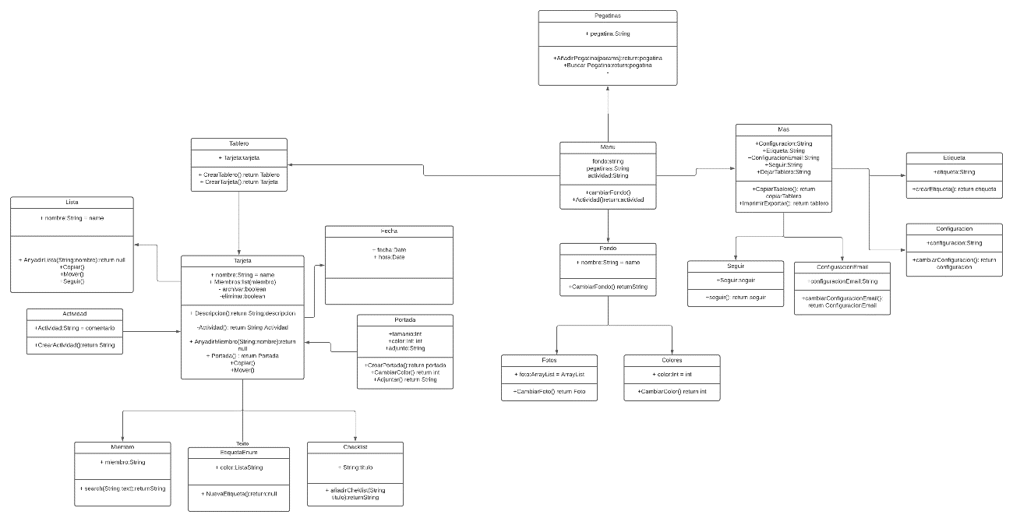

https://lucid.app/lucidchart/e5aa6809-433e-4c2c-a07e-4f8cfc082c18/edit?page=0_0#?folder_id=home&browser=icon