Massey High – Database Specifics

To create / maintain your database, go to: <http://massey.ddns.net/phpmyadmin/>

Your username and password is the same as your school username / login **unless** your username is more than 16 characters. If that is the case, your username is similar to ‘normal’ but it does not include any numbers.

You can only make / have one database online at a time. Your database name is always the same as your username. Whilst it looks like you can rename the database in the ‘operations’ area, attempting to do so will result in an error.

To upload your code so that you can see your work, you need to use the file manager which is here:

<http://massey.ddns.net/~username>

<instead of username, put YOUR actual username>

Then click on the ‘filemanager.php’ link. In the field that appears, enter your PASSWORD. It should let you in. Your first step when getting into this area MUST be to create a folder for your project. Then you can place all of your project code inside the folder you have made. You can have more than one project folder if you wish.

You can create / update code either on our computers (and then upload the code) or if you prefer, you can edit your code directly.

In the filemanager you’ll see a file called dbconnection.php. If you edit it in the file manager you’ll see your database connection details . There’s a hashed password in there. The hashed password should be used in any php scripts that you make. Please DON’T code your main password into your project. If you’re curious, the hash was generated by taking your password and running it through an SHA1 MD5 algorithm. It would have been better if we used bcrypt but the underlying principle is the same.

At some point early in the process, you will create a file called ‘config.php’ which will allow your database / website to connect. If you follow the eBook exactly at this point things won’t work! Your settings should be as follows…

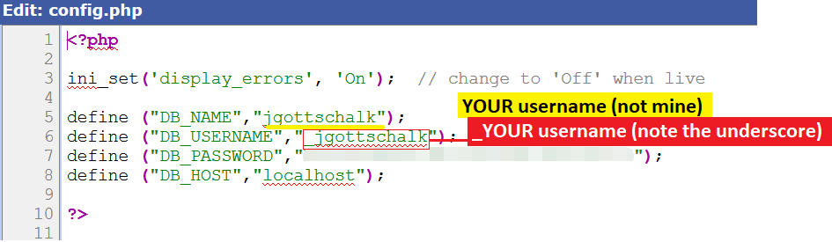

Use your hashed password for the password on line 7.

**Random Notes**

* You can edit your code online BUT the editor is quite basic and it does not auto close tags / help you in any way. The alternative is to edit in something like brackets and then upload your changes each time. I’d suggest keeping all your code in brackets and uploading each time to see changes. Whilst this is tedious, you’ll end up with working code that is backed up to the cloud and safely on our system as well.
* If you decide to delete a project, the system won’t let you delete material if it contains folder which have content inside. If you get a ‘cannot delete’ error and are absolutely sure you want to delete the material, you’ll need to go into all your subfolders and delete their contents. Then delete the subfolder. Then try and delete the project.