* **2.4 Scatterplots, Correlation, and Regression**
  + Paired sample data (bivariate)
  + Scatter plot – plot of paired data; aka, scatter diagram
  + Correlation – values of one variable are somehow associated with values of another variable
    - Correlation does not imply causation
  + Linear correlation – correlation of two variables can be approximated by a straight line (on scatter plot)
  + Linear correlation coefficient = r
    - Measures strength of linear association between two variables
    - Values between -1 to 1…close to -1 or 1, correlation…close to 0, no correlation
  + Regression – line of best fit or least-squares line; straight line that ‘best’ fits the scatterplot of the data
    - b0 = y-intercept
    - b1 = slope
* **10.1 Correlation**
  + Correlation – values of one variable are somehow associated with values of another variable
  + Before applying a statistical technique…explore the data visually with graphs
  + Linear correlation – correlation of two variables can be approximated by a straight line (on scatter plot)
    - Positive linear correlation – as x increases, y also increases
    - Negative linear correlation – as x increases, y decreases
    - Nonlinear relationship – distinct pattern of correlation, but pattern is not straight line
  + Strength of Linear Correlation
    - Linear correlation coefficient = r
      * Measures strength of the linear correlation between paired data
      * Can always be calculated, but requirements should be followed:
        + Simple random sample of quantitative data
        + Visual examination of scatterplot confirms ~straight line pattern
        + Outliers…

Remove outlier errors

Calculate r with & without outliers to consider effects

* + - * 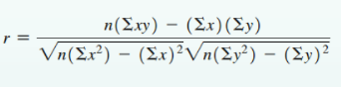n = number of pairs of sample data
      * 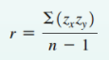r = linear correlation coefficient for sample data
      *  = linear correlation coefficient for population data
      * Rounding – three decimals unless otherwise stated
      * Interpreting…
        + P-value <=  – supports claim of linear correlation
        + P-value >  – does not support linear correlation
        + …or…
        + Absolute value r >= critical value, supports linear correlation
        + Absolute value r < critical value, does not support linear correlation
  + Explained variation = r2 – proportion of the variation in y that is explained by the linear relationship between x and y
  + Errors with Interpreting Correlation
    - Assuming correlation implies causality
    - Used data based on means (suppresses variation and may inflate r)
    - Ignoring possibility of nonlinear relationship
  + Hypothesis Testing to determine if there is a significant linear correlation between two variables…
    - 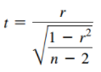Null Hypothesis = H0:  = 0
    - Alternative Hypothesis = H1:  != 0
    - Test statistic
      * n – 2 is degrees of freedom
    - One-tailed tests can occur if testing postive or negative linear correlations
* **10.2 Regression**
  + Regression line – straight line that best fits the scatterplot of paired data
    - Aka, line of best fit, least-squares line
    - ŷ = b0 + b1x – sample statistic
      * ŷ – response variable, dependent variable
      * x – explanatory variable, predictor variable
    - y = 0 + 1x – Population Paramter
    - Requirements…
      * Random sample
      * Visual examination approximates straight line
      * 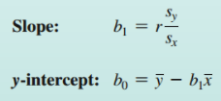Remove outlier errors
    - Slope and y-intercept equations…
      * r – linear correlation coefficient
      * sy - standard deviation of y values
      * sx – standard deviation of x values
      * round to three significant digits
  + Making predictions
    - Regression equations useful for predicting values
    - Bad Model – don’t use it for a bad fit…use sample mean instead
    - Good Model – use only if scatterplot confirms regression line fits points reasonable well
    - Correlation – use equation only if correlation coefficient indicates a linear correlation
    - Scope – use equation only for predictions much beyond the scope of available data
  + Interpreting Regression Equation
    - Marginal change – amount of change in response variable (y) when the predictor variable (x) changes by 1 unit
      * Slope
  + Outliers and Influential Points
    - Outlier – in scatterplot an outlier is a point lying far away from other data points
    - Influential points – points that strongly affect the regression line
  + Residuals and Least-Squares Property
    - 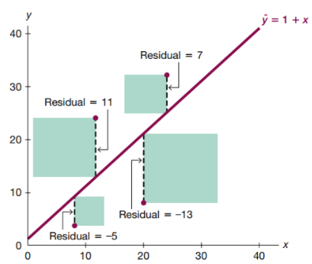Residual – difference between observed sample value of y and y value that is predicted by regression equation
    - Least-Squares property – a straight line satisfies this requirement if the sum of the squares of all residuals is the smallest sum possible
  + Residual Plots
    - Scatterplot of (x.y) values after each of the y-coordinate values has been replaced by the residual value…in other words, plotting (x, y-ŷ)
    - Should not have any pattern (not even straight line)
    - 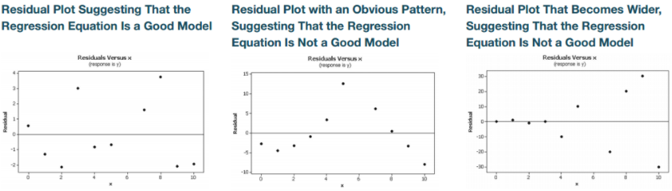Should NOT become wider viewing from left to right
* **10.3 Prediction Intervals and Variation**
  + Prediction interval – range of values used to estimate a variable (such as predicted value of y in regression equation)
    - Not the same as Confidence Interval – range of values to estimate a population parameter
    - Requirements
      * For each fixed value of x…corresponding values of y are normally distributed about the regression line…and those normal distributions have same variance
    - 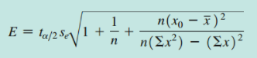Margin of Error…
      * x0 – fixed value of x
      * t/2 – n-2 degrees freedom
      * se – standard deviation of estimate
  + Explained and Unexplained Variation
    - 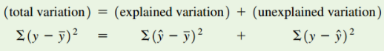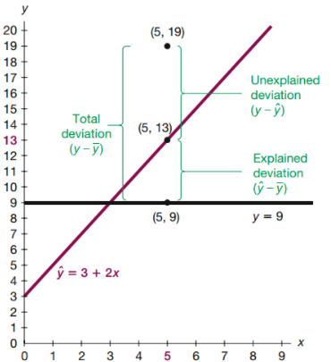We can explain the discrepancy between actual values and predicted values (y != 0) by noting there is a linear relationship best described by the regression line
    - Total deviation – vertical distiance of y-ŷ, which is the distance between data point (x,y) and the horizontal line passing through the sample mean y bar
    - Explained deviation – vertical distance ŷ-ybar (mean), which is vertical distance between predicted y value and horizontal line of sample mean
    - Unexplained deviation – vertical distance y-ŷ, which is vertical distance between sample point (x,y) and predicted value on regression line (y-ŷ is also the residual)
  + Coefficient of Determination
    - r2 – proportion of variation in y that is explained by the linear relationship between x and y
      * Square of correlation coefficient…or… explained variation/total variation
  + Standard error of estimate – measure of the difference between the observed sample y-values and predicted values of yhat obtained using regression equation
  + Statcrunch –
    - Model / SS = explained variation
    - Error / SS = unexplained variation
* **9.1 Two Proportions**
  + Notation for two proportions
    - p1 = proportion of population 1
    - phat1 = x1/n1 = sample 1 proportion
    - n1 = size of sample 1
    - x1 = number of successes in sample 1
    - qhat1 = 1-phat1 = complement of phat1
    - Corresponding notations for population2/sample 2 with subscript
  + Pooled sample proportion – combines two samples proportions into one proportion
    - pbar = x1 + x2 / n1 + n2
    - qbar = 1-pbar
  + Requirements for hypothesis test of two population proportions…
    - Simple random sample
    - Both samples are independent (not related or naturally paired or matched in any way)
    - For each population – at least 5 successes and 5 failures
  + 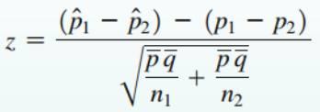Test statistic for two proportions **(H0: p1=p2)**
    - Equation to right…
    - Where p1-p2=0 (assumed null hypothesis)
    - pbar = pooled sample proportion
    - 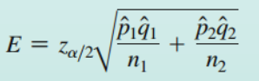qbar = complement of pool
  + Confidence interval estimate of p1-p2
    - Margin of error equation to right…
    - CI…
  + recommendation…
    - Testing a claim about two proportions – use P-value or critical value methods
      * P-value method – calculate test statistic for two proportions, then use Z-table to find P-value (keep in mind one tail or two tail)…compare to significance level
      * Critical value method – calculate test statistic of two proportions, calculate test statistic of critical value (two tail, so z/2) on normal distribution
      * Both methods use standard deviation based on assumption that population proportions are equal and pooling is the common value
    - Estimating difference between 2 population proportions – use CI method
      * CI method – uses a standard deviation based on sample proportions
      * If calculated CI does not include 0…then population proportions are different
      * Do NOT use CI method to test for equality!
  + If requirements are NOT met…
    - Not random samples – nothing to be done about bad sampling
    - Less than 5 successes or failures (Hypothesis test) – Use Fisher’s exact test (finds exact P-value instead of the normal approximation)
    - Less than 5 successes or failures (CI) – Use bootstrap resampling
* **9.2 Two means: Independent Samples**
  + 1 and 2 UNKNOWN and NOT ASSUMED EQUAL…
    - Independent samples – sample values from on population are NOT related to or somehow naturally paired or matched with sample values from other population
      * If two samples have different sample sizes, then must be independent; if same sample size, may or may not be independent
    - Notation for two means
      * 1 = population mean
      * 1 = population standard deviation
      * n1 = size of sample 1
      * xbar1 = sample 1 mean
      * s1 = sample 1 standard deviation
      * Same notation for population/sample 2
    - Requirements
      * Values of 1 and 2 are unknown and assumed to be not equal
        + Means we use t distribution
      * Both samples independent
      * 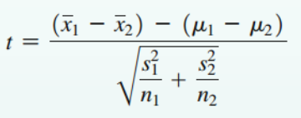Simple random samples
      * Either n > 30 (both samples) or both samples approximately normal distribution
        + no outliers and departure against normality is not too extreme
    - 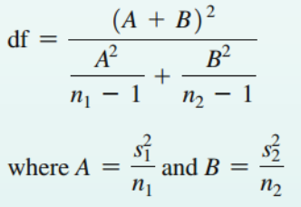Hypothesis test for two means **(H0: 1 = 2)**
      * Test statistic equation to right…
      * Degrees of freedom…
        + df = smaller of n1-1 and n2-1 (approximate)
        + More accurate equation…
      * 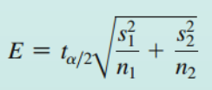P-value or Critical Value methods
    - Confidence Interval Estimate
      * Calculate margin or error…
      * Calculate CI…
    - All methods give same conclusion (unlike two proportions)
  + 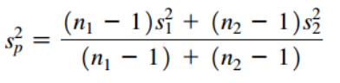1 = 2 but UNKNOWN
    - 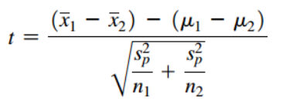pool sample variances to obtain population variance 2 (denoted by s2p)…
    - 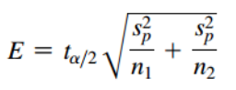Then calculate test statistic…
    - Calculate E and CI…
    - df = n1+n2 – 2
    - Why assume 1 = 2?
      * Samples from same population (i.e., treatment and placebo groups with sound sampling methodologies) & we assume H0: m1=m2…not unreasonable to assume standard deviations are equal
      * However we rarely know this assumption so use first part of this chapter
    - Advantage of pooling?
      * Degrees of freedom is higher…so power is greater and CI’s are narrower
  + 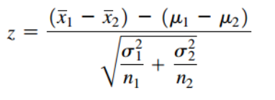1 and 2 are KNOWN
    - 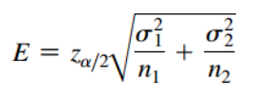Rarely known in reality…but if they are…we can use the normal distribution and not the t distribution
    - Calculate test statistic…
    - Calculate E and CI…
  + 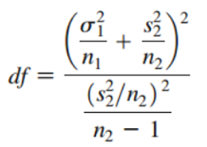One  known, other  unknown
    - Use first section of this chapter except replace s1 with known …then calculate df…
* **9.3 Two Dependent Samples (Matched Pairs)**
  + Dependent samples – pairs matched in some way…before and after, husband vs wife, etc.
  + Same methods as previous chapter, but this time we’re interested in differences of means of matched pairs…
  + Notation
    - d = individual difference between two values in single matched pair
    - d = mean value of differences d for the population of all matched pairs of data
    - dbar = mean value of differences d for the paired sample data
    - sd = standard deviation of differences d for paired sample data
    - n = number of pairs of sample data
  + Requirements
    - Sample data are dependent
    - Matched pairs are from a simple random sample
    - n>30 and/or pairs of values have differences approximately normal distribution
      * 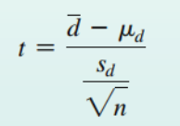Robust against departures from normality
      * If n<30 use bootstrap method
  + Hypothesis test **(h0: md = 0)**
    - 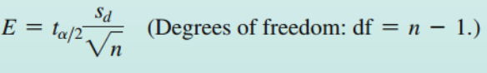Calculate test statistic…
    - Make conclusion with either P-value or Critical value methods
  + Confidence Interval
    - Calculate E and CI…
  + Procedure…
    - Verify requirements
    - Find differences d between matched pairs (subtract in consistent way)
    - Find mean of differences in sample dbar and standard deviation of differences in sample sd
    - Calculate test statistic, E, CI as needed…
    - Conclusions can be based on P-value, critical value, or CI (unlike proportions)
      * If CI includes 0, then null fail to reject null hypothesis
* **11.1 Goodness of Fit**
  + Goodness of fit test – used to test the hypothesis that an observed frequency distribution fits some claimed distribution
  + Objective…
    - Test whether a single row or column of frequency counts agrees with some specific distribution (e.g., normal, uniform, etc)
  + Notation
    - O = observed frequency of an outcome, found from sample data
    - E = expected frequency of an outcome, found by assuming the distribution is as claimed (e.g., uniform, all the same)
    - k = number of different categories or cells
    - n = number of trials (total observed sample values)
    - p = probability that sample value falls within a particular category
  + Requirements
    - Data are randomly selected
    - Sample data consist of frequency counts for each of the different categories
    - For each category, the expected frequency is at least 5 (if the data has the distribution that is being claimed)
  + **Null and Alternative Hypotheses**
    - H0 – null hypothesis, frequency counts agree with claim, have equality only
    - H1 – alternative hypothesis, frequency counts do not agree with claim, do not have equality
  + 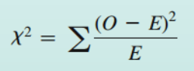Test Statistic for Goodness-of-fit tests
    - Chi squared equation…
    - Draw conclusion based on P-values or Critical values
      * **Critical values found by using k-1 degrees of freedom**
      * 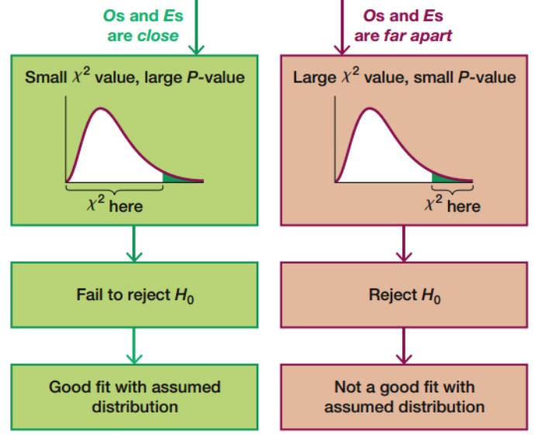Goodness-of-fit hypothesis tests are always right-tailed
      * If observed and expected frequencies are close, the test statistic will be small and the P-value large
      * If observed and expected frequencies are far apart, test statistic will be large and the P-value small
  + Finding Expected Frequencies E
    - Informally ask…”how can the observed frequencies be split up among the different categories so that there is perfect agreement with the claimed distribution?”
    - If expected frequencies are all equal (uniform distribution): E=n/k
    - If expected frequencies are not all equal: E=n/p for each category
    - Note: Observed frequencies are whole numbers, expected frequencies don’t have to be
    - Good example in text page 505
  + Rationale for test statistic…
    - Summing differences (O-E) simply sums to zero…so that’s useless
    - The sum of the square of the differences gives us a magnitude of the difference…so better than nothing
    - The full equation (sum of O-E/E) gives us magnitude relative to what’s expected
    - The theoretical distribution of (sum of O-E/E) is a discrete distribution because number of possible values is finite…but approximated with the continuous chi squared distribution
    - Degrees of freedom k-1…because we can freely assign frequency to that many categories, then last category is fixed (because has to add up to total number of trials)
* **11.2 Contingency Tables**
  + Contingency table – table consisting of frequency counts of **categorical data** corresponding to two different variables (one variable categorizes rows, other variable categorizes columns); aka, two-way frequency table
    - Contingent – dependence on some factor
    - Test of Independence - Contingency table tests for independence between the row and column variables using a hypothesis test
  + Notation
    - O = observed frequency in a cell of a contingency table
    - E = expected frequency in a cell, found by assuming row and column variables are independent
    - r = number of rows in contingency table (not including labels or row totals)
    - c = number of columns (not including labels or column totals)
  + Requirements
    - Randomly selected sample data
    - Sample data represented as frequency counts in a two-way table
    - Every cell in table has expected frequency E of at least 5 (not for observed frequency O)
  + **Hypothesis test for independence**
    - **H0: row and column variables are independent**
    - H1: row and column variables are dependent
    - 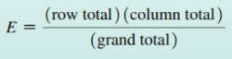Calculate Test statistic for test of independence…
      * Distribution can be approximated by chi-square distribution
      * E equation – row total: total frequencies in row containing cell of interest; column total: total frequencies in column containing cell of interest; grand total: sum of all frequencies in table
      * Test statistic measures amount of disagreement between O and what we theoretically expect E
      * Large values have a lot of difference (small P), small values have small difference (large P)
    - Conclusion based on P-values or Critical Values
      * P-values
      * Critical Values
        + Degrees of freedom = (r-1)(c-1)
      * Always right-tailed test
    - Rationale for Expected Frequencies E
      * We assume rows and columns are independent…so can use the multiplication rule for independent events (from Chapter 4)
        + This gives us a probability for each cell…that we can then multiply by the grand total to give us the count for that cell
  + Test of Homogeneity
    - Hypothesis test for Independent tests sample from one population…in chi-square test of homogeneity we test samples from different populations to determine if they are similar
    - Chi-square test of homogeneity – test of the claim that different populations have the same proportions of some characteristic
    - Sampling – subjects are typically randomly selected from the different populations separately
    - Notation, requirements, hypotheses, and calculations are the same as a Test for Independence EXCEPT…
      * Instead of testing H0 that sample variables are independent…we test **H0 that the different populations have the same proportion of some characteristic**
  + Fisher’s Exact Test
    - Testing hypotheses of contingency tables are constrained by E has to be at least 5 in each cell… this is required for the chi-square distribution to be a good approximation
    - Fisher’s exact Test – often used for 2x2 contingency table with one or more cells where E<5
      * Provides an exact P-value and is NOT an approximation
  + 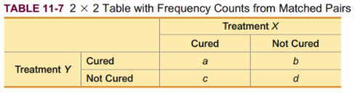McNemar’s Test for Matched Pairs
    - Used for 2x2 contingency tables for matched pairs (dependent)
    - Tests hypothesis that frequencies from discordant (different) categories occur in same proportion
    - Requirements
      * Frequencies are such that b+c >= 10
      * Test statistic…
      * 1 degree of freedom
* **12.1 One-way ANOVA**
  + One-way **AN**alysis **O**f **VA**riance – hypothesis test **that three or more populations have means that are all equal**; “single factor” ANOVA
    - **H0: 1=2=3…**
    - 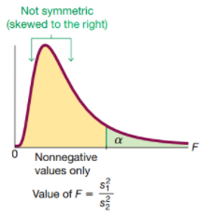Uses data categorized by one factor (or treatment or variable) so that there is one characteristic used to separate the sample data
      * Example: Blood lead level (factor) – low, medium, high
    - Require F distribution
      * Different F distribution for each different pair of degrees of freedom for numerator and denominator
      * Not symmetric
      * 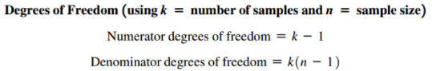Cannot be negative
      * Shape depends on two different df
      * **F is very sensitive to sample means…even though obtained by estimates of common pop. variance**
    - Requirements
      * Populations approximately normal
        + If extremely non-normal then use Kruskal-Wallis test
      * Populations have same (similar) variance
      * Samples are simple random samples
      * Samples are independent from each other
      * Samples from populations that are categorized in only one way
    - Procedure…
      * Use technology to obtain test statistic and P-value
        + Value very sensitive to sample means
      * **Always right-tailed…only large values of test statistic (low P) cause rejection of H0**
      * 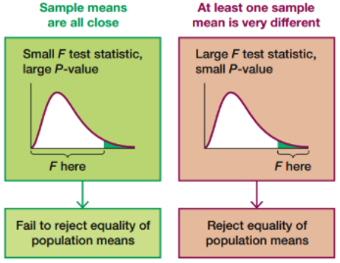Form conclusion from P-value and significance level 
        + Reject H0 if P<= 

We cannot conclude from ANOVA that any particular mean is different than others…just that at least one is

* + - * + Fail to reject H0 if P> 
    - Why not just test two means at a time?
      * Confidence level decreases…0.95*0.95*0.95…
      * Increase chance of Type 1 error (finding a difference in means, when there is not…rejecting null hypothesis)
    - Uneven sample sizes…
      * Use technology…use weighted measures that take sample sizes into account
  + Designing Experiments
    - Can’t always be sure that the factor being considered in ANOVA is responsible for difference in means…could be another factor…use completely randomized design, that includes a placebo group for example
  + Identifying Which Means Are Different
    - Can’t ID specific means that are different with ANOVA
    - Informal methods – compare boxplots, construct confidence intervals
    - Range tests – procedure to ID subsets of means that are NOT significantly different
    - Multiple comparison tests – uses pairs of means, but adjust as to not decrease confidence level
      * Common ones include – Duncan, Student-Newman-Keuls test (SNK), Tukey test, Scheffe test, Dunnett test, least significant difference test, Bonferroni test
      * Bonferroni Multiple Comparison Test…
        + Separate t test for each pair of samples, but adjust…

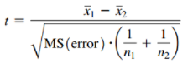Use “MS(error)” for t statistic for each pair

Find P-value with…df=N-k…then adjust P-value by multiplying by number of different possible pairings of two samples

Find critical value with…adjust  by dividing it by number of different possible pairings of two samples

* **13.1 Basics of Nonparametric Tests**
  + Parametric test – has requirements about the distribution of the populations involved
  + Nonparametric test – do not require samples come from populations with a particular type of distribution; also called distribution-free test
    - Advantages…
      * Less rigid requirements so can be applied to a wider variety of situations
      * Can be used with more data types (i.e., data of ranks or categories)
    - Disadvantages…
      * Tend to waste information because exact numerical data are often reduced to qualitative form (capturing weight loss as either negative or positive and ignoring the magnitudes)
      * 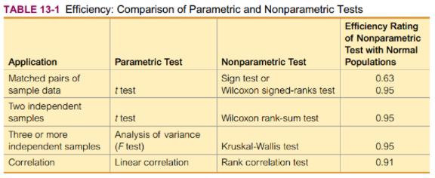Not as efficient as parametric tests (when parametric requirements are met), so nonparametric tests generally needs stronger evidence to reject a null hypothesis (larger sample size or greater differences)
        + Usually better to use parametric procedure when requirements are met
  + Ranks – a number assigned to an individual sample item according to its order in a sorted list…first item has a rank of 1, second item has a rank of 2, etc.
    - Ties among Ranks – if tie ranks occur, commonly find the mean of the ranks involved
* **13.2 Sign Test**
  + Sign test – nonparametric test that uses positive and negative signs to test different claims…
    1. Claims involving matched pairs of sample data
    2. Claims involving nominal data with two categories
    3. Claims about the median of a single population
    - Basically analyzing frequency of positive and negative signs and determine if there is a significant difference
  + Procedure
    - Notation
      * x = number of times the less frequent sign occurs
      * n = total number of positive and negative signs combined
    - Requirements
      * Simple random sample
    - Hypotheses
      * H0 (null): there is no difference
      * H1 (alternative): there is a difference
    - Test Statistic
      * If n <= 25
        + Test statistic is x (number of times of less frequent sign occurs)
      * 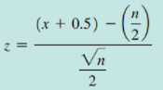If n > 25
        + Calculate test statistic…
    - P-values
      * P-values can be found by using the test statistic…
    - Critical Values
      * If n<= 25…compare test statistic x to critical value found in table A-7
      * If n > 25…critical value found in table A-2 (normal distribution table)
    - *Hints…*
      * *because z is based on the less frequent sign…all one-sided tests are treated as left-tailed*
      * *If one sign occurs significantly more than the other sign, sample data can contradict the alternative hypothesis…sample of 7% boys can never be used to support claim that boys occur more than 50%*
        + *So even though H1 may signify right-tail, we do the opposite test for a left-tailed*
  + Claims about Matched Pairs
    - Convert sample data as follows…
      * Subtract each value of the second variable from the corresponding value of the first value
      * Record only the sign of the difference; if two values are equal (subtraction = 0) then delete
    - Main concept here is – if two datasets have equal medians, the number of positive signs should be approximately equal to the number of negative signs
  + Claims involving Nominal Data with Two Categories
    - No numbers for nominal data, which limits possible calculations
    - We can ID the proportion of sample data that belong to a particular category and test claims about the corresponding population proportion
* **13.3 Wilcoxon Signed-Ranks Test for Matched Pairs**
  + Nonparametric test that uses ranks for these applications:
    - Testing a claim that a population of matched pairs has the property that the matched pairs have differences with a median equal to 0
    - Testing a claim that a single population of individual values has a median to equal to some claimed value
      * Matched pairs created by pairing each sample value with claimed median
  + Claims involving Matched Pairs
    - The sign test uses only signs…but the Wilcoxon signed-ranks test takes into account the magnitudes in the ranking…so it uses and includes more information
    - Notation
      * T = the smaller of the following two sums…
        1. Sum of the positive ranks of the nonzero differences d
        2. Absolute value of the sum of the negative ranks of the nonzero differences d
      * Matched pairs – differences obtained by subtracting second value from first value
      * Individual values – differences obtained by subtracting ‘claimed median’ from each sample value
    - Requirements
      * Simple random sample
      * Population of differences has a distribution that is approximately symmetric
        + How is this not “normal” distribution?
    - 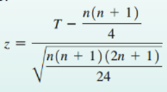Test Statistic
      * If n<=30…test statistic is T
      * If n>30…test statistic is z value…
    - Make conclusions based on P-values or Critical Values
      * For critical values use table A-8 (n<=30)
    - Procedure…
      * Find difference d
      * Sort the absolute value of d from lowest to highest, then rank, assign tie ranks with mean of ranks
      * Attach sign of difference d to each calculated rank of absolute value
      * Sum ranks that are positive AND sum of absolute values of negatives
      * T is the smaller of these two sums
      * n is the number of matched pairs with differences != 0
      * Determine test statistic
      * Form conclusion
  + If there is no significant difference between matched pairs, then the two signed-rank totals should be about equal
* **13.4 Wilcoxon Rank-Sum Test for Two Independent Samples**
  + Nonparametric test that uses ranks of **sample data from two independent populations to this the null hypothesis H0: two independent samples come from populations with equal medians**
    - Alternative hypothesis H1 can be all three possibilities !=, <, >
    - Rationale – if two samples are drawn from identical populations and the individual values are all ranked as one collection, then the high and low ranks should fall evenly between both samples
    - Does not require normal distribution (unlike parametric t test)
    - Can be used with data down to ordinal level
    - Often preferred over parametric t test because such high efficiency (0.95) and easier calculations even when normality is met
  + Notation
    - n1 = size of sample 1
    - n2 = size of sample 2
    - R1 = sum of ranks for sample 1
    - R2 = sum of ranks for sample 2
    - R = same as R1
    - R = mean of sample R values that is expected when two populations have equal medians
    - R = standard deviation of sample R values that is expected with two populations having equal medians
  + Requirements
    - Simple random samples
    - Samples are independent
    - 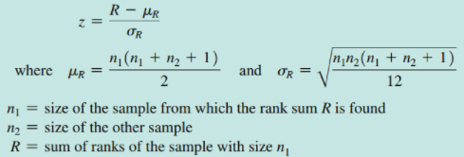Each sample has n > 10 (if <10, then need special tables)
  + Test Statistic
    - Calculate as follows…
  + Procedure…
    - Combine both samples into one, then sort, then rank
    - Find sum of ranks for either one of the two samples (n1…can use either sample)
    - Calculate test statistic and draw conclusion – large z, higher ranks in sample 1

**Questions…**

1. A lot of the methods we have studied so far are based on normal distributions….or approximately normal. And we’ve used a histogram and normal quantile plots to do that, but it’s very qualitative and ambiguous in some cases…How do you quantify ‘normality’ of sample data?
   1. ***Answer…YES there are methods to do this, but normally statisticians transform the dataset to fit a normal distribution***
2. Chi squared goodness-of-fit test…
   1. This is basically variance?
   2. Only for frequency data? How to test if a group of sample means were from the same population?
      1. Estimate population mean?
      2. Expected frequency by percentile?
      3. Observed frequency by percentile?
      4. Then chi-squared goodness-of-fit test?
3. Contingency tables…
   1. Tests whether all are independent or dependent? Or can just one be independent/dependent?
4. Degrees of Freedom…I don’t understand why we use df versus total number (i.e., standard deviation or variance)? Test statistics?
5. How is ‘symmetric’ different than ‘normal’ distribution?
6. Wilcoxon Signed-rank test…isn’t the median of differences very misleading?