1. **1.1 Statistical and Critical Thinking**
   1. Data
      1. Collections of observations, measurements, survey responses
   2. Census
      1. Collection of data from every member of population
   3. Statistical Significance
      1. Result that is unlikely to be achieved by chance
   4. Practical Significance
      1. May be statistically significant, but not practical
   5. Misleading conclusions
      1. Self-reported results instead of measured
      2. Loaded questions
      3. Order of questions
      4. Nonresponse & biased results of people who do respond
      5. Percentages
2. **1.2 Types of Data**
   1. Population Parameter vs Sample Statistic
   2. Quantitative vs Categorical
      1. Categorical can be coded with numbers
   3. Discrete vs Continuous
      1. Discrete is countable – number of tests; can be finite number of tests or infinite number of tests that never end
      2. Continuous is not countable – infinite values on a scale of measurements
   4. Levels of Measurement
      1. Nominal – categorical data, no order to it
      2. Ordinal – can be arranged, but differences between data values is meaningless; course grades like A, B, C, D, E
      3. Interval – can be arranged, differences are meaningful, but no 0 starting point; temperature or years/dates
      4. Ratio – can be arranged, differences, 0 starting point, & ratio is meaningful; heights of students 0-180 cm, duration of class times 0-50 minutes
3. **1.3 Collecting Sample Data**
   1. Gold Standard – randomization with placebo / treatment groups
   2. Experiment vs Observational Study
      1. Observation – measure/survey without trying to affect them
      2. Experiment – assign groups to apply some treatment
   3. Lurking variable – affect variables in study, but not included in study
   4. Confounding – variable included in study; we see effect, but can’t ID the cause in an experiment
   5. Experiment design
      1. Replication – sufficiently large sample sizes
      2. Blinding – subject doesn’t know if they have treatment or placebo
      3. Randomization – individuals assigned to different groups
   6. Simple random sample – n subjects selected in such a way that every possible sample of the same size n has the same chance of being chosen
   7. Systematic sampling – select starting point then every kth element
   8. Stratified sampling – subdivide population into at least 2 groups, then draw sample from each subgroup (used for survey)
   9. Randomized block – like stratified, but for an experiment
   10. Cluster sampling – subdivide population into sections (clusters), then randomly select some clusters and use all members in those clusters
   11. Convenience sampling – data that is easy to get
   12. Matched pairs – get measurements from same subject before & after (or use twins)
   13. Observation studies
       1. Cross-sectional study – data observed, measured, collected at one point in time
       2. Retrospective study – data collected from a past time (making predictions about future)
   14. Prospective study – data collected in future (making predictions about past leading up to the present point)
4. **2.1 Frequency Distributions for Organizing & Summarizing Data**
   1. Lower class limits – smallest numbers that can belong to each of the different classes
   2. Upper class limits – largest numbers that can belong to each of the different classes
   3. Class midpoints – values between each class (midpoints between lower & upper limits)
   4. Class boundaries – numbers used to separate classes without gaps caused by class limits
   5. Class width – difference between two consecutive lower class limits (or two consecutive lower class boundaries) in a frequency distribution
   6. Procedure to construct frequency distribution
      1. Select number of classes (use round numbers if possible)
      2. Calculate class width (max value – min value / number of classes) – round to nearest whole number if convenient
      3. Choose value for first lower class limit using either min data value or convenient value below the minimum
      4. add other class limits by adding the class width to first lower class limit
      5. List lower class limits in vertical column then determine and enter upper class limits
      6. Take each individual data value and count for each class
   7. Relative frequency – frequency per class/sum of all frequencies (displayed as frequency or percentage)
   8. Cumulative frequency – sum all frequencies from low to high
      1. May need to replace class limit labels by “less than X”
   9. Normal distribution of frequencies
      1. Gaps may indicate data from multiple populations
   10. Combining multiple frequency distributions into one table for easier comparison
5. **2.2 Histograms**
   1. Data vs data frequency
      1. Easier to interpret than frequency table
      2. Display shape of distribution
      3. Location of center
      4. Spread of data
      5. Outliers
   2. Relative frequency histogram – same as histogram, but y-axis is percentage
   3. Common shapes
      1. Bell-shaped (normal)
      2. Uniform
      3. Skewed
   4. Normal quantile plots
      1. Criteria for normality
         1. Normal distribution if pattern of points is close to a straight line (no systematic pattern)
6. **2.3 Graphs that Enlighten & Graphs that Deceive**
   1. Graphs that enlighten
      1. Dotplots – shows shape of distribution & uses original data values
      2. Stem plots – shows shape & uses original data values
      3. Time-series Graph – shows trends over time
      4. Bar graph – frequencies for categorical data
         1. Pareto chart – bar graph, but arranged in descending order
      5. Pie chart – not as effective as Pareto; frowned upon because lack of scale
      6. Frequency polygon chart – uses line segments connecting points above class midpoint values…similar to histogram
         1. also relative frequency polygon chart allow comparison of multiple groups
   2. Graphs that deceive
      1. Non-zero axis
      2. Pictographs – 2D image that doesn’t scale to differences in 1D data
   3. **3.1 Measures of Center**
      1. Mean
         1. Uses every data value
         2. Sample means from a population vary less than other measures of center
         3. Disadvantage – just one outlier can change mean value substantially…not resistant
   4. *Resistant – presence of outliers doesn’t cause much change*
      1. Median
         1. Middle value arranged in order
         2. Resistant
         3. Doesn’t use every data value
      2. Mode
         1. Not used much for quantitative data, but only measure of center for qualitative data
         2. No mode, one mode, bimodal, multimodal
      3. 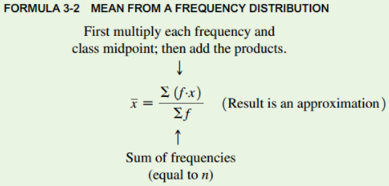Midrange
         1. Max data value + min data value / 2
         2. Not resistant
      4. Rounding
         1. Mean, median, midrange – carry one more decimal place than in original data
         2. Mode – value(s) same as original data values…no rounding
      5. 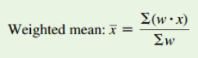Mean of a Frequency Distribution
         1. See formula to middle right…
      6. Weighted mean
         1. See formula to bottom right…
   5. **3.2 Measures of Variation**
      1. Rounding measures of variation
         1. Carry one more decimal place than original data values
      2. Range
         1. Max – Min
      3. 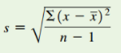Standard Deviation of a Sample
         1. show much data deviates away from mean
         2. s = sample standard deviation
         3. s = population standard deviation
         4. 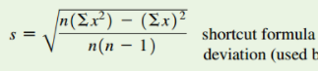Never negative, 0 only when data values are exactly the same
         5. Larger values indicate greater variation
         6. Can increase dramatically with outliers
         7. s is BIASED estimator of s…values of s don’t center around s
      4. Range rule of thumb
         1. Simple tool for understanding standard deviation…based on most data values lie within 2 standard deviations of mean…
            1. Significantly low – values less than mean + 2*standard deviation
            2. Significantly high – values greater than mean + 2*standard deviation
      5. Standard deviation of Population
         1. See formula to right…
      6. Variance
         1. s2 – sample variance
         2. s2 – population variance
         3. Units are squares of original data units (m2 vs m)
         4. Variance is NOT resistant…affected by outliers
         5. Never negative…only 0 when all data values are same
         6. Sample variance is UNBIASED estimator of population variance
      7. Standard deviation formula
         1. Just adding difference of mean will always sum to 0 S(x – xbar)
         2. Mean Absolute Deviation (MAD) – sum of absolute values of differences
            1. Not common because absolute value is not algebraic
         3. Why divide by n-1?
            1. n-1 variance centers around population variance…with just n in sample standard deviation, variance underestimates population variance
      8. 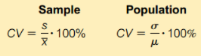Coefficient of variation
         1. Compare two sample standard deviations only when sample means are ~same…or when two samples/populations have different scales or units
         2. Round to one decimal place
   6. **3.3 Measures of Relative Standing & Boxplots**
      1. 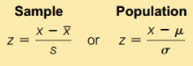Z score
         1. Conversion of a value to a standardized scale…number of standard deviations that a data value is above or below the mean
         2. Round z scores to two decimal places
         3. Significantly low if z score is less than -2 or greater than 2
      2. Percentiles
         1. Measures of location…denoted P1, P2…P99 which divide a dataset into 100 groups with 1% of values in each group
         2. If finding percentile of a specific data value…
         3. 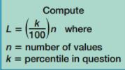If finding data value of a specific percentile…
            1. Sort list low to small
            2. Compute location for desired percentile
            3. If L = whole number…value of percentile is midway between calculated location and next highest location
            4. If L not whole number…round to higher whole number…value of percentile is rounded location
      3. Quartiles
         1. Q1, Q2, Q3 = P25, P50, P75
         2. Interquartile Range (IQR) = Q3-Q1
         3. Semi-interquartile range = Q3-Q1 / 2
         4. Midquartile = Q3 + Q1 / 2
         5. 10-90 percentile range = P90 – P10
      4. 5 number Summary
         1. Minimum
         2. First quartile Q1
         3. Second quartile Q2 (same as median)
         4. Third quartile Q3
         5. Maximum
      5. Boxplot
         1. shows 5 number summary
         2. whiskers connect max and min (modified boxplot connects min and max of non-outliers)
         3. Can show skewness of dataset
         4. Not as much detailed information as histogram or stemplot
         5. Good for comparing two or more datasets…use same scale
      6. Outliers
         1. Data below Q1 – (1.5 * IQR)…data above Q3 + (IQR * 1.5)
            1. Shown on modified boxplots
   7. **4.1 Basic Concepts of Probability**
      1. Probability deals with procedures that produce outcomes…then interpreting the likelihood of those outcomes using probability
         1. Event – collection of outcomes of a procedure
         2. Simple event – an outcome of a procedure that can’t be broken down any further
         3. Sample space – all possible simple events
         4. Example…
            1. Procedure - single birth…or…3 births
            2. Event - 1 girl (simple event)…or…2 boys, 1 girl (bbg, bgb, gbb are all simple events resulting in the event
            3. Sample space – {b, g}…or…{bbb, bbg, bgb, bgg, gbb, gbg, ggb, ggg}
      2. Finding probability
         * P – probability
         * A, B, C, etc. – specific events
         * P(A) – probability of event A occurring
         1. Relative frequency Approximation of Probability
            1. P(A) = number of times A occurred / number of times procedure was repeated
            2. Probability approximated from a set of procedures…not the exact probability
         2. Classical Approach to Probability
            1. P(A) = number of ways A can occur / number of all different simple events
            2. Outcomes must all be equally likely
         3. Subjective probability
            1. Estimated probability using knowledge of relevant circumstances…educated guess
         4. Simulations
            1. Simulation of a procedure that behaves the same way as procedure itself
         5. Rounding
            1. Usually round to three significant digits unless otherwise stated…unless the number is exact (like ½ = 0.5)
            2. Or use fractions…look at directions
         6. Law of large numbers
            1. As a procedure is repeated the relative frequency probability approaches the actual probability
      3. Complementary events
         1. Complement – complement of A is A bar…all outcomes where A does not occur
            1. P(A) = 1 – P(A bar)
      4. Significant results
         1. Significantly high – for event x…P(x once or more times) <= 0.05
         2. Significantly low – for event x (Px once or fewer times) <=0.05
   8. **4.2 Addition Rule and Multiplication Rule**
      1. Compound event – any event combining two or more simple event
      2. Addition Rule
         1. P(A or B) = P(in a single trial, even A occurs OR event B occurs OR they both occur as a single outcome of a procedure)
            1. “Or” denotes using addition rule
         2. Intuitive definition – add number of ways event A can occur and the number of ways B can occur…but correct for overlapping occurrences…so P(A or B) = sum of A or B (minus overlap) / total number of outcomes
         3. Formal definition – P(A or B) = P(A) + P(B) – P(A and B)
         4. Disjoint – events A and B are disjoint (mutually exclusive) if they can’t occur at same time
            1. No overlap…simplifies addition rule
            2. P(A or B) = P(A) + P(B)
         5. Complementary events & Addition rule
            1. P(A or A bar) = P(A) + P(A bar) = 1
            2. A and A bar are disjoint
      3. Multiplication Rule
         1. P(A and B) = P(event A occurs in one trial, then B occurs in different trial)
            1. ***This has a different meaning in the Addition rule…both occur during same trial!!!***
         2. P(B | A) = probability of event B occurring after event A has already occurred
         3. 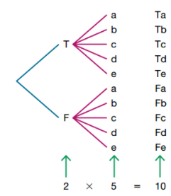Intuitive definition – multiply probability of A by probability of B
         4. Formal definition – P(A and B) = P(A) * P(B | A)
         5. Independent – two events are independent if occurrence of one doesn’t affect probability of the other…if they are, the two events are dependent
            1. With replacement…independent
            2. Without replacement…dependent…adjust total number of possibilities
            3. Small samples (<= 5%) from large population can assume independent
         6. Tree diagram – showing all possibilities of a procedure…can find sample space
   9. **4.3 Complements, Conditional Probability, Bayes Theorem**
      1. Probability of “at least 1” is same as “one or more”
         1. Not getting at least 1 girl in 10 births = getting 0 girls = getting 10 boys
         2. P(A) = 1 – P(A bar)
         3. 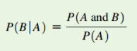See example 1
      2. Conditional Probability – probability of an event obtained with additional information that some other event has already occurred
         1. Probability of hole in one is 1/12,000…but if you know the person is a professional golfer, the probability is 1/2375
         2. P(B|A) != P(A|B)
      3. Bayes Theorem
         1. Revising a probability based on information obtained later…similar to conditional prob.?
         2. Prior probability – probability calculated initially
         3. Posterior probability – probability revised by using additional info.
         4. See example 4 & last paragraph…
            1. P(having cancer) = 0.01 – prior probability
            2. P(having cancer | positive test result) = 0.0748 – posterior probability
   10. **4.4 Risks and Odds**
       1. Absolute risk reduction
          1. Useful for comparing two probabilities
          2. Results always positive…caution with results because could be in favor of treatment or placebo
          3. Example…
             1. “For a subject treated with the Salk vaccine, there is an absolute risk reduction of 0.000407 (or 0.0407%) when compared to placebo”
       2. Relative risk
          1. Common for prospective study
          2. pt – proportion (incidence rate) of some characteristic in treatment group
          3. pc – proportion (incidence rate) or some characteristic in control group
          4. Relative risk = pt / pc … P(event occurring in treatment group) / P(event occurring in control group)
          5. RR = 1 … same in both groups…RR>1…greater in treatment group…RR<1…less in treatment group
          6. Example…
             1. The polio rate given the Salk vaccine is 0.287 of the polio rate for children given a placebo…or…children in the placebo group are 3.48 times more likely to get polio (reciprocal value of RR)
          7. If incidence rates are very small, this can show a large RR…but really has no practical significance
       3. 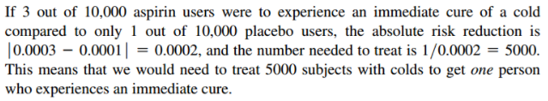Number Needed to Treat (NNT)
          1. Number of subjects that must be treated in order to prevent one event (disease or adverse reaction)
          2. NNT = 1 / absolute risk reduction
       4. Odds
          1. Odds against A occurring – P(A bar) / P(A)…a:b…’a to b’
          2. Odds in favor of A – P(A) / P(A bar)
       5. Odds ratio
          1. measure of risk found by evaluating the ratio of odds in favor of treatment to odds in favor of control group
          2. Retrospective OR prospective studies
       6. Why not use Relative Risk for retrospective study?
          1. RR is only good for actual incidence rates…retrospective study can be biased and not accurate incidence rate
   11. **6.1 The Standard Normal Distribution**
       1. The Normal Distribution
          1. Continuous random variable with Bell-shaped, symmetric distribution/graph
          2. Population mean = m = 0
          3. Population standard deviation = s = 1
          4. Also known as gaussian distribution
          5. Density curve – graph of any continuous probability distribution (uniform or normal) area is 1
       2. Uniform Distribution
          1. 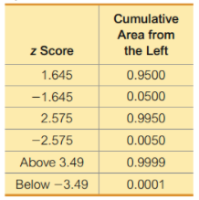Values are approximately equal
          2. Area under graph = 1 = height * width
          3. Relationship between area and probability
       3. Standard Normal Distribution
          1. Bell-shaped, area = 1, correspondence between area & probability
          2. Z score is horizontal axis (z score is number of s away from mean)
       4. Z table
          1. Z score on margins…distance along horizontal scale of graph
          2. 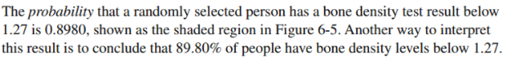Area in body of table…region under the curve
       5. Critical values
          1. Z score separating values that are significantly high from significantly low
          2. Z=1.96 (0.95 total…0.05 on one tail…0.025 on both tails)
          3. Za denotes z score with an area of a to its right
             1. Z0.025 = 1.96
   12. **6.2 Real Applications of Normal Distributions**
       1. Nonstandard Normal Distribution
          1. Mean m different than 0 and/or Standard deviation s different than 1
          2. Requires conversion to standard normal distribution (z score)
             1. ***This is one data value…not mean of multiple samples***
   13. **6.3 Sampling Distributions and Estimators**
       1. Sampling distribution of Statistic
          1. Distribution of all values of the statistic when all possible samples of the same size n are taken from the population
          2. Instead of values from population like standard normal distribution
          3. Represented as a probability distribution in the format of a histogram, formula, or table
          4. Sample proportions (p hat) and sample means (x bar) have normal distributions
          5. Sample variances (s2) have skewed distribution
       2. Sampling distribution of Sample Proportion
          1. Approximates normal distribution
          2. Target value of population proportion
          3. The mean of the sample proportions is equal to the population proportion
       3. Sampling distribution of Sample Mean
          1. All samples have same size n
          2. Approximates normal distribution
          3. Target value of population mean
          4. The mean of the sample means is equal to the population mean
       4. Sampling distribution of Sample Variance
          1. 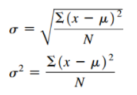All samples have same size n
          2. Distribution tends to be skewed to right
          3. Target population variance
          4. Mean of sample variances is the population variance
          5. *Note – be sure to calculate s vs s and s2 vs s2 correctly with N or n-1
       5. Biased vs Unbiased Estimators
          1. Estimator – sample statistic used to infer population parameter
          2. Unbiased estimator – sample statistic that targets corresponding population parameter
             1. Sample proportion, mean, variance
          3. Biased estimator – sample statistic does not target corresponding population parameter
             1. Sample median, range, standard deviation
             2. *Note – s does not target s, but bias is small in large samples so it can be used to estimate in some cases
       6. Sampling with replacement
          1. Small samples from large populations, replacement vs no replacement makes no significant difference
          2. Replacement results in independent events unaffected by previous outcomes
   14. 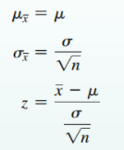**6.4 The Central Limit Theorem**
       1. For all samples of same size n (with n > 30), the sampling distribution of x bar can be approximated by a normal distribution with population mean m and standard deviation s/sqrt(n)
          1. Any population with any distribution (normal, uniform, skewed, etc)
       2. Central Limit Theorem
          1. Population (with any distribution) has mean m and standard deviation s
          2. Simple random samples all of same size (n) selected from population
          3. Population has normal distribution OR n > 30
             1. Mean of all sample means (x bar) approximates population mean m
             2. Standard deviation s of all sample means (x bar) approximates population s
             3. Z score conversion of individual sample mean x bar
          4. Population is NOT normal and n <= 30
             1. Distribution of sample means (x bar) might not be approximated well by a normal distribution so must use other methods like nonparametric or bootstrap
          5. Steps to work problems
             1. Check requirements – normal distribution and/or n > 30
             2. 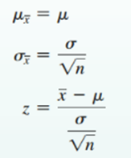Working with an individual data value…*use top equation*
             3. Working with mean of sample (mean of multiple values)…*use bottom equation*
             4. Mean of all values of x bar = mx = m
             5. Standard deviation of all values of x bar = sx = standard error of mean
          6. Correction for a finite population
             1. Use of sx (Standard error of mean) assumes population is infinite

With replacement pop. Is effectively infinite

* + - * 1. Without replacement from finite population need to correct sx

Sample size > 5% of finite population size N (n > 0.5*N)

Adjust standard error by multiplying sx by this correction factor…

* 1. **6.5 Assessing Normality**
     1. 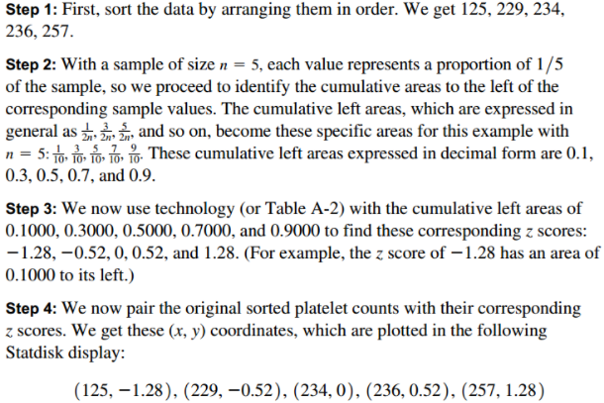Criteria for determining if normal distribution requirement is satisfied…
        1. Visual inspection of histogram
           1. If shape departs from bell shape…not normal
        2. Identifying outliers
           1. If more than one conclude not normal
        3. Normal quantile plot
           1. X axis – original sample data values
           2. Y axis –z score for cumulative data values
           3. straight line…normal
           4. not straight pr show systematic pattern…NOT normal
  2. **7.1 Estimating a Population Proportion**
     1. Point estimate – single value statistic used to estimate a population parameter; sample proportion p hat is best point estimate for population proportion p
        1. p hat is an unbiased estimator (sampling distribution of p hat has a mean that is equal to the population parameter)
     2. Confidence interval (CI) – range (or interval) of values used to estimate the true value of a population parameter
        1. can use sample proportion to construct confidence interval estimate of true population proportion
        2. Confidence level – probability that 1-a (such as 0.95 or 95%) that the CI actually does contain the population parameter
        3. Interpretation – “We are 95% confident that the interval from XX to XX actually does contain the true value of the population parameter”
           1. The CI of 0.95 refers to success rate of the process used to estimate the parameter
     3. Critical values
        1. 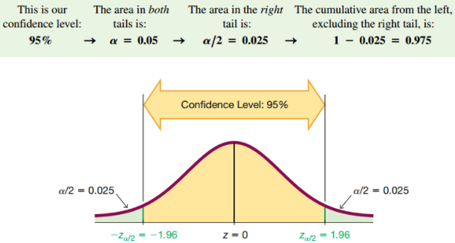When certain requirements met, the sampling distribution of sample proportions can be approximated by a normal distribution
        2. A z score associated with a sample proportion p hat has a probability of a/2 of falling in the right tail portion (or left tail if -za/2) portion…two tails because we’re estimating the center or the population parameter
        3. Finding critical value…
     4. Margin of Error (E)
        1. When estimating a population parameter, the difference between the population parameter and the sample statistic is an error…the maximum likely amount is the margin of error (E) based on confidence level…also called maximum error of the estimate
        2. For proportions…
        3. 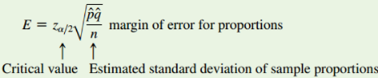Requirements
           1. Simple random sample
           2. Conditions for binomial distribution

Fixed number of trials

Trials are independent

Two categories of outcomes

Probabilities independent for each trial

* + - * 1. At least 5 successes and 5 failures (n*p >= 5) and (n*q>=5)
      1. Round CI limits for p to three significant digits (unless other wise stated)
    1. Finding point estimate and E from a CI
       1. Point estimate = upper CI + lower CI / 2
       2. E = upper CI – lower CI / 2
    2. Determining sample size needed to estimate population parameter…
       1. 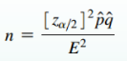Solve E equation for n…
       2. If p hat is known…use p hat (and 1-p hat for q hat)
       3. If p hat is unknown…use p hat=0.5 and q hat=0.5 (results in largest sample size so we are sure n will be adequate
    3. Role of Population size N
       1. Sample size required does not depend on N…but instead the CI & E and estimate of p hat
    4. Better confidence intervals
       1. Disadvantage of Wald CI
          1. Coverage probability – actual proportion of calculated CI’s that contain the true population parameter…if using 95% confidence level to estimate CI then 95% of all calculated CI’s should be in that range…but not the case…usually less
       2. Plus Four Method
          1. Better than Wald…coverage probability closer to confidence level used
          2. Add 2 to number of successes x & add 2 to number of failures (so sample size n increases by total 4)
       3. Wilson Score
          1. Just a more complex equation for E…easy to implement with technology and better coverage probability than Wald
       4. Clopper-Pearson Method
          1. “exact” method based on exact binomial distribution instead of normal approximation of distribution
  1. **7.2 Estimating a Population Mean**
     1. Point estimate – sample mean x bar is best point estimate for population mean m
        1. Unbiased estimator
     2. Estimating Population Mean m use sample mean x bar
        1. Verify requirements…
           1. Simple random sample
           2. Either population is normally distributed OR n>30

Finding CI for population m is robust against departure from normality…so normality requirement is “loose”

Smaller sample sizes are OK if the distribution is close to normal and no outliers

* + - 1. If population standard deviation s IS NOT known…
         1. Use degrees of freedom n-1…then technology or t table to find critical value ta/2
         2. Evaluate margin of error…
      2. If population standard deviation s IS known…
         1. Use standard normal distribution
      3. Use E to construct CI
      4. Round…original set of data values use one more decimal place…if using summary statistics use same number of decimals
    1. Confidence Intervals can be used informally to compare different data sets on a graph…but should not be used for formal conclusions
    2. 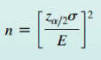For finding required sample size…
       1. Use equation…
       2. If s is not known…
          1. Use range rule of thumb where s = range/4 (using range of sample data set)
          2. Start the sample collection process without knowing s and calculate sample s using first few values
          3. Estimate s by using results of previous studies
    3. Summary
       1. Population s IS NOT known…and requirements verified…use t distribution
       2. Population s IS known…and requirements verified…use normal distribution
       3. Population s IS known…and requirements NOT verified…use bootstrapping or nonparametric
  1. **7.4 Bootstrapping: Using Technology for Estimates**
     1. If requirements for estimating population parameters are not met, we can sometimes use bootstrapping method with technology…
        1. Must be simple random sample…bootstrapping doesn’t correct for bad sampling methods
        2. CI Proportion – np >=5 and nq>=5
        3. CI for Mean = population is normally distributed OR n>30
        4. If these requirements not met then can use bootstrap method (it is one nonparametric method because it doesn’t require normal distribution of data)
     2. Bootstrap sample – given simple random sample of size n, a bootstrap sample is another random sample of n values obtained with replacement from original sample
        1. Find statistic for original sample and each bootstrap sample
        2. Sort the list of statistics from bootstraps…then find corresponding percentile values from list
     3. **8.1 Basics of Hypothesis Testing**
        1. Hypothesis – a claim or statement about a property of a population (in statistics)
           1. “Property of population” is often a population parameter like proportion or mean
        2. Hypothesis test (or significance test) – procedure for testing a claim about a hypothesis
        3. Procedure for Hypothesis test…
           1. ID the claim
           2. Give it in symbolic form
           3. ID Null and Alternative hypotheses (H0 and HA)
           4. Select Significance level a

0.05 is common

* + - * 1. ID test statistic (normal or t distribution)
        2. P value method or Critical value method

P value method

Find value of test statistic & P-value

Reject H0 if P-value <= a … OR …Fail to reject H0 if P-value > a

Critical value method

Find value of test statistic and critical value

Reject H0 if test statistic in critical region

Fail to reject H0 if test statistic not in critical region

* + - * 1. 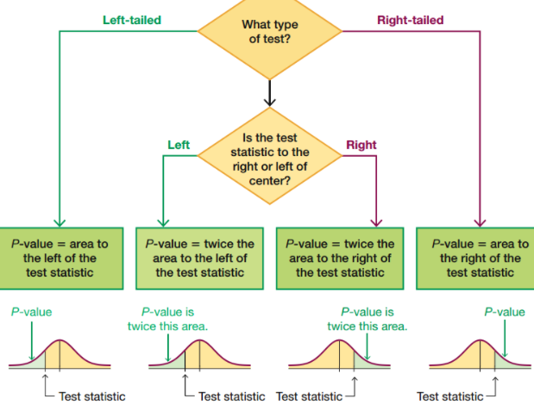Restate decision in nontechnical terms
        2. Can also use Confidence Interval method…
      1. 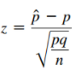Find test statistic for proportion…
      2. Two-tailed, left-tailed, right-tailed tests…
         1. Left-tailed or right-tailed…use P-value
         2. Two-tailed…use 2*P-value
      3. P-values…
         1. Large sample sizes could result in small P-value
         2. Consider confidence level used, practical significance, etc.
         3. If P-value<=a then reject H0
      4. Critical value method
         1. Calculate critical area for confidence level
         2. Calculate test statistic for sample…if it falls in critical region then reject H0
      5. 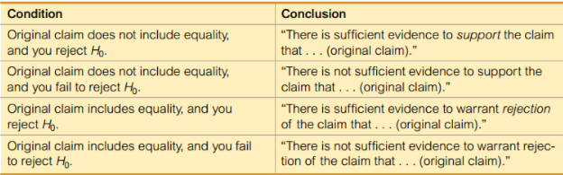Wording of final conclusion…
      6. Errors…
         1. Type I error

Null hypothesis is true, but reject H0

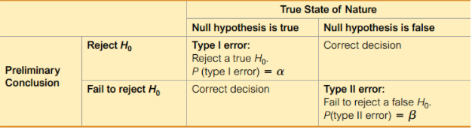Uses symbol a to represent probability of a type I error

* + - * 1. Type II error

Null hypothesis is false, but fail to reject H0

Uses symbol b to represent probability of type ii error

* + - 1. Power of a Hypothesis test
         1. Probability of 1 – b …where b is probability of type II error (failing to reject false H0)
         2. The higher the power…the higher the probability of making a correct conclusion
    1. **8.2 Testing a Claim about a Proportion** 
       1. Normal approximation method
          1. Notation

n = sample size or number of trials

p hat = x/n (sampl proportion)

p = population proportion (p is the value used in the null hypothesis)

q = 1-p

* + - * 1. Requirements

Simple random sample

Binomial distribution

Fixed number of trials

Trials are independent

Each trial has 2 categories - success or failure

Probability of success is independent

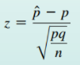n*p >= 5…and…n*q>=5

* + - * 1. Test statistic for a claim about a proportion

Can use P-values or Critical values…

If using CI…might get a different conclusion

* + - 1. Exact binomial distribution method
         1. Instead of normal appoximation can use binomial probability distribution to get exact value
         2. Doesn’t require np >= 5 or nq >= 5
         3. Probability of type 1 error is less than or equal to a

Can use a correction for this

* + 1. **8.3 Testing a Claim about a Mean** 
       1. For the t test…P-value method, critical value method, and CI method are all equivalent in that they should lead to same conclusion
       2. Procedure…
          1. Notation

n = sample size

s = sample standard deviation

x bar = sample mean

mxbar = population mean (value used for null hypothesis)

* + - * 1. Requirements

Simple random sample

Population is normally distributed and/or n>30

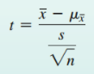Very loose definition here

* + - * 1. Test statistic for testing a claim about a population mean m

Can use P-values or critical values or CI…

* + - * 1. Can use bootstrapping if some requirements not met