Homework 4

Matt Massey

3/12/2022

**Question 1.**

**1A.**

*Type:* Comparative experiment – the experimenter is testing if dog therapy improves (decreases) patient recovery time.

*Factors:* Dog visitation therapy with two levels – either the selected hospital and all of its selected patients receive dog therapy, or they don’t.

*Treatments:* Two treatments of dog visitation therapy – either the selected hospital and all of its selected patients receive dog therapy, or they don’t.

*Experimental Units:* Hospitals – treatments are given to selected hospitals (and all selected patients within that hospital)

*Observational Units:* Patients – the time until hospital discharge is measured for each patient.

**1B.**

*Type:* Observational Study – the researcher is testing if school funding affects student performance.

*Factors:* School funding – each of the 15 schools is presumably receiving different amounts of funding (factor levels).

*Treatments:* School funding – there are 15 different treatments (each of the 15 schools receives different amounts of funding).

*Experimental Units:* Schools – each of the 15 schools receives a different amount of funding.

*Observational Units:* Classes of students – mean test scores of each of the selected 15 classes is measured

**1C.**

*Type:* Comparative experiment – the experimenter is studying the effects of different fertilizers on grain production, and what factors may affect the potency of the fertilizers.

*Factors:* Type of grain (wheat rice, spelt), type of fertilizer (3 different kinds), amount of precipitation (high or low), and temperature (high or low).

*Treatments:* Grain (3 levels), fertilizer (3 levels), precipitation (2 levels), and temperature (2 levels) for a total of 36 treatments.

*Experimental Units:* Greenhouse – the treatments are the same for each greenhouse (same grains, fertilizer, precipitation, temperature).

*Observational Units:* Grain production for each plant variety in each greenhouse – total grain production of each type of plant is measured and compared for each greenhouse.

**Question 2.**

**2A.**

Method 2 is set apart from the other two methods by employing replication. Shirts are grouped into threes, consisting of one shirt from each treatment. There are four simulation runs of each group of shirts/treatments, which serve as replicates of the experiment.

**2B.**

Method 1 does not employ any replication strategy. First, each treatment (press treatment) is applied to only one experimental unit (one group of randomly selected shirts), which does provide blocking for the variation in treatment. However, the simulations are carried out only once for each experimental unit, and hence, there is no replication.

Method 3 also does not employ all the experimental strategies it should. It applies the treatment to multiple experimental units (single shirt rather than group of shirts), and provides no blocking for any possibly variation in the treatment process. However, method 3 uses the same simulation strategy as method 1, which does not replicate the simulations carried out.

**Question 3.**

**3A.**

This experiment is testing the hypothesis that the three teaching methods are not equal. I assume that the response is the difference in performance of each class (either between classes or before/after for each class) based on some kind of test. There is no detail specified on any kind of randomization for the experiment. The current design of the experiment includes no replication, as each treatment (teaching method) is assigned only once. Finally, the experiment does not include any blocking, which could account for the difference in quality of teaching and quality of students.

**3B.**

The experiment would be greatly improved in three main areas. First, the experimenter needs to provide more detail of the experiment (i.e., how the response will be measured, how the treatments will be assigned). Second, the design should include replication. The teaching methods should be replicated, possibly by assigning each teaching method to each teacher. Finally, the design should account for nuisance factors of the quality of the teacher and the quality of the students in each class by using blocking. For example, I would suggest that, (1) each teacher uses all three teaching methods (replication and blocking), (2) the order of teaching methods taught be randomly determined for each teacher, and (3) the performance should be measured based on average class performance before and after each teaching method.

**Question 4.**

**4A.**  
This experiment is testing the effect of nitrogen fertilizer on lettuce production, where nitrogen fertilizer is the explanatory variable and lettuce production is the response variable, and expressed by the general equation:

y*ij* = m*i* + e*ij*

where:

*i* the number of treatments; five rates of ammonium nitrate fertilizer application (0, 50, 100, 150, 200 lbs/acre)

*j* the number of experimental units; number of plots used for each treatment of fertilizer (4 for each treatment)

y*ij* the observed response (lettuce production) for the *jth* experimental unit assigned to the *ith* treatment

m*I* the mean response (lettuce production) for the *ith* treatment

e*ij* the error for the *jth* experimental unit assigned to *ith* treatment; difference between the observed lettuce production in the *jth* experimental unit and the mean lettuce production for *ith* treatment

**4B-D.**

#import packages  
library (ggplot2)

#read data  
lettuce = read.csv("hw4_lettuce-1.csv", header=T)

#define factors  
n = as.factor(lettuce$NITROGEN)

# anova  
lettuce.aov = aov(lettuce$LETTUCE ~ factor(lettuce$NITROGEN))  
summary(lettuce.aov)

## Df Sum Sq Mean Sq F value Pr(>F)   
## factor(lettuce$NITROGEN) 4 4995 1248.7 5.611 0.00576 **  
## Residuals 15 3338 222.5   
## ---  
## Signif. codes: 0 '***' 0.001 '**' 0.01 '*' 0.05 '.' 0.1 ' ' 1

#fit model & find means of treatments  
model = lm(LETTUCE~n-1,data=lettuce)  
summary(model)

##   
## Call:  
## lm(formula = LETTUCE ~ n - 1, data = lettuce)  
##   
## Residuals:  
## Min 1Q Median 3Q Max   
## -22.000 -8.625 0.500 5.125 28.500   
##   
## Coefficients:  
## Estimate Std. Error t value Pr(>|t|)   
## n0 112.000 7.459 15.02 1.91e-10 ***  
## n50 145.500 7.459 19.51 4.53e-12 ***  
## n100 149.000 7.459 19.98 3.21e-12 ***  
## n150 157.500 7.459 21.12 1.43e-12 ***  
## n200 149.000 7.459 19.98 3.21e-12 ***  
## ---  
## Signif. codes: 0 '***' 0.001 '**' 0.01 '*' 0.05 '.' 0.1 ' ' 1  
##   
## Residual standard error: 14.92 on 15 degrees of freedom  
## Multiple R-squared: 0.992, Adjusted R-squared: 0.9893   
## F-statistic: 370 on 5 and 15 DF, p-value: 3.757e-15

# 95% confidence intervals of means of treatments  
confint(model)

## 2.5 % 97.5 %  
## n0 96.102 127.898  
## n50 129.602 161.398  
## n100 133.102 164.898  
## n150 141.602 173.398  
## n200 133.102 164.898

# PLOTS

#plot of data  
ggplot(lettuce, aes(NITROGEN, LETTUCE, colour=factor(NITROGEN))) + geom_point(shape=19, size=2.5, fill="white") +   
   
 labs(x="Nitrogen (pounds / acre)", y = "Lettuce (heads / plot)", title = "Lettuce production vs. Fertilizer application", colour="Treatment\n(N lbs/acre)") +   
   
 theme(text = element_text(size = 15), plot.title=element_text(hjust=0.5, face="bold.italic"), axis.title.x = element_text(face="italic"), axis.title.y = element_text(face="italic"), legend.title = element_text(size=11))

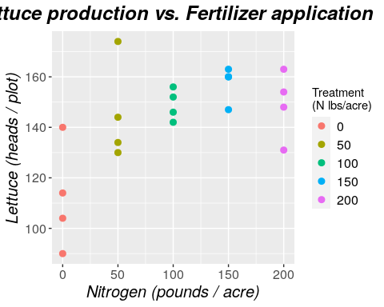

#boxplot of data  
ggplot(lettuce, aes(NITROGEN, LETTUCE, colour=factor(NITROGEN))) +

geom_boxplot() +

labs(x="Nitrogen (pounds / acre)", y = "Lettuce (heads / plot)", title = "Lettuce production vs. Fertilizer application", colour="Treatment\n(N lbs/acre)") +   
   
 theme(text = element_text(size = 15), plot.title=element_text(hjust=0.5, face="bold.italic"), axis.title.x = element_text(face="italic"), axis.title.y = element_text(face="italic"), legend.title = element_text(size=11))

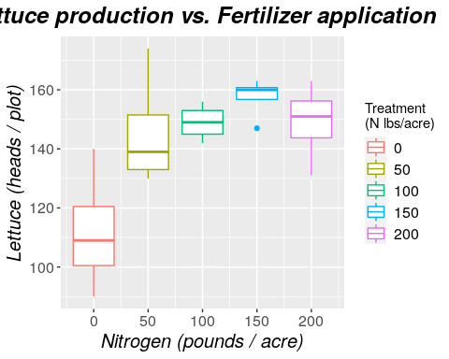

#plot residuals, leverage, normal QQ  
plot(model)

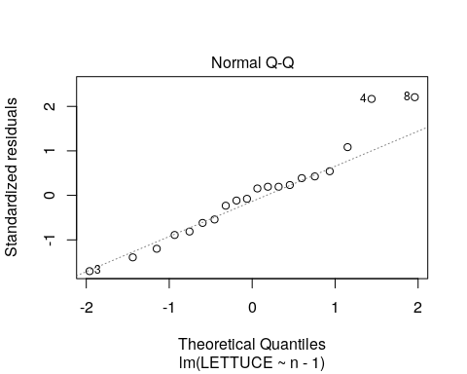

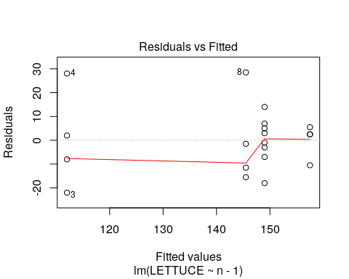

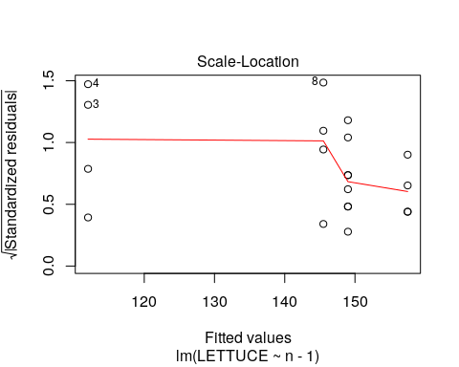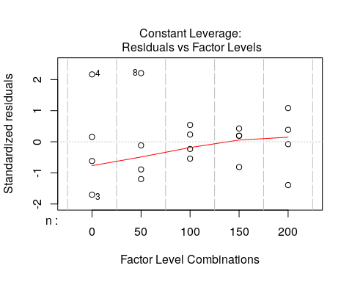

#define residuals and plot normal QQ...again for some reason  
res = model$residuals  
qqnorm(res)  
qqline(res)

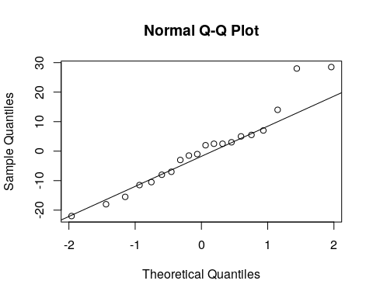

**4B.**

This experiment aims to test the hypothesis that on average, lettuce production increases as the amount of ammonium nitrate fertilizer applied to the lettuce plot increases. To test this hypothesis, we assume a null hypothesis H0: m1=m2=m3=m4=m5, and an alternative hypothesis HA: mj≠mk for some j and k, and a significance level of a=0.05. If the F value is beyond the critical value, and the associated P value is at or below the significance level, we will reject the null hypothesis. Otherwise we will fail to reject the null hypothesis.

The ANOVA for this experiment is shown above, with a model F value of 5.611 and an associated P value of 0.00576. This is well below our significance level of 0.05, and we reject the null hypothesis. We are 95% confident that at least one of the mean responses is significantly different than another mean response

**4C.**

Nitrogen fertilizer 0 lbs/acre: Mean: 112.0 95%CI: 96.102 to 127.898

Nitrogen fertilizer 50 lbs/acre: Mean: 145.5 95%CI: 129.602 to 161.398

Nitrogen fertilizer 100 lbs/acre: Mean: 149.0 95%CI: 133.102 to 164.898

Nitrogen fertilizer 150 lbs/acre: Mean: 157.5 95%CI: 141.602 to 173.398

Nitrogen fertilizer 200 lbs/acre: Mean: 159.0 95%CI: 133.102 to 164.898

For the treatment using 200 pounds of nitrogen fertilizer per acre, the mean response is significantly different than using 0 pounds, but not significantly different than any of the other treatments (50, 100, 150 pounds). We also see that the calculated mean of observed responses of lettuce production for the 200 pound treatment is exactly the same as that for 100 pounds of treatment, as are the confidence intervals. This seems to be due to the two outliers of both treatment groups.

**4D.**

The assumptions for the single factor ANOVA model here are: (1) the errors are normally distributed, (2) the errors have a mean of zero, (3) the errors have constant variance, and (4) the errors are independent.

In this example, the errors are approximately normally distributed as can be seen by the Normal QQ and Residuals vs. Fitted plots above. The errors have a mean of approximately zero, as can be seen by the Residuals vs Fitted plot. The errors have a constant variance as can be seen by the Residuals and Standardized Residuals plots and the IQR of residuals from -8.625 to 5.125. And the errors are independent, as they are not correlated or show any association with each other on any of the plots.

There are a few possible outlier points in the dataset including the highest value of treatment N=50, the lowest value of treatment N=200, and the lowest value of treatment N=150. These points are obvious on the scatter and box plots of the data. However, the Residuals, QQ, and Leverage plots only indicate that N=50 may be an outlier, in addition to the highest value point in treatment N=0 group. The two points from N=0 and N=50 may should be examined further.