assignment5

## Problem 1 (R Output)

setwd("C:/Users/Melissa/Dropbox (Personal)/STA 674/code for homework/Assignment 5")  
library(emmeans)  
pest = read.csv("pesticides.csv", header = T)  
KILLED = pest$Killed/100  
  
# the following specifications are required   
PESTICIDE = as.factor(pest$Pesticide)  
PEST = data.frame(PESTICIDE, KILLED)  
out = lm(KILLED ~ PESTICIDE)  
summary(out)

##   
## Call:  
## lm(formula = KILLED ~ PESTICIDE)  
##   
## Residuals:  
## Min 1Q Median 3Q Max   
## -0.09000 -0.03000 -0.01667 0.01667 0.12000   
##   
## Coefficients:  
## Estimate Std. Error t value Pr(>|t|)   
## (Intercept) 0.46667 0.04047 11.531 4.25e-07 ***  
## PESTICIDE2 0.09333 0.05723 1.631 0.1340   
## PESTICIDE3 0.36333 0.05723 6.348 8.37e-05 ***  
## PESTICIDE4 0.18000 0.05723 3.145 0.0104 *   
## PESTICIDE5 0.37333 0.05723 6.523 6.70e-05 ***  
## ---  
## Signif. codes: 0 '***' 0.001 '**' 0.01 '*' 0.05 '.' 0.1 ' ' 1  
##   
## Residual standard error: 0.0701 on 10 degrees of freedom  
## Multiple R-squared: 0.8688, Adjusted R-squared: 0.8164   
## F-statistic: 16.56 on 4 and 10 DF, p-value: 0.0002075

#lsmeans and confidence interval without correction  
lsmeans(results, "PESTICIDE")

## PESTICIDE lsmean SE df lower.CL upper.CL  
## 1 0.467 0.0405 10 0.376 0.557  
## 2 0.560 0.0405 10 0.470 0.650  
## 3 0.830 0.0405 10 0.740 0.920  
## 4 0.647 0.0405 10 0.556 0.737  
## 5 0.840 0.0405 10 0.750 0.930  
##   
## Confidence level used: 0.95

#lsmeans and confidence interval with Bonferroni correction  
lsmeans(results, "PESTICIDE", level=(1-.05/5))

## PESTICIDE lsmean SE df lower.CL upper.CL  
## 1 0.467 0.0405 10 0.338 0.595  
## 2 0.560 0.0405 10 0.432 0.688  
## 3 0.830 0.0405 10 0.702 0.958  
## 4 0.647 0.0405 10 0.518 0.775  
## 5 0.840 0.0405 10 0.712 0.968  
##   
## Confidence level used: 0.99

## Problem 2 (R Output)

kuehl = read.csv("kuehl_6_6.csv", header = T)  
library(multcomp)

## Loading required package: mvtnorm

## Loading required package: survival

## Loading required package: TH.data

## Loading required package: MASS

##   
## Attaching package: 'TH.data'

## The following object is masked from 'package:MASS':  
##   
## geyser

PROPORTION = as.factor(kuehl$PROPORTION)  
SURFACE = as.factor(kuehl$SURFACE)  
FILLER = as.factor(kuehl$FILLER)  
LOSS = kuehl$LOSS  
KUEHL = data.frame(PROPORTION, SURFACE, FILLER, LOSS)  
  
#ANOVA table  
result.anova = aov(LOSS ~ PROPORTION*SURFACE*FILLER, data=KUEHL)  
summary(result.anova)

## Df Sum Sq Mean Sq F value Pr(>F)   
## PROPORTION 1 5663 5663 19.598 0.002206 **   
## SURFACE 1 12939 12939 44.782 0.000154 ***  
## FILLER 1 3875 3875 13.411 0.006381 **   
## PROPORTION:SURFACE 1 150 150 0.519 0.491634   
## PROPORTION:FILLER 1 3452 3452 11.946 0.008615 **   
## SURFACE:FILLER 1 1743 1743 6.033 0.039556 *   
## PROPORTION:SURFACE:FILLER 1 203 203 0.703 0.426184   
## Residuals 8 2311 289   
## ---  
## Signif. codes: 0 '***' 0.001 '**' 0.01 '*' 0.05 '.' 0.1 ' ' 1

###check assumptions  
  
result_lm = lm(LOSS ~ PROPORTION*SURFACE*FILLER)  
result_rg1 = ref_grid(result_lm)  
#summary(result_lm)  
plot(result_lm)

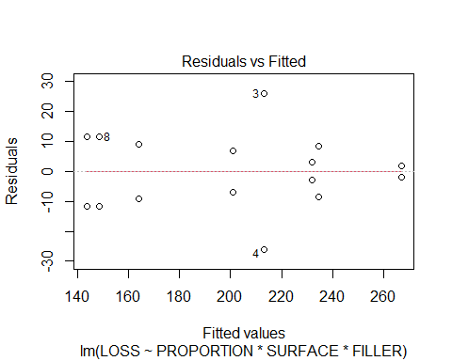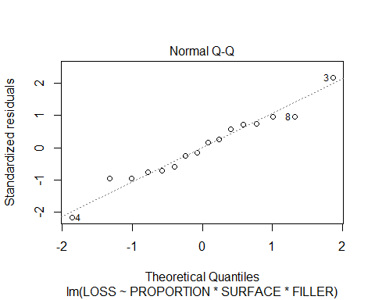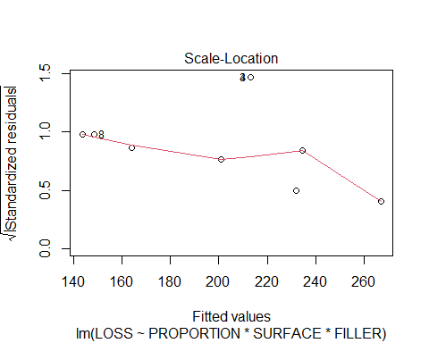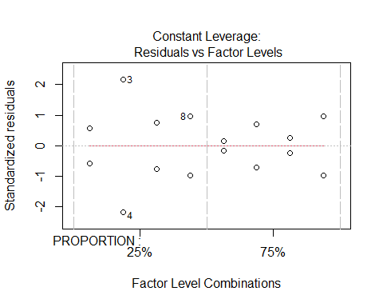

boxplot(LOSS ~ PROPORTION*SURFACE*FILLER)

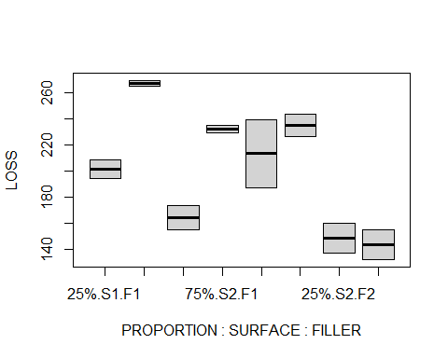

#LSMeans and confidence intervals (the emmean column is LSMeans)  
  
result_emm =emmeans(result_rg1, ~(PROPORTION*SURFACE*FILLER))  
confint(result_emm, level = (1 - 0.05/8))

## PROPORTION SURFACE FILLER emmean SE df lower.CL upper.CL  
## 25% S1 F1 201 12 8 156.8 245  
## 75% S1 F1 267 12 8 222.8 311  
## 25% S2 F1 164 12 8 119.8 208  
## 75% S2 F1 232 12 8 187.8 276  
## 25% S1 F2 213 12 8 168.8 257  
## 75% S1 F2 234 12 8 190.3 279  
## 25% S2 F2 148 12 8 104.3 193  
## 75% S2 F2 144 12 8 99.3 188  
##   
## Confidence level used: 0.99375

**SAS Output**

**Problem 1**

**The GLM Procedure**

| **Class Level Information** | | |
| --- | --- | --- |
| **Class** | **Levels** | **Values** |
| **Pesticide** | 5 | 1 2 3 4 5 |

|  |  |
| --- | --- |
| **Number of Observations Read** | 15 |
| **Number of Observations Used** | 15 |

**The GLM Procedure**

**Dependent Variable: killrate**

| **Source** | **DF** | **Sum of Squares** | **Mean Square** | **F Value** | **Pr > F** |
| --- | --- | --- | --- | --- | --- |
| **Model** | 4 | 0.32544000 | 0.08136000 | 16.56 | 0.0002 |
| **Error** | 10 | 0.04913333 | 0.00491333 |  |  |
| **Corrected Total** | 14 | 0.37457333 |  |  |  |

| **R-Square** | **Coeff Var** | **Root MSE** | **killrate Mean** |
| --- | --- | --- | --- |
| 0.868829 | 10.48283 | 0.070095 | 0.668667 |

| **Source** | **DF** | **Type I SS** | **Mean Square** | **F Value** | **Pr > F** |
| --- | --- | --- | --- | --- | --- |
| **Pesticide** | 4 | 0.32544000 | 0.08136000 | 16.56 | 0.0002 |

| **Source** | **DF** | **Type III SS** | **Mean Square** | **F Value** | **Pr > F** |
| --- | --- | --- | --- | --- | --- |
| **Pesticide** | 4 | 0.32544000 | 0.08136000 | 16.56 | 0.0002 |

**The GLM Procedure**

**Least Squares Means**

| **Pesticide** | **killrate LSMEAN** |
| --- | --- |
| **1** | 0.46666667 |
| **2** | 0.56000000 |
| **3** | 0.83000000 |
| **4** | 0.64666667 |
| **5** | 0.84000000 |

| **Pesticide** | **killrate LSMEAN** | **95% Confidence Limits** | |
| --- | --- | --- | --- |
| **1** | 0.466667 | 0.376495 | 0.556838 |
| **2** | 0.560000 | 0.469828 | 0.650172 |
| **3** | 0.830000 | 0.739828 | 0.920172 |
| **4** | 0.646667 | 0.556495 | 0.736838 |
| **5** | 0.840000 | 0.749828 | 0.930172 |

**The GLM Procedure**

| **Class Level Information** | | |
| --- | --- | --- |
| **Class** | **Levels** | **Values** |
| **Pesticide** | 5 | 1 2 3 4 5 |

|  |  |
| --- | --- |
| **Number of Observations Read** | 15 |
| **Number of Observations Used** | 15 |

**The GLM Procedure**

**Dependent Variable: killrate**

| **Source** | **DF** | **Sum of Squares** | **Mean Square** | **F Value** | **Pr > F** |
| --- | --- | --- | --- | --- | --- |
| **Model** | 4 | 0.32544000 | 0.08136000 | 16.56 | 0.0002 |
| **Error** | 10 | 0.04913333 | 0.00491333 |  |  |
| **Corrected Total** | 14 | 0.37457333 |  |  |  |

| **R-Square** | **Coeff Var** | **Root MSE** | **killrate Mean** |
| --- | --- | --- | --- |
| 0.868829 | 10.48283 | 0.070095 | 0.668667 |

| **Source** | **DF** | **Type I SS** | **Mean Square** | **F Value** | **Pr > F** |
| --- | --- | --- | --- | --- | --- |
| **Pesticide** | 4 | 0.32544000 | 0.08136000 | 16.56 | 0.0002 |

| **Source** | **DF** | **Type III SS** | **Mean Square** | **F Value** | **Pr > F** |
| --- | --- | --- | --- | --- | --- |
| **Pesticide** | 4 | 0.32544000 | 0.08136000 | 16.56 | 0.0002 |

**The GLM Procedure**

**Least Squares Means**

| **Pesticide** | **killrate LSMEAN** |
| --- | --- |
| **1** | 0.46666667 |
| **2** | 0.56000000 |
| **3** | 0.83000000 |
| **4** | 0.64666667 |
| **5** | 0.84000000 |

| **Pesticide** | **killrate LSMEAN** | **99% Confidence Limits** | |
| --- | --- | --- | --- |
| **1** | 0.466667 | 0.338408 | 0.594925 |
| **2** | 0.560000 | 0.431741 | 0.688259 |
| **3** | 0.830000 | 0.701741 | 0.958259 |
| **4** | 0.646667 | 0.518408 | 0.774925 |
| **5** | 0.840000 | 0.711741 | 0.968259 |

**The GLM Procedure**

| **Class Level Information** | | |
| --- | --- | --- |
| **Class** | **Levels** | **Values** |
| **Pesticide** | 5 | 1 2 3 4 5 |

|  |  |
| --- | --- |
| **Number of Observations Read** | 15 |
| **Number of Observations Used** | 15 |

**The GLM Procedure**

**Dependent Variable: killrate**

| **Source** | **DF** | **Sum of Squares** | **Mean Square** | **F Value** | **Pr > F** |
| --- | --- | --- | --- | --- | --- |
| **Model** | 4 | 0.32544000 | 0.08136000 | 16.56 | 0.0002 |
| **Error** | 10 | 0.04913333 | 0.00491333 |  |  |
| **Corrected Total** | 14 | 0.37457333 |  |  |  |

| **R-Square** | **Coeff Var** | **Root MSE** | **killrate Mean** |
| --- | --- | --- | --- |
| 0.868829 | 10.48283 | 0.070095 | 0.668667 |

| **Source** | **DF** | **Type I SS** | **Mean Square** | **F Value** | **Pr > F** |
| --- | --- | --- | --- | --- | --- |
| **Pesticide** | 4 | 0.32544000 | 0.08136000 | 16.56 | 0.0002 |

| **Source** | **DF** | **Type III SS** | **Mean Square** | **F Value** | **Pr > F** |
| --- | --- | --- | --- | --- | --- |
| **Pesticide** | 4 | 0.32544000 | 0.08136000 | 16.56 | 0.0002 |

**The GLM Procedure**

**Least Squares Means**

**Adjustment for Multiple Comparisons: Tukey**

| **Pesticide** | **killrate LSMEAN** | **LSMEAN Number** |
| --- | --- | --- |
| **1** | 0.46666667 | 1 |
| **2** | 0.56000000 | 2 |
| **3** | 0.83000000 | 3 |
| **4** | 0.64666667 | 4 |
| **5** | 0.84000000 | 5 |

| **Least Squares Means for effect Pesticide Pr > |t| for H0: LSMean(i)=LSMean(j)  Dependent Variable: killrate** | | | | | |
| --- | --- | --- | --- | --- | --- |
| **i/j** | **1** | **2** | **3** | **4** | **5** |
| **1** |  | 0.5121 | 0.0006 | 0.0627 | 0.0005 |
| **2** | 0.5121 |  | 0.0057 | 0.5765 | 0.0044 |
| **3** | 0.0006 | 0.0057 |  | 0.0573 | 0.9998 |
| **4** | 0.0627 | 0.5765 | 0.0573 |  | 0.0437 |
| **5** | 0.0005 | 0.0044 | 0.9998 | 0.0437 |  |

| **Pesticide** | **killrate LSMEAN** | **95% Confidence Limits** | |
| --- | --- | --- | --- |
| **1** | 0.466667 | 0.376495 | 0.556838 |
| **2** | 0.560000 | 0.469828 | 0.650172 |
| **3** | 0.830000 | 0.739828 | 0.920172 |
| **4** | 0.646667 | 0.556495 | 0.736838 |
| **5** | 0.840000 | 0.749828 | 0.930172 |

| **Least Squares Means for Effect Pesticide** | | | | |
| --- | --- | --- | --- | --- |
| **i** | **j** | **Difference Between Means** | **Simultaneous 95% Confidence Limits for LSMean(i)-LSMean(j)** | |
| **1** | **2** | -0.093333 | -0.281688 | 0.095022 |
| **1** | **3** | -0.363333 | -0.551688 | -0.174978 |
| **1** | **4** | -0.180000 | -0.368355 | 0.008355 |
| **1** | **5** | -0.373333 | -0.561688 | -0.184978 |
| **2** | **3** | -0.270000 | -0.458355 | -0.081645 |
| **2** | **4** | -0.086667 | -0.275022 | 0.101688 |
| **2** | **5** | -0.280000 | -0.468355 | -0.091645 |
| **3** | **4** | 0.183333 | -0.005022 | 0.371688 |
| **3** | **5** | -0.010000 | -0.198355 | 0.178355 |
| **4** | **5** | -0.193333 | -0.381688 | -0.004978 |

**SAS OUTPUT**

**Problem 2**

**The GLM Procedure**

| **Class Level Information** | | |
| --- | --- | --- |
| **Class** | **Levels** | **Values** |
| **PROPORTION** | 2 | 25% 75% |
| **SURFACE** | 2 | S1 S2 |
| **FILLER** | 2 | F1 F2 |

|  |  |
| --- | --- |
| **Number of Observations Read** | 16 |
| **Number of Observations Used** | 16 |

**The GLM Procedure**

**Dependent Variable: LOSS**

| **Source** | **DF** | **Sum of Squares** | **Mean Square** | **F Value** | **Pr > F** |
| --- | --- | --- | --- | --- | --- |
| **Model** | 7 | 28024.43750 | 4003.49107 | 13.86 | 0.0007 |
| **Error** | 8 | 2311.50000 | 288.93750 |  |  |
| **Corrected Total** | 15 | 30335.93750 |  |  |  |

| **R-Square** | **Coeff Var** | **Root MSE** | **LOSS Mean** |
| --- | --- | --- | --- |
| 0.923803 | 8.480530 | 16.99816 | 200.4375 |

| **Source** | **DF** | **Type I SS** | **Mean Square** | **F Value** | **Pr > F** |
| --- | --- | --- | --- | --- | --- |
| **PROPORTION** | 1 | 5662.56250 | 5662.56250 | 19.60 | 0.0022 |
| **SURFACE** | 1 | 12939.06250 | 12939.06250 | 44.78 | 0.0002 |
| **PROPORTION*SURFACE** | 1 | 150.06250 | 150.06250 | 0.52 | 0.4916 |
| **FILLER** | 1 | 3875.06250 | 3875.06250 | 13.41 | 0.0064 |
| **PROPORTION*FILLER** | 1 | 3451.56250 | 3451.56250 | 11.95 | 0.0086 |
| **SURFACE*FILLER** | 1 | 1743.06250 | 1743.06250 | 6.03 | 0.0396 |
| **PROPOR*SURFAC*FILLER** | 1 | 203.06250 | 203.06250 | 0.70 | 0.4262 |

| **Source** | **DF** | **Type III SS** | **Mean Square** | **F Value** | **Pr > F** |
| --- | --- | --- | --- | --- | --- |
| **PROPORTION** | 1 | 5662.56250 | 5662.56250 | 19.60 | 0.0022 |
| **SURFACE** | 1 | 12939.06250 | 12939.06250 | 44.78 | 0.0002 |
| **PROPORTION*SURFACE** | 1 | 150.06250 | 150.06250 | 0.52 | 0.4916 |
| **FILLER** | 1 | 3875.06250 | 3875.06250 | 13.41 | 0.0064 |
| **PROPORTION*FILLER** | 1 | 3451.56250 | 3451.56250 | 11.95 | 0.0086 |
| **SURFACE*FILLER** | 1 | 1743.06250 | 1743.06250 | 6.03 | 0.0396 |
| **PROPOR*SURFAC*FILLER** | 1 | 203.06250 | 203.06250 | 0.70 | 0.4262 |

**The GLM Procedure**

**Least Squares Means**

**Adjustment for Multiple Comparisons: Bonferroni**

| **PROPORTION** | **SURFACE** | **FILLER** | **LOSS LSMEAN** | **LSMEAN Number** |
| --- | --- | --- | --- | --- |
| **25%** | **S1** | **F1** | 201.000000 | 1 |
| **25%** | **S1** | **F2** | 213.000000 | 2 |
| **25%** | **S2** | **F1** | 164.000000 | 3 |
| **25%** | **S2** | **F2** | 148.500000 | 4 |
| **75%** | **S1** | **F1** | 267.000000 | 5 |
| **75%** | **S1** | **F2** | 234.500000 | 6 |
| **75%** | **S2** | **F1** | 232.000000 | 7 |
| **75%** | **S2** | **F2** | 143.500000 | 8 |

| **Least Squares Means for effect PROPOR*SURFAC*FILLER Pr > |t| for H0: LSMean(i)=LSMean(j)  Dependent Variable: LOSS** | | | | | | | | |
| --- | --- | --- | --- | --- | --- | --- | --- | --- |
| **i/j** | **1** | **2** | **3** | **4** | **5** | **6** | **7** | **8** |
| **1** |  | 1.0000 | 1.0000 | 0.4178 | 0.1304 | 1.0000 | 1.0000 | 0.2689 |
| **2** | 1.0000 |  | 0.5720 | 0.1478 | 0.3657 | 1.0000 | 1.0000 | 0.0978 |
| **3** | 1.0000 | 0.5720 |  | 1.0000 | 0.0085 | 0.0902 | 0.1105 | 1.0000 |
| **4** | 0.4178 | 0.1478 | 1.0000 |  | 0.0032 | 0.0274 | 0.0329 | 1.0000 |
| **5** | 0.1304 | 0.3657 | 0.0085 | 0.0032 |  | 1.0000 | 1.0000 | 0.0024 |
| **6** | 1.0000 | 1.0000 | 0.0902 | 0.0274 | 1.0000 |  | 1.0000 | 0.0191 |
| **7** | 1.0000 | 1.0000 | 0.1105 | 0.0329 | 1.0000 | 1.0000 |  | 0.0228 |
| **8** | 0.2689 | 0.0978 | 1.0000 | 1.0000 | 0.0024 | 0.0191 | 0.0228 |  |

| **PROPORTION** | **SURFACE** | **FILLER** | **LOSS LSMEAN** | **99.375% Confidence Limits** | |
| --- | --- | --- | --- | --- | --- |
| **25%** | **S1** | **F1** | 201.000000 | 156.809437 | 245.190563 |
| **25%** | **S1** | **F2** | 213.000000 | 168.809437 | 257.190563 |
| **25%** | **S2** | **F1** | 164.000000 | 119.809437 | 208.190563 |
| **25%** | **S2** | **F2** | 148.500000 | 104.309437 | 192.690563 |
| **75%** | **S1** | **F1** | 267.000000 | 222.809437 | 311.190563 |
| **75%** | **S1** | **F2** | 234.500000 | 190.309437 | 278.690563 |
| **75%** | **S2** | **F1** | 232.000000 | 187.809437 | 276.190563 |
| **75%** | **S2** | **F2** | 143.500000 | 99.309437 | 187.690563 |

| **Least Squares Means for Effect PROPOR*SURFAC*FILLER** | | | | |
| --- | --- | --- | --- | --- |
| **i** | **j** | **Difference Between Means** | **Simultaneous 99.375% Confidence Limits for LSMean(i)-LSMean(j)** | |
| **1** | **2** | -12.000000 | -119.752292 | 95.752292 |
| **1** | **3** | 37.000000 | -70.752292 | 144.752292 |
| **1** | **4** | 52.500000 | -55.252292 | 160.252292 |
| **1** | **5** | -66.000000 | -173.752292 | 41.752292 |
| **1** | **6** | -33.500000 | -141.252292 | 74.252292 |
| **1** | **7** | -31.000000 | -138.752292 | 76.752292 |
| **1** | **8** | 57.500000 | -50.252292 | 165.252292 |
| **2** | **3** | 49.000000 | -58.752292 | 156.752292 |
| **2** | **4** | 64.500000 | -43.252292 | 172.252292 |
| **2** | **5** | -54.000000 | -161.752292 | 53.752292 |
| **2** | **6** | -21.500000 | -129.252292 | 86.252292 |
| **2** | **7** | -19.000000 | -126.752292 | 88.752292 |
| **2** | **8** | 69.500000 | -38.252292 | 177.252292 |
| **3** | **4** | 15.500000 | -92.252292 | 123.252292 |
| **3** | **5** | -103.000000 | -210.752292 | 4.752292 |
| **3** | **6** | -70.500000 | -178.252292 | 37.252292 |
| **3** | **7** | -68.000000 | -175.752292 | 39.752292 |
| **3** | **8** | 20.500000 | -87.252292 | 128.252292 |
| **4** | **5** | -118.500000 | -226.252292 | -10.747708 |
| **4** | **6** | -86.000000 | -193.752292 | 21.752292 |
| **4** | **7** | -83.500000 | -191.252292 | 24.252292 |
| **4** | **8** | 5.000000 | -102.752292 | 112.752292 |
| **5** | **6** | 32.500000 | -75.252292 | 140.252292 |
| **5** | **7** | 35.000000 | -72.752292 | 142.752292 |
| **5** | **8** | 123.500000 | 15.747708 | 231.252292 |
| **6** | **7** | 2.500000 | -105.252292 | 110.252292 |
| **6** | **8** | 91.000000 | -16.752292 | 198.752292 |
| **7** | **8** | 88.500000 | -19.252292 | 196.252292 |

| **Obs** | **PROPORTION** | **SURFACE** | **FILLER** | **LOSS** | **resid** |
| --- | --- | --- | --- | --- | --- |
| **1** | 25% | S1 | F1 | 194 | -7.0 |
| **2** | 25% | S1 | F1 | 208 | 7.0 |
| **3** | 25% | S1 | F2 | 239 | 26.0 |
| **4** | 25% | S1 | F2 | 187 | -26.0 |
| **5** | 25% | S2 | F1 | 155 | -9.0 |
| **6** | 25% | S2 | F1 | 173 | 9.0 |
| **7** | 25% | S2 | F2 | 137 | -11.5 |
| **8** | 25% | S2 | F2 | 160 | 11.5 |
| **9** | 75% | S1 | F1 | 265 | -2.0 |
| **10** | 75% | S1 | F1 | 269 | 2.0 |
| **11** | 75% | S1 | F2 | 243 | 8.5 |
| **12** | 75% | S1 | F2 | 226 | -8.5 |
| **13** | 75% | S2 | F1 | 235 | 3.0 |
| **14** | 75% | S2 | F1 | 229 | -3.0 |
| **15** | 75% | S2 | F2 | 155 | 11.5 |
| **16** | 75% | S2 | F2 | 132 | -11.5 |