BANDIT LEVEL 6

GOAL: To find the password for the next level which is stored in a file somewhere under the inhere directory and has all of the following properties:
- human-readable
- 1033 bytes in size
- not executable

COMMANDS USED: ls,cat,cd,find

Enter into the inhere directory using commands ls and cd.Then type ls to see the files in the directory.You will get something like the below shot.

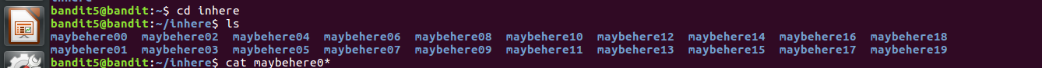

The password is in one of the directories in the inhere directory.It is given that the file is human readable,1033 bytes and non executable.First check the length or the number of files in inhere directory.For this use ls -l .You can see there are 80 files.So checking one by one is a difficult task.
To minimise our effort use the command find.Type find . -size 1033c to see the file of 1033 bytes.It shows that only one file have size of 1033 bytes and that is ./maybehere./file2.Enter into this file using cd and read the content using cat.

PASSWORD: DXjZPULLxYr17uwoI01bNLQbtFemEgo7

