BANDIT LEVEL 8

GOAL: To find the password for the next level which is stored in the file data.txt next to the word millionth

COMMANDS USED: grep,cat

There is a text file data.txt. Our mission is to find the password which is next to the word millionth, so type cat data.txt | grep millionth. It will give you the password.

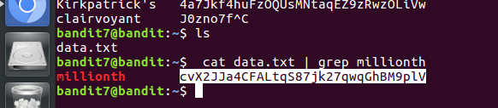

PASSWORD: cvX2JJa4CFALtqS87jk27qwqGhBM9plV

