**Spring 2018 - Vol. 1, Issue 2**

Please share the newsletter with people who may find MassTrack interesting. Subscribe @ [Contact Us](http://listserv.state.ma.us/cttest?url=https%3A//matracking.ehs.state.ma.us/Contact_Us/index.html).

# News and Updates

**Content updates**: An [exposures](https://matracking.ehs.state.ma.us/planning_and_tools/exposures/index.html) page is now available on the MA EPHT website, where you can learn about exposure, different exposure pathways, and how exposure is measured.

**Data Updates:** New data are available for outdoor air quality.

# Featured Topic: Asthma

Spring is in the air and so are many particles that can cause allergies and asthma attacks. According to the Allergy and Asthma Foundation of America (AAFA), Spring is one of the peak seasons for asthma and allergies. The increased output of pollen from trees, grass, and weeds can bring about seasonal allergies and trigger respiratory symptoms in adults and children with asthma. Increased outdoor activity during these warmer months may also mean more exposure to air pollutants such as ozone and particles found in haze, smoke, and dust. Warmer temperatures can also be a time when respiratory irritants (e.g. pollen and mold) are abundant inside the home. Before you head outdoors or start spring cleaning, read on to learn more about asthma and air quality.

**Data Highlights**

## Pediatric Asthma

Asthma remains the most common chronic disease among children in the United States. To learn about the occurrence of asthma over time and across Massachusetts, MDPH’s Bureau of Environmental Health collects information from about 1900 private, public, and charter schools.

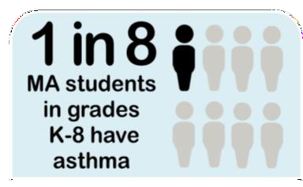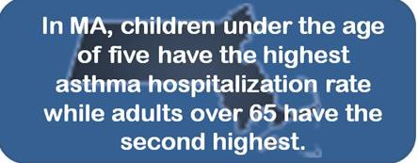

Approximately 85,000 students in grades K-8 have asthma, with data showing that it is 1.4 times more common among boys than girls. Data on pediatric asthma are available on [MA](https://matracking.ehs.state.ma.us/Health-Data/Asthma/pediatric.html) [EPHT](https://matracking.ehs.state.ma.us/Health-Data/Asthma/pediatric.html) by school and by city/town of residence through school year 2014-2015.

## Asthma Hospitalization

Asthma is one of the top seven conditions that contribute to high costs and emergency room expenditures in the Commonwealth. The [Center for Health Information and](https://www.mass.gov/orgs/center-for-health-information-and-analysis) [Analysis](https://www.mass.gov/orgs/center-for-health-information-and-analysis) collects information on all inpatient hospital admissions and emergency department (ED) visits in

Massachusetts. [MA EPHT](https://matracking.ehs.state.ma.us/Health-Data/Asthma/hospitalization.html) analyzes these data and provides asthma hospitalization rates for adults and children.

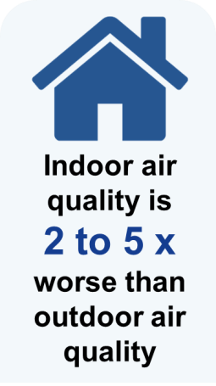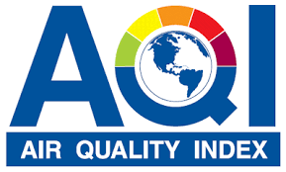

## What are some common respiratory irritants?

Respiratory irritants are substances that can trigger asthma and allergies. Pollen is one common example typically associated with spring, as warmer temperatures and rain helps plants thrive. Other outdoor and indoor pollutants can also play a role in aggravating pre-existing conditions or triggering seasonal allergies:

|  |  |
| --- | --- |
| **Outdoor** | **Indoor** |
| * Particulate Matter (e.g. [Fine Particles](https://matracking.ehs.state.ma.us/Environmental-Data/Air-Quality/Fine_Particles.html)) | * Fine particles like smoke and dust |
| * [Ozone](https://matracking.ehs.state.ma.us/Environmental-Data/Air-Quality/Ground_Level_Ozone.html) | * Pet dander, insect and rodent droppings |
| * Pollutants generated by vehicles and   other combustion sources | * Cleaning supplies, household   chemicals, and pesticides |
| * Molds | * Excess moisture and humidity |

The best way to prevent seasonal allergies or lessen respiratory symptoms from asthma or chronic obstructive pulmonary disease (COPD) is to reduce contact with irritants or triggers when outdoors, and reduce pollutant sources indoors.

## How can I reduce my exposure to outdoor air pollutants?

Outdoor pollutants peak at different seasons, so it is important to know when certain pollutants are at higher levels. For example, ozone is measured from April to September when it is more likely to be created in the environment.

Weather can also change outdoor pollutant levels. Rain can reduce airborne pollen levels, while hot, dry, and windy days may result in higher pollen counts. Lastly, time of day is also a factor in exposure. Pollen counts are usually highest in the morning.

People living near highways and major roads may have greater exposure to vehicle exhaust, especially in the morning when lower wind conditions result in poorer dispersion of these pollutants. Reducing time spent outdoors or walking rather than running when pollutants are high can prevent attacks. The following tips and resources can help reduce the onset of allergies or asthma symptoms:

* [MassAir Online](http://eeaonline.eea.state.ma.us/DEP/MassAir/Pages/MapCurrent.aspx) provides current air quality conditions (AQI), forecasts, as well as conditions for individually monitored pollutants, including particulate matter and ozone.
* [Pollen.com](https://www.pollen.com/) provides current and forecasted reports of allergens that are in the air.
* Avoid exercising near highways and busy roads. Pollutants from vehicles are generally higher within 600 feet of the road.

## How can I reduce my exposure to indoor air pollutants?

Poor indoor environmental quality can be caused by tobacco smoke, cleaning (e.g. dust and chemicals), cooking (e.g. pollutants from gas stoves or fine particles from electric stoves), moisture vapor generated in bathrooms, and dampness from leaks. Food and water sources attract cockroaches and other pests that may trigger asthma symptoms. Outdoor pollutants can drift in through open windows and doors.

Racial redlining and historical housing policies have created areas where there is housing stock that have conditions that can exacerbate asthma symptoms. This housing stock is disproportionately used by communities of color and low resourced families. However, families can work with landlords to improve these conditions by reporting their concerns to local health departments. On the other hand, home ownership provides individuals with opportunities to improve housing conditions, like indoor environmental quality, compared to people who rent.

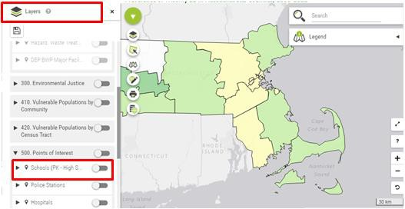

The following tips and resources can help to improve indoor air quality and reduce personal exposures:

* [Wash hands/face, change clothes, and bathe pets](https://www.pollen.com/allergy/allergy-prevention) when you come indoors during pollen season.
* Do not smoke or allow others to [smoke in your home](http://www.mass.gov/eohhs/gov/departments/dph/programs/mtcp/smoke-free-housing.html) or car.
* Close windows during days when pollen levels are high. For homes near [highways](https://www.epa.gov/mobile-source-pollution/how-mobile-source-pollution-affects-your-health), close windows and doors during rush hour to prevent vehicle exhaust from entering the home.
* Excess moisture can lead to mold growth. Use kitchen and bathroom ventilation to remove excess moisture, particulate matter, and odors. A dehumidifier can also be used to reduce humidity. Homeowners should fix leaks to prevent water damage. Renters should contact the landlord to address leaks, dampness, or other [Sanitary Code](https://www.mass.gov/regulations/105-CMR-41000-minimum-standards-of-fitness-for-human-habitation-state-sanitary-code) concerns. If a landlord does not respond to a tenant’s complaints about a Sanitary Code violation, the tenant may request that the [local board of health](http://member.mahb.org/Directory_BOH_Browse.aspx) inspect the apartment.
* Use a wet cloth and a mild soap and water mixture or products with [safer ingredients](https://www.epa.gov/saferchoice/safer-ingredients) to wipe down flat surfaces. Feather-dusting will move dust and dander into the air, which can result in eye and respiratory irritation. Many cleaning products, as well as candles, fragrances, and deodorizers, contain [chemicals](http://www.mass.gov/eohhs/docs/dph/environmental/iaq/fragrances-fact-sheet.pdf) that can aggravate asthma.
* Store food in airtight containers, clean dirty dishes, and sweep up any food. Learn about [methods](https://www.epa.gov/safepestcontrol/pest-control-resources-residents) that remove conditions that attract pests.
* A portable, [stand-alone filtration system](https://www.epa.gov/indoor-air-quality-iaq/residential-air-cleaners-second-edition-summary-available-information) placed at breathing level can be used as an additional measure to reduce indoor pollutants like dust and tobacco smoke.

# MA EPHT Tools and Tips

## Explore Maps in EPHT: Map Layers

Select additional data to overlay on any map by selecting the "Layers" menu within our interactive maps. For example, look at [pediatric asthma](https://matracking.ehs.state.ma.us/Health-Data/Asthma/index.html) rates in your community, and see where local schools are located by adding the "Schools" layer to your map.

View the mapping tool by selecting the "Explore Maps & Tables" button on any health and environmental topic page where data are available.

[MA EPHT Website](https://matracking.ehs.state.ma.us/) | [CDC's National EPHT Program](https://ephtracking.cdc.gov/showHome) | [MDPH Bureau of Environmental Health](http://www.mass.gov/eohhs/gov/departments/dph/programs/environmental-health/)

The MA EPHT website has a host of features that can help you get the health and environmental information you need! To contact us, call **1-617-624-5757** and ask for the "EPHT Coordinator".

Please leave a voicemail if calling after office hours.

[send email to unsubscribe](http://listserv.state.ma.us/content/unsubscribe-dph-ept-newsletter%40listserv.state.ma.us)