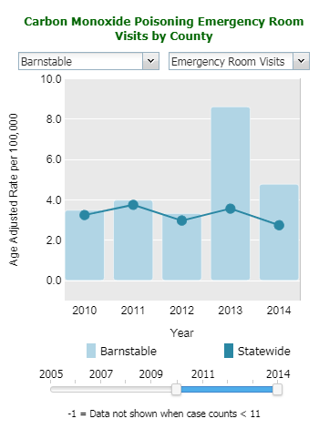

**2019 Vol. 2 Issue 1**

# News and Updates

**Data updates**: New data are available for [reproductive outcomes](https://matracking.ehs.state.ma.us/Health-Data/Reproductive-Outcomes/index.html?utm_source=MassTrack&utm_medium=pdf&utm_campaign=vol5issue1) and [all hospitalization](https://matracking.ehs.state.ma.us/index.html) [datasets](https://matracking.ehs.state.ma.us/index.html).

# Exploring Data on MA Environmental Public Tracking

The Massachusetts Environmental Public Health Tracking (MA EPHT) Program provides health and environmental data to inform decision-making and guide public health actions. Our most recent enhancements improve accessibility to local data through **Interactive Data Widgets**. Our new **Tutorials** have been added to make it easier to use the data on MA EPHT.

## Interactive Data Widgets

We learned from our users that quick, easy access to data is important. In response, MA EPHT recently launched new interactive data widgets that show graphs of health and environmental indicators over time. The widgets compare the selected geography, such as community or county, to the state. Our widgets are embedded into the content pages for the following topic areas:

* [Asthma](https://matracking.ehs.state.ma.us/Health-Data/Asthma/hospitalization.html?utm_source=MassTrack&utm_medium=pdf&utm_campaign=vol5issue1) • [Carbon Monoxide Poisoning](https://matracking.ehs.state.ma.us/Health-Data/Carbon-Monoxide-Poisoning.html?utm_source=MassTrack&utm_medium=pdf&utm_campaign=vol5issue1)
* [COPD](https://matracking.ehs.state.ma.us/Health-Data/copd.html?utm_source=MassTrack&utm_medium=pdf&utm_campaign=vol5issue1) • [Childhood Lead Poisoning](https://matracking.ehs.state.ma.us/Health-Data/Childhood_Blood_Lead_Levels.html?utm_source=MassTrack&utm_medium=pdf&utm_campaign=vol5issue1)
* [Heat Stress](https://matracking.ehs.state.ma.us/Health-Data/heat-stress-hospitalization.html?utm_source=MassTrack&utm_medium=pdf&utm_campaign=vol5issue1) • [Heart Attack](https://matracking.ehs.state.ma.us/Health-Data/Heart_Attack_Hospitalization.html?utm_source=MassTrack&utm_medium=pdf&utm_campaign=vol5issue1)
* [Outdoor Air Quality](https://matracking.ehs.state.ma.us/Environmental-Data/Air-Quality/index.html?utm_source=MassTrack&utm_medium=pdf&utm_campaign=vol5issue1) • [Pediatric Asthma](https://matracking.ehs.state.ma.us/Health-Data/Asthma/pediatric.html?utm_source=MassTrack&utm_medium=pdf&utm_campaign=vol5issue1)
* [Pediatric Diabetes](https://matracking.ehs.state.ma.us/Health-Data/diabetes-pediatric.html?utm_source=MassTrack&utm_medium=pdf&utm_campaign=vol5issue1)

The widgets provide a summary of data; however, you can click the “Explore Maps and Tables” button to examine the data in depth.

## Tutorials

The recently added **Tutorials** guide you through the process of running a query to make tables, charts, and maps of environmental and health data for your community.

Each tutorial provides a brief overview of the following:

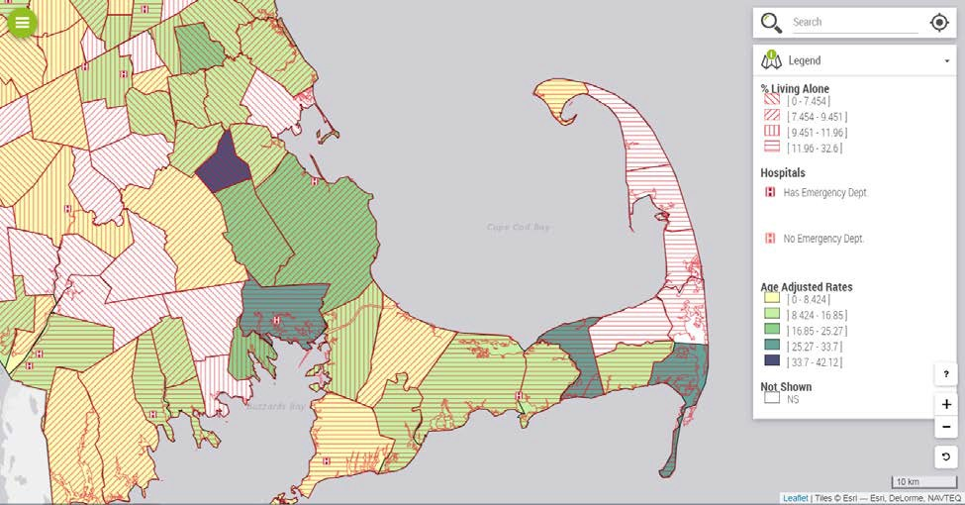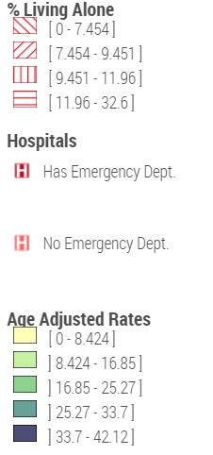

|  |  |
| --- | --- |
| * [Running a query](https://matracking.ehs.state.ma.us/tutorials/running-a-query.html?utm_source=MassTrack&utm_medium=pdf&utm_campaign=vol5issue1) | * [Finding a dataset](https://matracking.ehs.state.ma.us/tutorials/finding-a-dataset.html?utm_source=MassTrack&utm_medium=pdf&utm_campaign=vol5issue1) |
| * [Mapping: advanced settings](https://matracking.ehs.state.ma.us/tutorials/mapping-advanced-settings.html?utm_source=MassTrack&utm_medium=pdf&utm_campaign=vol5issue1) | * [Mapping: key features](https://matracking.ehs.state.ma.us/tutorials/mapping-key-features.html?utm_source=MassTrack&utm_medium=pdf&utm_campaign=vol5issue1) |
| * [Tables](https://matracking.ehs.state.ma.us/tutorials/tables.html?utm_source=MassTrack&utm_medium=pdf&utm_campaign=vol5issue1) | * [Mapping: finding you address](https://matracking.ehs.state.ma.us/tutorials/mapping-finding-your-address.html?utm_source=MassTrack&utm_medium=pdf&utm_campaign=vol5issue1) |

Using these tutorials, you can create customized maps to identify at-risk populations and explore environmental exposures. For example, we know that weather-related events drive the use of alternate power and heat sources (e.g., power generators, fireplaces) that can lead to carbon monoxide poisoning. The map below shows non-fire related emergency department visits for carbon monoxide poisoning. It also shows hospital locations and communities with more individuals living alone. Together, this information identifies communities with populations that may be especially vulnerable to carbon monoxide poisonings during cold weather or power outages. Using this information, local health departments can develop targeted prevention activities to reduce risks from carbon monoxide poisoning. Annual flyers can remind residents to test their carbon monoxide detectors, inspect their chimneys and clean flues before using the fireplace, and conduct wellness checks of neighbors living alone during storms.

To learn more, select the green and white [Tutorials](https://matracking.ehs.state.ma.us/tutorials/howtouse.html?utm_source=MassTrack&utm_medium=pdf&utm_campaign=vol5issue1) button located at the top of each page.

|  |
| --- |
| [MA EPHT Website](http://listserv.state.ma.us/t/720086/34061878/23/12/) | [CDC's National EPHT Program](http://listserv.state.ma.us/t/720086/34061878/24/13/) | [MDPH Bureau of Environmental Health](http://listserv.state.ma.us/t/720086/34061878/25/14/) |
| The MA EPHT website has a host of features that can help you get the health and environmental information you need! If your organization is interested in scheduling a **live demonstration** of the MA EPHT website, contact us at **1-617-624-5757** and ask for  the "EPHT Coordinator". Please leave a voicemail if calling after office hours. |
| unsubscribe from this list | update subscription preferences | view email in browser |