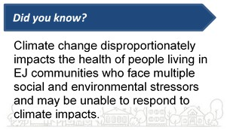

**A Newsletter of the Massachusetts Department of Public Health Bureau of Environmental Health**

**Environmental Public Health Tracking Program 2020 Volume 3, Issue 1**

# News and Updates

**Content Update**:

* Check out our new [radon fact sheets](https://matracking.ehs.state.ma.us/Environmental-Data/radon/?utm_source=MassTrack&utm_medium=email&utm_campaign=vol3issue1), designed to help [residents](https://matracking.ehs.state.ma.us/Environmental-Data/radon/pdfs/RadonHomes_Final.pdf?utm_source=MassTrack&utm_medium=email&utm_campaign=vol3issue1), [school administrators](https://matracking.ehs.state.ma.us/Environmental-Data/radon/pdfs/RadonSchoolsChildCarePrograms_Final.pdf?utm_source=MassTrack&utm_medium=email&utm_campaign=vol3issue1), and [healthcare professionals](https://matracking.ehs.state.ma.us/Environmental-Data/radon/pdfs/RadonHealthcareProviders_Final.pdf?utm_source=MassTrack&utm_medium=email&utm_campaign=vol3issue1) learn more about [testing for radon](https://matracking.ehs.state.ma.us/Environmental-Data/radon/pdfs/RadonTesting_Final.pdf?utm_source=MassTrack&utm_medium=email&utm_campaign=vol3issue1), [fixing radon problems](https://matracking.ehs.state.ma.us/Environmental-Data/radon/pdfs/RadonFixing_Final.pdf?utm_source=MassTrack&utm_medium=email&utm_campaign=vol3issue1), and [preventing radon-induced lung cancer.](https://www.mass.gov/service-details/radon-get-the-facts?utm_source=MassTrack&utm_medium=email&utm_campaign=vol3issue1)
* Use our new [Healthy Home Guide](https://matracking.ehs.state.ma.us/planning_and_tools/healthy-home/MDPH_healthy-home-guide_Final.pdf?b_action=cognosViewer&ui.action=run&ui.object=%2Fcontent%2Ffolder%5B%40name%3D%27MEPHTN%27%5D%2Ffolder%5B%40name%3D%27dph%27%5D%2Freport%5B%40name%3D%27Emergency%20Preparedness%20Planning%20Tool%27%5D&ui.name=Emergency%20Preparedness%20Planning%20Tool&run.outputFormat&run.prompt=true&cv.header=false&cv.toolbar=false&utm_source=MassTrack&utm_medium=email&utm_campaign=vol3issue1) as a resource for homeowners, homebuyers, and renters to understand potential exposures in and around their home.

**Data Update:** New data are available for:

* [Rainfall and Temperature](https://cognos10.hhs.state.ma.us/cv10pub/cgi-bin/cognosisapi.dll?b_action=cognosViewer&ui.action=run&ui.object=%2Fcontent%2Ffolder%5B%40name%3D%27MEPHTN%27%5D%2Ffolder%5B%40name%3D%27Community%27%5D%2Freport%5B%40name%3D%27community-profile%27%5D&ui.name=community-profile&run.outputFormat&run.prompt=true&cv.header=false&cv.toolbar=false&utm_source=MassTrack&utm_medium=email&utm_campaign=Vol3Issue1) projections at the city/town level for 2030-2070 in the Community Profile
* [Recreational Fresh and Marine Beach Water Quality](https://cognos10.hhs.state.ma.us/cv10pub/cgi-bin/cognosisapi.dll?b_action=cognosViewer&ui.action=run&ui.object=%2Fcontent%2Ffolder%5B%40name%3D%27MEPHTN%27%5D%2Ffolder%5B%40name%3D%27environmental%27%5D%2Freport%5B%40name%3D%27water-body-testing%27%5D&ui.name=water-body-testing&run.outputFormat&run.prompt=true&cv.header=false&cv.toolbar=false&utm_source=MassTrack&utm_medium=email&utm_campaign=Vol3Issue1) data from 2002-2018
* [Climate Change Vulnerability](https://matracking.ehs.state.ma.us/Climate-Change/index.html?utm_source=MassTrack&utm_medium=email&utm_campaign=vol3issue1) mapping layers updated to 2016
* [Hospitalization datasets](https://cognos10.hhs.state.ma.us/cv10pub/cgi-bin/cognosisapi.dll?b_action=cognosViewer&ui.action=run&ui.object=%2Fcontent%2Ffolder%5B%40name%3D%27MEPHTN%27%5D%2Ffolder%5B%40name%3D%27health%27%5D%2Freport%5B%40name%3D%27hospitalization%27%5D&ui.name=hospitalization&run.outputFormat&run.prompt=true&cv.header=false&cv.toolbar=false&utm_source=MassTrack&utm_medium=email&utm_campaign=vol3issue1) updated to 2016

# Featured Topic: Climate-Enhanced Community Profiles

**The Massachusetts Environmental Public Health Tracking (MA EPHT) Program recently released version 2.0 of its popular** [**Community Profiles**](https://cognos10.hhs.state.ma.us/cv10pub/cgi-bin/cognosisapi.dll?b_action=cognosViewer&ui.action=run&ui.object=%2Fcontent%2Ffolder%5B%40name%3D%27MEPHTN%27%5D%2Ffolder%5B%40name%3D%27Community%27%5D%2Freport%5B%40name%3D%27community-profile%27%5D&ui.name=community-profile&run.outputFormat&run.prompt=true&cv.header=false&cv.toolbar=false&utm_source=MassTrack&utm_medium=email&utm_campaign=vol3issue1)**.** This new version includes more climate change- related measures as well as important resources and information about climate adaption strategies.

Our Community Profiles provide a snapshot of locally tailored environmental health, sociodemographic, and climate change data for each of Massachusetts' 351 communities. They are linked to our EPHT database to include up-to-date health and environmental indicators. Profiles can be used to guide public health actions, identify priority groups, and shape policy decisions.

The [**Community Profiles**](https://cognos10.hhs.state.ma.us/cv10pub/cgi-bin/cognosisapi.dll?b_action=cognosViewer&ui.action=run&ui.object=%2Fcontent%2Ffolder%5B%40name%3D%27MEPHTN%27%5D%2Ffolder%5B%40name%3D%27Community%27%5D%2Freport%5B%40name%3D%27community-profile%27%5D&ui.name=community-profile&run.outputFormat&run.prompt=true&cv.header=false&cv.toolbar=false&utm_source=MassTrack&utm_medium=email&utm_campaign=vol3issue1)are subdivided into the following topic areas:

**Population:** The profiles contain key demographic and social determinants of health data related to age, disabilities, income, poverty, race, ethnicity, English language proficiency, and educational attainment. They highlight the Massachusetts Executive Office of Energy and Environmental Affairs Environmental Justice (EJ) communities and contextualize the importance of EJ in public health planning. Climate-related messaging explains how these populations are vulnerable to the effects of climate change.

**Health:** Lead poisoning, heart attack and asthma hospitalizations, and pediatric asthma data are included. When possible, health data are stratified by gender and compared to state rates.

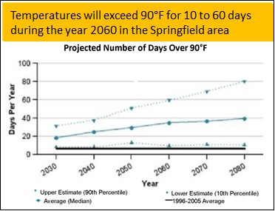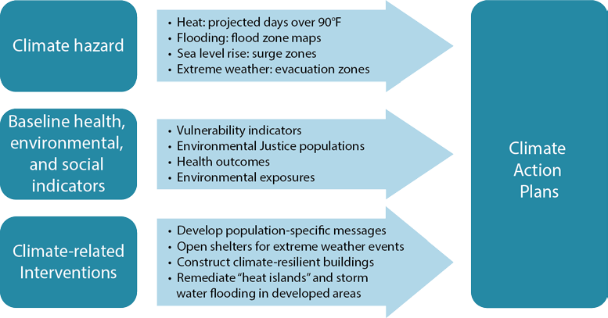

**Environment:** Environmental data include air quality indicators for fine particles and ozone, as well as water quality data for a community’s public water system. The profile highlights how changing weather patterns may increase air pollution and how climate-related flooding may impact drinking water.

**Climate Change:** This section shows how data can help a community plan for these changes, and provides additional resources for climate adaptation planning.

Climate change is increasing the number of very hot days, and hot days increase the risk of hospital visits for people with chronic conditions including lung, heart, vascular, and kidney diseases. Some medications can also impair the body’s ability to cool itself.

Click [**here**](https://cognos10.hhs.state.ma.us/cv10pub/cgi-bin/cognosisapi.dll?b_action=cognosViewer&ui.action=run&ui.object=%2Fcontent%2Ffolder%5B%40name%3D%27MEPHTN%27%5D%2Ffolder%5B%40name%3D%27Community%27%5D%2Freport%5B%40name%3D%27community-profile%27%5D&ui.name=community-profile&run.outputFormat&run.prompt=true&cv.header=false&cv.toolbar=false&utm_source=MassTrack&utm_medium=email&utm_campaign=vol3issue1)to explore the MA EPHT Community Profiles.

# Data for Climate Action Plans

The MA EPHT website has the tools you need to assess baseline health and environmental conditions in your community. Click the explore maps & tables button to get started. Use [advanced settings](https://matracking.ehs.state.ma.us/tutorials/mapping-advanced-settings.html?utm_source=MassTrack&utm_medium=email&utm_campaign=vol3issue1) within the map view to add feature layers that can be concurrently displayed with health data. For example, [MassTrack volume 2](https://matracking.ehs.state.ma.us/newsletter/masstrack_vol_2_issue_1.html?utm_source=MassTrack&utm_medium=email&utm_campaign=vol3issue1) [issue 1](https://matracking.ehs.state.ma.us/newsletter/masstrack_vol_2_issue_1.html?utm_source=MassTrack&utm_medium=email&utm_campaign=vol3issue1) provides a tutorial to view rates of carbon monoxide poisoning within populations that are most vulnerable to climate

change hazards. Together, these data sets can be used to identify communities with populations that may be especially vulnerable to carbon monoxide poisonings during cold weather or power outages. Take a look at the [tutorials](https://matracking.ehs.state.ma.us/tutorials/howtouse.html?utm_source=MassTrack&utm_medium=email&utm_campaign=vol3issue1) for step-by-step instructions to help you explore our data – data that help a community plan for climate-related interventions.

[MA EPHT Website](https://matracking.ehs.state.ma.us/?utm_source=MassTrack) | [CDC’s National EPHT Program](https://ephtracking.cdc.gov/) | [MDPH Bureau of Environmental Health](https://www.mass.gov/orgs/bureau-of-environmental-health/?utm_source=MassTrack)

The MA EPHT website has many features that can help you get the health and environmental information you need. To contact us, call **1-617-624-5757** and ask for the "EPHT Coordinator".

*This work is partially supported by the Environmental Public Health Tracking Network Cooperative Agreement (CDC-RFA-EH17-1702) and the Climate and Health Cooperative Agreement (5 NUE1EH001322-04) to the Massachusetts Department of Public Health by the U.S. Centers for Disease Control and Prevention. The content of this publication does not necessarily reflect the official views of the Centers for Disease Control and Prevention of the Department of Health and Human Services.*

[unsubscribe from this list](mailto:unsubscribe-dph-ept-newsletter@listserv.state.ma.us) | [view email in browser](https://matracking.ehs.state.ma.us/newsletter/masstrack_vol_3_issue_1.html?utm_source=MassTrack&utm_medium=email&utm_campaign=vol3issue1)