Instructions for Using the MA-EPHT Cancer Rates Map

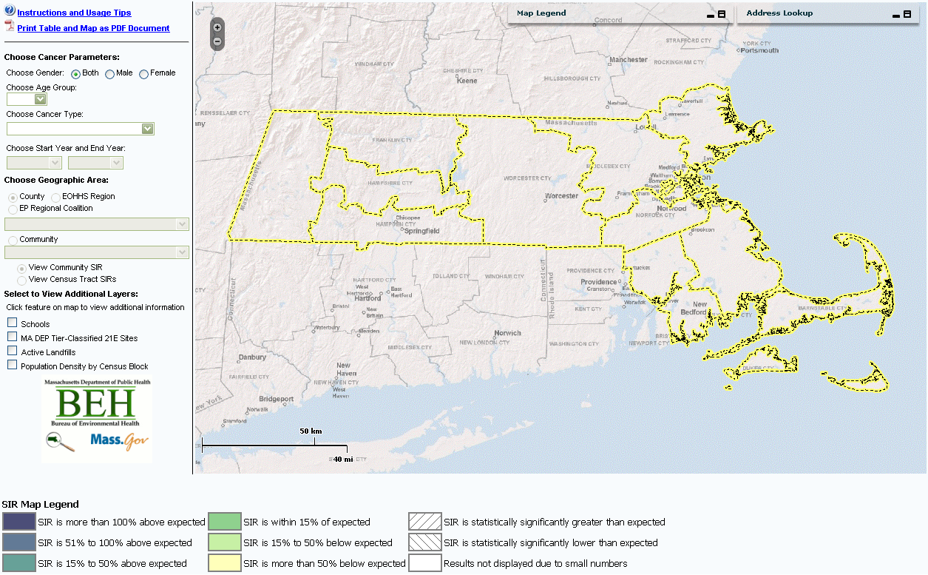
Screen shot of the cancer rates map report page. Note: the layout will vary slightly between web browsers.
Table of Contents

Elements of the Report Page

Selecting Cancer Parameters

Navigating Within the Map Viewer

General Notes
Elements of the Report Page

Cancer Parameters: Where query variables are selected by the user.

Map Viewer: Displays query results on an interactive map.
SIR Map Legend: Depicts symbology for SIR calculation results.

Map Controls: Allows user to toggle additional map features on and off.
Selecting Cancer Parameters

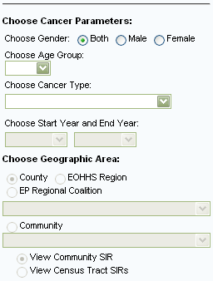

- Select gender, either Both, Male, or Female.

- Select an Age Group from the drop down menu, ‘0 - 85 +’ or ‘0 - 19’.

- Choose a single Cancer Type from the drop down menu.

- Choose a Start and End Year, from ‘2000’ – ‘2004’

- Select a Geographic Area. Selecting the‘County’, ‘EOHHS Region’, or ‘EP Regional Coalition’ radial button will display the boundaries of the selected Geographic Area on the map. The drop down menu will update to contain the choices for which ever ‘Geographic Area’ is selected. Once a ‘Geographic Area’ is selected the ‘Community’ drop down menu will update to contain all the communities within the selected region.

- If the ‘Community’ radial button is selected the drop down menu will contain an alphabetical list of all 351 Massachusetts cities and towns. Typing the first letter of a community’s name will scroll the list to that letter.

Once a Geographic Area is selected the map will zoom to the selected area and calculate a Standardized Incidence Ratio (SIR) based on the selected Cancer Parameters. The ‘SIR Map Legend’ explains what the map colors represent. The colors are based on the calculated SIR’s relationship to the expected results. The query parameters and results are also displayed in a table below the map. SIRs can be calculated for only one geographic area at a time. Changing any of the Cancer Parameters or Geographic Areas will redraw the map and recalculate the SIR based on the new selections.

If a County, EOHHS Region, or EP Regional Coalition is selected the map will zoom to that selected area and display the communities within that area. Double clicking on a community within that area will zoom the map to the community and recalculate an SIR for that community based on the selected Cancer Parameters.

If ‘View Census Tract SIRs’ is clicked while a community is selected, the map will display the census tracts for the selected community, and the SIRs based on the currently selected Cancer Parameters. Clicking ‘View Community SIR’ will then display the SIR at the community level, and the census tract boundaries will no longer be displayed in the map.

Navigating Within the Map Viewer

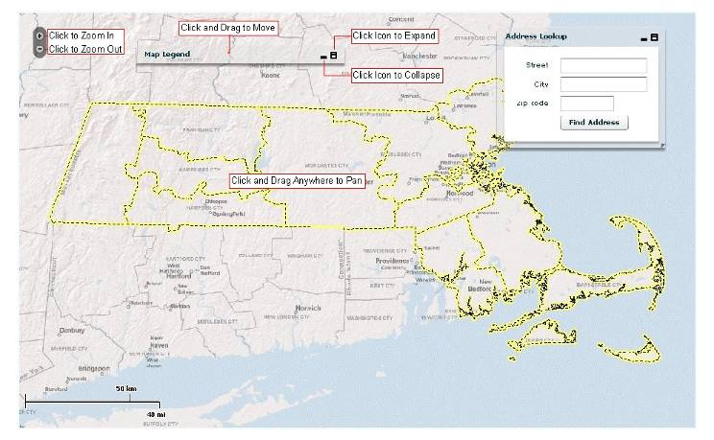
The map viewer is a dynamic environment, designed to be an interactive experience, and the map can be explored without choosing Cancer Parameters. Clicking the ‘+’ or ‘-‘ icon zooms the map in or out, and the map can be paned by clicking on any point and dragging the mouse. Both the ‘Map Legend’ and ‘Address Lookup’ boxes can be moved by clicking along the top of the box and dragging the mouse. Both boxes can be expanded or collapsed by clicking on the small icons in the top right corner.

Once Cancer Parameters have been entered the Address Lookup box can be used. Enter a valid Massachusetts street address into the ‘Street’ field, and either a ‘City’ or ‘Zip Code’, and then click ‘Find Address’ to zoom to that address and calculate an SIR for that community based on the selected Cancer Parameters.

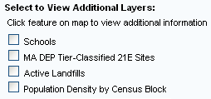
Additional map layers can be turned on and off. Clicking the check box next to the layer name toggles the layer on or off. These layers may be toggled on or off at any time.

Clicking on a School, 21E Site, or Landfill on the map will pop-up a small window containing some additional information on that feature. Click the ‘X’ in the pop-up to close.
General Notes

Holding the mouse over certain features will display information about the feature. Once an SIR has been calculated based on the selected Cancer Parameters and Geographic Area, holding the mouse over a Community or Census Tract will display the name and SIR for that Community or Tract. If the Address Locator was used to locate a point on the map, holding the mouse over the point will display the address of the point. If additional map layers are turned on this information will not display.

The map will update before the table, so there may be a slight delay between updates to the map and updates to the table.

Footnotes below the table contain links to metadata and more general information on cancer.

Clicking on any of the Geographic Area radial buttons (County, EOHHS Region, EP Regional Coalition, or Community) will zoom the map out to show the entire Commonwealth.

The performance of the dynamic map viewer can be impacted by heavy internet network activity. If the report becomes unresponsive or seems frozen it may be necessary to close the window and reopen the report.

- For definitions, maps, and a community look up table please see the glossary for County, EOHHS Region, or EP Regional Coalition.
- For more information on the Standardized Incidence Ratio (SIR) calculation please see the glossary.
Additional map layers are not viewable at all zoom levels; if a layer is checked on and not visible it is necessary to zoom in.

