Vocabulary List  
Lesson Two  
Are you familiar with these terms? After having tried to understand them from context, use a monolingual dictionary to help you out.  
  
Task 3, Paragraph 1  
lion’s share  
  
Task 3, Paragraph 2  
growth spurts  
military might

Task 4, Paragraph 2  
flick of a switch  
cope

Task 4, Paragraph 3  
aprons  
grief  
foul-mouthed

Task 4, Paragraph 4   
building code violation  
multiple-unit dwellings  
sagging roofs

Task 4, Paragraph 5  
strolled into  
hair-raising newsreel  
pawnshop

Task 4, Paragraph 6  
chunky legs  
wiry body  
impish

Task 4, Paragraph 8  
ailerons  
flaps  
slats  
*I thought this image would help!*

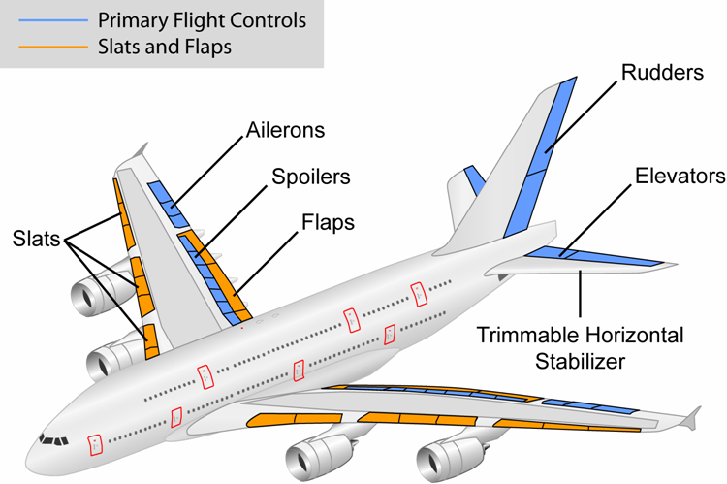

Task 4, Paragraph 9  
grinding  
rumbling  
whirring  
winnower

Here is an explanation of a winnower. (http://candy.about.com/od/candyfactoriesstores/ss/sb_choc_made_5.htm)

|  |
| --- |
| After roasting, the beans are transferred to a “winnower” that removes the shells of the beans and leaves the “nibs”—the essence of the cocoa bean that’s full of cocoa solids and cocoa butter. The beans are first cracked open, then vibrated and set over a series of screens that have progressively smaller openings, so the larger pieces of shell and debris are removed, while the nibs are collected for the next step in the process. |

Task 4, Paragraph 10  
shed  
streaked  
spires