Introduction

Unlike systems in the real world, LCA models usually scale linearly (REF). This may not be an issue for systems where the marginal and average material and energy requirements per unit of function are similar. For example, the amount of coal and related CO2 emissions to produce the first and the last kilowatt-hour of electricity of a power plant are generally similar (REF). For that reason, the environmental burden of ten kilowatt-hour of electricity from that coal-fired power plant will be similar to ten times the environmental burden of one kilowatt-hour from that same power plant (REF). But other systems behave differently. It is notably the case with renewable energy systems, where the initial environmental burden of manufacture spreads as the load factor of the plant increases (REF), or with emerging technologies, where a massive increase in production volumes lead to reduction in the environmental burden thanks to economies of scale and technological learning (REF).

It is also the case for transport systems, and in particular, the transport of goods. In this example, the non-linear relation between the environmental burden per ton-km of transport and the cargo mass and trip distance is shown using a parametrized model for heavy goods vehicle.

Method

The parametrized LCA model for heavy goods vehicles *carculator_truck* (REF) is used for this example. The tool models trucks of various powertrain types (i.e., internal combustion engine, battery electric, fuel cell, etc.), sizes (i.e., from 3.5 to 60 tons of gross weight) across time (i.e., from 2000 to 2050), for different application contexts (i.e., urban, regional and long haul). The reader should refer to the online documentation as well as (REF) for a detailed description of data sources and modeling assumptions.

A first exercise attempts to highlight the non-linear relation between the capacity utilization rate of a truck and its GHG emission per ton-kilometer. To do that, a 40-ton articulated curtainside truck with a diesel engine is modeled with a capacity utilization rate ranging from 0 to 100% with 1% increment step.

For each iteration, the vehicle components and drivetrain are sized, after which the tank-to-wheel energy consumption of the vehicle is calculated given a specific driving cycle. In this case, the driving cycle chosen corresponds to long haul operations. The tank-to-wheel energy consumption would entail the energy needed to overcome different sources of resistance, such as the inertia of the vehicle itself, the rolling resistance, the aerodynamic drag, the road gradient, but also resistance in the transmission shaft and the engine. The curb mass of the vehicle is obtained as being the sum of the components mass, excluding passengers and cargo. The maximum payload is the difference between the maximum gross weight allowed (40 tons) and the curb mass. Finally, the cargo mass is calculated as the fraction of the maximum payload actually used (the capacity utilization rate). When the vehicle is “built”, its material and energy inventory is solved. Such inventory contains all the relevant life cycle phases of the vehicle, including its manufacture, maintenance, use and end-of-life.

A second exercise attempts to demonstrate the non-linear relation between the distance a truck is required to drive without refueling and its GHG emissions per ton-kilometer. A similar approach to the first exercise is adopted, using a 40-ton articulated truck power instead by an electric powertrain. In this case, the energy storage is sized based on the tank-to-wheel energy consumption of the vehicle on one end, and the range the vehicle is required to operate without recharging on the other end. It is worth noting that in the case of electric powertrains, a part of the energy used for braking (during downhill or decelerating sections of the driving cycle) is recovered using the electric motor. The energy storage is modeled using lithium-ion batteries using a nickel manganese cobalt chemistry, with a battery cell energy density of approximately 0.2 kWh per kg of cell. The additional mass of the energy storage components reduce the maximum payload available by an equivalent amount. Material and energy inventories are solved for a required vehicle range of 100 to 1,600 km, by increment step of 100 km.

For both exercises, the inventories between each iteration are characterized against the midpoint indicator Global Warming Potential (REF). The scores for this indicator are normalized to a ton-kilometer by dividing the overall burden successively by the amount of kilometers driven along the use phase and the cargo mass transported.

Results

As expected, total GHG emissions increase as the utilization rate of the available payload increases. As shown in the left plot of Figure 1, this corresponds to the minimum emission of 1 million kg of CO2-eq. for an empty vehicle, to 1.6 million kg of CO2-eq. for a utilization rate of 100% (i.e., the transport of 24 tons of cargo). On a per ton-km basis, the first ton transported has a GWP score of 2.9 kg CO2-eq., against 0.062 for the 24th ton, as shown in the middle plot of the same figure. Hence, the assumed initial capacity utilization rate is important in determining the environmental burden of a ton transported over one kilometer.

Similarly, it appears clear that transporting 10 tons of cargo (which correspond to a utilization rate of about 40%) yield a different result than transporting ten times 1 ton of cargo.

The right plot from Figure 1 shows the change in GHG emissions on a per ton-km basis associated with adding an extra ton of cargo, given an initial amount of cargo already loaded. For example, adding one ton of cargo with an initial load of 5 tons reduce the impact per ton-km by about 0.06 kg CO2-eq.. On the other end, passed an initial load of 15 tons, the benefits of adding an additional ton on the per ton-km impacts become comparatively negligible.

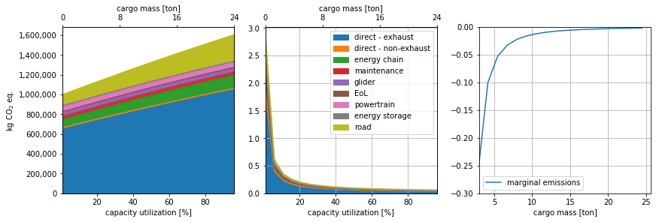

Figure 1 Left: Total GHG emissions function of capacity utilization. Middle: Per ton-km GHG emissions function of capacity utilization. Right: Change in per ton-km GHG emissions function of cargo mass.

In the second exercise, where the minimum driving range of a battery electric truck is incremented by steps of 100 km, another trend is observed. As the driving range increases, the maximum available payload decreases because of the mass increase of the energy storage components. On the left plot of *Figure 2*, a required driving range of 100 km allows to transport 19 tons of cargo for 1.1 million kg of CO2-eq., while a driving range of 1,000 km only allows transporting 8 tons of cargo for a total emission of 1.4 million kg of CO2-eq. The green area, which represents CO2-eq. emissions associated to electricity supply, and indirectly, energy consumption, does not vary much as the driving range increases. This is because the driving mass of the vehicle does not increase despite the energy storage becoming voluminous, as the cargo mass diminishes. It also explains why the emissions associated to the road manufacture and maintenance remain constant, as they are scaled on the vehicle mass. This indicates a certain limitation of battery electric trucks for long distance trips. This pattern is equally illustrated in the middle plot of *Figure 2*, where one sees that transporting one ton of cargo with a truck designed to drive 1,600 km yields a different result per ton-km than transporting the same ton of cargo twice with a truck designed to drive 800 km. The plot to the right in *Figure 2* shows the change in GHG emissions per ton-km from adding 100 km of driving range, function of an initial driving range. For example, for a 40-ton battery electric truck with a range of 200 km, adding another 100 km of autonomy will only add 0.005 kg CO2-eq. to a ton-km. This is to be contrasted with adding 100 km of driving range to a vehicle with an initial driving range of 1,000 km, where such change would add 0.025 to the per ton-km impacts. In parallel, a loss in utility is also observed as adding 100 km of driving range would lead to losing 1.06 ton of cargo payload in the first case, against 1.2 ton in the second case.

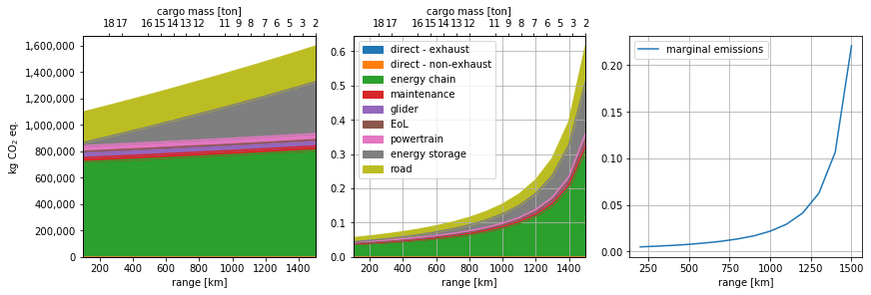

Figure 2 Left: Total GHG emissions function of vehicle range. Middle: Per ton-km GHG emissions function of vehicle range. Right: marginal per ton-km GHG emissions function of vehicle range.