Speakers

Luca Consoli, Radboud University Nijmegen, The Netherlands

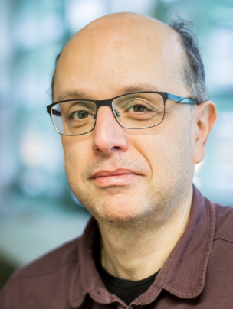

Ellen-Marie Forsberg, Østfold University of Applied Sciences, Norway

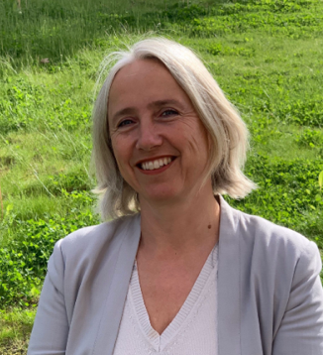

Mike Hicks, University of Glasgow, UK



Julian Kinderlerer, Emeritus Professor of Intellectual Property Law at the University of Cape Town, South Africa



Laurens Landeweerd, Radboud University Nijmegen, The Netherlands

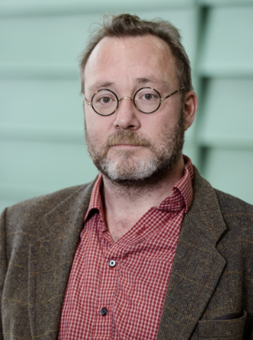

Denis Newman-Griffis, University of Sheffield, UK



Hub Zwart, Erasmus University Rotterdam, The Netherlands

