Battery Watchdog — Implementation Plan
Auto-restart system for the Growatt ABM 5.5L-A1-H master battery · v1.0 · July 2026

1. The problem and the approach
The master battery on the Growatt inverter sometimes shuts itself off while grid power is on. When grid power later returns, the inverter has no battery, the house stays down, and the power button must be pressed by hand. The installer cannot fix the underlying fault, so this project builds a non-invasive "watchdog" that watches the battery front panel and presses the button automatically.
Design principle: nothing is wired into the battery or inverter. Light sensors read the LEDs through the panel, and a small servo motor physically presses the power button — exactly what you do manually today. If the watchdog is ever removed, the system is untouched.

Confirmed behavior (from your answers)
Fact | Consequence for the design
ALM lights at power-on, turns off after ~3 seconds | ALM briefly on right after a press is normal; ALM on for over a minute means trouble and triggers an alert
Button is a simple press-and-release | Servo does a short ~0.6 second press, then returns to rest
You have 6 LM393 LDR modules | We use 3 (RUN, one SOC LED, ALM) with 3 spares
Wi-Fi is available at the battery; alerts wanted in v1 | Telegram alerts are built into version 1
Sometimes RUN is off while SOC LEDs still show | That is a shutdown in progress: the watchdog waits for ALL lights off before pressing

2. How the watchdog behaves
Every 2 seconds the ESP32 reads three light sensors. The decision logic:
RUN | SOC LED | What it means | Action
ON | any | Battery running normally | Do nothing
OFF | ON | Battery shutting down | Wait (alert once); do NOT press yet
OFF | OFF | Battery fully off | After 16 s of stable "all off": press the button once
— | — | ALM on for over 60 s | Alert; something is wrong

After a press, the watchdog waits 45 seconds (time for the ALM+RUN startup dance and inverter reconnection), then checks RUN:
- RUN back on → Telegram "SUCCESS" message. Back to monitoring.
- RUN still off → Telegram "FAILED" message, wait 5 minutes, then it may try again.

Safety limits
- Maximum 3 presses per hour. If the battery keeps dying, the watchdog locks itself out and alerts you instead of fighting a battery that is protecting itself.
- 16-second debounce before any press, so a brief LED flicker never triggers the servo.
- The servo detaches after each press — it cannot jam against or hold the button.
- Lockout clears automatically only when the battery is seen running again.

Why the leftmost SOC LED
The SOC bar fills left to right (the ramp symbol under the LEDs). At low charge only the leftmost LED remains, so it is the last one to turn off — the single most reliable indicator that the SOC display is completely dark.

3. Hardware and wiring
Everything needed is already in your Temu order. Parts used in v1:
Part | Qty | Role
ESP32 DevKit | 1 | Brain: reads sensors, drives servo, sends Telegram alerts
LM393 LDR module | 3 (of 6) | One over RUN, one over leftmost SOC LED, one over ALM
SG90 servo + horn | 1 | Presses the power button
50 cm servo extension | 1 | Keeps the ESP32 enclosure away from the button area
Dupont wires (F-F, F-M) | ~12 | Sensor and servo connections
Heat shrink + black tape | — | Light shrouds around each sensor (critical!)
3M foam tape, zip ties | — | Mounting sensors and servo
Project enclosure | 1 | Houses the ESP32
USB charger 5V 2A + cable | 1 | Powers ESP32 and servo together

Pin map
Connection | ESP32 pin | Note
LDR 1 (RUN) — AO pin | GPIO 34 | ADC1, input-only pin
LDR 2 (SOC leftmost) — AO pin | GPIO 35 | ADC1, input-only pin
LDR 3 (ALM) — AO pin | GPIO 32 | ADC1
All LDR VCC | 3V3 | Sensors run on 3.3 V so AO never exceeds the ESP32 limit
All LDR GND | GND
Servo signal (orange) | GPIO 18 | Via 50 cm extension
Servo power (red) | VIN (5V) | 5 V from the USB charger
Servo ground (brown) | GND | Must share ground with ESP32

Two rules that prevent 90% of ESP32 mistakes: (1) use the AO (analog) pin of each LM393 module, not DO — analog lets the software calibrate thresholds instead of fiddling with the tiny potentiometer; (2) only GPIO 32-39 work for analog reading while Wi-Fi is on (ADC2 pins silently fail), which is why those pins were chosen.
If the servo causes the ESP32 to reboot when it moves (brown-out), power the servo from a second USB charger instead: cut a spare USB cable, join red/black leads to the servo power wires with your LC422 lever connectors, and keep the black wire also connected to ESP32 GND.

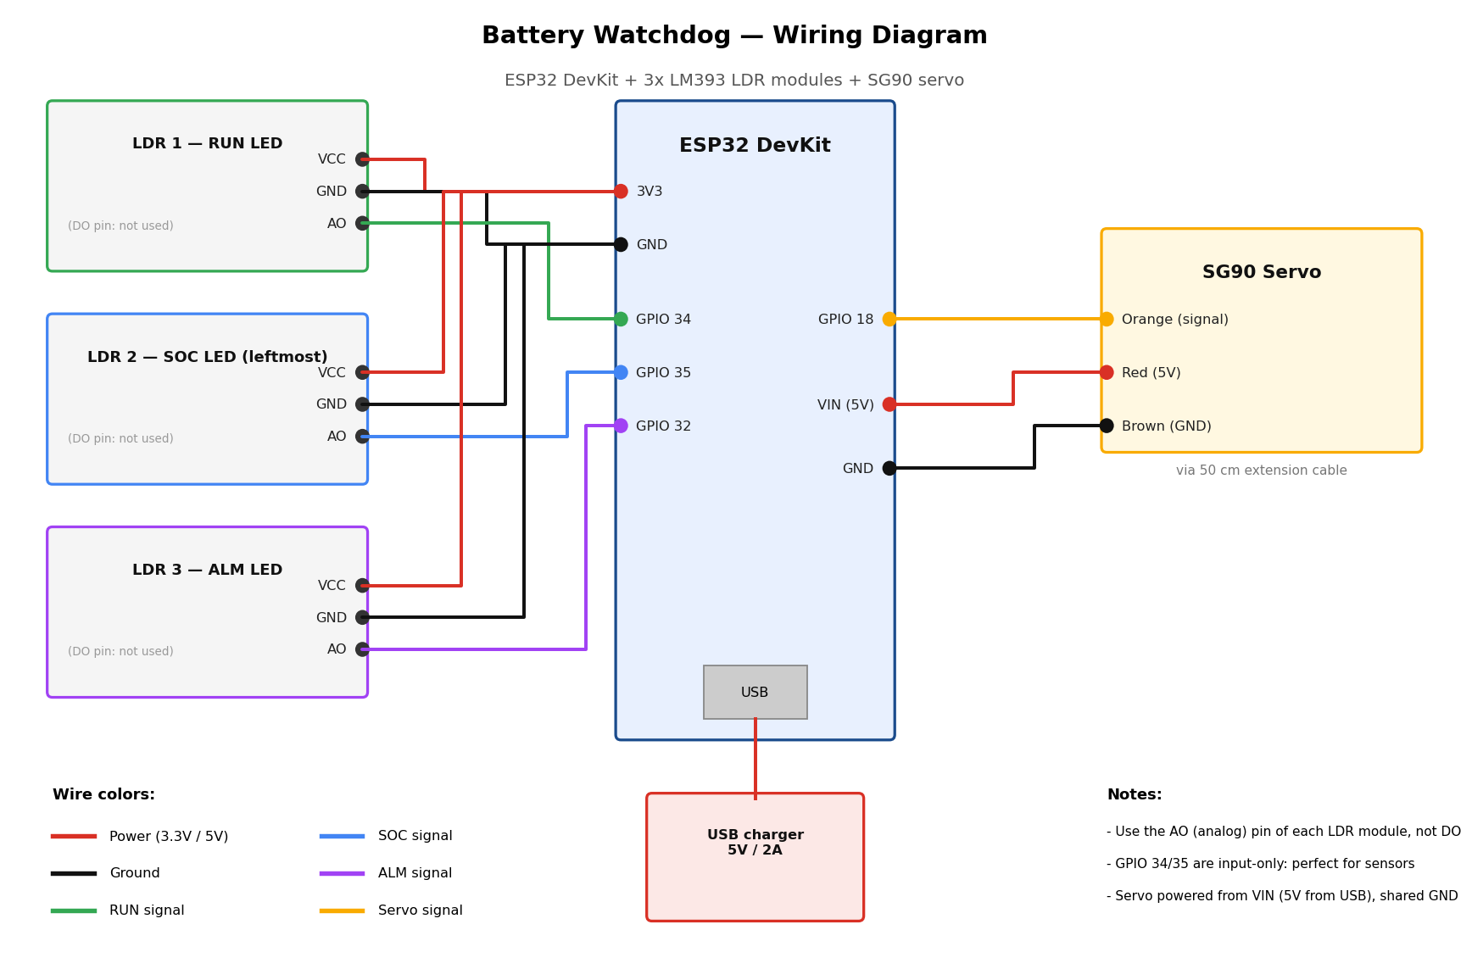
Full-size image: wiring_diagram.png (same folder)

4. Mechanical build

Light sensors
- Slide a short piece of heat shrink (or roll of black tape) over each LDR head so it forms a tube — this is the light shroud. Room light must not reach the sensor.
- Stick each shrouded sensor directly over its LED with foam tape: LDR 1 on RUN, LDR 2 on the leftmost SOC LED, LDR 3 on ALM. RUN and ALM are ~5 mm apart, so the shrouds are what stop cross-reading.
- Important: the sensors must NOT cover the power button or block airflow vents.

Servo
- Fit the single-arm horn on the servo. Do not screw it tight yet — the angle gets set during calibration.
- Add a small pad of foam tape on the horn tip so it presses the button gently and cannot scratch it.
- Mount the servo body beside the button with foam tape + a zip-tie anchor, so the horn sweeps onto the center of the button. The servo must be rock solid — if the body flexes, the press will be weak.
- Route the 50 cm extension to the ESP32 enclosure; zip-tie the cable so pulling it cannot move the servo.
Tip: do all servo mounting with the ESP32 in calibration mode so you can jog the horn to any angle live (type an angle in the Serial Monitor) and find perfect rest/press positions before sticking anything down permanently.

5. Software
The complete firmware is provided: battery_watchdog/battery_watchdog.ino (same folder as this document). It has three modes controlled by one line at the top:
Mode | What it does | When
MODE_CALIBRATE | Streams live sensor values to the Serial Monitor; lets you jog the servo by typing angles | First: find thresholds and servo angles
MODE_DRY_RUN | Full logic and Telegram alerts, but the servo never moves — logs "would press" | Run 2-3 days to trust the detection
MODE_ACTIVE | The real thing | After a clean dry run

One-time setup
- Install Arduino IDE, then add ESP32 support: File > Preferences > Additional Board URLs: https://espressif.github.io/arduino-esp32/package_esp32_index.json, then Boards Manager > install "esp32".
- Library Manager > install "ESP32Servo".
- Telegram bot: message @BotFather > /newbot > copy the token. Message @userinfobot to get your chat ID. Then send your new bot any message once (bots cannot message you first). Paste token, chat ID, and Wi-Fi credentials into the sketch.
- Select board "ESP32 Dev Module", plug in the USB cable, upload. If upload hangs at "Connecting...", hold the BOOT button on the ESP32 until it starts.

6. Build phases
Phase | What | Done when
0. Bench test | Flash the sketch in CALIBRATE mode with nothing mounted. Wave a phone flashlight over each LDR; jog the servo with typed angles. | Sensor numbers move with light; servo obeys
1. Mount sensors | Shroud + tape the 3 LDRs onto RUN, SOC, ALM. Record on/off analog values for each (use a dark room and lights-on room). | Clear gap between LED-on and LED-off readings, day and night
2. Set thresholds | Put each threshold halfway between its on/off values; set LIGHT_IS_LOW to match your modules. | Serial log shows correct ON/OFF for every LED
3. Mount servo | Fix servo by the button; find REST and PRESS angles in calibrate mode; test a real press turns the battery on. | A commanded press reliably starts the battery
4. Dry run | Switch to MODE_DRY_RUN. Live with it 2-3 days. | No false "would press" events; real shutdowns are detected and alerted correctly
5. Go live | Switch to MODE_ACTIVE. | Next real shutdown is fixed automatically with a SUCCESS Telegram message

Safe to test any time: pressing the power button of a running battery briefly is not part of any test — all servo tests happen against the button only when you decide, and phase 3's real-press test is best done at a moment the battery is already off or when a restart is harmless.

7. Honest limitations and the real fix
- This is a workaround, not a repair. The master battery shutting down (with the ALM at startup and the inverter losing the battery) is the underlying fault. Keep pressing Growatt / the distributor: likely suspects are the inter-battery comm cable, DIP switch addressing between master and slave, or battery BMS firmware.
- If the battery is shutting down to protect itself (temperature, cell fault), waking it repeatedly is not ideal — that is exactly why the watchdog stops after 3 attempts per hour and alerts you instead.
- When grid and battery are both down, the Wi-Fi router may be off too, so a Telegram alert can be delayed until power returns — but the servo press itself needs no internet and still works as long as the ESP32's USB charger socket has power. Plug the ESP32 charger into an inverter-backed socket.
- Version 2 ideas (later): grid-presence sensing via a spare USB charger + optocoupler, a small web dashboard on the ESP32, event history, OTA updates.

8. What to do right now
- Install Arduino IDE + ESP32 board support + ESP32Servo library (section 5).
- Create the Telegram bot and collect token + chat ID.
- Wire the 3 LDRs and servo to the ESP32 on the desk per the diagram (nothing mounted yet).
- Flash battery_watchdog.ino in MODE_CALIBRATE and tell me what sensor values you see — I will guide you through calibration and every phase after.

