EMPID – 139884

USERID – TD_USER18

PASSWORD – TD_USER18

NAME – priyam gawande

Q2

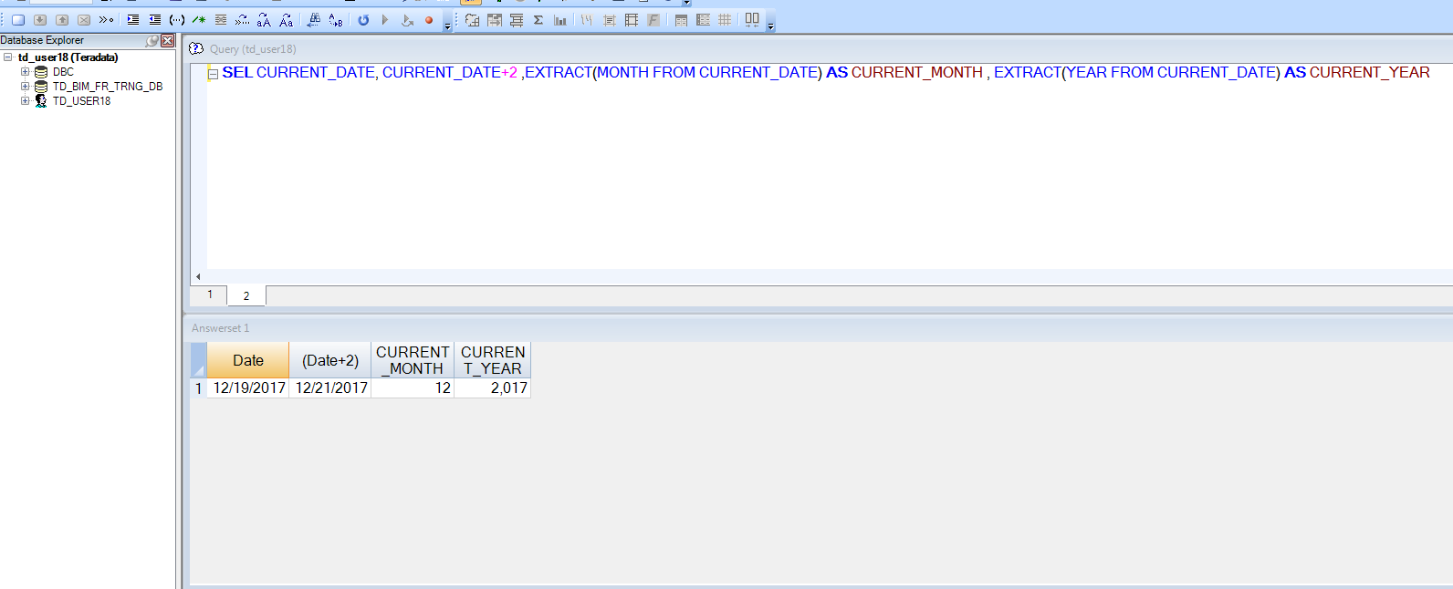

Q3

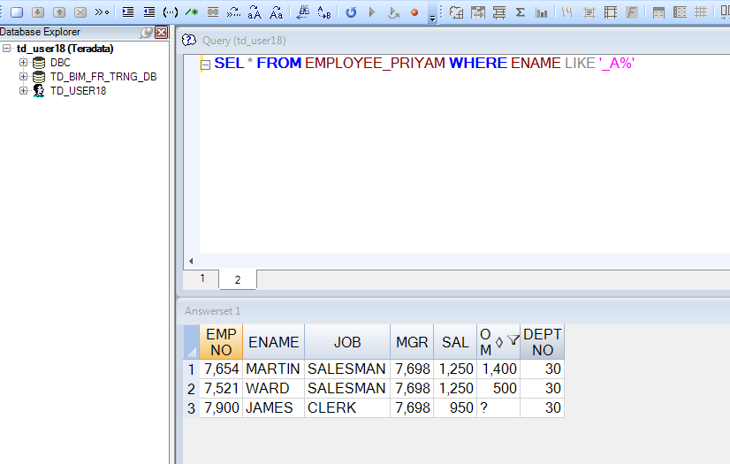

Q4

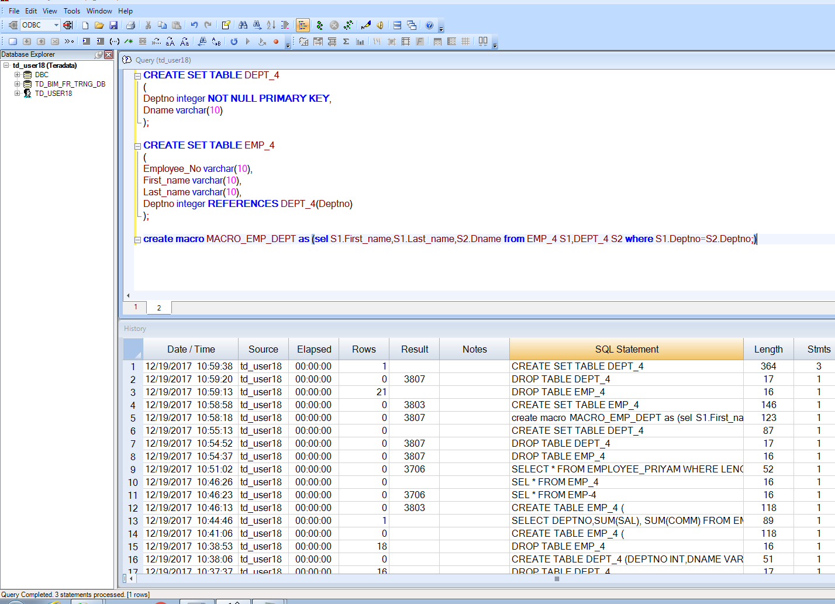

Q5

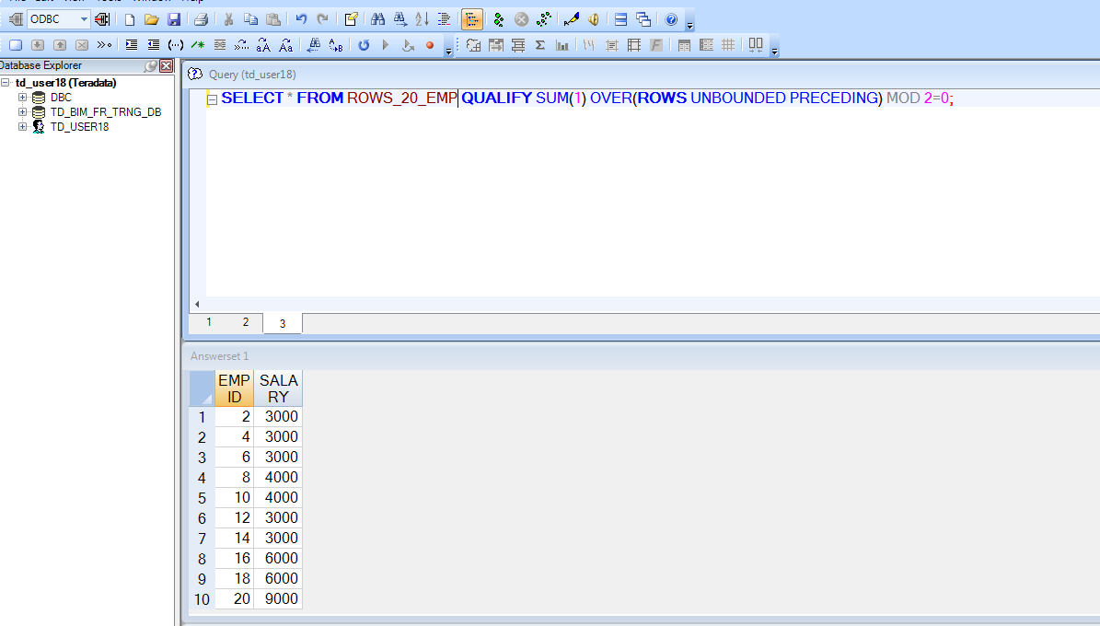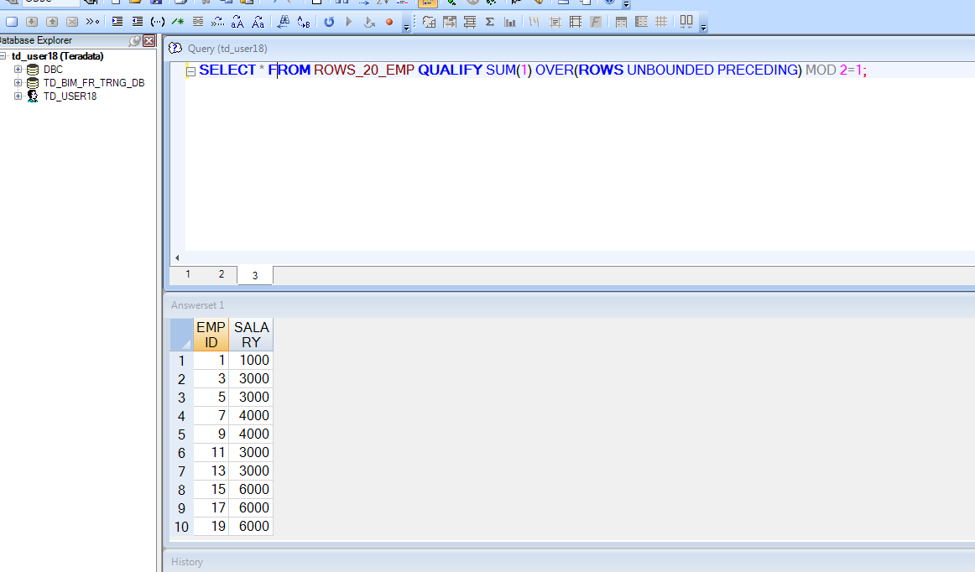

Q7

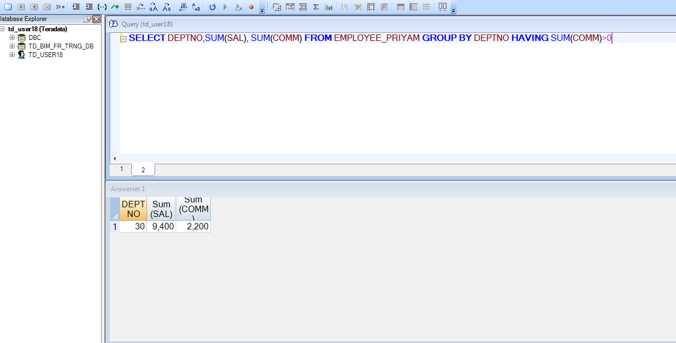

Q8

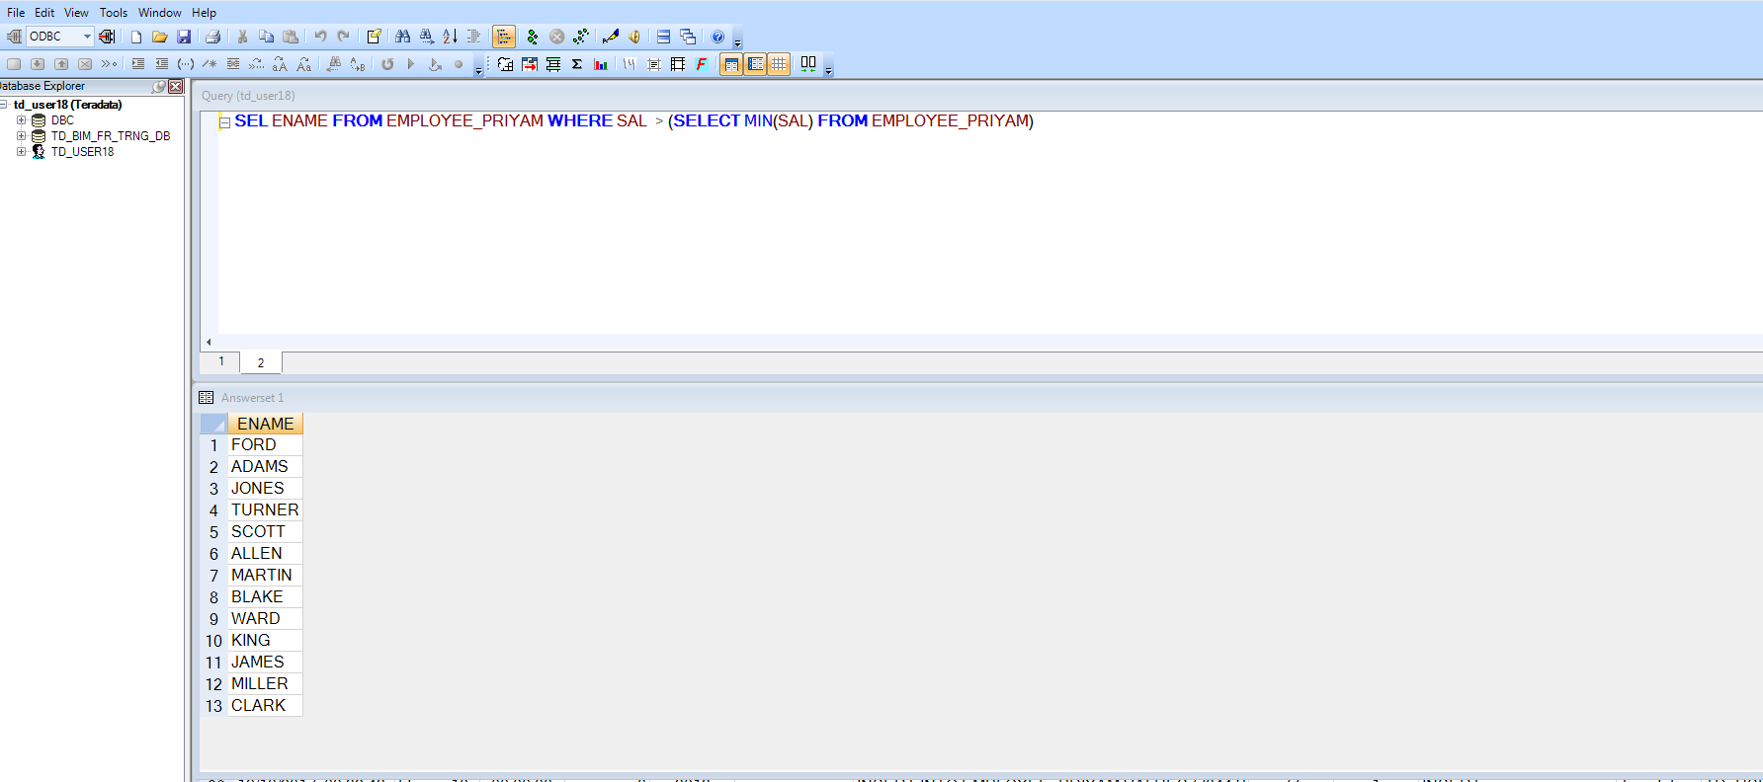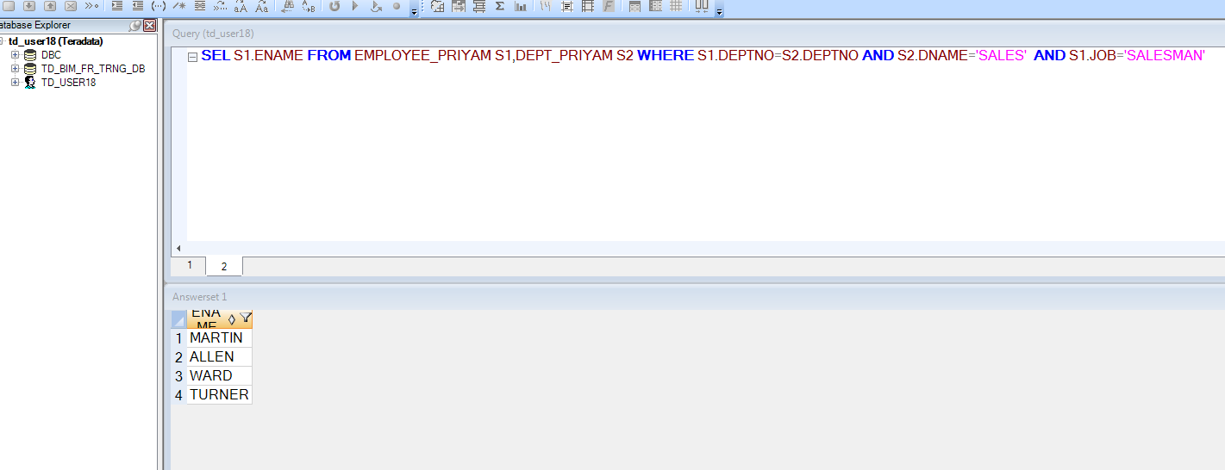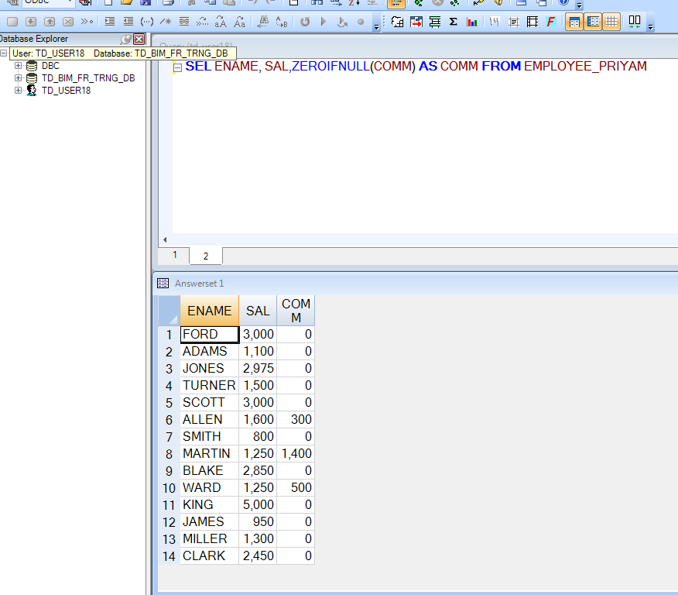

Q9

.LOGTABLE td_user18.DEPT_log;

.LOGON 10.74.161.248/td_user18,td_user18;

.BEGIN MLOAD TABLES DEPT_10;

.LAYOUT DEPT;

.FIELD in_DEPTNO * INT;

.FIELD in_DNAME * VARCHAR(10);

.DML LABEL INSERT_DEPT_LABEL_10;

INSERT INTO DEPT_10 (

DEPTNO,

DNAME

)

VALUES (

:in_DEPTNO,

:in_DNAME

);

.DML LABEL INSERT_DEPT_LABEL_20;

INSERT INTO DEPT_20 (

DEPTNO,

DNAME

)

VALUES (

:in_DEPTNO,

:in_DNAME

);

.IMPORT INFILE INPUT_FILE.txt

FORMAT VARTEXT ','

LAYOUT DEPT

APPLY INSERT_DEPT_LABEL_10 WHERE IN_DEPTNO = 10;

APPLY INSERT_DEPT_LABEL_20 WHERE IN_DEPTNO = 20;

.END MLOAD;

LOGOFF;

