**Task 1 Sign in and Sign up**

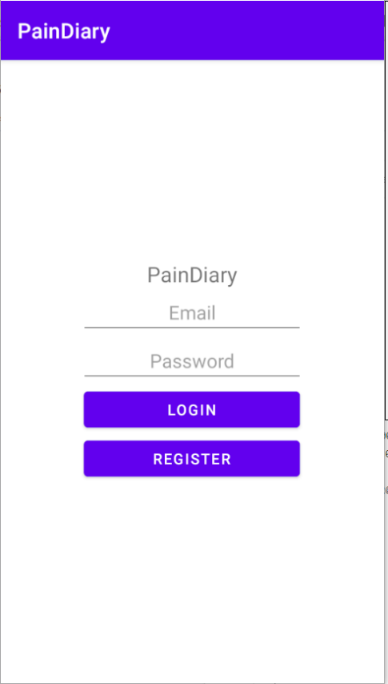

Figure Login

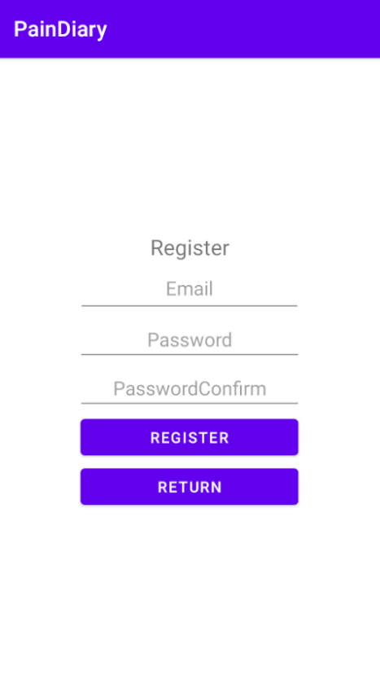

Figure Register

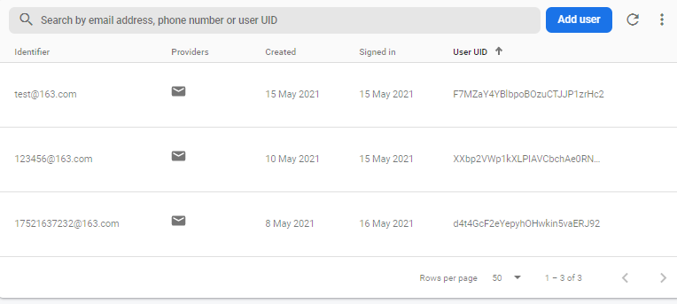

Figure account info in Firebase authentication

**Task 2 Home screen**

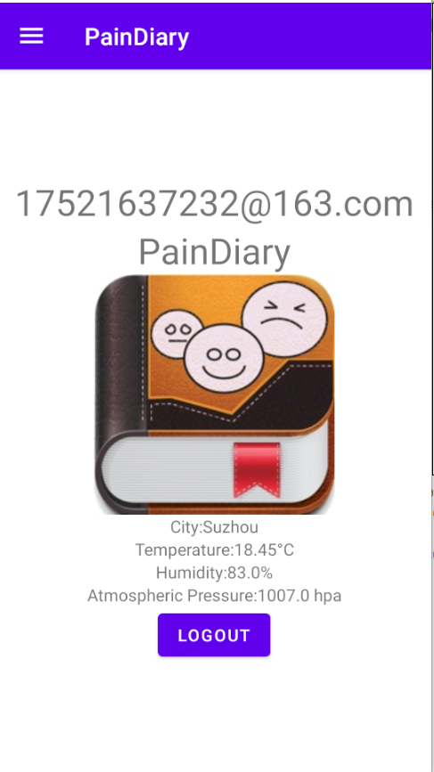

Figure Home Screen

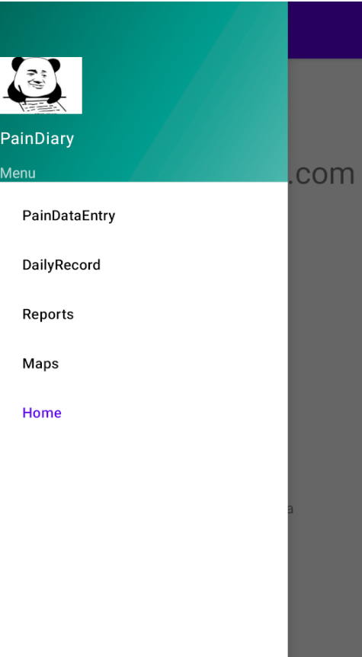

Figure Navigation

**Task 3 Pain Data Entry**

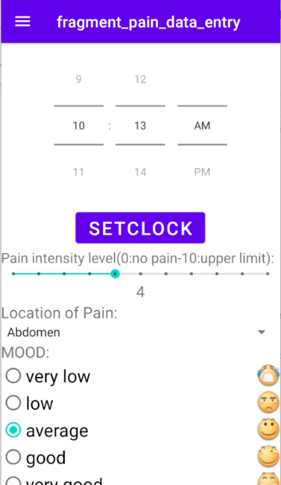

Figure FirstPartWithClockSetting

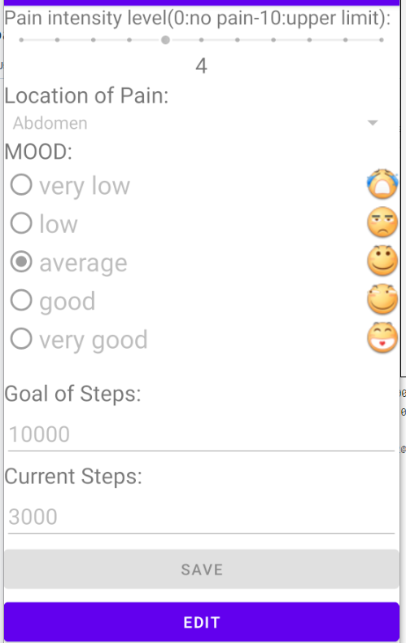

Figure Second Part（ScrollView，save clicked）

**Task 4 Daily Record using Room Database and LiveData**

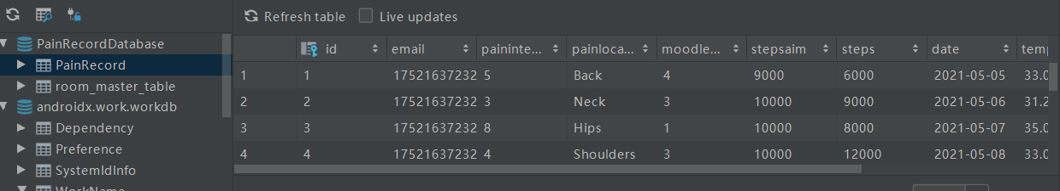

Figure Database

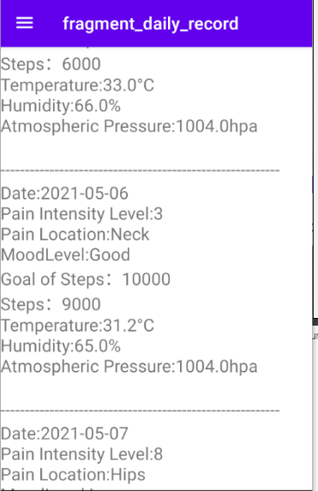

Figure DailyRecord（RecylerView）

**Task 5 Reports**

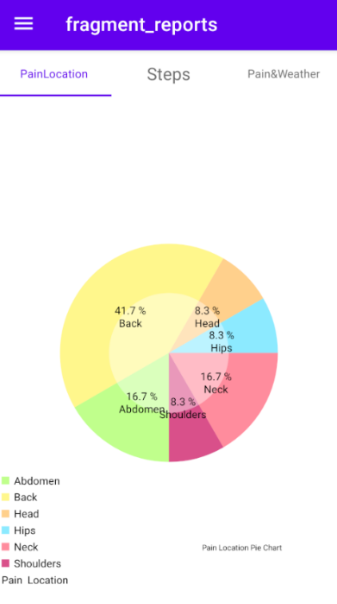

Figure Pain Location Pie Chart

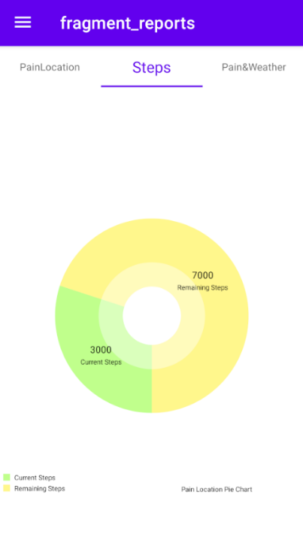

Figure Steps Pie Chart

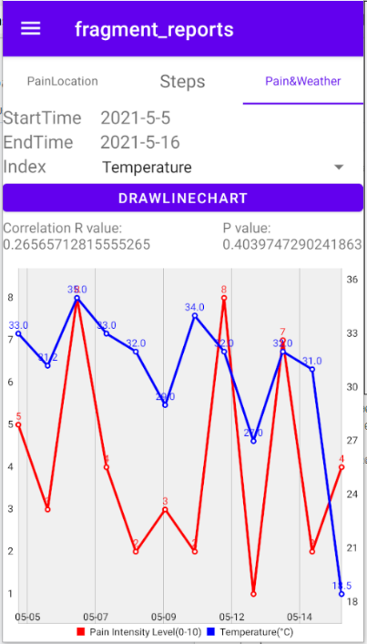

Figure Pain and Weather Line Chart

**Task 6 Map**

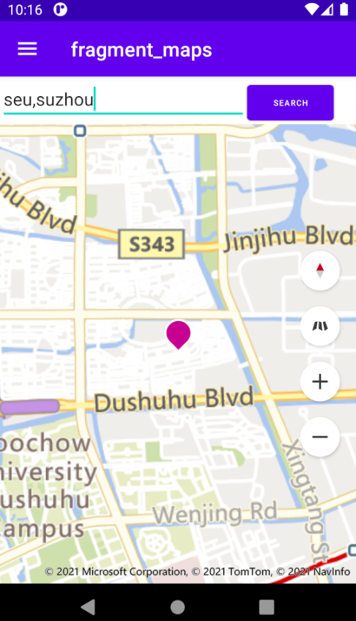

Figure Map(seu,suzhou)

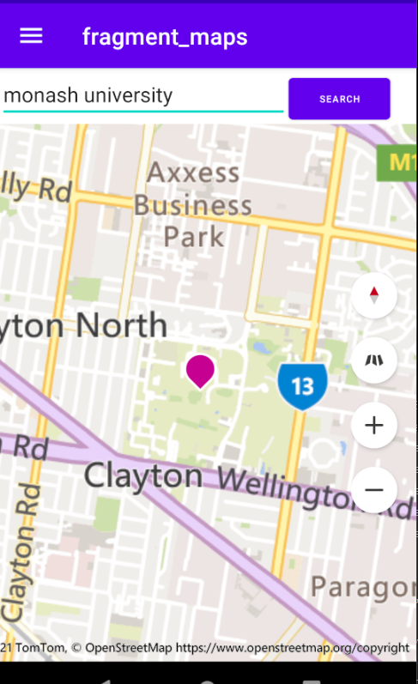

Figure Map(monash university)

Task 7 Advanced Features

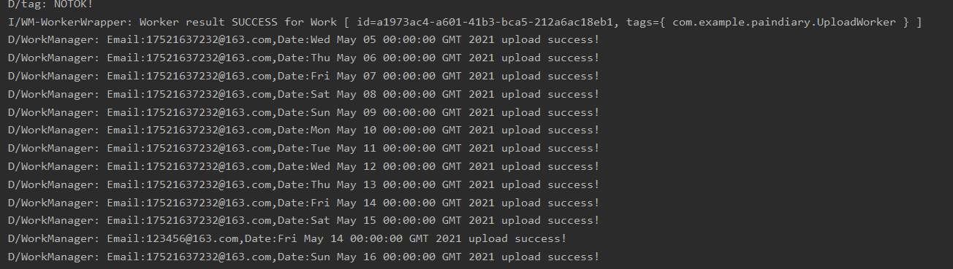

Figure Logcat(when uploading data using WorkManager)

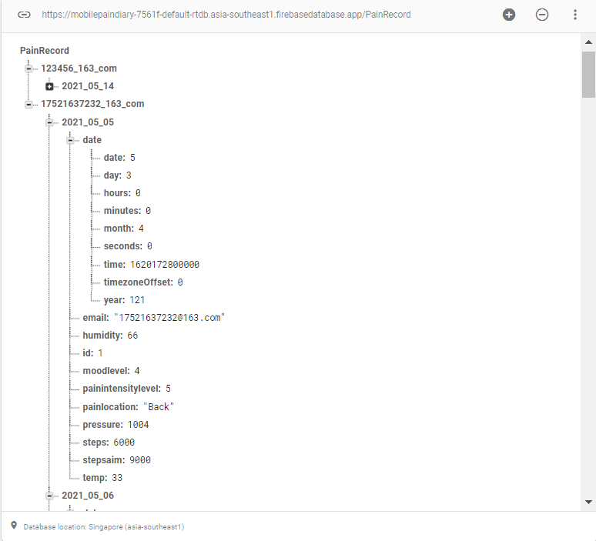

Figure Data in firebase(RealTime database)