**EKS cluster with eksctl commands.**

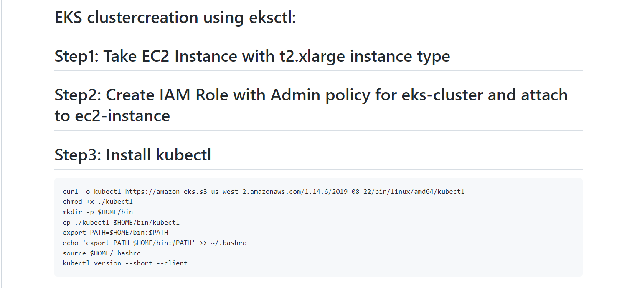

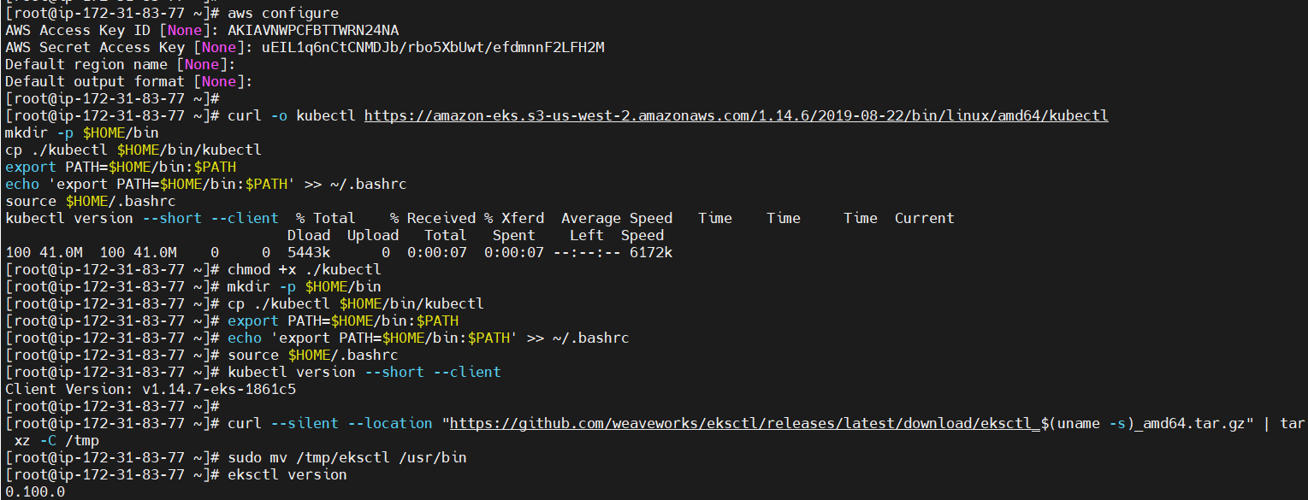

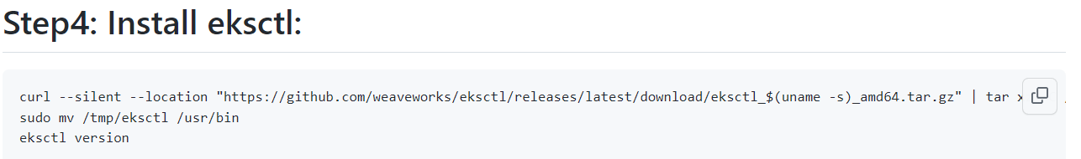



Note: eksctl is the commands to install the eks cluster.

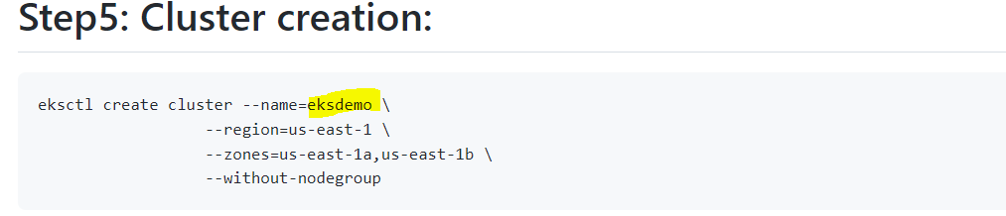

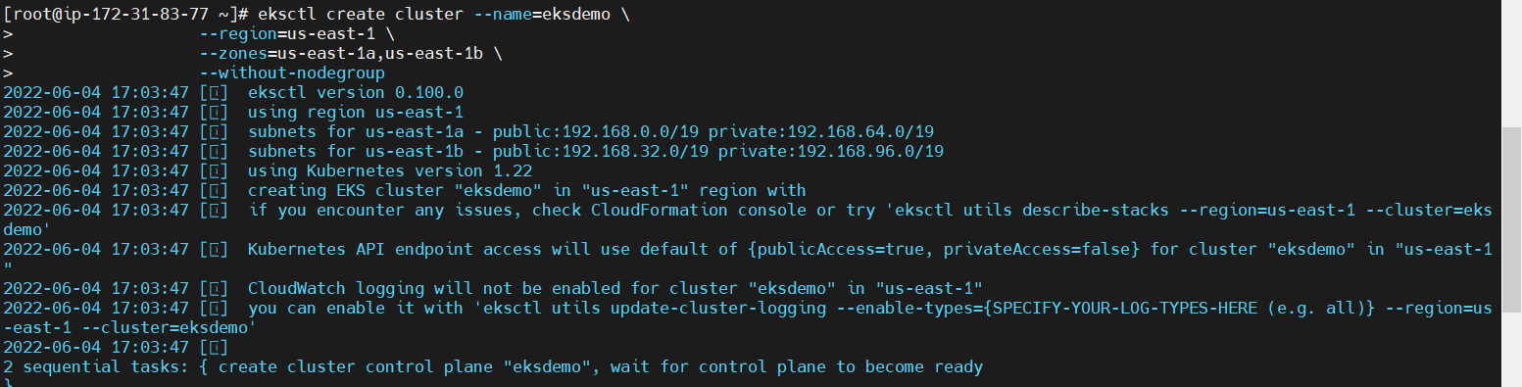

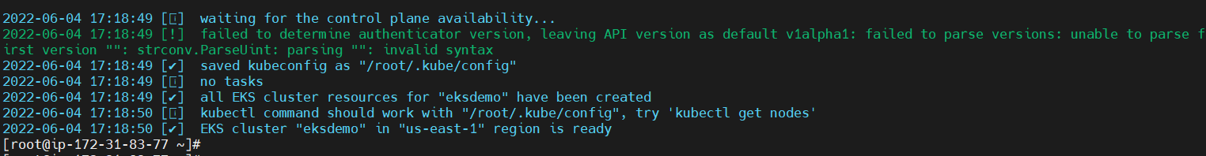

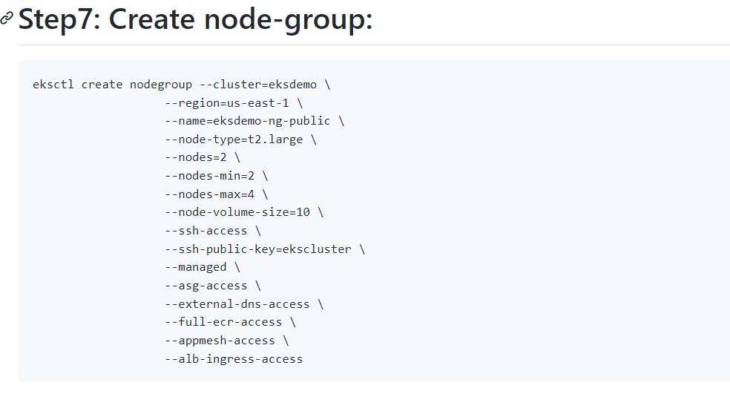

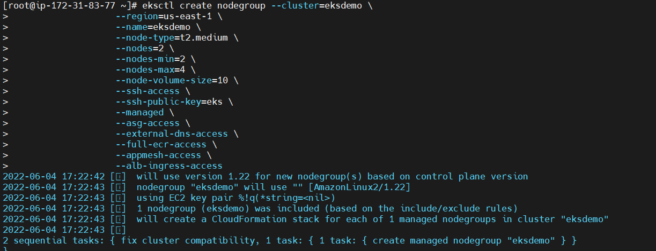

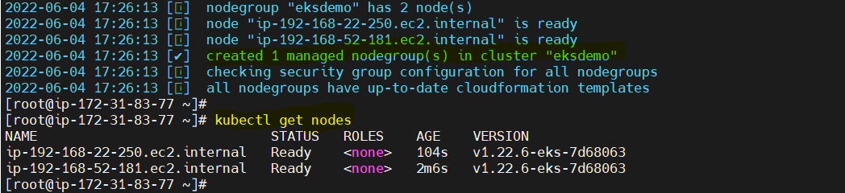

Now deploy the deployment yaml to create the pods

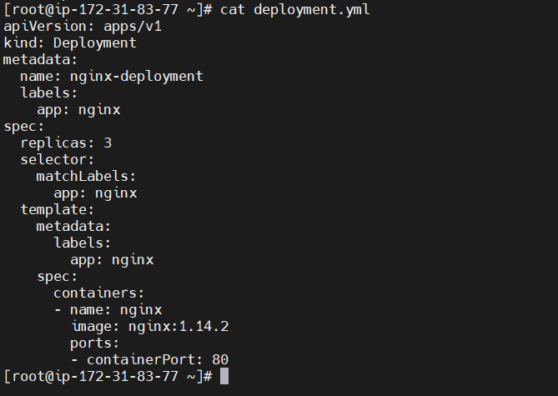

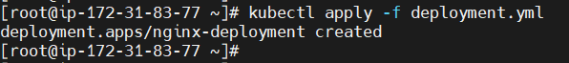

Now deploy the service.yml to access from outside world.

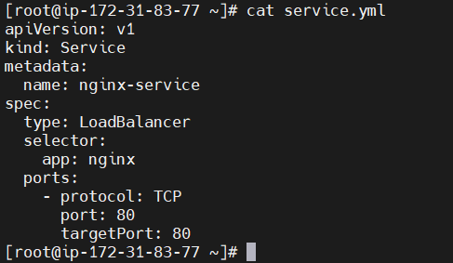



**Now go to the loadbalancer and copy load balancer name and paste it in the browser.**

