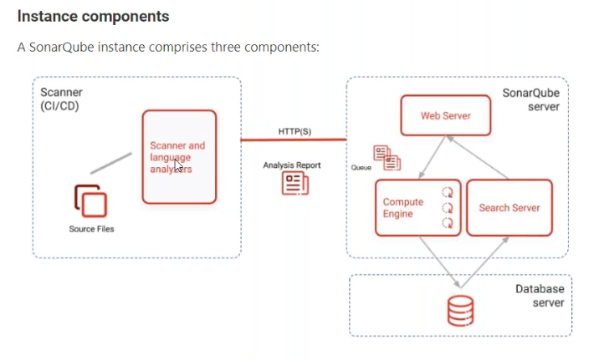

Testing team also there:

------------------------

developer they will write some code --> testing team will test code

we need to integrate sonarqube with jenkins

Sonarqube setup:

----------------

https://devopscube.com/setup-and-configure-sonarqube-on-linux/

https://github.com/mastanshaik-kadapa/sonarqube-installation

some database --> embedded database

if you are going to use your own database, otherwise it will take embedded database.

yum install java*

yum install java-11-amazon-corretto -y

amazon-linux-extras list

amazon-linux-extras install java-openjdk11

we downloaded zip file

cd /opt sudo wget https://binaries.sonarsource.com/Distribution/sonarqube/sonarqube-7.6.zip

extracted zip

change ownership with non-root user to /opt/sonarqube-7.6

change RUN_AS_USER as non-root user

[root@ip-10-0-1-156 linux-x86-64]# cat sonar.sh | grep -i ec2-user

RUN_AS_USER=ec2-user

[root@ip-10-0-1-156 linux-x86-64]#

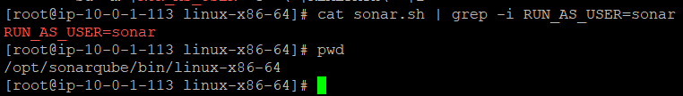

/opt/sonarqube-7.6/bin/linux-x86-64/sonar.sh

./sonar.sh start

Default user name and password is admin and admin to login the console.

<https://devopscube.com/setup-and-configure-sonarqube-on-linux/>

url: user name and password --> our own database

create database SonarQubedB;

CREATE USER sonar WITH PASSWORD 'Sonar#123';

GRANT CONNECT ON DATABASE SonarQubedB TO sonar;

Now up to db., user, password created. now these details need to integrated with SonarQube.

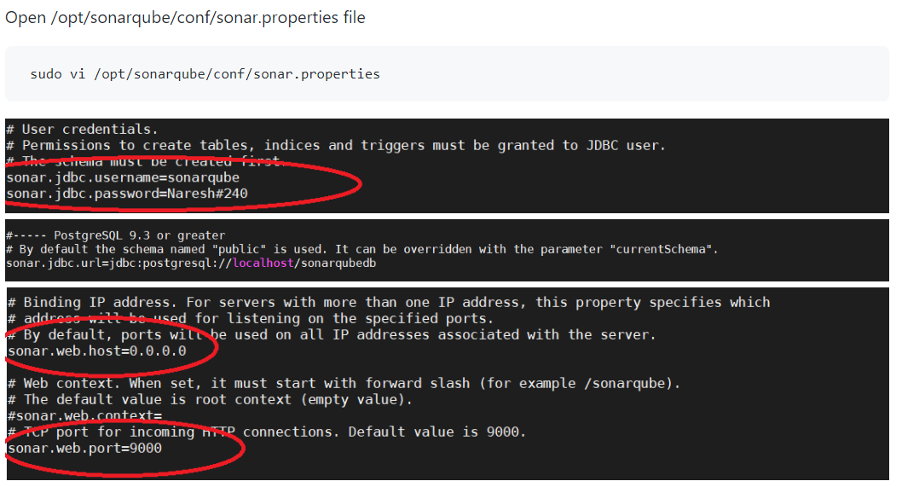

Now connect to postgres database and check the tables.

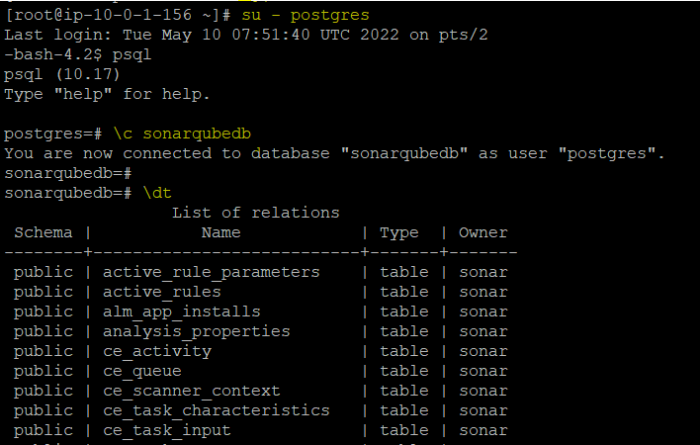

Now the scanner will send the report to sonarqube and data will be stored in postgres DB.

**Installation steps of sonarqube scanner.**

wget <https://binaries.sonarsource.com/Distribution/sonar-scanner-cli/sonar-scanner-cli-4.4.0.2170-linux.zip>

unzip sonar-scanner-cli-4.4.0.2170-linux.zip

setup the environment variable to use the sonar-scanner command from any where

export PATH=$PATH:/opt/sonar-scanner/bin

sonar-scanner

now we need to integrate sonar-scanner with sonarqube.

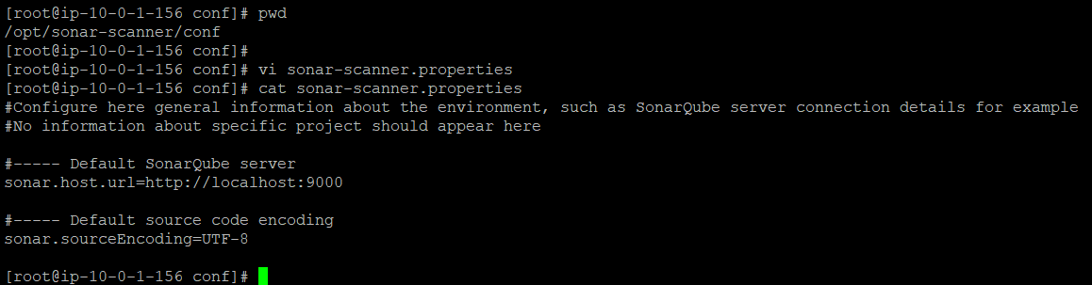

Now clone the repository.

git clone <https://github.com/mastanshaik-kadapa/sonarqube.git>

Cd /root/sonarqube/springboot

Now we required artifacts to scan src folder

Mvn clean install

sonar.jdbc.url=jdbc:postgresql://localhost/sonarqubedb

sonar-scanner -Dsonar.projectKey=hellospringboot \

-Dsonar.projectName=hellospringboot \

-Dsonar.sourceEncoding=UTF-8 \

-Dsonar.sources=src

