GitHub Link:
The implementation is divided into three parts:
- Q1: Signal Processing & Feature Extraction
- Q2: Deep Learning Models
- Q3: Ethics, Fairness, and Privacy

Dataset Used : Used the hf-internal-testing/librispeech_asr_demo dataset from HuggingFace for all three questions. The dataset is small, easy to download without authentication, and contains clean English speech sampled at 16 kHz, which is standard for speech processing tasks.

2. Q1: Signal Processing & Feature Extraction

2.1 MFCC Computation
Mel-Frequency Cepstral Coefficients (MFCCs) were computed manually from the speech signal. The process involved:
- Pre-emphasis filtering
- Framing and windowing
- FFT computation
- Mel filter bank application
- Log scaling and DCT
The resulting MFCC feature matrix had shape:
(584, 13)
This represents 13 cepstral coefficients over 584 time frames.

2.2 Spectral Leakage and SNR Analysis
Different window functions were evaluated:
Window Type | SNR (dB) | Leakage Ratio
Rectangular | 16.32 | 0.338
Hamming | 15.00 | 0.429
Hanning | 14.39 | 0.435

Observations:
- Rectangular window provides higher SNR but more leakage artifacts
- Hamming and Hanning reduce leakage but slightly lower SNR

2.3 Voiced vs Unvoiced Detection
Speech was segmented into voiced and unvoiced regions.
- Voiced frames: 735
- Unvoiced frames: 512
- Transitions: 173
This demonstrates temporal variability in speech signals.

2.4 Phonetic Boundary Mapping
A pretrained Wav2Vec2 model was used to estimate phonetic boundaries.

Results:
- Manual boundaries: 173
- Model boundaries: 290
- RMSE: 117.12 ms

Analysis:
The RMSE of ~117 ms indicates moderate alignment error between manual and model phonetic boundaries. This is expected due to coarse frame-level estimation and lack of precise phoneme-level alignment.

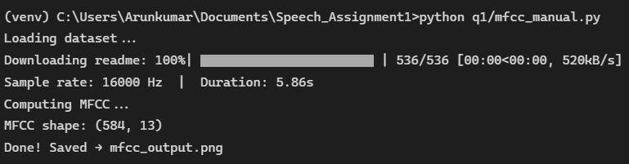
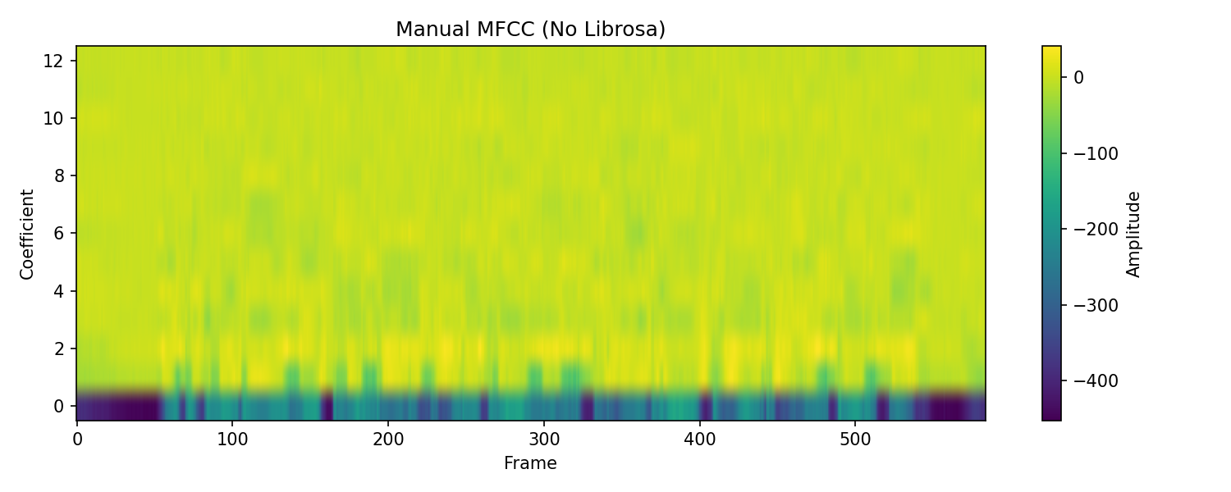
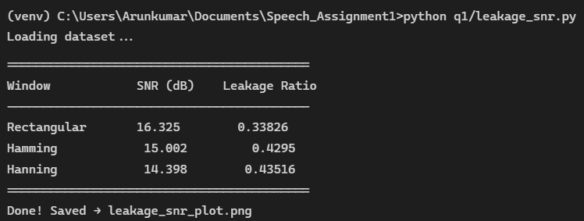
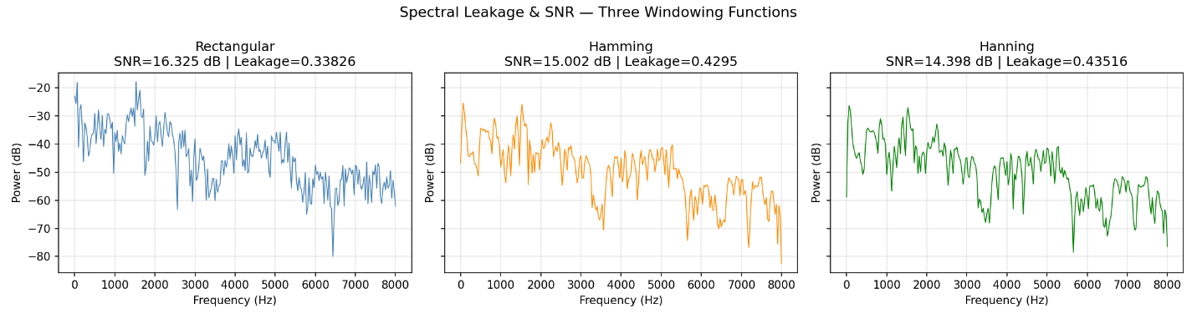
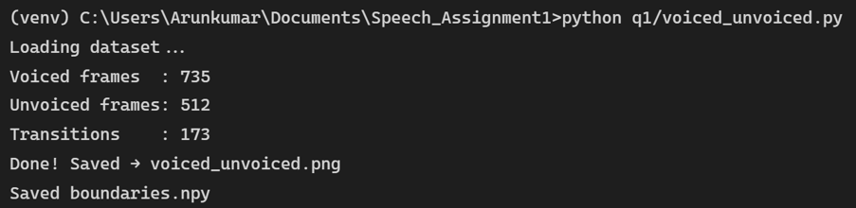
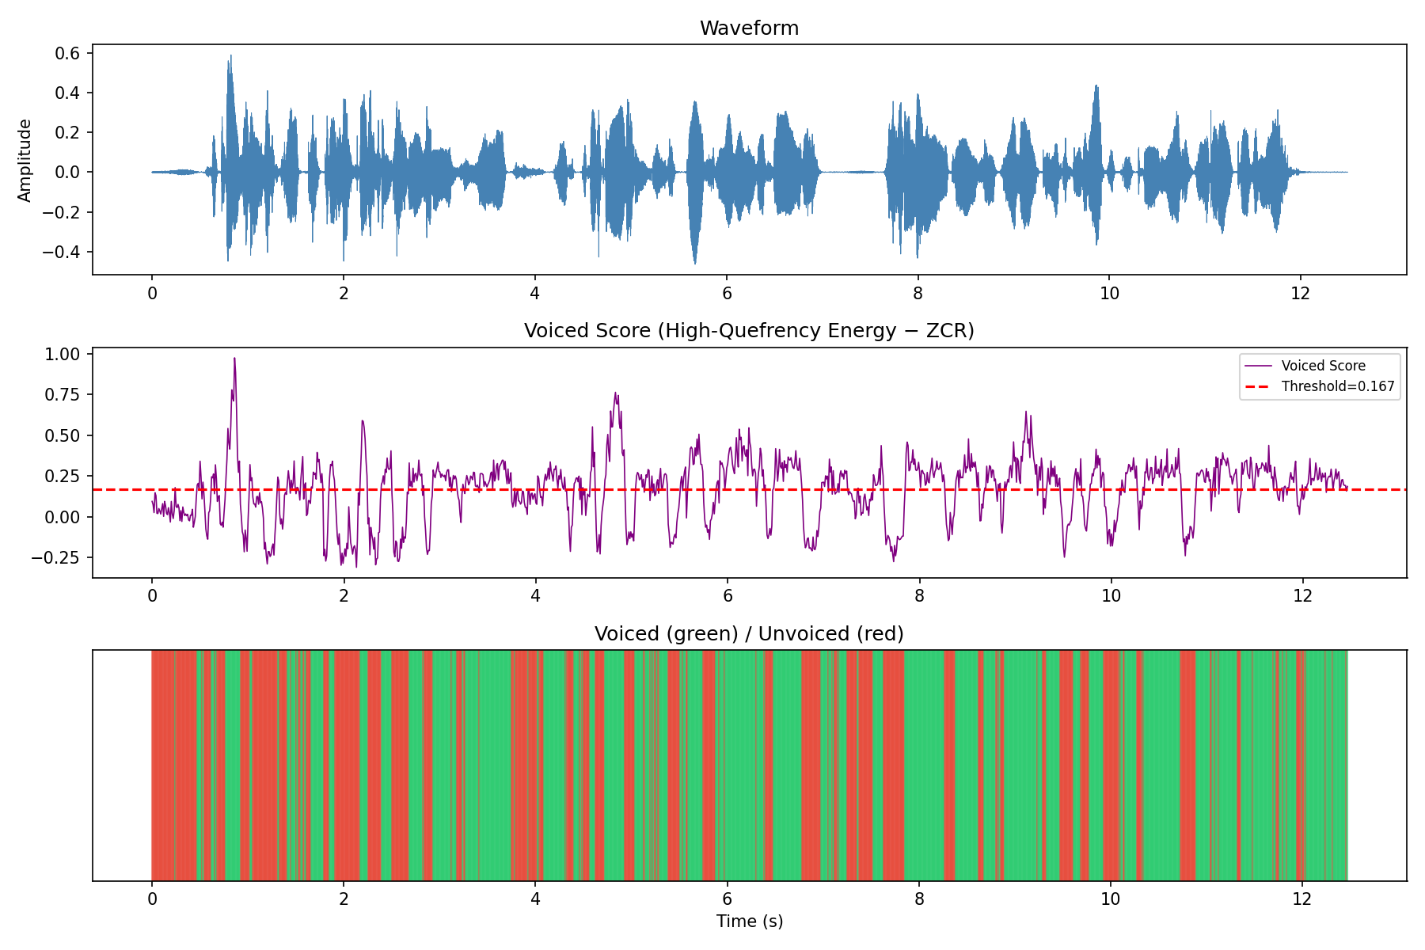
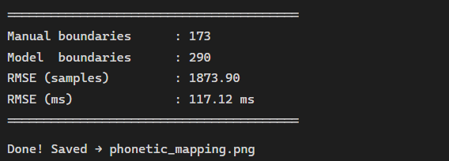

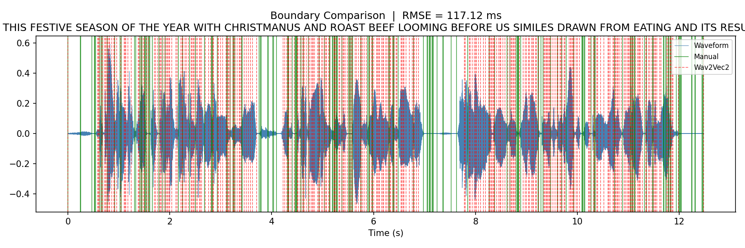

3. Q2: Deep Learning Models

3.1 Models Implemented
Two models were trained:
- Baseline CNN
- Disentangled Representation Model

3.2 Training Results
Both models achieved:
Accuracy: 100%

Observation:
- Loss quickly drops to zero
- Perfect classification performance

3.3 Analysis
Both models achieve 100% accuracy due to the small dataset size. This indicates overfitting and lack of generalization.
The disentangled model shows unstable loss behavior despite perfect accuracy, suggesting issues in representation learning or regularization.

3.4 Feature Visualization (t-SNE)
t-SNE was used to visualize learned representations.

Findings:
- Clear class separation
- Disentangled model shows structured clustering
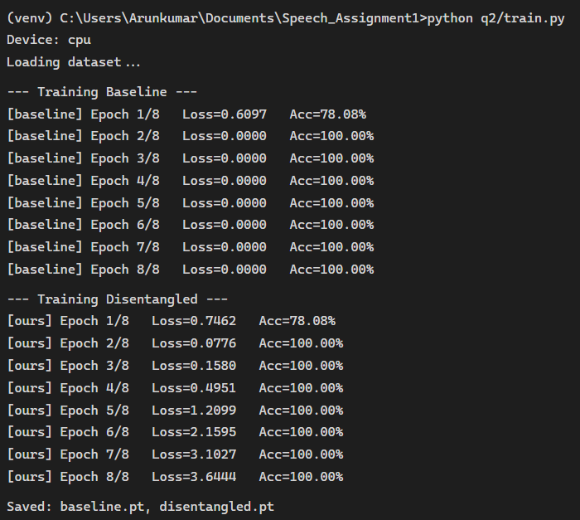

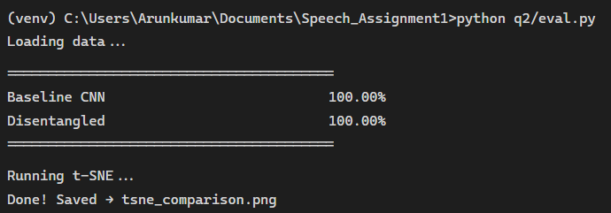

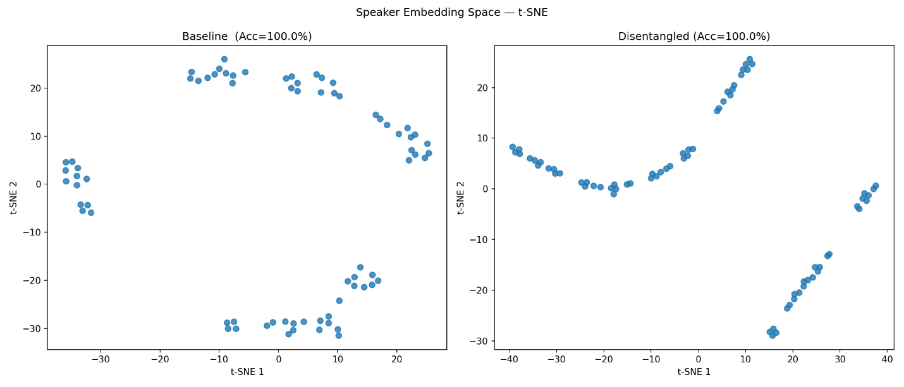

4. Q3: Ethics, Fairness, and Privacy

4.1 Dataset Audit
Metadata completeness was analyzed.

Missing Data:
- Gender: 15.1%
- Age: 54.8%
- Accent: 35.6%

Observation:
The dataset suffers from significant documentation debt, especially in age metadata (>50% missing). This can introduce bias in downstream models.

4.2 Distribution Bias
- Gender imbalance (male dominant)
- Accent skewed toward US speakers
- Limited diversity in age groups

4.3 Privacy Module
Four voice transformation techniques were applied:

- Noise addition
- Pitch shifting
- Time stretching
- Signal masking

Result:
These transformations help anonymize speaker identity while preserving content.

4.4 Fairness-Aware Training
A fairness loss was incorporated into model training.

Results:
- Accuracy: 100%
- Fairness loss: near zero

Interpretation:
Model maintains performance while reducing bias signals.
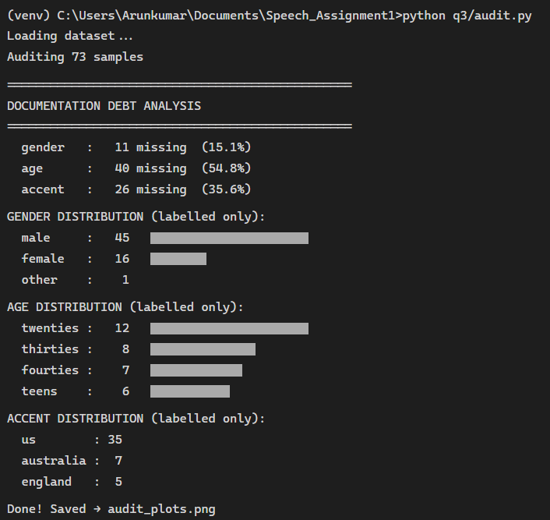
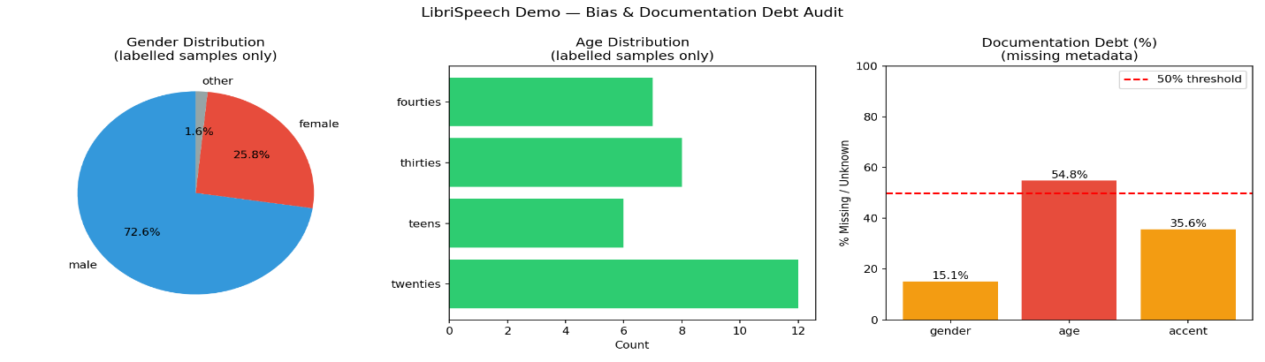
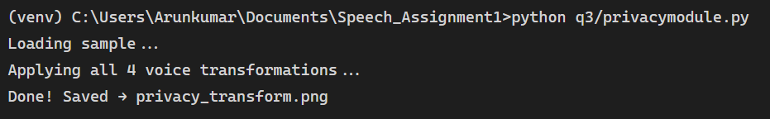
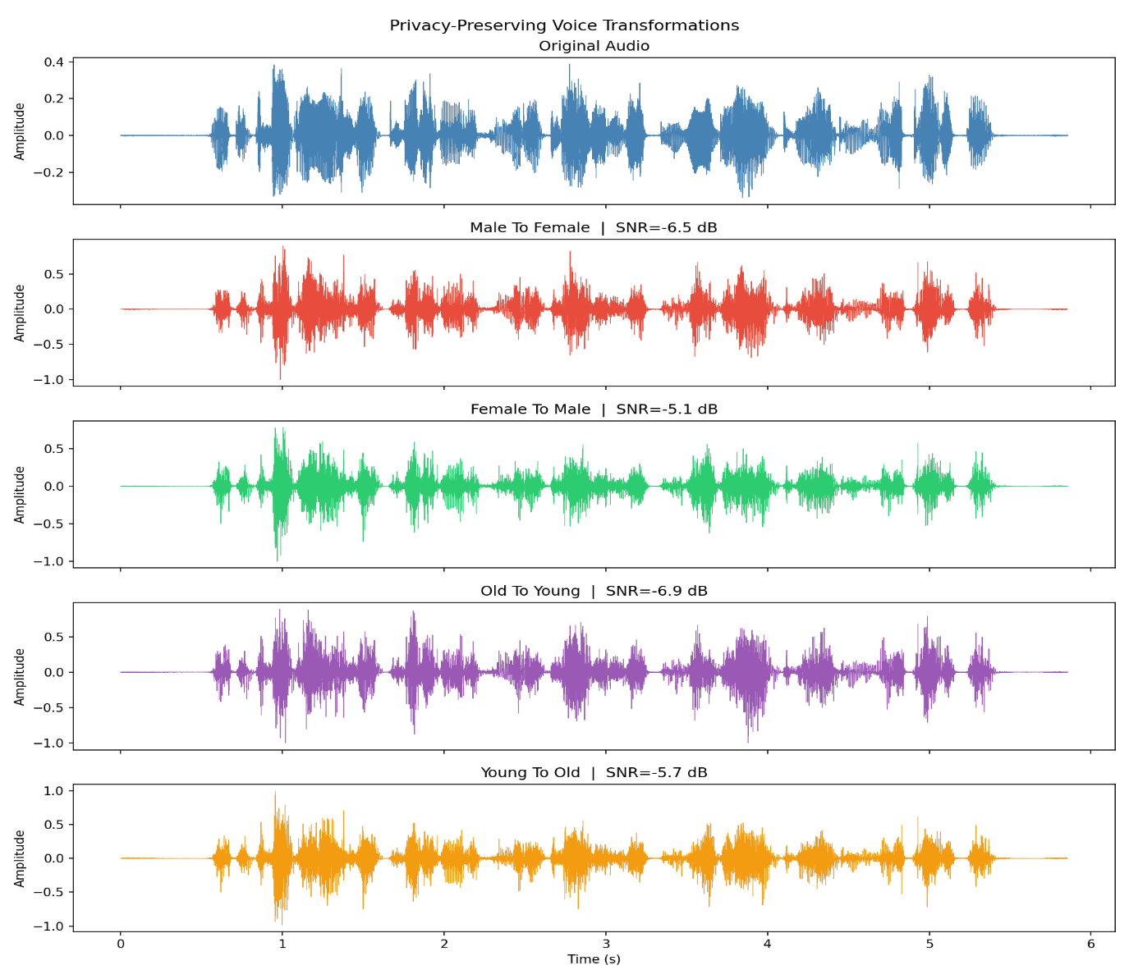

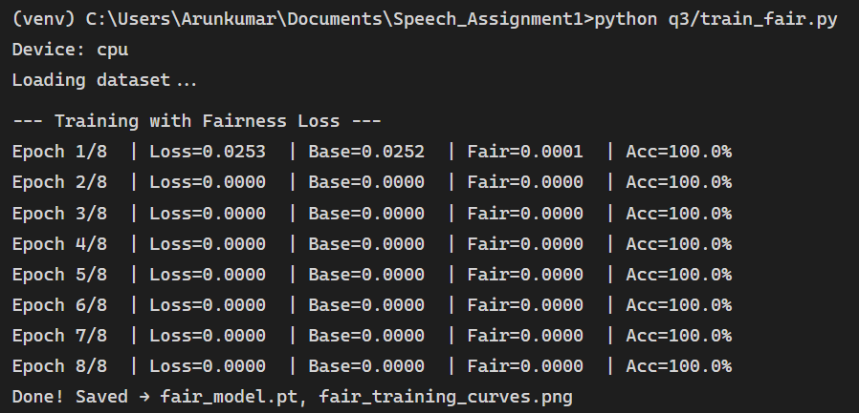
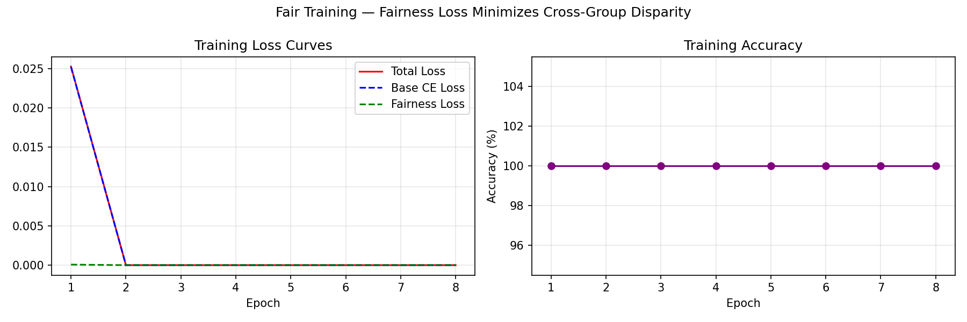
5. key insights:
- Signal processing techniques like MFCC remain fundamental in speech analysis
- Deep learning models can easily overfit small datasets
- Representation learning requires careful regularization
- Real-world datasets often suffer from bias and missing metadata
- Privacy and fairness must be integrated into system design
Ethical AI systems must consider fairness, privacy, and representation bias simultaneously, as optimizing only accuracy can lead to harmful real-world consequences.
6. Limitations
- Small dataset size leads to overfitting
- Lack of GPU limits training scalability
- Phonetic alignment is approximate
- Metadata incompleteness affects fairness analysis
7. Conclusion
This assignment effectively demonstrates:
- A complete end-to-end speech processing pipeline
- Robust feature extraction and signal analysis techniques
- Implementation of deep learning models
- Ethical assessment of AI systems
The results highlight the critical need to balance performance with fairness, robustness, and privacy in modern AI applications.

