response_functions

Mike Stefanuk

October 5, 2018

Response functions will be identified for the relationship between tree ring chronologies and climate variables.

This code should be run after chronologies_v3.rmd

Stages:

1 - Load chronology and climate data

2 - Prepare data for use by treeclim:: functions

3 - Response fucntion analysis (stationary)

4 - Response function analysis (moving window)

5 - Seasonal partial correlation

1 - Load chronology and climate data

2 - Prepare data for use by treeclim:: functions

Data formatting requirements:

* chronologies as would be output by dplR::chron (year as rowname, value in column)
* climate as (optionally) named list of 13 column dataframes (year, monthly data * 12)
* no missing climate data is permitted

NA values filled using zoo::na.StrucTS:

* uses seasonal Kalman filter & fixed-interval smoothing
* found to be effective for seasonal data with trends in <https://arxiv.org/ftp/arxiv/papers/1510/1510.03924.pdf>

Temporal autoregression (and trends) must be removed from climate data for proper analysis

This will be done using standization and prewhitening (for SPEI)

SPEI data will be prewhitened to remove any trends in the data

Climate data will be standardized to:

* have a mean of 0
* have a standard deviation of 1

Note that SPEI data are scaled by default, but they were rescaled after prewhitening as the sd nolonger equals 1

Centering and scaling creates a dataset that:

* has a SD of 1
* had a mean of 1
* it appears that the order of operations for the scale function centers (mean = 0) then scales (sd = 1), therefore the mean shifts
* the mean shift is by a matter of thousandths at the most, so the mean is effectively 0
* these results are identical to (x - mean(x)) / sd(x), and therefore I assume that they are effective

3 - Response fucntion analysis (stationary)

First, the window should be set:

* 1894 (Adirondack prt min + 1) to 2011

Old - 1890 to 2011 (mirroring max window from productivity trend analysis)

t.s <- c(1894, 2011)

Below are the stationary response functions for:

* January to October of the year of growth
* January to October of the previous year to the year of growth
* June to October for the year of growth and previous year
* January of the previous year to October of the year of growth by a 3 year moving window (following Bishop 2015)

Note that tests were done (not included) to see whether there was a difference between results from RFA with the PCA and mean chronologies. There were very slight differences in the ‘shape’ of the plots, but no compelling reason was found to use one chronology or the other.

## Running for timespan 1894 - 2011...

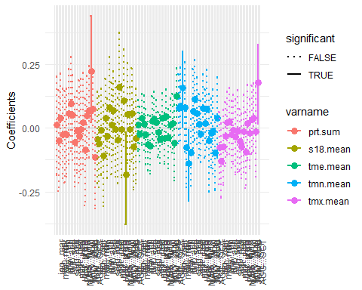

## Running for timespan 1894 - 2011...

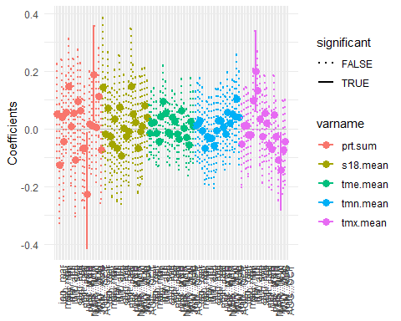

## Running for timespan 1894 - 2011...

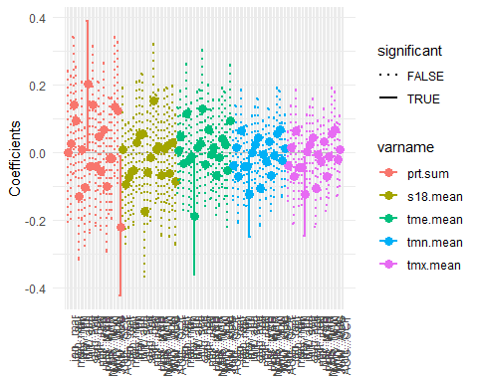

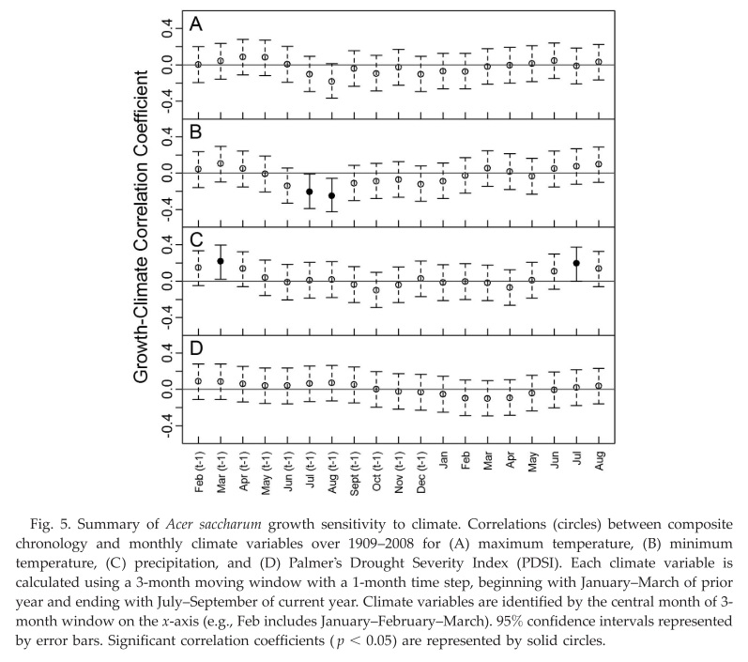

Bishop figure for reference

* Current and lagged spring (April, May and June)
* Current and lagged spring (3 month mean)
* Current and lagged summer (July and August)
* Current and lagged summer (2 month mean)
* Current and lagged autumn (September and October)
* Current and lagged autumn (2 month mean)

4 - Response function analysis (moving window)

t.s <- c(1894, 2011)

The selection of the treeclim::dcc function for “moving” seems to be limited by window size

The formula for max allowed window size seems to be:

* number of climate variables * number of ‘months’

Doing a moving window analysis with the resolution of the stationary analysis is therefore impossible

Window size will be manipulated to give the greatest perspective possible

# set window offset (yrs)  
w.o <- 5  
  
# set window size (yrs)  
w.s <- 20

Below are the moving response functions for:

* Spring and Summer of the current and lagged year of growth

## [1] "Algonquin"

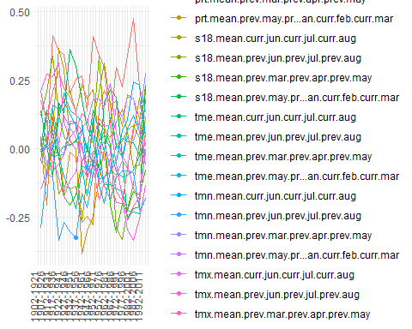

## [1] "Frontenac"

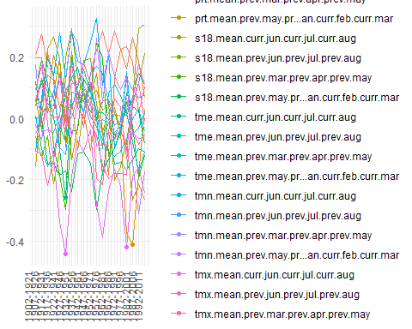

## [1] "Frontenac"

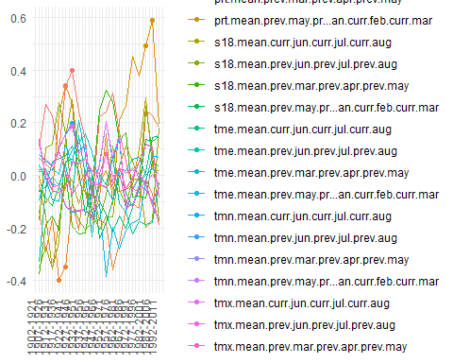

* January of the previous year to October of the year of growth (non-overlapping seasonal means) (following Bishop 2015)

# set window offset (yrs)  
w.o <- 5  
  
# set window size (yrs)  
w.s <- 40

## [1] "Algonquin"

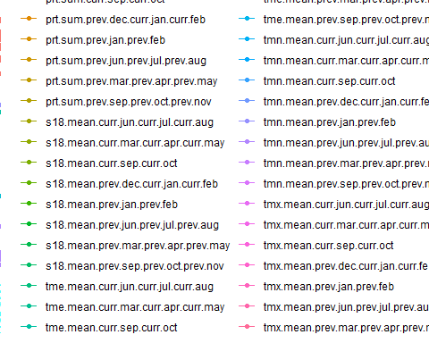

## [1] "Frontenac"

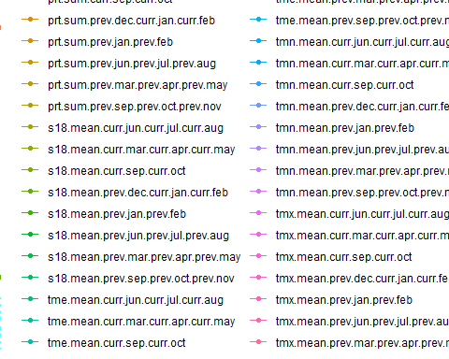

## [1] "Frontenac"

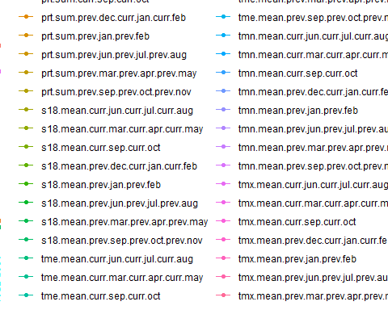

5 - Seasonal partial correlation

t.s <- c(1894, 2011)

# set primary variable  
pri <- "tmx"  
  
# set secondary variable  
sec <- "tmn"

## Running for timespan 1894 - 2011...

## [1] "Algonquin"

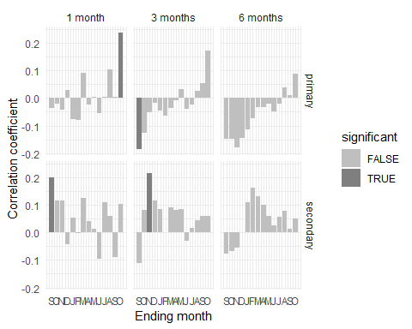

## Running for timespan 1894 - 2011...

## [1] "Frontenac"

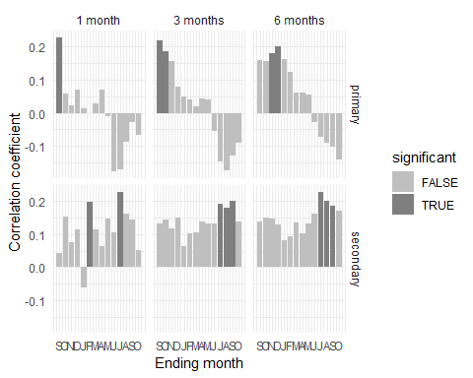

## Running for timespan 1894 - 2011...

## [1] "Adirondack"

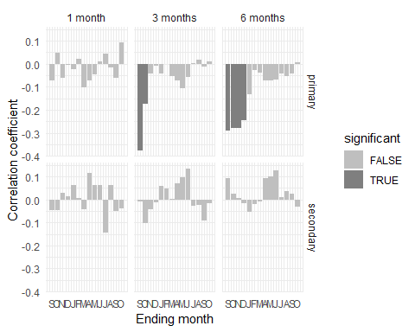

Deprecated code kept for reference