**ITERATION 1**

**Updated Case Diagram/ Iteration 1 Case Diagram**

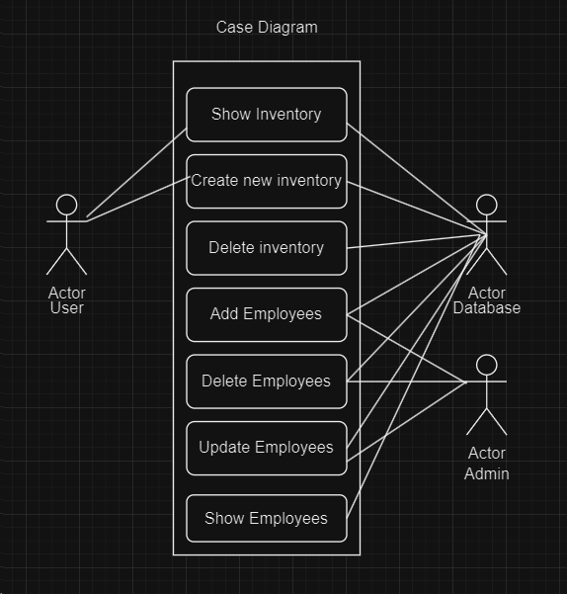

**Updated Use Case Scenarios/ Iteration 1 Scenarios (Due to project switching)**

Scenario 1

Use case: User Views Inventory

Actors: User, Database

Goal: User views the inventory

|  |  |  |  |
| --- | --- | --- | --- |
|  | Actor/User’s Action |  | System’s Response |
|  |  | 1 | System prompts user with login screen |
| 2 | User inputs username and password and clicks Sign In | 3 | System checks if the credentials match/verify and takes user to the home page |
| 4 | User selects Navigate option at top left corner | 5 | System shows various options to the user |
| 6 | User selects Inventory | 7 | System shows Lego Inventory DBMS with Set Name, Item Number, Price, Quality and Last received date |

Scenario 2

Use case: Adding/Updating inventory

Actors: User, Database

Goal: Add or update new product to inventory

|  |  |  |  |
| --- | --- | --- | --- |
|  | Actor/User’s Action |  | System’s Response |
|  |  | 1 | System prompts user with login screen |
| 2 | User inputs username and password and clicks Sign In | 3 | System checks if the credentials match/verify and takes user to the home page |
| 4 | User selects Navigate option at top left corner | 5 | System shows various options to the user |
| 6 | User selects Inventory | 7 | System shows inventory table with Set Name, Item Number, Price, Quantity and Last received date |
| 8 | User clicks the Add/Update option | 9 | System prompts user to fill in set information |
| 10 | User inputs set credentials and submits | 11 | System updates inventory table and adds the set to the database |

Scenario 3

Use case: Deleting inventory

Actors: User, Database

Goal: Deleting a product from inventory

|  |  |  |  |
| --- | --- | --- | --- |
|  | Actor/User’s Action |  | System’s Response |
|  |  | 1 | System prompts user with login screen |
| 2 | User inputs username and password and clicks Sign In | 3 | System checks if the credentials match/verify and takes user to home page |
| 4 | User selects Navigate option at top left corner | 5 | System shows various options to the user |
| 6 | User selects Inventory | 7 | System shows Lego Inventory DBMS with Set Name, Item Number, Price, Quantity and Last received date |
| 8 | User selects row they want to delete and click the Delete Row button | 9 | System deletes the row from the program and database |

Scenario 4

Use case: Add Employees

Actors: Admin

Goal: To add an employee to the database

|  |  |  |  |
| --- | --- | --- | --- |
|  | Actor/Admin’s Action |  | System’s Response |
|  |  | 1 | System prompts user with login screen |
| 2 | Admin inputs username and password and clicks Sign In | 3 | System checks if the credentials match/verify and takes user to home page |
| 4 | Admin selects Navigate option at top left corner | 5 | System shows various options to the user including Home, Employee, Inventory and Sign Out |
| 6 | Admin selects Employee option | 7 | System shows the Employee table including their employee ID, First Name, Last Name and if they are Manager or not |
| 8 | Admin selects Add option | 9 | System prompts user to fill in employee details |
| 10 | Admin inputs employee credentials and submits | 11 | System updates employee table and adds the employee to the database |

Scenario 5

Use case: Delete Employees

Actor: Admin

Goal: To delete employee information from the database

|  |  |  |  |
| --- | --- | --- | --- |
|  | Actor/Admin’s Action |  | System’s Response |
|  |  | 1 | System prompts user with login screen |
| 2 | Admin inputs username and password and clicks Sign In | 3 | System checks if the credentials match/verify and takes user to Inventory Management page |
| 4 | Admin selects Navigate option at top left corner | 5 | System shows various options to the user including Home, Employee, Inventory and Sign Out |
| 6 | Admin selects Employee option | 7 | System shows the Employee table including their SSN, First Name, Last name and if they are managerial or not |
| 8 | Admin selects the row they want to delete and hits the delete button | 9 | System deletes the row from the program and from the database |

Scenario 6

Use case: Sign up

Actor: User

Goal: Allows the user to make a username and password and have it registered and stored in the database

Precondition: Admin has added the employee with valid credentials into the database

|  |  |  |  |
| --- | --- | --- | --- |
|  | Actor/User’s Action |  | System’s Response |
|  |  | 1 | System prompts user with login screen |
| 2 | User selects sign up button | 3 | System prompts user to enter login credentials |
| 4 | User inputs their login credentials and selects sign up button | 5 | System changes view to home page and adds login information to the database |

***Sequence Diagrams***

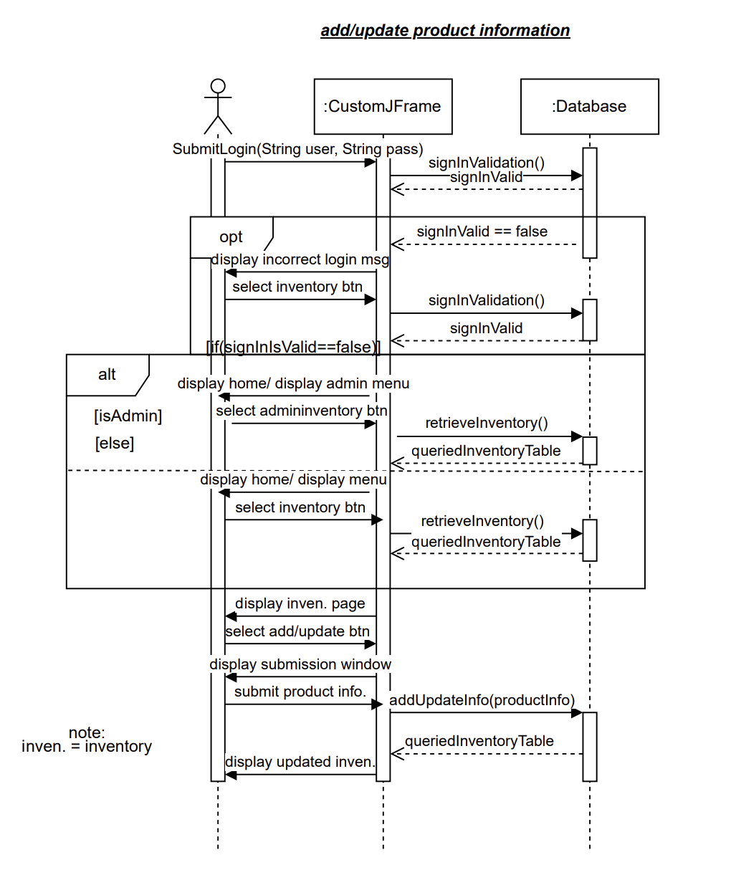

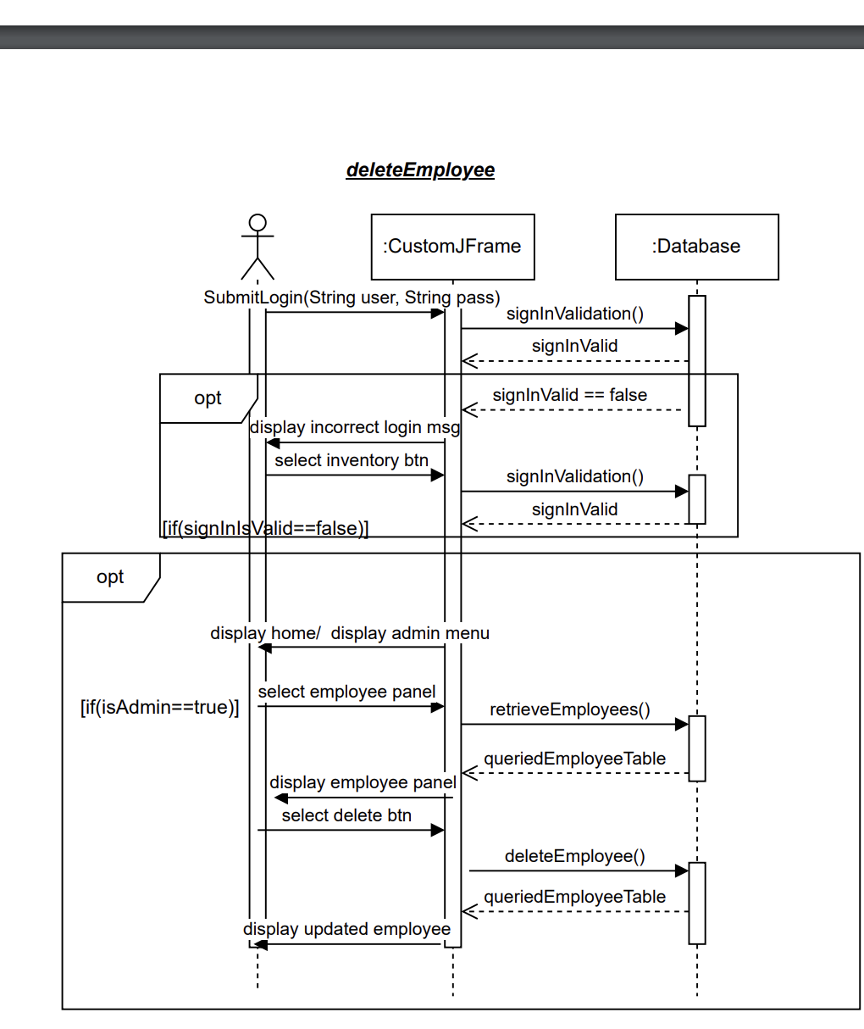

**Updated Class Diagram**

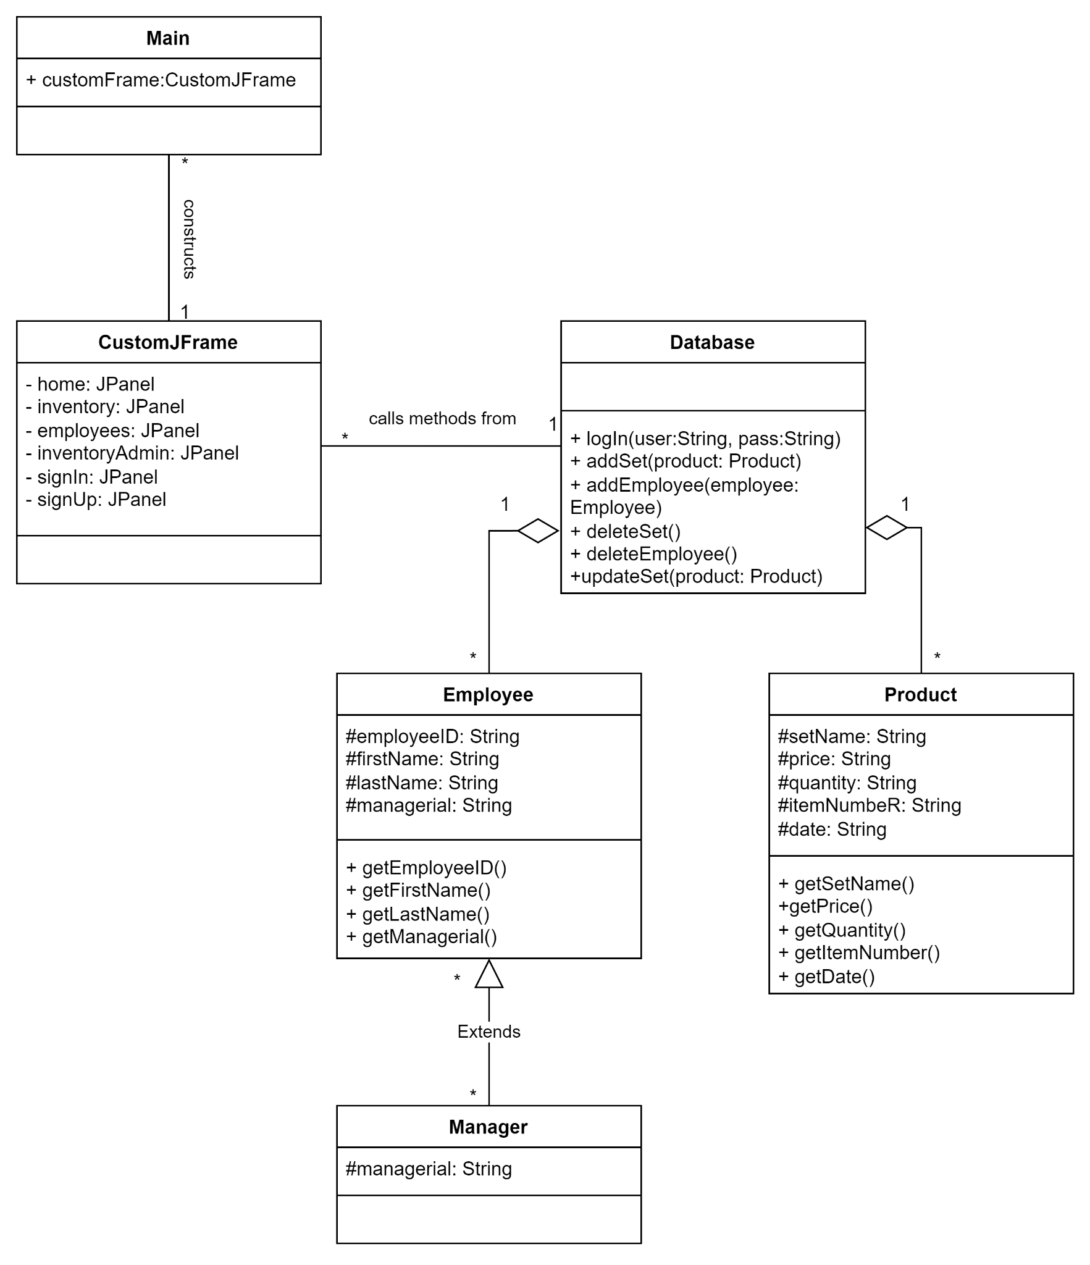

***Commit Logs***

