<https://tailwindcss.com/docs/guides/angular>

npm install -D tailwindcss postcss autoprefixer

npx tailwindcss init

Created Tailwind CSS config file: tailwind.config.js

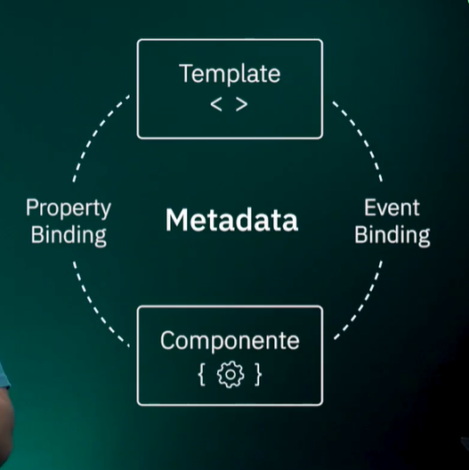

ng g c domains/products/pages/list

ng g c domains/products/components/product

**Tailwind CSS IntelliSense**

Extension para uso vscode

Angular DevTools

Extension para navegador

**Angular Language Service**

Extension para uso vscode

