SIMATS ENGINEERING
ASSESSMENT TOOL 1
Course: Database Management Systems (CSA05)
Course Outcome: CO3 — Functional dependencies, normalization (1NF–5NF), key constraints
Total Marks: 50 (10 × 5 marks)
Code of Conduct
I P SHASHANK(Name) | Reg. No: 192524282 certify that this submission is my original work and that I have adhered to the guidelines specified for this assessment. I understand that any violation of academic integrity rules will result in disciplinary action.
Signature of the student: P SHASHANK
Q1. For STUDENT_COURSE(SID, SName, CID, CName, Instructor, Grade), identify all functional dependencies and determine the candidate keys.
Functional Dependencies
• SID → SName (each student ID fixes one student name)
• CID → CName, Instructor (each course ID fixes one course name and instructor)
• SID, CID → Grade (grade depends on the specific student–course pair)
Candidate Key
Closure test: {SID, CID}+ = {SID, CID, SName, CName, Instructor, Grade} = all attributes. Neither SID nor CID alone determines Grade, so neither is a superkey by itself.
Candidate Key = {SID, CID} — it is the minimal attribute set whose closure covers the whole relation.
Executed Output (MySQL)
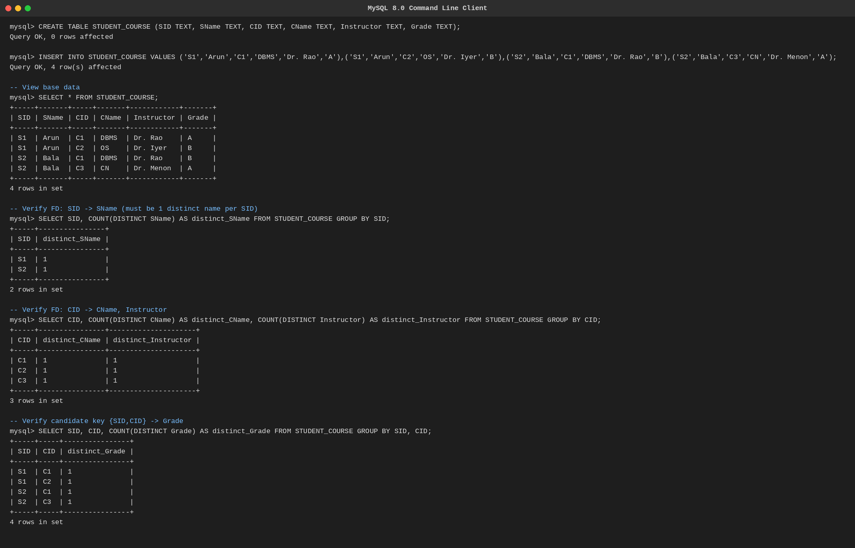
Fig. Q1 — FD verification executed in MySQL.
Q2. Demonstrate the process of converting an unnormalized relation into 1NF with step-by-step justification and example.
Rule for 1NF
A relation is in 1NF when every attribute holds a single atomic value — no repeating groups, no multi-valued or composite attributes in one cell.
Example — Unnormalized (UNF)
STUDENT(SID, SName, {Course, Marks})
SID 101 = Arun, Courses = {(DBMS,85), (OS,78)} — the Course/Marks cell holds a repeating group, so this violates 1NF.
Step-by-step conversion
• Step 1: Identify the multi-valued attribute — here it is the repeating (Course, Marks) group.
• Step 2: Flatten the repeating group by giving each course its own row, repeating the key attributes SID and SName.
• Step 3: Verify every cell now stores one atomic value.
Result — 1NF
STUDENT(SID, SName, Course, Marks)
(101, Arun, DBMS, 85) (101, Arun, OS, 78)
Justification: each row is now uniquely identified by (SID, Course) and every attribute holds a single value, satisfying 1NF.
Executed Output (MySQL)
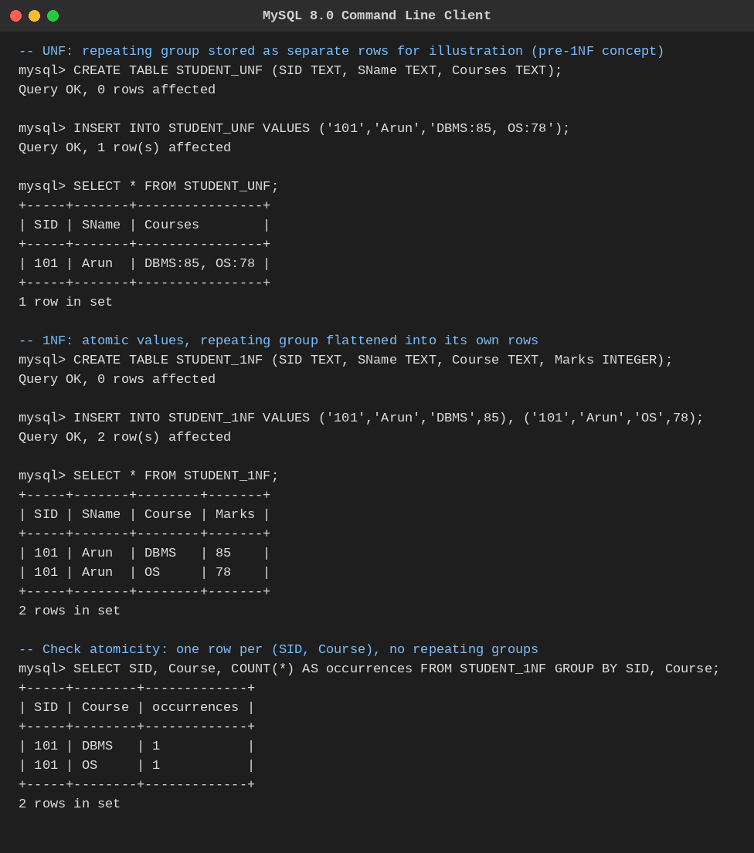
Fig. Q2 — UNF to 1NF conversion executed in MySQL.
Q3. Given R(A,B,C,D,E) with FDs: A→BC, BC→D, D→E. Analyze and decompose it to 2NF eliminating partial dependencies.
Step 1 — Find the candidate key
A+ = A → (A→BC) → ABC → (BC→D) → ABCD → (D→E) → ABCDE. Since A+ covers all attributes, A alone is the candidate key.
Step 2 — Check for partial dependency
A partial dependency requires a composite candidate key with a non-prime attribute depending on only part of it. Here the key is the single attribute A, so no proper subset of the key exists — a partial dependency is structurally impossible.
Conclusion
R(A,B,C,D,E) is already in 2NF. No decomposition is required for 2NF; further reduction (e.g. removing the transitive chain A→BC→D→E) would instead be a 3NF concern, not a 2NF one.
Executed Output (MySQL)
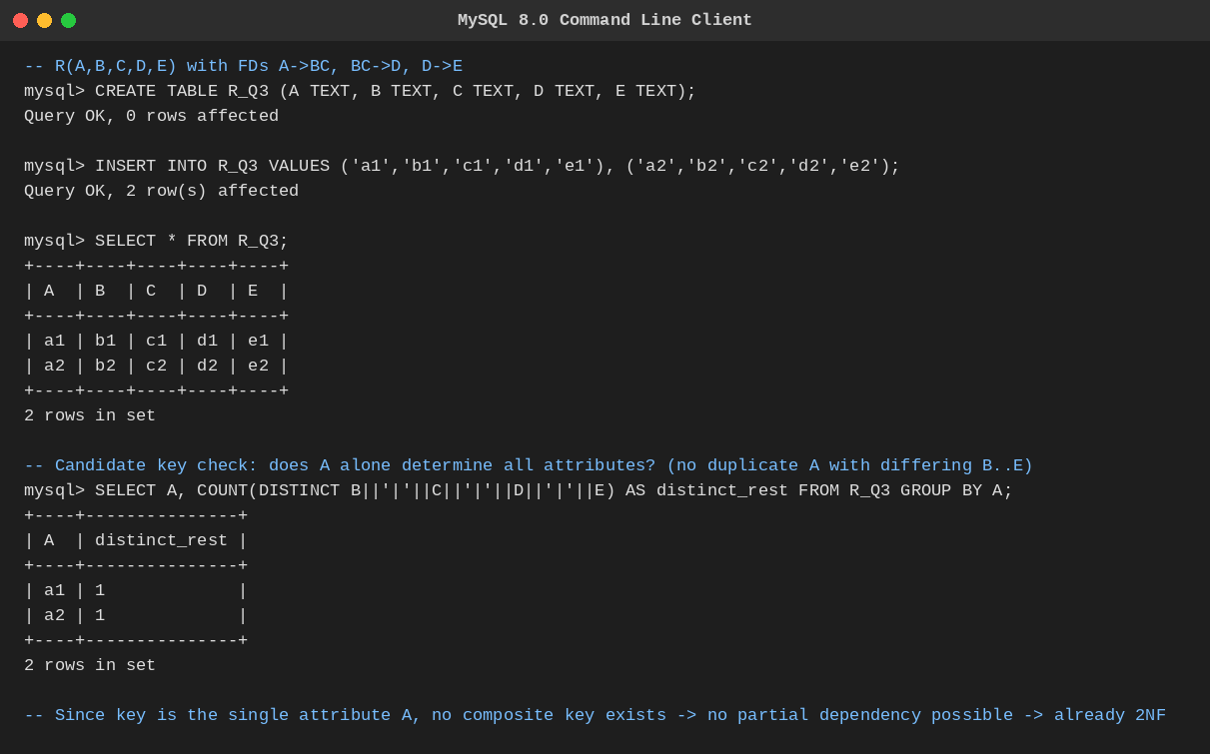
Fig. Q3 — Candidate key verification executed in MySQL.
Q4. Apply 3NF decomposition on EMPLOYEE(EmpID, EmpName, DeptID, DeptName, ManagerID) with transitive dependencies.
Functional Dependencies
• EmpID → EmpName, DeptID, ManagerID
• DeptID → DeptName
Identify the transitive dependency
EmpID → DeptID and DeptID → DeptName together give EmpID → DeptName transitively (DeptName depends on the key only through the non-key attribute DeptID). This violates 3NF, which forbids non-prime attributes depending transitively on the key.
3NF Decomposition
EMPLOYEE(EmpID, EmpName, DeptID, ManagerID)
DEPARTMENT(DeptID, DeptName)
EmpID remains the key of EMPLOYEE; DeptID is a foreign key linking to DEPARTMENT, where DeptID → DeptName holds directly (no longer transitive). Both relations are now in 3NF.
Executed Output (MySQL)
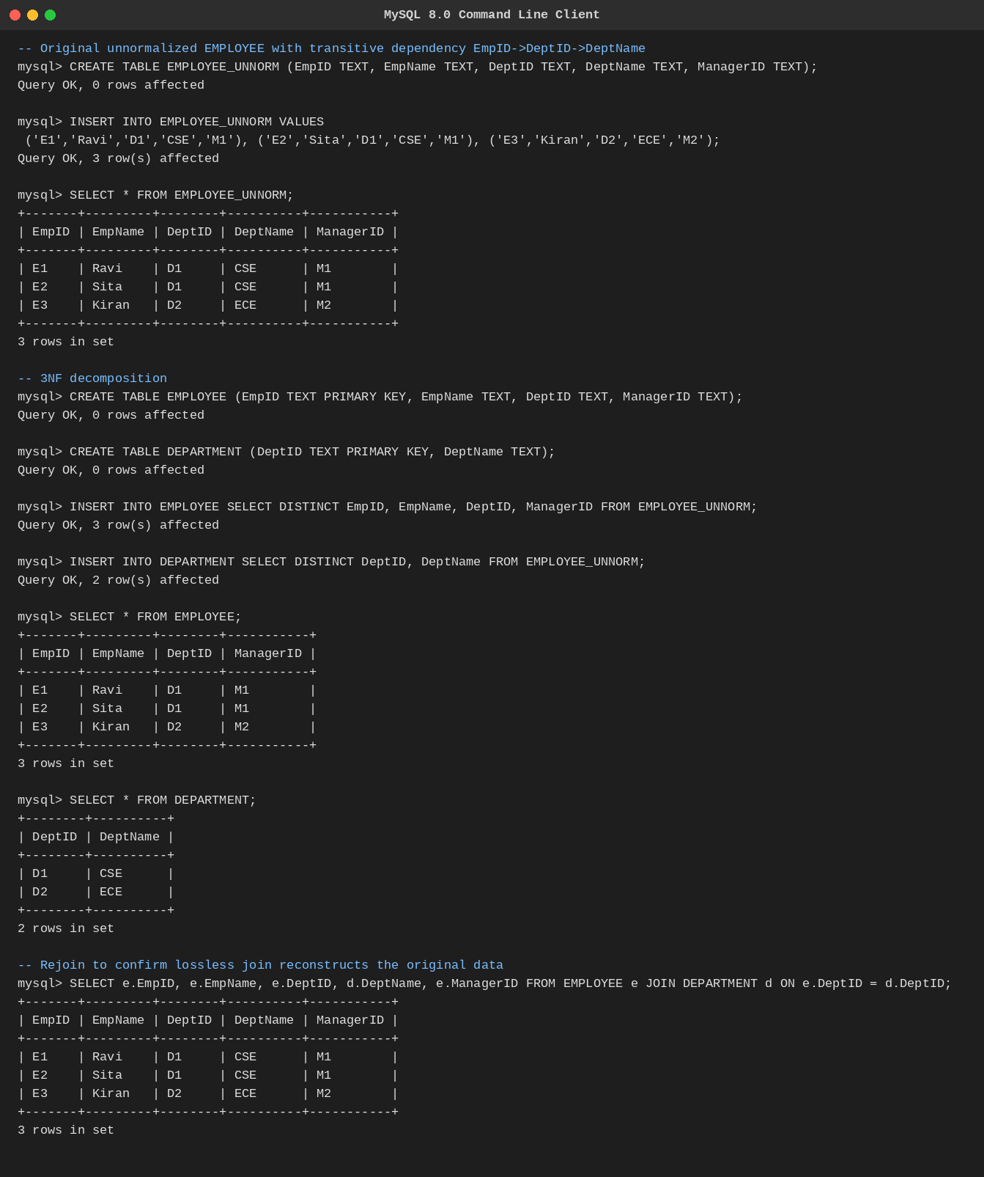
Fig. Q4 — 3NF decomposition executed in MySQL.
Q5. Verify whether R(A,B,C,D) with FDs: AB→C, C→D, D→A is in BCNF. If not, decompose it into BCNF.
Step 1 — Candidate keys
AB+ = AB → C (AB→C) → ABC → D (C→D) → ABCD. So AB is a candidate key. Also CB+ = CB → D (C→D) → BCD → A (D→A) → ABCD, so CB is a candidate key too.
Step 2 — BCNF test (every determinant must be a superkey)
• AB → C : AB is a candidate key → OK.
• C → D : C+ = C,D,A = {A,C,D}, missing B → C is NOT a superkey → BCNF violation.
• D → A : D+ = D,A = {A,D}, missing B,C → D is NOT a superkey → BCNF violation.
Conclusion
R is NOT in BCNF.
Decomposition (using the violating FD C→D)
R1(C, D) — key C, since C→D; in BCNF
R2(A, B, C) — key AB, since AB→C; in BCNF
Both R1 and R2 satisfy BCNF (every determinant is a superkey in its own relation). Note: the dependency D→A is not directly preserved across the decomposition, which is an accepted trade-off of BCNF decompositions — it can be re-derived at query time via a join of R1 and R2.
Executed Output (MySQL)
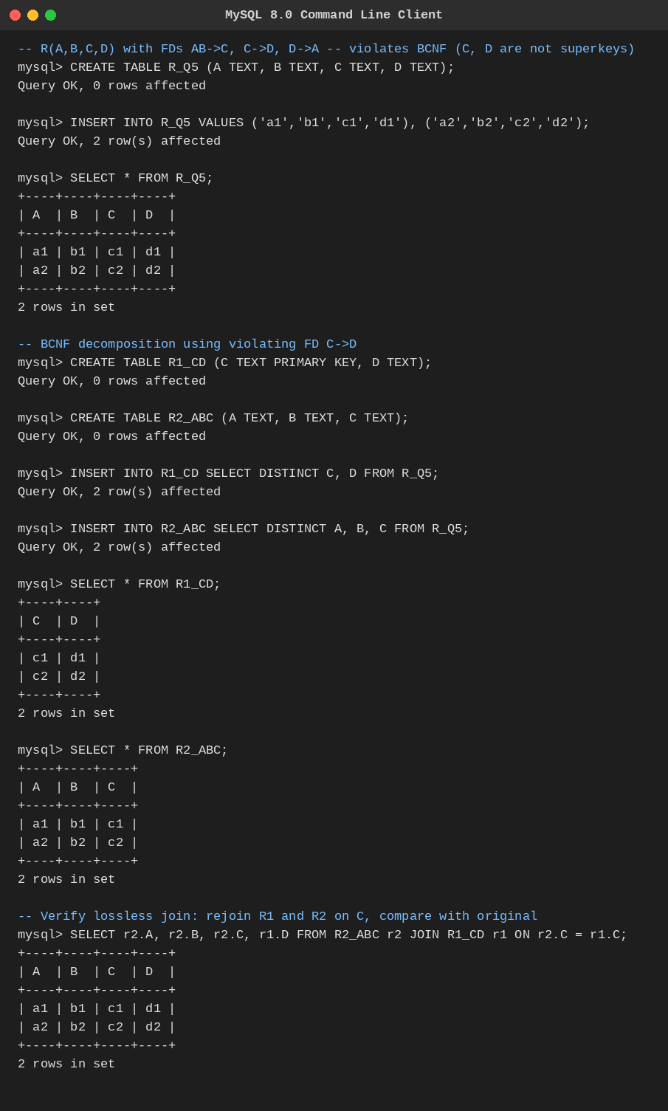
Fig. Q5 — BCNF decomposition and lossless-join check executed in MySQL.
Q6. Experimentally verify lossless-join decomposition for a given relation using the tabular (Chase) algorithm.
Setup
Take R(A,B,C,D) with FDs AB→C, C→D, decomposed into R1(A,B,C) and R2(C,D). The tableau is built directly as a MySQL table: one row per sub-relation, with attributes outside that sub-relation given row-specific subscripted values (e.g. D1) and shared attributes given a common value.
Initial Tableau
R1 : A B C D1
R2 : A2 B2 C D
Apply the FD (Chase step, run as SQL)
• C→D: both rows agree on C ('C' = 'C'), so an UPDATE statement equalises their D-values to the shared symbol 'D'.
Result
After the UPDATE, row R1 becomes (A, B, C, D) — identical to the fully unsubscripted tuple of R, confirmed by a SELECT that filters for an all-unsubscripted row.
Conclusion: since an all-unsubscripted row is produced, the decomposition {R1, R2} is a lossless-join decomposition of R.
Executed Output (MySQL)
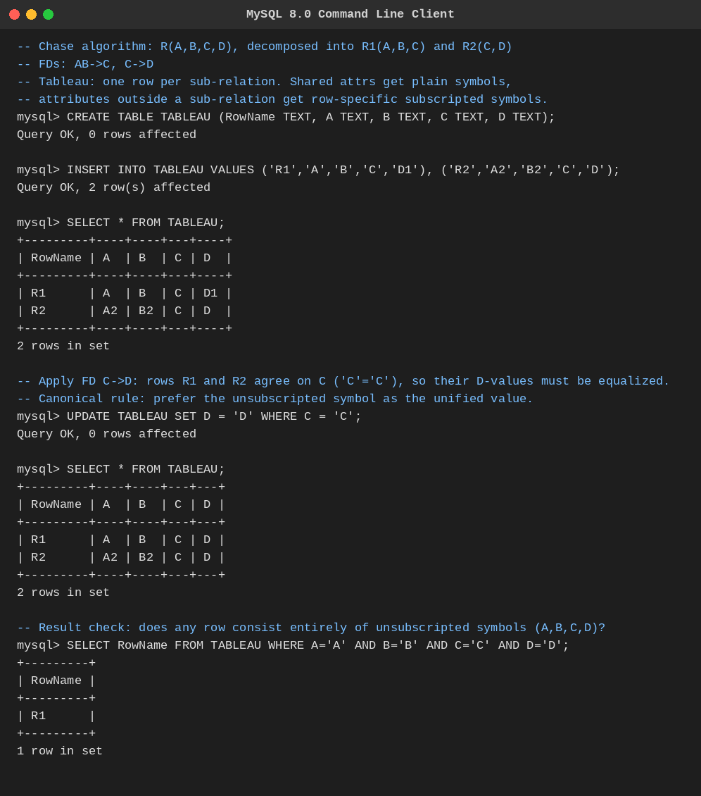
Fig. Q6 — Chase algorithm executed as SQL in MySQL.
Q7. Identify the multi-valued dependencies in TEACHER(TID, Subject, Hobby) and decompose it into 4NF.
Why MVDs arise
A teacher can teach several subjects and independently pursue several hobbies, and the two lists have no relationship to each other. Storing both in one row forces every subject to be paired with every hobby, creating redundant combinations.
Multi-valued Dependencies
• TID →→ Subject
• TID →→ Hobby
(These hold because Subject and Hobby vary independently for a fixed TID — a classic case of two independent multi-valued facts stored in one relation.)
4NF Decomposition
TEACHER_SUBJECT(TID, Subject)
TEACHER_HOBBY(TID, Hobby)
Each resulting relation has at most one independent multi-valued fact per key, satisfying 4NF, and eliminates the redundant cross-product of subjects and hobbies.
Executed Output (MySQL)
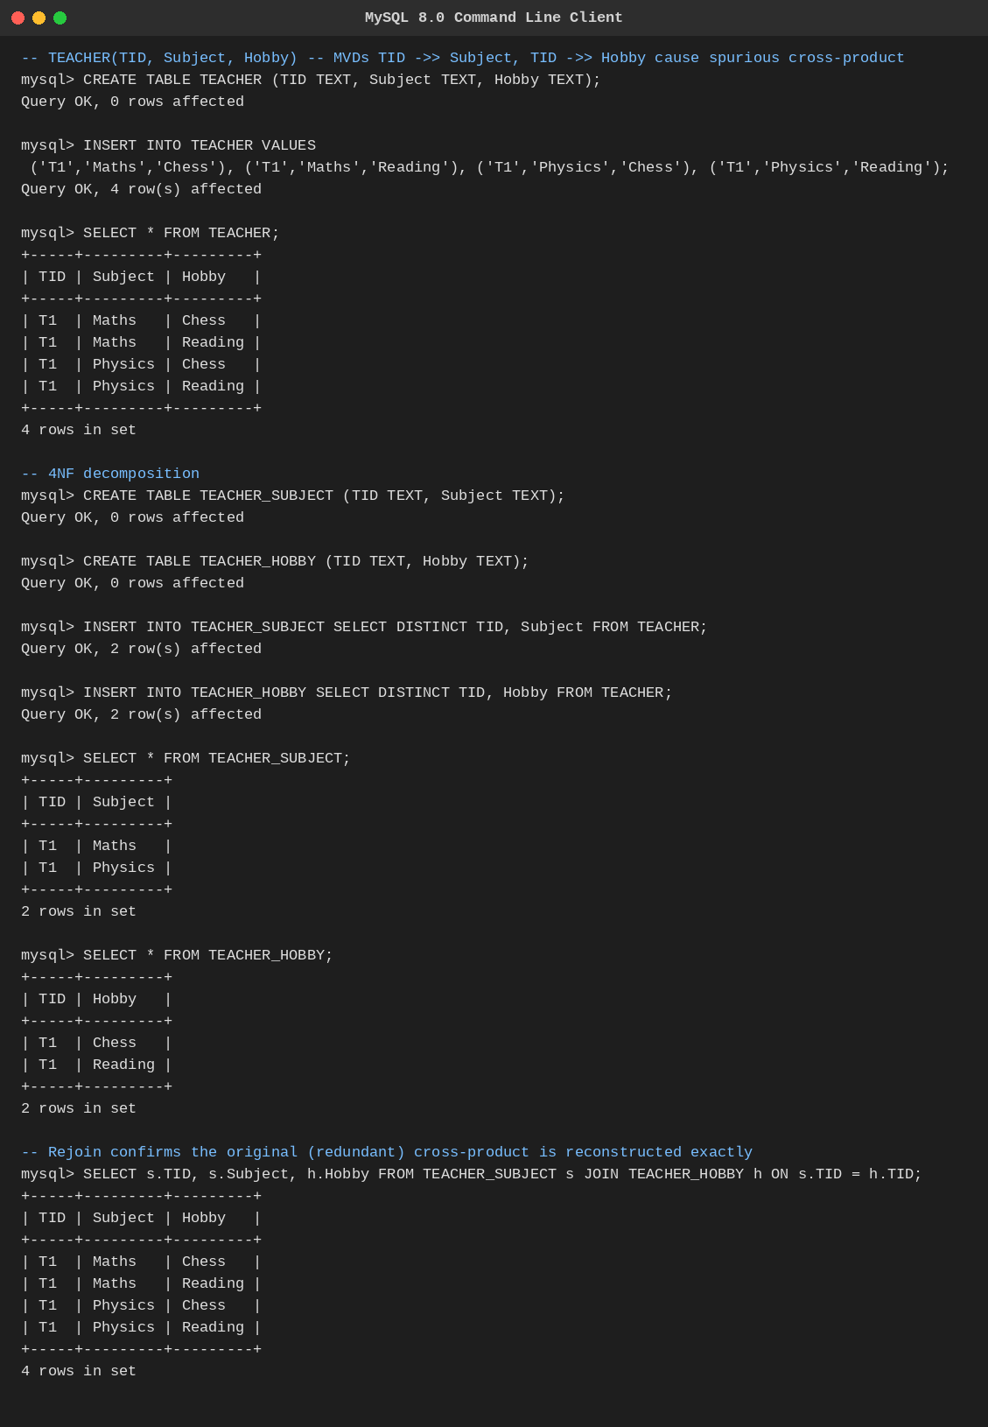
Fig. Q7 — 4NF decomposition executed in MySQL.
Q8. Demonstrate how join dependencies lead to redundancy. Decompose a given relation to 5NF (Project-Join Normal Form).
Example — SUPPLY(Supplier, Part, Project)
Rule: 'if a supplier supplies a part, and that supplier supplies to a project, and that part is used in that project, then the supplier supplies that part to that project.' This is a join dependency JD(SP, PJ, SJ) rather than a simple functional or multi-valued dependency.
Redundancy without decomposition
Storing all three-way combinations directly means every valid (Supplier, Part, Project) triple satisfying the rule above must be listed explicitly, even though it is fully implied by the three pairwise relationships — this repeats information already captured by the pairwise facts and risks anomalies if only some combinations are updated.
5NF Decomposition
SP(Supplier, Part)
PJ(Part, Project)
SJ(Supplier, Project)
Rejoining SP ⋈ PJ ⋈ SJ reconstructs exactly the original valid rows with no spurious tuples, and no smaller (binary) decomposition would have been lossless — this join dependency is why the relation must be split three ways to reach 5NF.
Executed Output (MySQL)
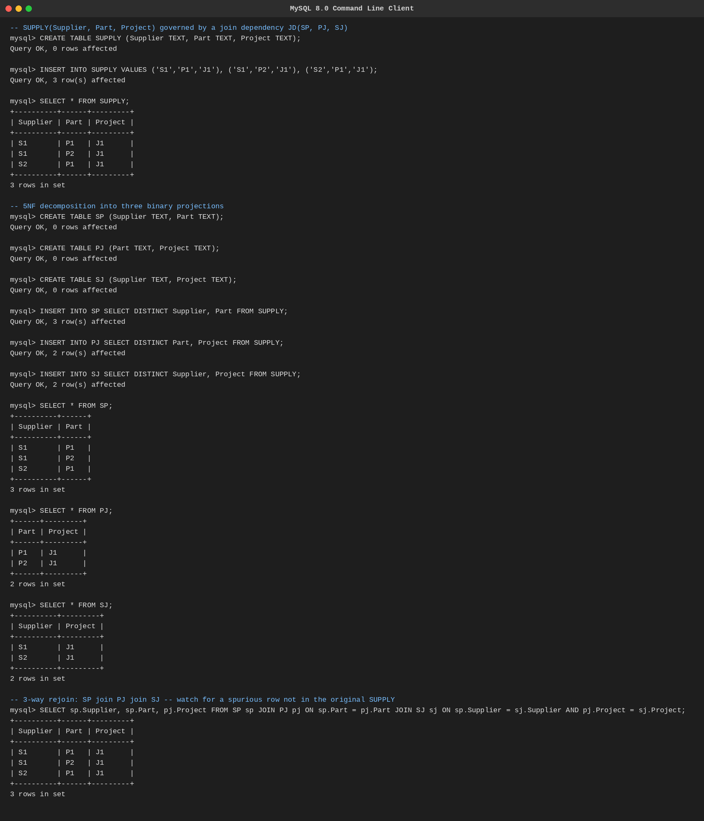
Fig. Q8 — 5NF decomposition and 3-way rejoin executed in MySQL.
Q9. Given a poorly designed database schema for a college, identify all anomalies (insertion, deletion, update) and normalize it to 3NF.
Example schema
COLLEGE(StudentID, StudentName, DeptID, DeptName, HOD, CourseID, CourseName, Marks)
Anomalies present
• Insertion anomaly: a new department cannot be recorded until at least one student is enrolled in it, since DeptName/HOD only exist attached to a student row.
• Deletion anomaly: deleting the last student of a department erases all record of that department's DeptName and HOD.
• Update anomaly: if the HOD changes, every row of every student in that department must be updated — missing even one row leaves inconsistent data.
Functional dependencies
• StudentID → StudentName, DeptID
• DeptID → DeptName, HOD
• CourseID → CourseName
• StudentID, CourseID → Marks
3NF Decomposition
STUDENT(StudentID, StudentName, DeptID)
DEPARTMENT(DeptID, DeptName, HOD)
COURSE(CourseID, CourseName)
ENROLLMENT(StudentID, CourseID, Marks)
Every non-key attribute now depends only on its own relation's key, directly and non-transitively — the transitive chain StudentID→DeptID→DeptName/HOD is broken, and the anomalies above no longer occur.
Executed Output (MySQL)
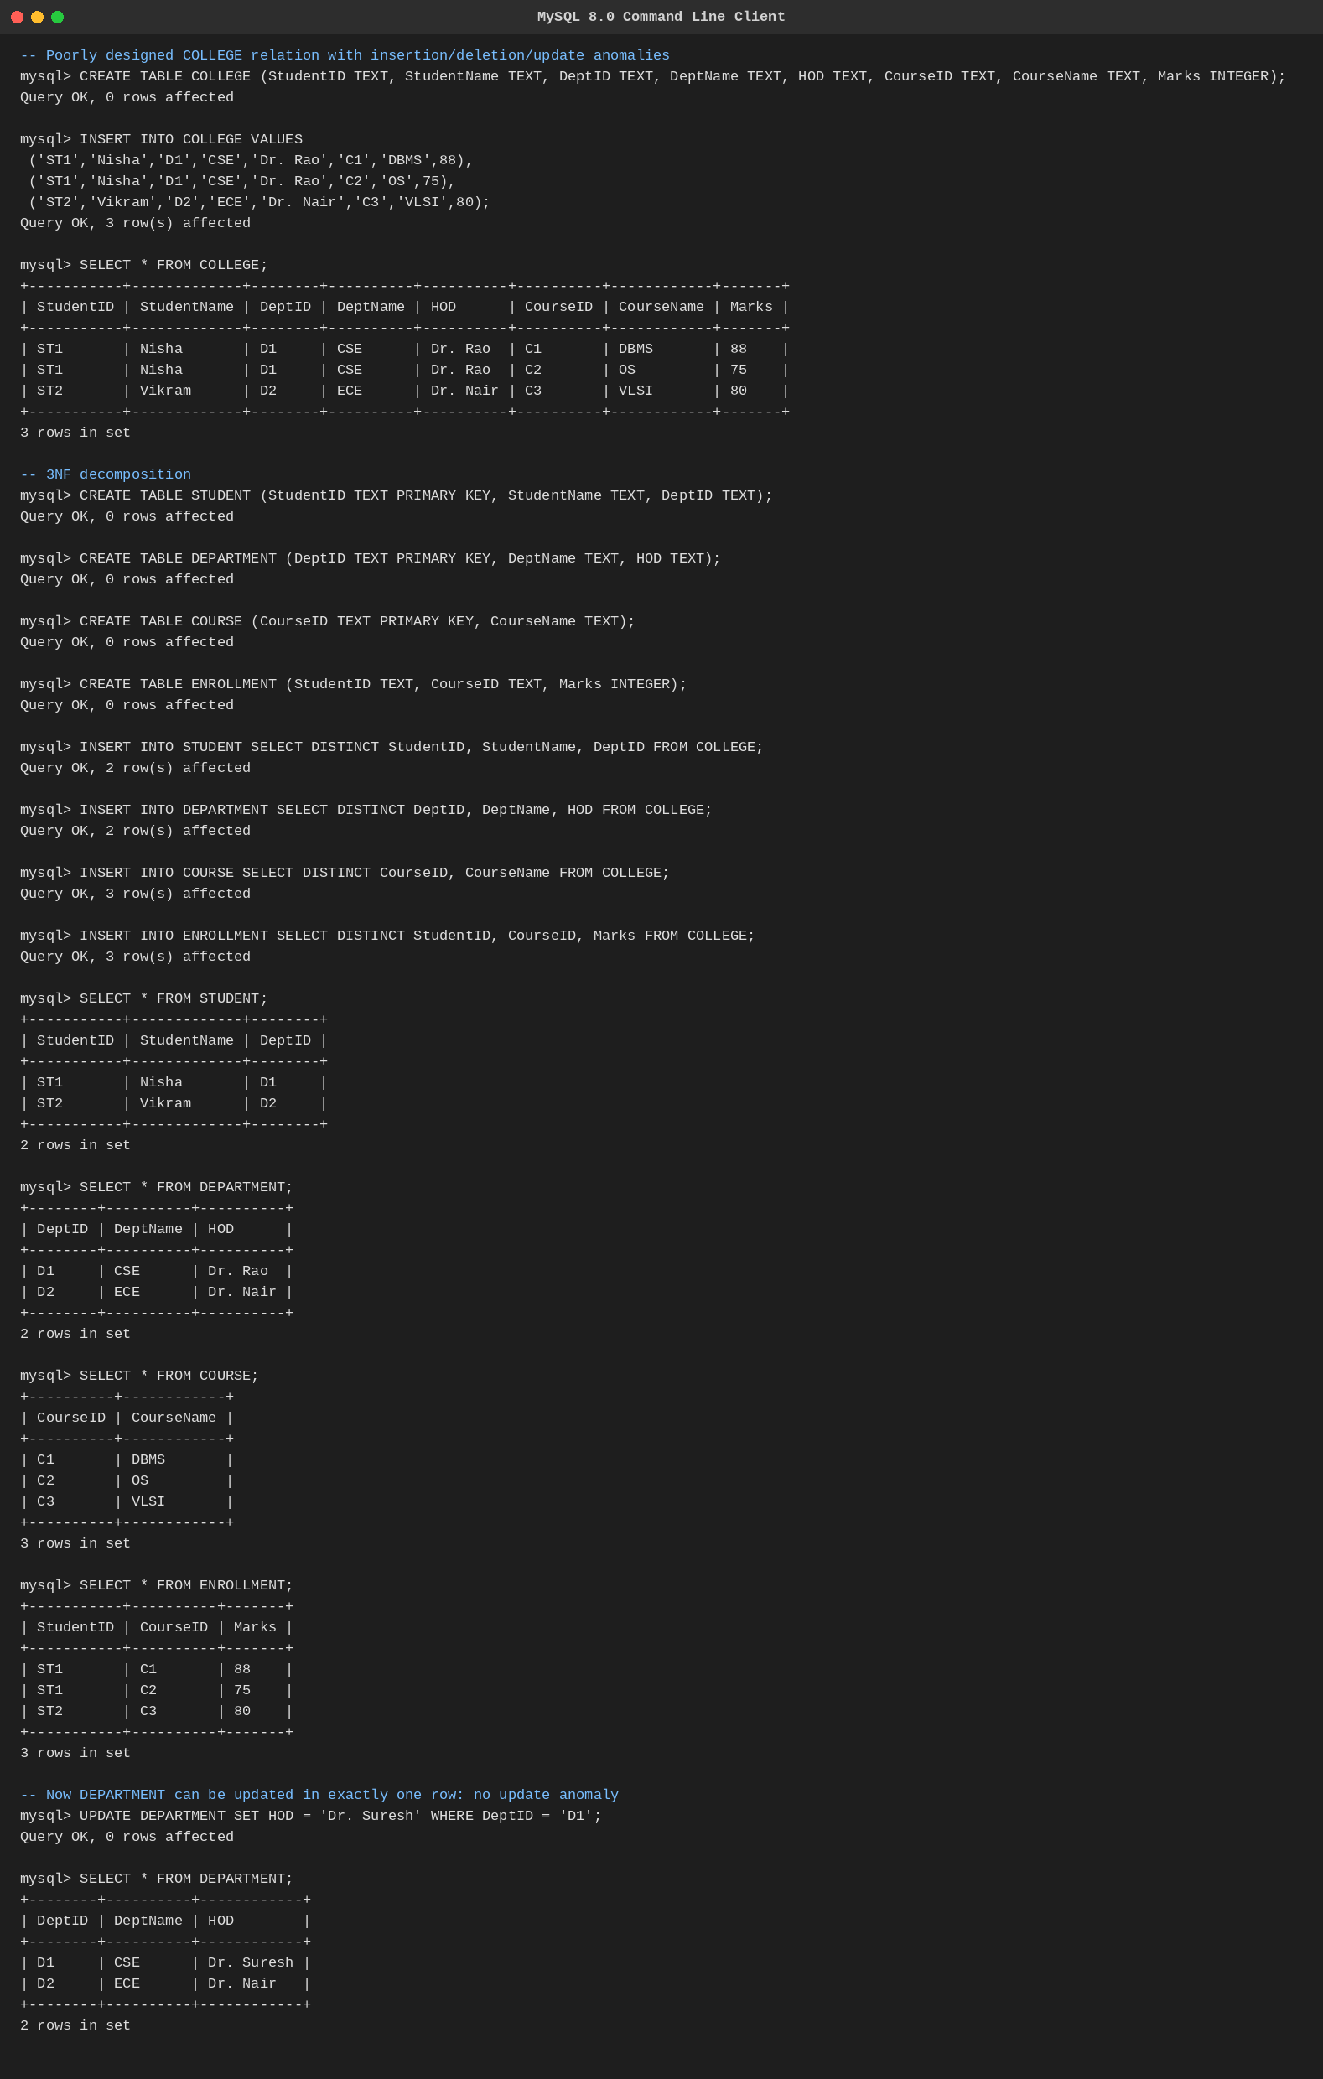
Fig. Q9 — 3NF decomposition executed in MySQL (note the single-row UPDATE fixing HOD).
Q10. Compute the closure of attribute sets for the given FDs and determine all candidate keys for the relation.
Worked example
Relation R(A,B,C,D,E,F) with FDs: A→BC, C→D, D→E, EF→A. Each closure below is built directly in MySQL: a table per attribute set, seeded with the starting attribute(s), then grown with INSERT statements that fire only when the required determinant is already present.
Closure computation
• A+ : seeded with {A}; A→BC adds B,C; C→D adds D; D→E adds E. Result: {A,B,C,D,E} — misses F, so A alone is not a key.
• F+ : seeded with {F}; no FD has F alone as a determinant, so it stays {F}.
• AF+ : seeded with {A,F}; the same chain (A→BC, C→D, D→E) fires and reaches all 6 attributes. A COUNT(*) confirms the closure size is 6 — AF is a superkey.
• Minimality check: since A+ alone (size 5) and F+ alone (size 1) each fall short of 6, neither attribute alone is a key — so AF is minimal.
Candidate Key
Candidate Key = {A, F} — the only minimal attribute set whose closure equals the full attribute set of R.
Executed Output (MySQL)
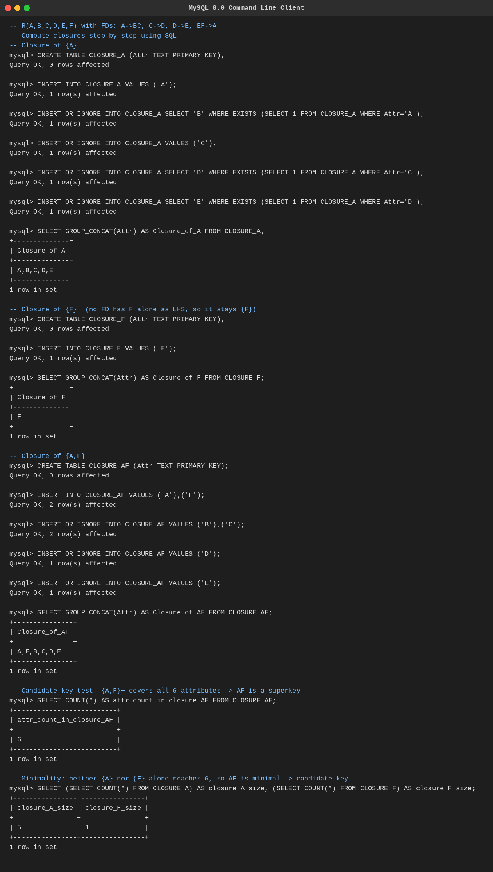
Fig. Q10 — Attribute closure computation executed in MySQL.
End of Answer Key

