# CHAPTER ONE

# Introduction

Technology is spreading its wing in almost every walks of human life activities. Now a day it is better if every activity is done using new technology in order to fulfil the need of human being, Organization, Enterprise etc. As today’s world there are many organizations and each organizations needs to be preferable, computable and work on fastest way in order to satisfy users interest etc. i.e. they should have facilitate their activities in computerized way.

Hence Pharmacy management system is a management system that is designed to improve accuracy and to enhance the performance of the task in the pharmacy. It is a computer based system which helps to the employee inside the pharmacy to facilitate the activity of the pharmacy in a manner way.

In the pharmacy there are two places in which the drug are available. Those are stock and store. The stock is the place in which the drug that needs to be sold is stored. And the store is the place in which the new bought drug is stored.

At present manual system is being utilized in the pharmacy. It requires the pharmacist to manually monitor each drug that is available in the pharmacy. This usually leads to mistakes as the workload of the pharmacist increases.

## 1.1 Background of the project

Eskinder pharmacy which is found in Debre Berhan town was established in 2002 EC. Now it gives an honourable service for the society. Supply and demand of Eskinder pharmacy is based on market needs. The Employee uses the manual system in order to manage the overall activity of the pharmacy.

Today with the growth of population number, our world is facing serious problems. Many organizations are in trouble to accommodate these large numbers of people according to their needs. Many problems in the organizations are associated with the increasing number of customers and way of helping them. Currently, all activities of pharmacy system are going on manually, which lead to wastage of time, labour, accuracy, and speed. Pharmacy System is the backbone of the medical health sector. So it should be advanced and computerized to provide fast services for the customer and also for other users of the system like manager, pharmacist, store coordinator and cashier.

**1.2 Statement of the Problem**

* Managing a very large pharmacy with records on papers will be tedious and difficult to keep track of inventory with regards to the drugs in the stock or store inside the pharmacy.
* Since it is manual system quantity of drugs available based on the categories and their functions can’t be easily known. Due to this the patient can’t get the drug they want.
* Difficulty of getting full information about drugs when needed immediately.
* Preparing report for each drug takes long time.
* It is difficult to identify which drugs are out dated or expired.
* The most sensitive data is lost because of they are paper based.
* Most of the time redundant data occur.

**1.3 Objective of the project**

### 1.3.1 General objective

The main objective of this project is to develop a Web Based Pharmacy Management System which solves the above mentioned problems with the existing system.

### 1.3.2 Specific objective

In order to achieve the main objective, we have the following specific objectives:

* Previous System analysis.
* Current System design.
* To create fast and reliable system.
* To design a user friendly interactive system.
* Automating drug selling.
* To Check decreasing and increasing items in stock or store.
* To Delete or remove expired drugs.
* To Generate report with in short period of time.

## 1.4 Scope and limitation of the project

## 1.4.1 Scope of the project

The scope of the project is listed in the following:-

* New store item registration.
* Check availability items in the data base.
* Store and stock item expired date checking before the actual expired date reaches.
* System checks expired date whenever the users login.
* System response when the user sells expired drugs.
* Sale drugs.
* Manage account.
* Register employee.
* Delete employee.
* View report.
* Register money.
* Generate report.

**1.4.2 Limitation of the project**

* Can’t order to take medicine, it only recommend for the entered medical information.
* The system organization does not have any interaction with other organization system.
* The system applies to only Eskinder pharmacy.
* The system does not have any physical control mechanism.

## 1.5 Significance of the project

## As per the scope of the project, the outcome will include the followings:-

## Better stock management.

## Provide better data store in the systems.

## Minimize the cost.

## Facilitate quality control.

## Decrease items damage.

## Better customer satisfaction.

## To reduce resource wastage in terms of time.

## To minimize the work load of the employees.

## Enhance best controlling method for the drug.

## Beneficiaries of the system

Here we described the benefits that are expected to gain after the development of the system.

* **To the system developing team members**
* Having knowledge how real life problem should be solved.
* Going back and forth through each and every system development phase and acquire skill and experience in the developing software.
* **To the pharmacist**
* Decreasing more time consumption.
* Increasing job satisfaction and eliminating tedious tasks.
* Helping pharmacists by facilitating the work load.
* **To the customer**
* To get fast response.
* Have more confidence or trust about the drug.
* Better satisfaction.

## 1.6 Feasibility study

Feasibility study is essential to evaluate the cost and benefits of the new system. On the basis of the feasibility study decision is taken on whether to proceed or to cancel the project.

Need of the feasibility study:

* It determines the potential of the existing system.
* It used to determine/finds out the problem of the existing system.
* To determine all goals of the new system.
* It finds all possible solutions of the problems of the existing system.

**1.6.1 Operational feasibility**

The system to be developed will provide accurate, active, secured service and decreases labour of workers and also it is not limited to particular groups or body. And also it is plat form independent i.e. it run’s in all operating system.

### 1.6.2 Technical feasibility

### The proposed system doesn’t require much technical expertise. The system to be developed by using technologically system development techniques such as PHP, Java script, css and Mysql database without any problems and the group members have enough capability to develop the project. So the system will be technically feasible.

**1.6.3 Schedule feasibility**

Since schedule feasibility is a process of assigning the degree to which the potential time frame and computation date for all major activities within a project meet organizational deadlines, so our project will be continued next.

**1.6.4 Behavioural/Political feasibility**

Since the proposed system is user friend, solve difficulties (problems) with society regarding to traditional pharmacy system and accepted almost by all the customers behaviourally it is feasible.

### 1.6.5 Economic Feasibility (Cost Benefit Analysis)

This stage determines the cost or value analysis. It can be software, hardware, and the people. The new proposed system will be economically feasible because it takes less capital as compared as the existing system.

## 1.7 Methodology for the project

The team chooses object oriented analysis and design approach to analyze and design the system, based on our preliminary analysis of the old system.

In our project the team will use Object Oriented Software Development Methodology (OOSD) because it has the following advantages:-

* **Increase reusability**: - the object oriented provides opportunities for reuse through the concepts of inheritance, polymorphism, encapsulation and modularity.
* **Increased extensibility**: - when there is a need to add new feature to the system you only need to make changes.
* **Improved quality**: - quality of our system must be on time and meet our exceeded the expectation of the users of our system, improved quality comes from increased participation of users in the system development.

### 1.7.1 Data collection method

We use document analysis in order to obtain the information about the practices and problems of the pharmacy which ultimately assists us in developing the computerised system. There are saved documents referred for the preparation of the system. In addition, we use internet access.

**Document analysis:** The team reviewed documents such as books, e-books and some related previously done projects which are very important to develop our project. During the analysis of documents, we give a special consideration to those documents which can bring more features to our system.

**Interview:** This is one of data collection method that enables to gather information from the organization directly in the form of asking question and getting answers for those questions. So, we will use this method to gather information by asking the manager of the pharmacy some basic questions regarding the following issues will be asked during the interview:-

* How drug information management system is going on?
* During managing, are there any problems? If there, what are they?
* What requirements are needed for the process?
* Who is responsible for what?

**Observation:** This is also another data collecting method. In fact we have also used this observation method to gather data. This method enables us observing and understanding how drug information management is going on.

# 1.7.2 System Development Tools

**1.7.3 Programming tools:**

* XAMPP Server 2012
* Rational Rose, Visual Paradigm, E draw:-For designing UML diagrams associated with the project.
* Microsoft office 2010**:-** for documenting the corresponding deliverables associated with the project.
* Php programming language: - for the software developing.
* Edit plus and notepad++:- for writing code.

**1.7.4 Hardware tools:**

* Flash disk
* CD-R
* Personal Computer

### 1.8 Team composition and management

### Table 1.1: Team composition and management

|  |  |  |  |
| --- | --- | --- | --- |
|  | NAME | ID NO | ROLL IN TEAM |
|  | ABDELA EBABU | COMPR/001/04 | DESIGNER |
|  | MUSTAFE MAHAMOUD | COMPR/033/04 | SYSTEM ANALIST |
|  | BEREKET TENAW | COMPR/013/04 | PROGRAMMER |
|  | HARAN HILUF | COMPR/003/04 | MANAGER |
|  | RAHWA GIDAY | COMPR/037/04 | DATA COLLECTOR |

**1.9 Schedule of the project (using Gantt chart)**

This involves questions such as how much time is available to build the new system, when it can be built.

**Table 1.2: Schedule feasibility table using Gantt chart**

|  |  |  |
| --- | --- | --- |
| No. | Task Name | 2007 EC. |
| Nov8,2007- Dec4,2007- Dec26,2007- Feb18,2007- Jun7,2007-  Dec3, 2007 May 25,2014 Jan 30,2007 Jun5,2007 Jun9,2007 |
| 1 | Requirement gathering |  |
| 2 | SRS |  |
| 3 | Design Document |  |
| 4 | Implementation document |  |
| 5 | Operation testing |  |

# 1.10 Cost Analysis

To complete our project starting down from the beginning up to the end of this project we planned the following cost list.

**Table 1.3: shows the cost of the proposed system**

|  |  |  |  |  |
| --- | --- | --- | --- | --- |
| No | Item | quantity | Price per item | Total price |
| 1 | Paper | 250 | 25c | 62.50 |
| 2 | CD | 2 | 10 | 20 |
| 3 | Pen | 5 | 5 | 25 |
| 4 | Mobile card | 10 | 10 | 100 |
| 5 | Print | 80 | 1 | 80 |
| 6 | Binding | 2 | 10 | 20 |
| 7 | Miscellaneous cost | - | - | 550 |
| Total | 7 | 349 |  | 807.5 |

**CHAPTER TWO**

**System Analysis**

## 2.1 Description of the Existing System

The current system of Eskinder pharmacy information management is manual system. That means checking expired date and availability of drugs is done by checking every drug inside the pharmacy. This leads loosing time and resource of the organization. An existing system compromises different players to carry out its job. Among those different actors (players), the most common are:

* P**harmacist**

The customer comes with the ordered prescription then the pharmacist looks that order of drug and gives the drug accordingly. The customer gets his/her requested service from the pharmacist*.*

* **Pharmacy manager**

The manager gets reports from the pharmacist, store coordinator, and cashier. The reports help the manager to see how services are given to the client.

## Store coordinator

Store coordinator is responsible to register the drugs that buy from the private sectors or from the governmental association, and also control the drug that are goes out to the stock.

* **Cashier**

The cashier receives the cost of the drug from the customer ordered by the pharmacist.

### 2.2 Business Rule of the organization

The existing system has its own mechanism in which its customers are treated.

These include:

* The pharmacist must treat customers in good manner and should address customer’s request.
* The cashier should receive the price of medicine honestly from customers and he/she should generate report for manager.
* Manager should control the entire activity in the stock or store and should receive clear and appropriate report from the workers of the pharmacy.
* Sold drug should order in their identifiable type to facilitate searching requested drug.
* Manager should control the overall information from any biases properly.
* Forms should contain stock or store information appropriately.
* Pharmacist doesn’t sell the expired drug.

**2.3 Class Responsibility and Collaboration (CRC) Modeling**

Class Responsibility Collaborator (CRC) Modeling is a collection of standard index cards that have been divided into three sections.

* On top of the card, the class name.
* On the left, the responsibilities of the class.
* On the right, collaborators with which this class interacts with.

**Table 1.4: SHOWS CLASS RESPONSIBILITY AND COLLABORATION (CRC)**

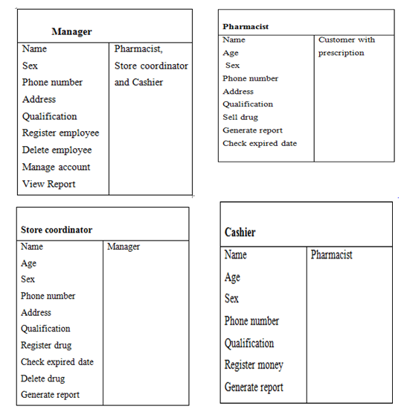

**2.4 Proposed system description**

By carefully analysing and observing the problem of existing system we came up with a solution that the current manual system should be computerised. The computerised system will eliminate/reduce the problem on time, work load and complexity on storing drugs information. The system will include a database for recording drugs that facilitate fast information retrieval, modifying, inserting and deleting. It also includes an attractive user interface that facilitates accessing the database and recording drugs easily.

The system allows the user to enter a manufacturing and expiry date for a particular product or drug during opening stock and sales transaction. It also involves arrival of new batches of drugs, getting information about the drugs e.g. expiry date, number of drug type left, and location of a drug in the pharmacy.

Players represent external entities that interact with the system. They manage and perform the systems functionality.

* Pharmacists having access to the proposed system at any time
* Improving the efficiency of the system by ensuring effective managing of services and activities.
* Generating report
* Reducing the employees’ workload in the organization

**2.5 Purpose of the proposed system**

In the existing system the stock or store management is done manually. Such as:-

* Stock or store controlling.
* Stock items searching and selling.
* Stock or store items expire date checking.
* New store item registration.

All the above lists are made in the existing system performs manually. To solve this problems, the proposed system will change manual system into computerized system as per its purpose:

* To decrease the time for shopping of medicines from the pharmacy.
* To know the medicine that is finished in the pharmacy and replaces it by new medicine in computerized way.
* To know the medicine which their expired date is reached or passed.
* To bring better satisfaction for the customer.
* To decrease the work load of the pharmacist or store coordinator.
* Minimize the cost.

### 2.6 Functional Requirement and Nonfunctional Requirements

### 2.6.1 Functional requirement

## The functional requirement is the services that are provided by the system. It also describes the interactions between the system and the user, and any other external system.

## The new system is expected to provide the following functionalities.

* **Input requirement**
* Search user request.
* Verify the requested information.
* Stock or store items must be check by item name.
* Each input item information must include item id, item name, code, quantity, manufactured date, manufactured company, and expired date.
* **Output requirement**
* The system display report for the manager.
* The system should store all the data related with all the tasks performed into a database
* Display stock or store item that are reach to expired date.
* Display employee information to the manager
* When there is no item in the stock or store the system response the low stock or store items.
* The system displays the notification about the expired drug whenever the user enters to its page if there.

**2.6.2 Non functional requirement**

#### Non functional requirement describes user visible aspects of the system that are not designed to the functional behavior of the system. Some of the non functional requirements are:

#### Performance

#### The system will function fast.

* Very short response time.
* The system must be operationally all over the year.
* **User interface**
* The system should be user-friendly interactive.
* The pharmacist can easily retrieve information in the stock.
* The skilled person interacts with the system properly.
* **Security and access permission**
* The system should allow login to only authorized users.
* **Storage requirement**
* The system should store all the data related with all the tasks performed into the database

**2.7 Use case diagram**

Use Case represents interaction between a user (human or machine) and the system.

Use case components:

* **Actor:** is a person, or external entity that plays a role in one or more interaction with the system.
* **Use case:** describes a sequence of actions that provides something of measurable value to an actor and is drawn as a horizontal ellipse.
* **System boundary:** indicates the scope of the system project. Anything within the box represent functionalities in side with in scope.

**2.7.1 Actor identification**

In the use cases an actor interact with the system to perform a piece of meaningful work that helps them to achieve a goal and has access to define their overall role in the system and the scope of their action. Depending on the above explanation actors in this system are the following:

* **Manager:** Controls the overall activity in the shop.
* **Pharmacist:** Manages the drug information in the stock.
* **Store coordinator:** Manages the outgoing and incoming drug from the store.
* **Cashier:** Collect the price of the sold items and generate report to the manager.

**2.7.2 Use case identification**

Each Use Case describes the functionality to be built in the proposed system, which can include another Use Case's functionality or extend another Use Case with its own behavior. The most important and basic use cases of this system are the following:-

* Login
* Manage account
* Register employee
* Delete employee
* Register drug
* Delete drug
* Check expire date
* Sale Drug
* Register money
* View Report
* Generate Report

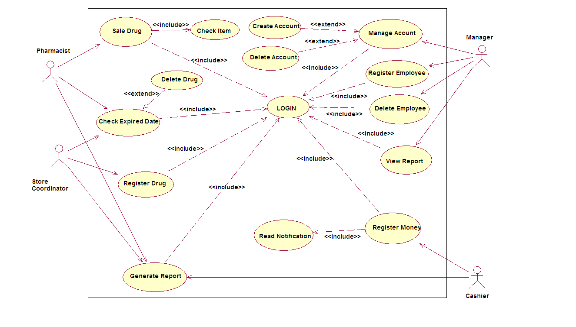***Figure 2.1: Use case diagram***

**2.7.3 Use Case Documentation**

**Table 2.1: Use case description for login**

|  |  |
| --- | --- |
| **Name** | **Login** |
| **ID** | **UC1** |
| Actors | Manager, Pharmacist, Casher, Store coordinator |
| Description | In order to get into or access the system |
| Pre condition | 1. The Manager, Store coordinator, pharmacist, or Cashier must open the system |
| Flow of events | 1. Open the system. 2. Click on login link. 3. Login form displayed. 4. Select account type and enter enter user name and password. 5. Click on the login button. 6. System verifies in the account database. 7. Main form displayed. 8. End of use case. |
| Post condition | 1. Access the system |

**Table 2.2: Use case description for manage account**

|  |  |
| --- | --- |
| **Name** | **Manage Account** |
| **ID** | **UC2** |
| Actors | Manager |
| Description | Create new account, delete an account. |
| Pre condition | 1. The manager initiates the system. 2. The manager should have a valid user name and password. |
| Flow of event | 1. The manager opens the system. 2. The manager log to his or her page. 3. The manager click on the create account or delete account link. 4. The system displays create or delete account form. 5. The manager inserts the necessary information of the user. 6. The manager clicks on sign up or delete button. 7. The system verifies the inserted information. 8. Then the system will generate successfully message 9. End of use case. |
| Post condition | 1. Access the system 2. Close the system |

**Table 2.3: Use case description for employee registration**

|  |  |
| --- | --- |
| **Name** | **Employee Registration** |
| **ID** | **UC3** |
| Actor’s | Manager |
| Description | Register the information of the workers in the pharmacy |
| Pre condition | 1. Initiate the system 2. Have user name and password |
| Flow of event | 1. The manager opens the system. 2. The manager log to his or her page 3. The manager click on the register employee link. 4. The system displays the register employee form. 5. The manager inserts the necessary information of the employee. 6. The manager click on the register button. 7. Then the system will generate successfully message 8. End of use case. |
| Post condition | 1. Access the system 2. Close the system |

**Table 2.4 : Use case description for delete employee**

|  |  |
| --- | --- |
| **Name** | **Delete Employee** |
| **ID** | **UC4** |
| Actor’s | Manager |
| Description | Delete the employee when it is necessary. |
| Pre condition | 1. Initiate the system. 2. Have user name and password. |
| Flow of event | 1. The manager log to his or her page. 2. The manager click on delete employee link. 3. The system displays the delete employee form. 4. The manager enters the id_no of the employee. 5. Click on the delete button. 6. Then the system will generate successfully message 7. End of use case |
| post condition | 1. Return to home page or 2. Close the system |

**Table 2.5: Use case description for view report**

|  |  |
| --- | --- |
| **Name** | **View Report** |
| **ID** | **UC 5** |
| Actor’s | Manager |
| Description | Report can be viewed by the manager |
| Pre condition | 1. Initiate the system. 2. Have user name and password. |
| Flow of event | 1. The manager opens the system. 2. The manager log to his or her page. 3. The manager click on view report link. 4. The system displays the report. 5. End of use case |
| Post Condition | 1. Return to home page or 2. Close the system |

**Table 2.6 : Use case description for drug registration**

|  |  |
| --- | --- |
| **Name** | **Register Drug** |
| **ID** | **UC 6** |
| Actors | Store coordinator |
| Description | Registering the new drug from the store in to the data base. |
| Pre condition | 1. Initiate the system. 2. Have user name and password. |
| Flow of event | 1. The Store coordinator opens the system. 2. The Store coordinator log to his or her page. 3. The Store coordinator click on Register drug link. 4. The system displays the register drug form. 5. The Store coordinator will enter the attributes of the drug. 6. Then click on submit. 7. Then the system will generate successfully message. 8. End of use case |
| Post condition | 1. Return to home page or 2. Close the system |

**Table 2.7: Use case description for check expired date**

|  |  |
| --- | --- |
| **Name** | **Check Expired Date** |
| **ID** | **UC 7** |
| Actors | Pharmacist, Store coordinator |
| Description | In order to check the drug that is the verge of the expired date. |
| Pre condition | 1. Initiate the system. 2. Have user name and password. |
| Flow of event | 1. Open the system. 2. The pharmacist or Store Coordinator log to his or her page. 3. The pharmacist or Store coordinator click on check expired date link. 4. Then the form will be displayed. 5. The pharmacist or Store coordinator enters the expired date of the drug. 6. Then the pharmacist or Store coordinator clicks on search button. 7. The system displays the list of the dug that is inserted in its date. 8. The pharmacist or Store coordinator click on the clear button. 9. Then the system will response successfully message. 10. End of use case. |
| Post Condition | 1. Return to home page or 2. Close the system |

**Table 2.8: Use case description for sell drug**

|  |  |
| --- | --- |
| **Name** | **Sale Drug** |
| **ID** | **UC 8** |
| Actors | Pharmacist |
| Description | To purchase the drug to the customer |
| Pre condition | 1. The customer brings with his/her prescription. |
| Flow of event | 1. The pharmacist opens the system. 2. The home page will be displayed. 3. The pharmacist inserts user name and password. 4. The system will verify the user name and password. 5. The pharmacist click on check list link. 6. The system displays the check list form. 7. The pharmacist enters the name of the drug. 8. The pharmacist click on the check button. 9. Then return to sale drug link. 10. Click on sale drug link. 11. Enter the necessary information of the customer and the drug. 12. Enter the calculate price button. 13. Then click on the load button. 14. Then the system will response successfully message. 15. End of use case. |
| Post condition | 1. Return to home page or 2. Close the system |

**Table 2.9: Use case description for register money.**

|  |  |  |
| --- | --- | --- |
| **Name** | **Register Money** | |
| **ID** | **UC 9** | |
| Actors | Cashier | |
| Description | Register the money which he received by the customer. | |
| Pre condition | 1. The pharmacist load customer detail. | |
| Flow of event | 1. Open the system. 2. The home page will be displayed. 3. The cashier inserts user name and password. 4. The system will verify the user name and password. 5. The Cashier click on the read notification link. 6. The system will display the customer detail. 7. The cashier receives money. 8. The cashier enables the status. 9. Then click on register button. 10. The cashier prints the receipt and give to the customer. 11. End of use case. | |
| Post condition | 1. Return to home page or 2. Close the system | |
|  | |

**Table 2.10 : Use case description for generate report**

|  |  |
| --- | --- |
| **ID** | **UC 10** |
| **Name** | **Generate Report** |
| Actors | Pharmacist, cashier and Store coordinator |
| Description | Generate report to the manager for their respective responsibility. |
| Pre condition | 1. There must be document containing valuable condition. |
| Flow of event | 1. Open the system. 2. The home page will be displayed. 3. The employee inserts user name and password with their account type. 4. The system will verify the user name and password. 5. Then the system display their page. 6. The employees click on generate report link. 7. The system will display the form. 8. The employees fill the form. 9. Then click on submit button. 10. Then the system will display response. 11. End of use case. |
| Post condition | 1. Return to their appropriate page. 2. Close the system |

**2.7 Sequence diagrams**

The sequence diagram is used primarily to show the interactions between objects in the sequential order that those interactions occur. The main purpose of a sequence diagram is to define event sequences that result in some desired outcome.

**Figure 2.2: Sequence Diagram for Login**

**Figure 2.3: Sequence Diagram for register drug**

**Figure 2.4: Sequence Diagram for check expire date**

**Figure 2.5: Sequence Diagram for Delete Drug**

**Figure 2.6: Sequence Diagram for Delete Employee**

**figure 2.7: Sequence Diagram for Sale Drug**

**2.8 Activity diagram**

Activity diagram is another important diagram in UML to describe dynamic aspects of the system. Activity diagram is basically a flow chart to represent the flow of information one activity to another activity.

**figure 2.8: Activity Diagram for Login**



**Figure 2.9: Activity Diagram for Register Drug**



**Figure 2.10: Activity Diagram for Register Employee**



**Figure 2.11: Activity Diagram for Delete Employee**



**Figure 2.12: Activity Diagram for Generate Report**



**Figure 2.13: Activity Diagram for Check Expire Date**



**Figure 2.14: Activity Diagram for Sale Drugs**

**2.9Collaboration diagram**

A collaboration diagram describes interactions among objects in terms of sequenced messages. Collaboration diagrams represent a combination of information taken from class, sequence, and use case diagrams describing both the static structure and dynamic behaviour of a system

**Figure 2.15: Collaboration diagram for Login**

**Figure 2.16: Collaboration diagram for Register Drug**

**Figure 2.17: Collaboration diagram for Check Expired Date**



**Figure 2.18: Collaboration diagram for Delete Employee**

**Figure 2.19: Collaboration diagram for Sale Drug**

**2.10 State chart diagram**

A state chart diagram is a view of a state machine that models the changing behaviour of a state. State chart diagrams show the various states that an object goes through, as well as the events that cause a transition from one state to another.

The common model elements that state chart diagrams contain are:

* States
* Start and end state
* Transitions

**Figure 2.20: State chart diagram for login**

**figure 2.21: State chart diagram for Register Drug**

**Figure 2.22: State chart diagram for Register Money**

**Figure 2.23: State chart diagram for delete employee**

**Figure 2.24: State chart diagram for delete drug**

**2.11 Analysis level of class diagram**

Class diagram is static model that shows the classes and the relationships among classes that remain constant over the time. Class is the main building block of class diagram, which stores and manages information in the system.

**Figure 2.25: analysis label class diagram**

**CHAPTER THREE**

**System design of the proposed system**

**3. 1 Introduction**

Systems design is the transformation of the analysis model into a system design model. This chapter mainly concerned with the design part of the pharmacy management system. The purpose of this chapter is to provide an overview as to how to actually build the proposed system and to obtain the information needed to derive the actual implementation of our system. In addition to these systems design makes the implementation easy the design is very important. In this section we will see different types of system modelling techniques that will be used for the implementation of the system such as system decomposition, component modelling, deployment diagram, user interface and prototype design, data base design and class mapping.

**3.2 Design goals and objectives**

The objectives of design are to model the system with high quality. The design goals are derived from non-functional requirements that means non-functional requirement is the description of the feature characteristics and attribute of the system as well as any constraints that may limit the boundary of the proposed solution.

Design goals describe the qualities of the system that the developers should consider.

* **Reliability:** EPIMS system should be reliable.
* **Security:** EPIMS system should be secured, i.e., not allow other users or unauthorized users to access data that has no the right to access it.
* **Modifiability:** EPIMS system should be modifiable for further modification and enhancement of the application.
* **Performance:** The system should respond fast i.e. it should perform the task quickly possible as possible such as check expired date.
* **Cost:** The system should be developed with minimum cost possible.

## 3.3 System architecture

## The system architecture defines how pieces of the application interact with each other, and what functionality each piece is responsible for performing. There are three main classes of application architecture. They can be characterized by the number of layers between the user and the data. The three types of application architecture are single-tier (or monolithic), two-tier, and n-tier, where n can be three or more.

In a three-tier or a multi tier architecture has client, server and database. Where the client request is sent to the server and the server in turn sends the request to the database. The database sends back the information/data required to the server which in turn sends it to the client. So our system is three tier architecture.

**Representation**

## 

## Figure 3.1: System architecture model

**3.4 System Decomposition**

Decomposition refers to the process by which a complex problem or system is broken down into parts that are easier to conceive, understand, program, and maintain. It results large systems in to a set of loosely dependent parts which make up the system.

To reduce the complexity of the solution domain, we decompose a system into simpler parts, called subsystems, which are made of a number of solution domain classes.

From the functional requirements the proposed system could consists of the following subsystems:

* **Register Subsystems:**
* Register drug
* Register employee
* Register money
* **Manage account subsystem:**
* Create account
* Delete account
* Update account
* **Deleting subsystem:**
* Delete drug
* Delete employee
* **Selling subsystem:**
* Selling drugs
* Check the availability of the drug
* **Generate report subsystem:**

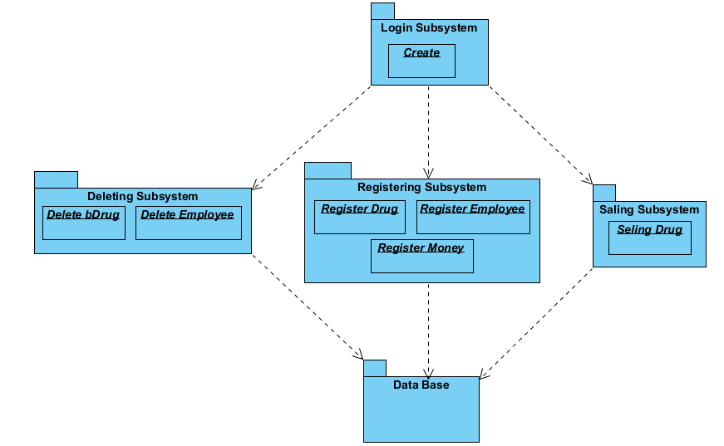

**Figure 3.2: system decomposition**

**3.5 Component diagram**

Component diagrams are often used to model high-level software components and how they interact. The interfaces between these components become clearer as the model grows, which provides a much clearer delineation of duties of each component. So from that point component diagrams are used to visualize the physical components in a system. These components are libraries, packages, files etc.

Component diagrams can also be described as a static implementation view of a system. Static implementation represents the organization of the components at a particular moment. It does not describe the functionality of the system but it describes the components used to make those functionalities. A single component diagram cannot represent the entire system but a collection of diagrams are used to represent the whole.

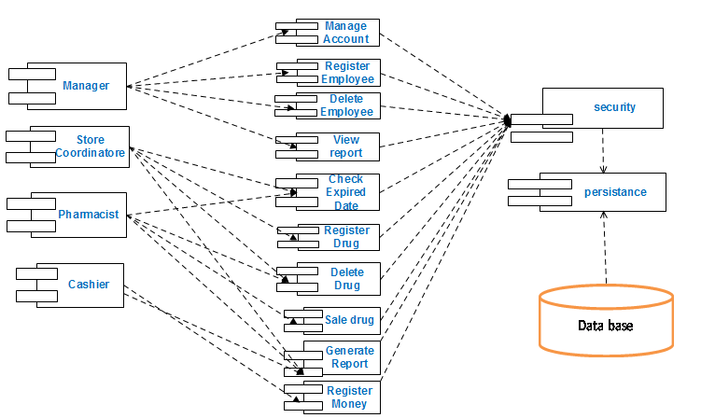**Figure 3.3: Component diagram**

**3.6 Deployment Diagram**

The deployment diagram shows how the software components, processes, and objects are deployed into the physical architecture of the system. It shows the configuration of the hardware units (e.g. Computers, communication devices, etc) and how the software components are distributed across the units.

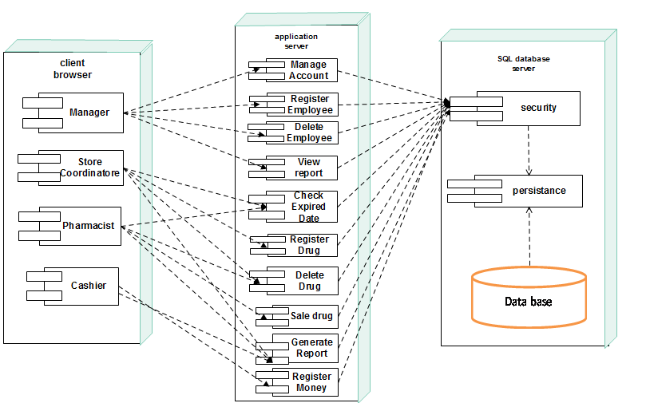 **Figure 3.4: Deployment diagram**

**3.7 User interface prototype and design**

User interface (UI) prototyping is an iterative analysis technique in which users are actively involved in the mocking-up of the UI for a system. User interface design or user interface engineering is the design of [websites](http://en.wikipedia.org/wiki/Website) with the focus on the [user's experience](http://en.wikipedia.org/wiki/User_experience) and interaction. The goal of user interface design is to make the user's interaction as simple and efficient as possible. UI prototypes have several purposes:

* As an analysis artifact that enables you to explore the problem space with your stakeholders.
* As a requirements artifact to initially envision the system.
* As a design artifact that enables you to explore the solution space of your system.
* A vehicle for you to communicate the possible UI design(s) of your system.
* A potential foundation from which to continue developing the system.

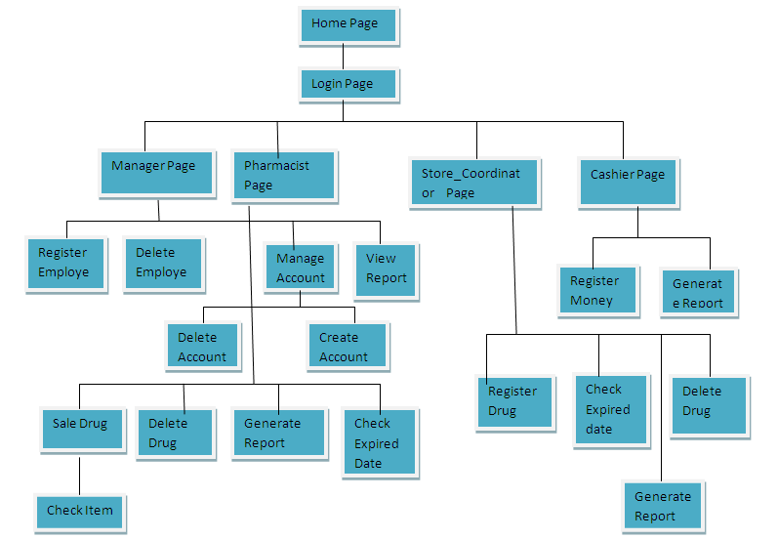

**Figure 3.5: User interface prototype and design**

**3.8 Design class diagram**

Class diagrams are the most common diagram found in modeling object-oriented systems. A class diagram shows a set of classes, interfaces, and collaborations and their relationships. We use class diagrams to model the static design view of a system. Class diagrams are also the foundation for a couple of related diagrams: component diagrams and deployment diagrams.

Class diagrams are important not only for visualizing, specifying, and documenting structural models, but also for constructing executable systems through forward and reverse engineering.

**Figure 3.6: Design class diagram**

**3.9 Database design**

**Database design** is the process of producing a detailed [data model](http://en.wikipedia.org/wiki/Data_model) of a [database](http://en.wikipedia.org/wiki/Database). This [logical data model](http://en.wikipedia.org/wiki/Logical_data_model) contains all the needed logical and physical design choices and physical storage parameters needed to generate a design in a [data definition language](http://en.wikipedia.org/wiki/Data_definition_language), which can then be used to create a database. A fully attributed data model contains detailed attributes for each entity. It can be thought of as the logical design of the base data structures used to store the data.

**Figure 3.7: Database design**

**CHAPTER FOUR**

**System implementation techniques and tools**

Systems implementation is the construction of the new system and the delivery of that system into production (that is, the day-to-day business or organization operation).

The construction phase does two things:

* Builds and tests a functional system that fulfills business or organizational design requirements,
* Implements the interface between the new system and the existing production system.

# 4.2 Conclusion and Recommendation

# 4.2.1 Conclusion

Effective documentation of this software will take care of the basic requirements of the pharmacy management system because it is capable of providing easy and effective of information storage related to the activities happening in the stipulated area. With these, the objectives of the system design will be achieved.

In order to allow for the future expansion, the system has been designed in such a way that will be allowed the possible modification as it may deem necessary by the pharmacy management, whenever the idea arises.

**4.2.2 Recommendation**

Designing this software (Pharmacy management system) is not an easy task. It has been started from the requirement gathering and passes through so many other stages before completion.

Based on the benefits of this system and tremendous value it will add to customer-user satisfaction, the below recommendation will be considered;

It is recommended that the new system should be used with the necessary specifications of the system requirements and provision for an uninterrupted power supply should be made available throughout the hours of operation of the pharmacy to avoid power outage. There should also be basic computer knowledge for the users of the software.

It is recommended that the software would be improved especially in areas of accounting as it will be of great impact to the development of sell pharmacy.

**References:-**

1. ["Clinical Informatics 2014 Diplomates"](http://www.theabpm.org/public/newci.cfm). *American Board of Preventive Medicine*. December 2013. Retrieved 7 January 2014.
2. American Society of Health-System Pharmacists. (2014). ASHP statement on the pharmacy technician’s role in pharmacy informatics. American Journal of Health-System Pharmacy, 71(3), 247–50
3. Management Sciences for Health. (2012). Computers in pharmaceutical management. In M. Ryan, M. Embrey, E. Jamandre, & L. Glassman (Eds.), MDS - 3: Managing Access to Medicines and Health Technologies (3rd ed., pp. 973–996). Arlington, VA: Management Sciences for Health.
4. Mettler T, Raptis DA (2012). "What constitutes the field of health information systems? Fostering a systematic framework and research agenda". *Health Informatics Journal*