Coffee Shop Sales Analysis Report
Report Period: January 01, 2023 – June 30, 2023

1. Executive Summary
Date Range | 2023-01-01 to 2023-06-30
Total Transactions | 149,116
Total Items Sold | 214,470
Total Revenue | $698,812.33
Average Transaction Value | $4.69
Median Transaction Value | $3.75

2. Revenue by Product Category
Product Category | Revenue
Coffee | $269,952.45
Tea | $196,405.95
Bakery | $82,315.64
Drinking Chocolate | $72,416.00
Coffee beans | $40,085.25
Branded | $13,607.00
Loose Tea | $11,213.60
Flavours | $8,408.80
Packaged Chocolate | $4,407.64

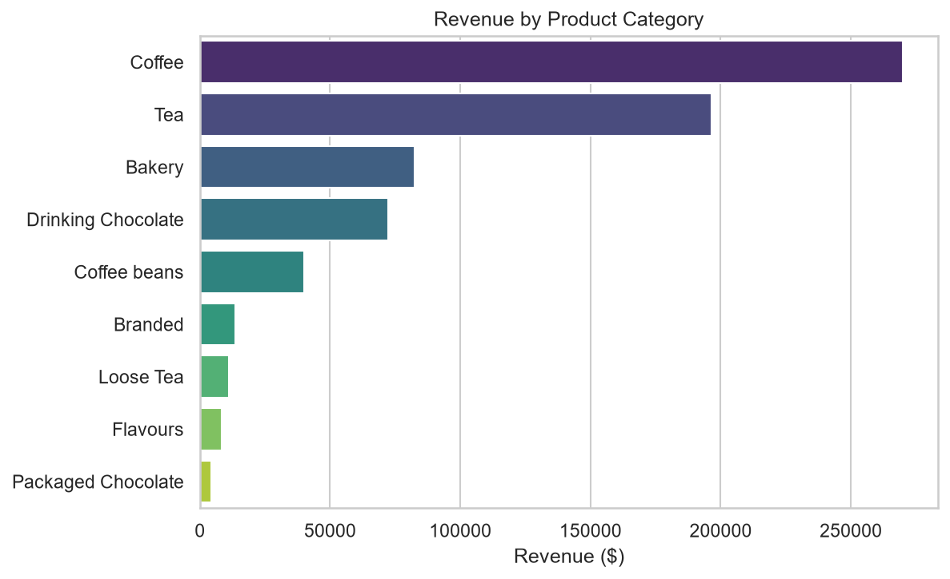

3. Revenue by Store
Store Location | Revenue
Hell's Kitchen | $236,511.17
Astoria | $232,243.91
Lower Manhattan | $230,057.25

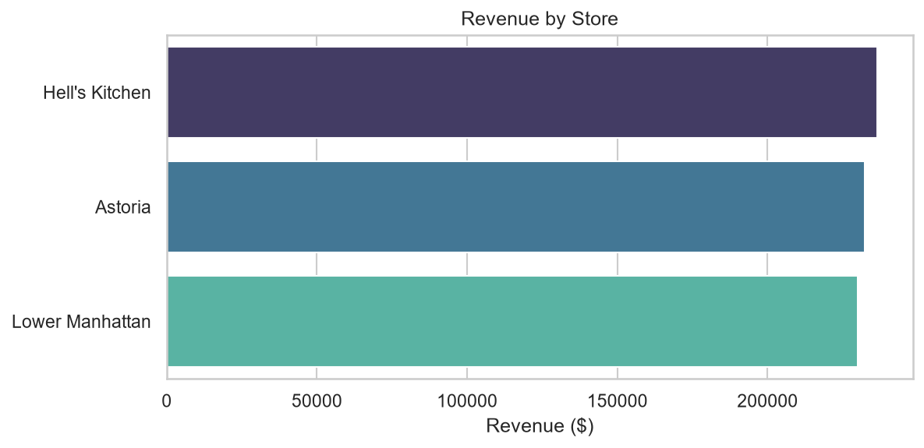

4. Revenue by Transaction Hour
The chart below shows revenue distribution across hours of the day.
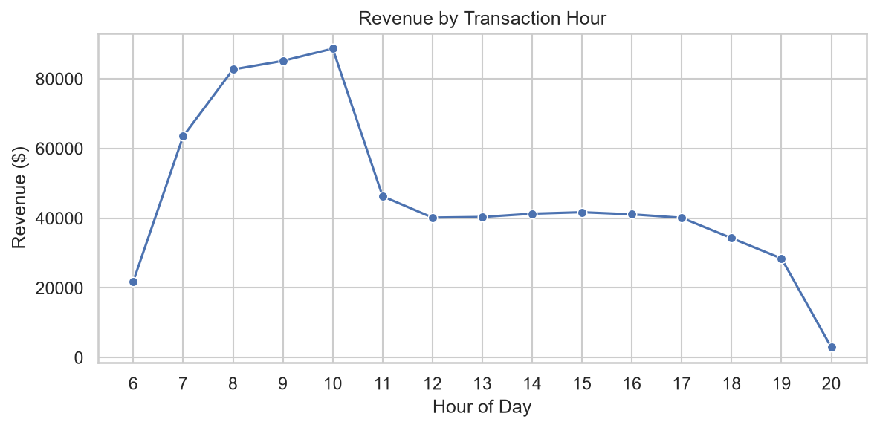

5. Top 10 Products by Revenue
Product | Revenue
Sustainably Grown Organic Lg | $21,151.75
Dark chocolate Lg | $21,006.00
Latte Rg | $19,112.25
Cappuccino Lg | $17,641.75
Morning Sunrise Chai Lg | $17,384.00
Latte | $17,257.50
Jamaican Coffee River Lg | $16,481.25
Sustainably Grown Organic Rg | $16,233.75
Cappuccino | $15,997.50
Brazilian Lg | $15,109.50

6. About This Report
This report was generated using Python with the following libraries: pandas (data processing), NumPy (statistical calculations), Matplotlib and Seaborn (data visualisation), and python-docx (Word report generation). Revenue is calculated as transaction_qty × unit_price.

