**[5장. 패키지 매니저]**

C:\>cd C:\materK1m\newmimac\test_kes

C:\materK1m\newmimac\test_kes>npm init

This utility will walk you through creating a package.json file.

It only covers the most common items, and tries to guess sensible defaults.

See `npm help json` for definitive documentation on these fields

and exactly what they do.

Use `npm install <pkg>` afterwards to install a package and

save it as a dependency in the package.json file.

Press ^C at any time to quit.

package name: (test_kes) npmtest

version: (1.0.0) 0.0.1

description: hello package.json

git repository:

author: kes

license: (ISC)

About to write to C:\materK1m\newmimac\test_kes\package.json:

{

"name": "npmtest",

"version": "0.0.1",

"description": "hello package.json",

"main": "test.js",

"scripts": {

"test": "echo \"Error: no test specified\" && exit 1"

},

"keywords": [],

"author": "kes",

"license": "ISC",

"dependencies": {

"express": "^4.16.4",

"readline-sync": "^1.4.9"

},

"devDependencies": {}

}

Is this OK? (yes) yes

C:\materK1m\newmimac\test_kes>

C:\materK1m\newmimac\test_kes>npm run test

> npmtest@0.0.1 test C:\materK1m\newmimac\test_kes

> echo "Error: no test specified" && exit 1

"Error: no test specified"

npm ERR! code ELIFECYCLE

npm ERR! errno 1

npm ERR! npmtest@0.0.1 test: `echo "Error: no test specified" && exit 1`

npm ERR! Exit status 1

npm ERR!

npm ERR! Failed at the npmtest@0.0.1 test script.

npm ERR! This is probably not a problem with npm. There is likely additional log

ging output above.

npm ERR! A complete log of this run can be found in:

npm ERR! C:\Users\Administrator\AppData\Roaming\npm-cache\_logs\2019-03-19T0

8_12_41_620Z-debug.log

C:\materK1m\newmimac\test_kes>npm install express

npm WARN npmtest@0.0.1 No repository field.

+ express@4.16.4

updated 3 packages and audited 122 packages in 1.534s

found 0 vulnerabilities

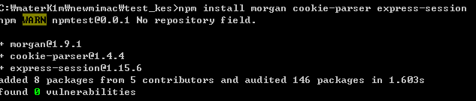

여러 모듈 동시에 설치

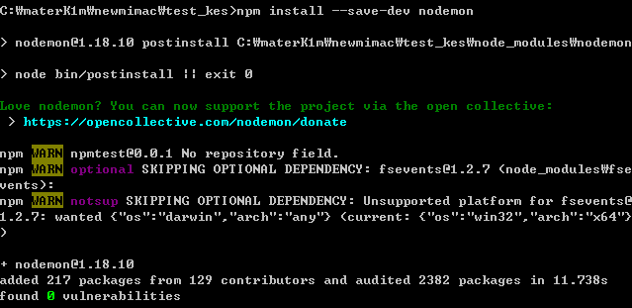

노드몬 설치

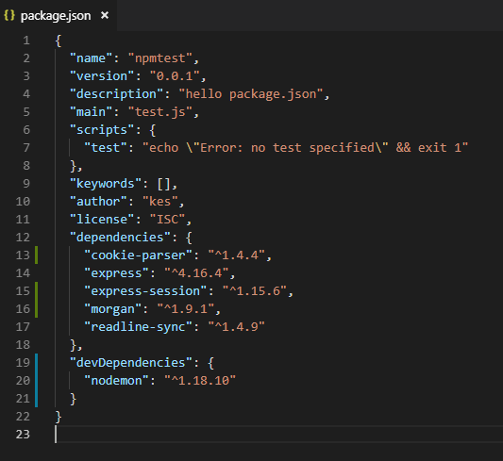

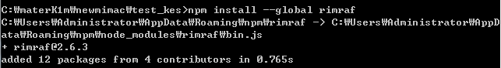

전역설치 옵션 사용

rimraf 패키지는 리눅스나 macOS의 rm –rf 명령어를 윈도에서도 사용할 수 있게 해주는 패키지



node_module 삭제

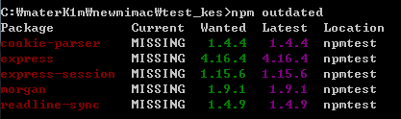

업데이트 할 수 있는 패키지 확인

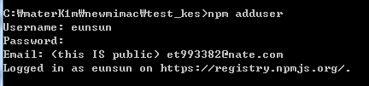

npm 회원가입 후 로그인



npm logout

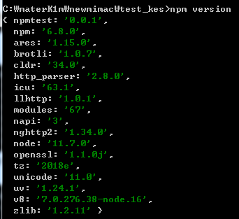

npm deprecate [패키지명][버전][메시지] 는 해당 패키지를 설치 할 때 경고 메시지를 띄우게 하는 명령어

npm publish 는 자신이 만든 패키지를 배포할 때 사용

npm unpublish는 배포한 패키지를 제거할 때 사용. 24시간 이내에 배포한 패키지만 제거할 수 있다.

C:\materK1m\newmimac\test_kes>npm publish

npm notice

npm notice package: npmtest_kes_01@0.0.1

npm notice === Tarball Contents ===

npm notice 472B package.json

npm notice 221B app.js

npm notice 235B app2.js

npm notice 56B index.js

npm notice 81B test.js

npm notice 1.8kB es6/ajax.html

npm notice 267B es6/arrow function.js

npm notice 537B es6/arrow function2.js

npm notice 1.4kB es6/async await.js

npm notice 349B es6/dataAttributeDataset.html

npm notice 512B es6/encodeDecodeURLComponent.html

npm notice 1.2kB es6/formData.html

npm notice 588B es6/object literal.js

npm notice 1.8kB es6/promise.js

npm notice 395B es6/templete literal.js

npm notice 788B es6/unstructure allot.js

npm notice 363B http_module/about.html

npm notice 812B http_module/cluster.js

npm notice 126B http_module/createServer.js

npm notice 54B http_module/restFront.css

npm notice 461B http_module/restFront.html

npm notice 3.0kB http_module/restFront.js

npm notice 2.0kB http_module/restServer.js

npm notice 359B http_module/server1-0.js

npm notice 495B http_module/server1-1.js

npm notice 501B http_module/server1-2.js

npm notice 241B http_module/server1.js

npm notice 241B http_module/server2.html

npm notice 310B http_module/server2.js

npm notice 635B http_module/server3.js

npm notice 352B http_module/server4.html

npm notice 1.3kB http_module/server4.js

npm notice 1.5kB http_module/server5.js

npm notice 49B node_basic/__filename__dirname.js

npm notice 486B node_basic/async.js

npm notice 486B node_basic/asyncOrder.js

npm notice 453B node_basic/buffer.js

npm notice 440B node_basic/cipher.js

npm notice 763B node_basic/console.js

npm notice 161B node_basic/copyFile.js

npm notice 410B node_basic/createReadStream.js

npm notice 275B node_basic/createWriteStream.js

npm notice 182B node_basic/error1.js

npm notice 143B node_basic/error2.js

npm notice 245B node_basic/error3.js

npm notice 2.1kB node_basic/event.js

npm notice 2.4kB node_basic/fsCreate.js

npm notice 931B node_basic/fsDelete.js

npm notice 38B node_basic/globalA.js

npm notice 89B node_basic/globalB.js

npm notice 266B node_basic/gzip.js

npm notice 324B node_basic/hash.js

npm notice 153B node_basic/jsExec.js

npm notice 212B node_basic/module_func.js

npm notice 293B node_basic/module_index.js

npm notice 150B node_basic/module_var.js

npm notice 296B node_basic/moduleExports_index.js

npm notice 63B node_basic/moduleExports.js

npm notice 1.3kB node_basic/os.js

npm notice 2.3kB node_basic/path.js

npm notice 298B node_basic/pbkdf2.js

npm notice 175B node_basic/pipe.js

npm notice 88B node_basic/process.env.js

npm notice 157B node_basic/process.exit.js

npm notice 219B node_basic/process.nextTick.js

npm notice 431B node_basic/querystring.js

npm notice 176B node_basic/readFile.js

npm notice 24B node_basic/readme.txt

npm notice 33B node_basic/readme2.txt

npm notice 100B node_basic/readme3.txt

npm notice 37B node_basic/readme4.txt

npm notice 60B node_basic/readme4.txt.gz

npm notice 33B node_basic/RERL.js

npm notice 1.7kB node_basic/searchParams.js

npm notice 319B node_basic/sync.js

npm notice 1.2kB node_basic/Timer.js

npm notice 601B node_basic/url.js

npm notice 462B node_basic/util.js

npm notice 288B node_basic/writeFile.js

npm notice 23B node_basic/writeme.txt

npm notice 44B node_basic/writeme2.txt

npm notice 37B node_basic/writeme3.txt

npm notice 37B node_basic/writeme4.txt

npm notice === Tarball Details ===

npm notice name: npmtest_kes_01

npm notice version: 0.0.1

npm notice package size: 14.5 kB

npm notice unpacked size: 45.1 kB

npm notice shasum: dd1b7920fc4c0200fc64781cea8061a45adb00aa

npm notice integrity: sha512-OsZTcYUNbDq8s[...]ZUxc/VUOqXNrw==

npm notice total files: 83

npm notice

npm ERR! code E403

npm ERR! 403 Forbidden - PUT https://registry.npmjs.org/npmtest_kes_01 - you mus

t verify your email before publishing a new package: https://www.npmjs.com/email

-edit

npm ERR! A complete log of this run can be found in:

npm ERR! C:\Users\Administrator\AppData\Roaming\npm-cache\_logs\2019-03-19T0

8_49_01_135Z-debug.log

C:\materK1m\newmimac\test_kes>npm publish

npm notice

npm notice package: npmtest_kes_01@0.0.1

npm notice === Tarball Contents ===

npm notice 472B package.json

npm notice 221B app.js

npm notice 235B app2.js

npm notice 56B index.js

npm notice 81B test.js

npm notice 1.8kB es6/ajax.html

npm notice 267B es6/arrow function.js

npm notice 537B es6/arrow function2.js

npm notice 1.4kB es6/async await.js

npm notice 349B es6/dataAttributeDataset.html

npm notice 512B es6/encodeDecodeURLComponent.html

npm notice 1.2kB es6/formData.html

npm notice 588B es6/object literal.js

npm notice 1.8kB es6/promise.js

npm notice 395B es6/templete literal.js

npm notice 788B es6/unstructure allot.js

npm notice 363B http_module/about.html

npm notice 812B http_module/cluster.js

npm notice 126B http_module/createServer.js

npm notice 54B http_module/restFront.css

npm notice 461B http_module/restFront.html

npm notice 3.0kB http_module/restFront.js

npm notice 2.0kB http_module/restServer.js

npm notice 359B http_module/server1-0.js

npm notice 495B http_module/server1-1.js

npm notice 501B http_module/server1-2.js

npm notice 241B http_module/server1.js

npm notice 241B http_module/server2.html

npm notice 310B http_module/server2.js

npm notice 635B http_module/server3.js

npm notice 352B http_module/server4.html

npm notice 1.3kB http_module/server4.js

npm notice 1.5kB http_module/server5.js

npm notice 49B node_basic/__filename__dirname.js

npm notice 486B node_basic/async.js

npm notice 486B node_basic/asyncOrder.js

npm notice 453B node_basic/buffer.js

npm notice 440B node_basic/cipher.js

npm notice 763B node_basic/console.js

npm notice 161B node_basic/copyFile.js

npm notice 410B node_basic/createReadStream.js

npm notice 275B node_basic/createWriteStream.js

npm notice 182B node_basic/error1.js

npm notice 143B node_basic/error2.js

npm notice 245B node_basic/error3.js

npm notice 2.1kB node_basic/event.js

npm notice 2.4kB node_basic/fsCreate.js

npm notice 931B node_basic/fsDelete.js

npm notice 38B node_basic/globalA.js

npm notice 89B node_basic/globalB.js

npm notice 266B node_basic/gzip.js

npm notice 324B node_basic/hash.js

npm notice 153B node_basic/jsExec.js

npm notice 212B node_basic/module_func.js

npm notice 293B node_basic/module_index.js

npm notice 150B node_basic/module_var.js

npm notice 296B node_basic/moduleExports_index.js

npm notice 63B node_basic/moduleExports.js

npm notice 1.3kB node_basic/os.js

npm notice 2.3kB node_basic/path.js

npm notice 298B node_basic/pbkdf2.js

npm notice 175B node_basic/pipe.js

npm notice 88B node_basic/process.env.js

npm notice 157B node_basic/process.exit.js

npm notice 219B node_basic/process.nextTick.js

npm notice 431B node_basic/querystring.js

npm notice 176B node_basic/readFile.js

npm notice 24B node_basic/readme.txt

npm notice 33B node_basic/readme2.txt

npm notice 100B node_basic/readme3.txt

npm notice 37B node_basic/readme4.txt

npm notice 60B node_basic/readme4.txt.gz

npm notice 33B node_basic/RERL.js

npm notice 1.7kB node_basic/searchParams.js

npm notice 319B node_basic/sync.js

npm notice 1.2kB node_basic/Timer.js

npm notice 601B node_basic/url.js

npm notice 462B node_basic/util.js

npm notice 288B node_basic/writeFile.js

npm notice 23B node_basic/writeme.txt

npm notice 44B node_basic/writeme2.txt

npm notice 37B node_basic/writeme3.txt

npm notice 37B node_basic/writeme4.txt

npm notice === Tarball Details ===

npm notice name: npmtest_kes_01

npm notice version: 0.0.1

npm notice package size: 14.5 kB

npm notice unpacked size: 45.1 kB

npm notice shasum: dd1b7920fc4c0200fc64781cea8061a45adb00aa

npm notice integrity: sha512-OsZTcYUNbDq8s[...]ZUxc/VUOqXNrw==

npm notice total files: 83

npm notice

+ npmtest_kes_01@0.0.1

C:\materK1m\newmimac\test_kes>npm info npmtest_kes_01

npmtest_kes_01@0.0.1 | ISC | deps: 5 | versions: 1

hello package.json

dist

.tarball: https://registry.npmjs.org/npmtest_kes_01/-/npmtest_kes_01-0.0.1.tgz

.shasum: dd1b7920fc4c0200fc64781cea8061a45adb00aa

.integrity: sha512-OsZTcYUNbDq8sitvuNuuGc7deRT8jnPZ6SZS/b3RYCEEiIUJAuSiLCBoM1xQ8

1cdc750T/++hZUxc/VUOqXNrw==

.unpackedSize: 45.1 kB

dependencies:

cookie-parser: ^1.4.4 express: ^4.16.4 readline-sync: ^1.4.9

express-session: ^1.15.6 morgan: ^1.9.1

maintainers:

- eunsun <et993382@nate.com>

dist-tags:

latest: 0.0.1

published just now by eunsun <et993382@nate.com>

C:\materK1m\newmimac\test_kes>npm unpublish npmtest_kes_01 --force

npm WARN using --force I sure hope you know what you are doing.

-npmtest_kes_01

C:\materK1m\newmimac\test_kes>npm info npmtest_kes_01

npm ERR! code E404

npm ERR! 404 Unpublished by eunsun on 2019-03-19T08:51:33.425Z

npm ERR! 404

npm ERR! 404 'npmtest_kes_01' is not in the npm registry.

npm ERR! 404 You should bug the author to publish it (or use the name yourself!)

npm ERR! 404

npm ERR! 404 Note that you can also install from a

npm ERR! 404 tarball, folder, http url, or git url.

npm ERR! A complete log of this run can be found in:

npm ERR! C:\Users\Administrator\AppData\Roaming\npm-cache\_logs\2019-03-19T0

8_51_44_619Z-debug.log