Kyle Amyx

PoliSci3780 Final Project

12/8/17

I have decided to explore killings by Police Officers in the United States, specifically the rate at which particular groups of people are killed. Given the current political and racial backdrop that has blanketed our country and led to sometimes violent riots/protests following these shootings, this problem has been and will continue to a priority for the foreseeable future.

**Hypothesis:**

Police officer involved shootings are attributed to a number of different factors. However, I believe that lack of training, Mental Health training and Race are the 2 key contributors in these situations. We hear much too often about these shootings, and it seems the victims that always make the news are persons of color and/or have a history of mental health issues. There is the argument, that these events are made to seem more frequent and blown out of proportion by the media which has valid points. I however do believe these 2 variables, contribute significantly to a proportion of these observations.

If in fact, lack of training and racial biases are contributing greatly to officer involved shootings, I would first expect to see a large percentage of shootings where signs of mental illness are present, as well as for persons of color, a higher percentage of shootings where the victim was unarmed, compared to persons of non-color. I would also expect to see the percentage of shootings skewed for different races when compared to the population proportions.

Mainly looking at 2 different datasets, one containing available records of police shootings at a national level, and similar 2nd one but localized to Austin, Texas. I expect to find similar results in the proportions of race of the victims and instances where there were signs of mental illness.

**Data Collection:**

All of the data originates from databases I acquired on data.gov. A very trusted source, I find it unlikely that intentionally incorrect datasets would shared on a government platform, therefore I think the information they contain is very reliable. Each row/observation attempts to provide us with as clear a picture as possible into the shooting. By providing Names, Dates, Location, Race, Age, Armed or not, Mental Illness indicators and others. We can use these possible predictors in an attempt to identify root causes of these shootings. I do however think the datasets could be improved, specifically by providing some kind of income level, and also a ranking of the victim’s neighborhood based on crime.

The datasets I’m using have a dates as far back as 2007, however most of the observations seem to be within the last few years. For the dataset pertaining to the National figures(washPost), there are 14 different variables. The localized datasets(Austin & Seattle) do not share the same variables, but I will only be using “Race” from these 2 datasets. I have ignored most of these variables except for the few that relate to my hypothesis and the question of interest.

I chose to focus mostly on the variables: Race, signs of mental illness, State of incident and whether the officer had a body camera or not. Starting with Race, I can begin to see how Race is distributed in these shootings. Are they evenly distributed? Or are 1-2 races clearly involved in more police shootings? I must remember to take into account that the population of every race are not the same and this can attribute to one race appearing more. The next relevant variable is “Signs of mental illness”, it is entered as either TRUE or FALSE. Simply looking at the number of shooting where this was relevant can give us some clues as to why this is happening. Do some states have a significantly higher proportion of mental illness related incidents than others? Of course we want to keep track of which State each of these shootings occurred in, in order to have some comparative statistics between the states. Lastly, studies have shown a decrease in police violence when officers wear body camera’s. Each incident was reported with a TRUE/FALSE, to determine if a body camera was worn during the shooting. It’s expected that the vast majority of these events will have taken place without a body camera in operation.

The data required some reformatting and transformations in order to present the information I was after. For example, “State” & “Date” were imported as Factor variables. This made using them in my functions difficult, therefore I used ‘Lubridate’ and basic R functionality to transform these variable types. Other basic manipulations were needed, for example, making a barplot() in base R is tough using data frames. When counting occurrences of each race I had transform a data.frame into a vector, in order for barplot() to output count of each race.

In order to make the density-map-plot, I used merged my dataset with state.fips so that I could map out each state. I however in doing so, lose data on Hawaii and Alaska. For some reason state.fips does not contain rows for these 2 states. AK & HI only had 11 and 17 incidents respectively, and their data is only lost in the density-map. I don’t believe this effected my analysis/results very much, as AK & HI made up a very small part of the sample.

I used a couple different visualizations to help in my analysis of the datasets and answering of the question.

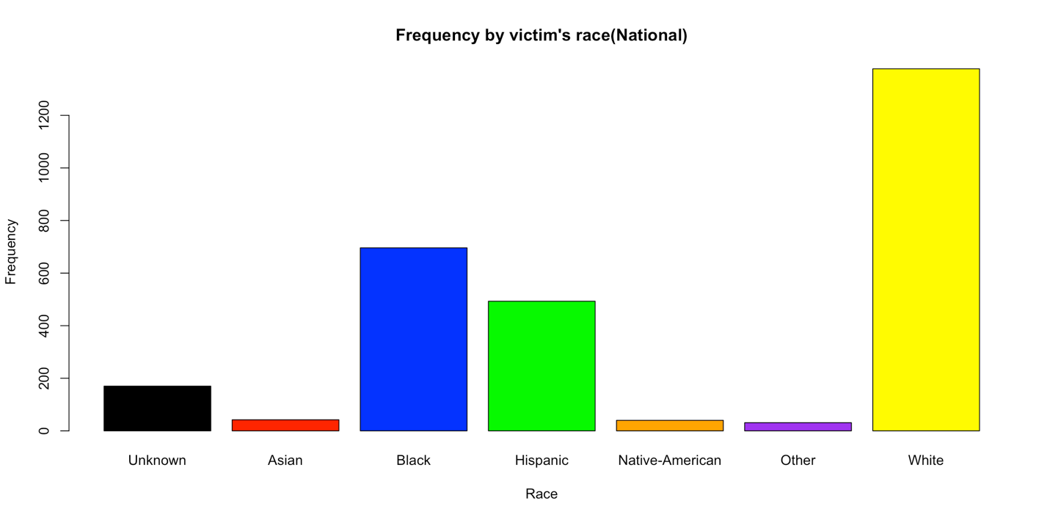

According to the Census Bureau, Whites make up 76.9% of population(Include Hispanic-White)

But according to my data, 48% of these documented shootings. While these numbers aren’t in proportion with each other as one might expect, it certainly does not provide enough evidence to say these killings are racial driven, and a direct cause of lack of training. There is also a possibility that other racial groups in fact commit crimes at a higher rate in certain areas and thus have more interaction with police in general which would increase the likelihood of a shooting incident.

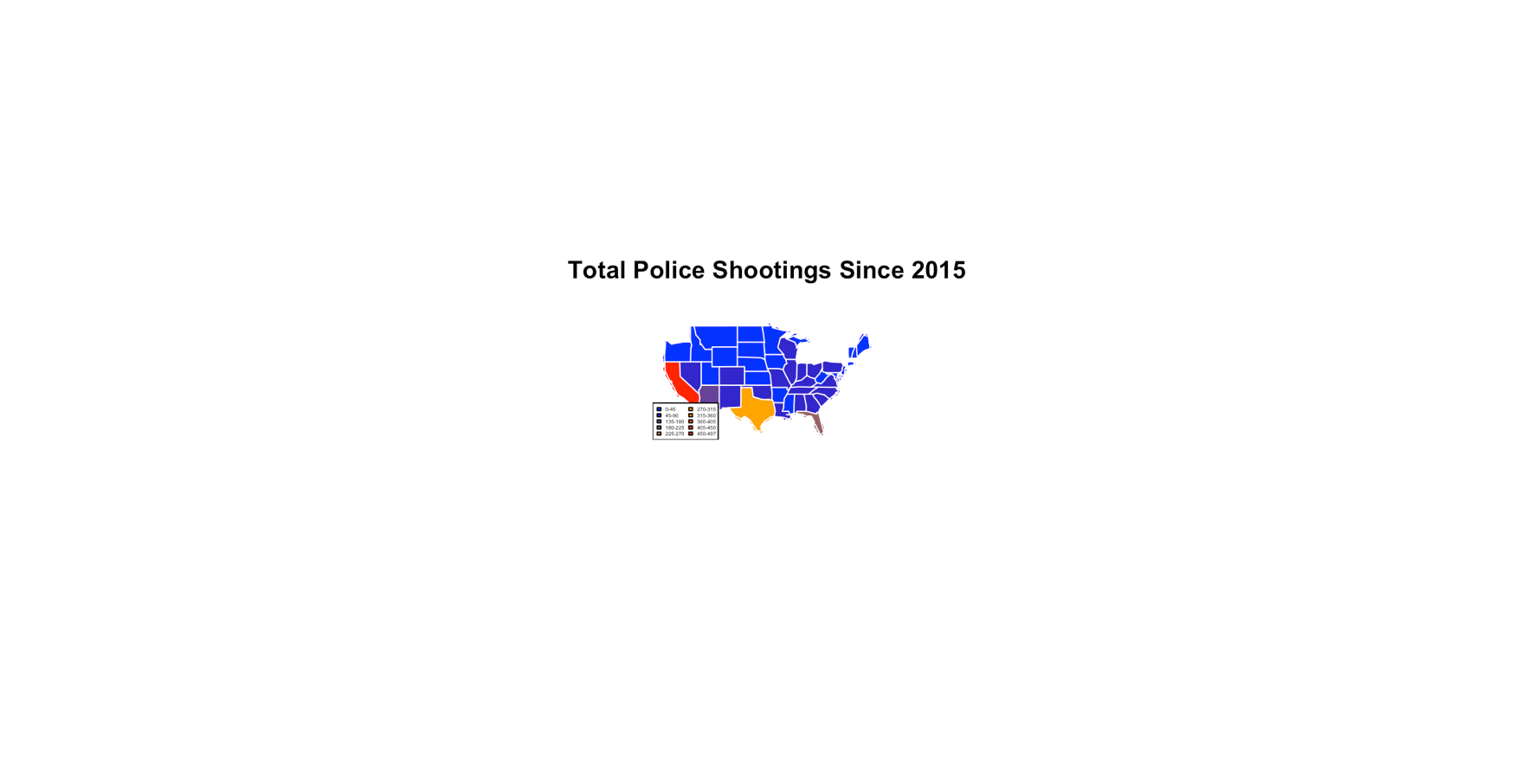*This plot is saved as usaMap.png in submission.*

I expected the highest concentration of shootings to occur in the Southeast United States, where the most of the black population lives. While the data used to make this map was missing some observations, it showed me that California in actually held the record for most shootings, but as I expected the Southeast as a whole seems to have a decent concentration. It is hard to make any assumptions from this because first we would need to explore population proportions in each state.

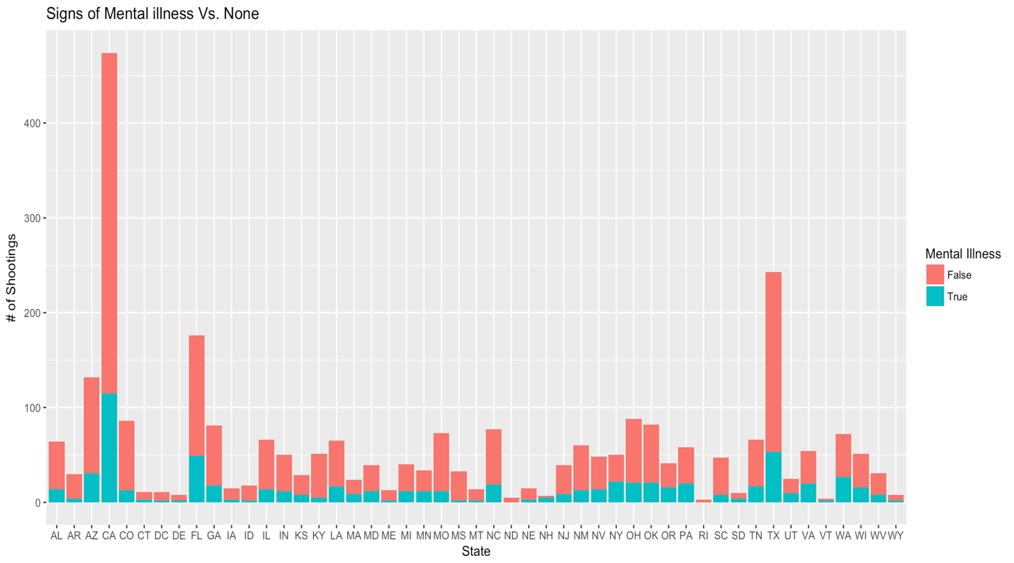

The plot above shows us how shootings where signs mental illness were present compare to shootings where they are not present. While the number of cases where mental illness was present was not as high as I had expected, it still seems to be a significant number. To me it is clear that more needs to be done, either by police departments themselves or an outside organization with experience in mental health.

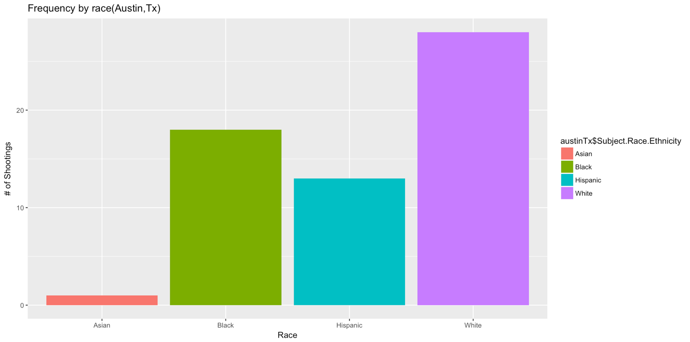

The proportions of the victims by race in Austin, Texas is vey similar to the national level. With Whites at #1, Blacks at #2, and Hispanic a close #3. I think the next step of investigation after this would be to analyze every major city to find of their proportions match the national level. If so, we need to investigate WHY? There is a reason that blacks and Hispanics are killed disproportionately to other races. Does their generally lower income level contribute to more policing of their neighborhoods which in turn leads to violent interactions which can turn deadly. These are all questions necessary for digging up the answer to this question, while it is a very complicated question and requires very deep analysis, I’m confident that the solution lies within the data somewhere.

**WORK CITED:**

(1). <https://www.huffingtonpost.com/entry/police-body-camera-study_us_561d2ea1e4b028dd7ea53a56>

(2.) <https://catalog.data.gov/dataset?q=officer+shooting&as_sfid=AAAAAAVCEhHoSNQE-FbwBLl0HQw9MuIos9R_25gnLWnjBiBdMEM0UyZ19jsTSwOMVU3NDqHXurHCx8aKRJ4QXrzYtKRhCeuvLDuJxzwCWBuGZwkSvKhZqBjTKRYnduQcUKZ6Z7o%3D&as_fid=b18564e3ffe4a82c6e4978643c4534c6c0d7eb81>

(3.) https://www.census.gov/quickfacts/fact/table/US/PST045216