**Industrial Internship Report on**

**”** **Banking Information System”**

**Prepared by**

**[Anurag Chowdhury]**

|  |
| --- |
| *Executive Summary* |
| This report provides details of the Industrial Internship provided by upskill Campus and The IoT Academy in collaboration with Industrial Partner UniConverge Technologies Pvt Ltd (UCT).  This internship was focused on a project/problem statement provided by UCT. We had to finish the project including the report in 6 weeks’ time.  My project was (Tell about ur Project)  This internship gave me a very good opportunity to get exposure to Industrial problems and design/implement solution for that. It was an overall great experience to have this internship. |

**TABLE OF CONTENTS**

1 Preface 3

2 Introduction 4

2.1 About UniConverge Technologies Pvt Ltd 4

2.2 About upskill Campus 8

2.3 Objective 9

2.4 Reference 9

2.5 Glossary 10

3 Problem Statement 11

4 Existing and Proposed solution 12

5 Proposed Design/ Model 13

5.1 High Level Diagram (if applicable) 13

5.2 Low Level Diagram (if applicable) 13

5.3 Interfaces (if applicable) 13

6 Performance Test 14

6.1 Test Plan/ Test Cases 14

6.2 Test Procedure 14

6.3 Performance Outcome 14

7 My learnings 15

8 Future work scope 16

# Preface

Summary of the whole 6 weeks’ work.

About need of relevant Internship in career development.

Brief about Your project/problem statement.

Opportunity given by USC/UCT.

How Program was planned

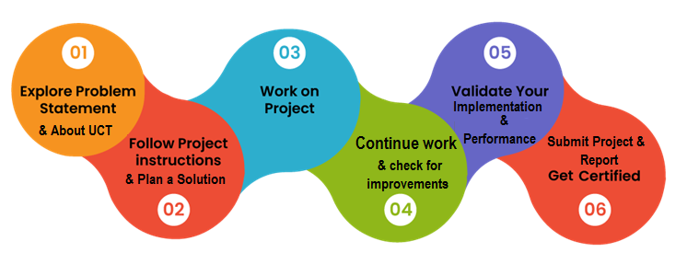

Your Learnings and overall experience.

Thank to all (with names), who have helped you directly or indirectly.

Your message to your juniors and peers.

# Introduction

## About UniConverge Technologies Pvt Ltd

A company established in 2013 and working in Digital Transformation domain and providing Industrial solutions with prime focus on sustainability and RoI.

For developing its products and solutions it is leveraging various**Cutting Edge Technologies e.g. Internet of Things (IoT), Cyber Security, Cloud computing (AWS, Azure), Machine Learning, Communication Technologies (4G/5G/LoRaWAN), Java Full Stack, Python, Front end**etc.

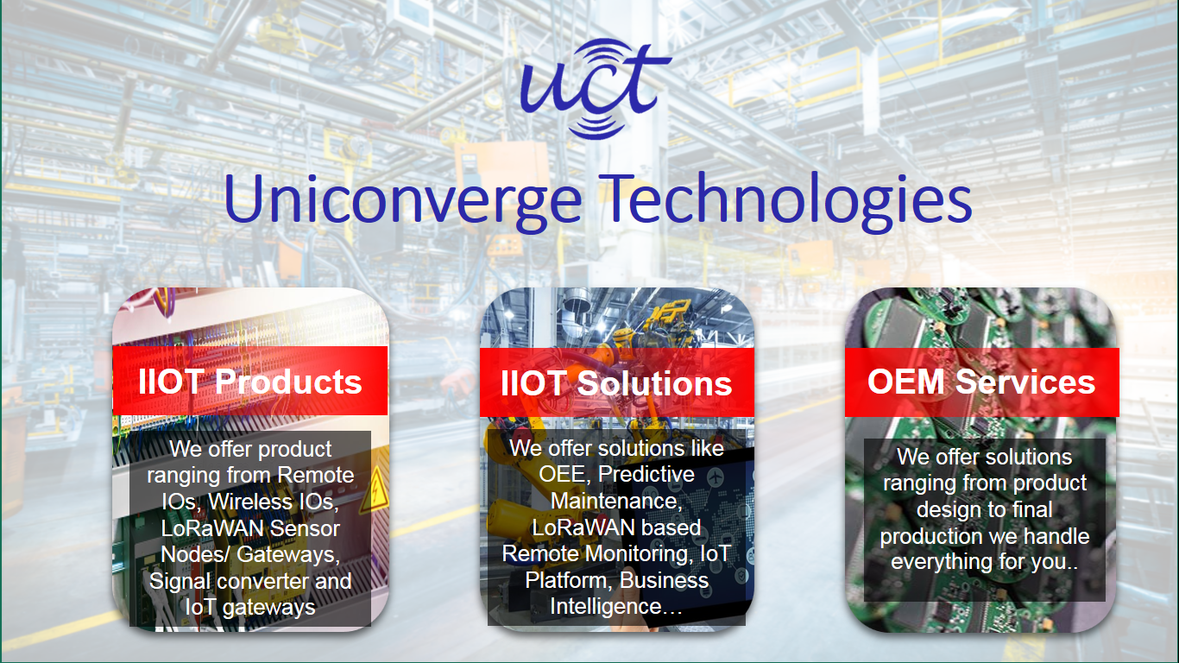

1. UCT IoT Platform **(****)**

**UCT Insight** is an IOT platform designed for quick deployment of IOT applications on the same time providing valuable “insight” for your process/business. It has been built in Java for backend and ReactJS for Front end. It has support for MySQL and various NoSql Databases.

* It enables device connectivity via industry standard IoT protocols - MQTT, CoAP, HTTP, Modbus TCP, OPC UA
* It supports both cloud and on-premises deployments.

It has features to  
• Build Your own dashboard  
• Analytics and Reporting  
• Alert and Notification  
• Integration with third party application(Power BI, SAP, ERP)  
• Rule Engine

 

1. **Smart Factory Platform (****)**

Factory watch is a platform for smart factory needs.

It provides Users/ Factory

* with a scalable solution for their Production and asset monitoring
* OEE and predictive maintenance solution scaling up to digital twin for your assets.
* to unleased the true potential of the data that their machines are generating and helps to identify the KPIs and also improve them.
* A modular architecture that allows users to choose the service that they what to start and then can scale to more complex solutions as per their demands.

Its unique SaaS model helps users to save time, cost and money.

 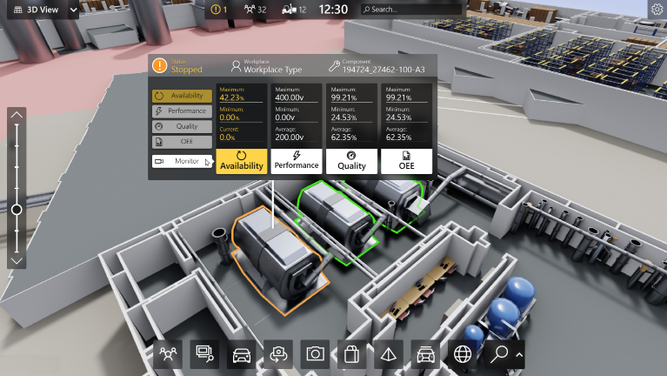

1. 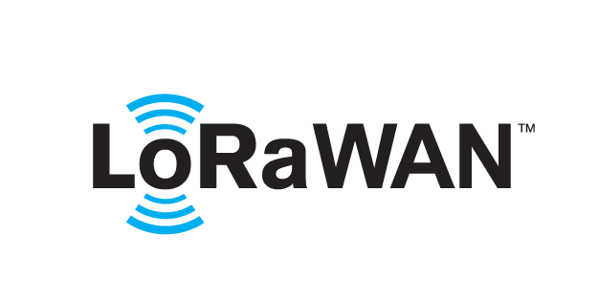 based Solution

UCT is one of the early adopters of LoRAWAN teschnology and providing solution in Agritech, Smart cities, Industrial Monitoring, Smart Street Light, Smart Water/ Gas/ Electricity metering solutions etc.

1. Predictive Maintenance

UCT is providing Industrial Machine health monitoring and Predictive maintenance solution leveraging Embedded system, Industrial IoT and Machine Learning Technologies by finding Remaining useful life time of various Machines used in production process.



## About upskill Campus (USC)

upskill Campus along with The IoT Academy and in association with Uniconverge technologies has facilitated the smooth execution of the complete internship process.

USC is a career development platform that delivers **personalized executive coaching** in a more affordable, scalable and measurable way.



Seeing need of upskilling in self paced manner along-with additional support services e.g. Internship, projects, interaction with Industry experts, Career growth Services

<https://www.upskillcampus.com/>

upSkill Campus aiming to upskill 1 million learners in next 5 year

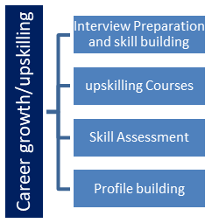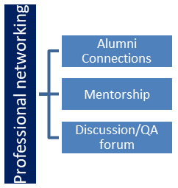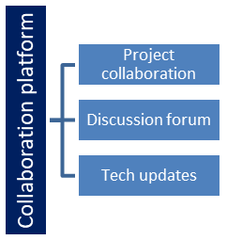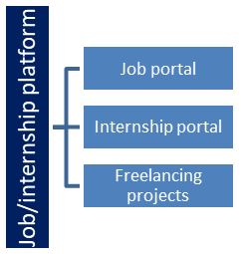

## The IoT Academy

The IoT academy is EdTech Division of UCT that is running long executive certification programs in collaboration with EICT Academy, IITK, IITR and IITG in multiple domains.

## Objectives of this Internship program

The objective for this internship program was to

 ☛ get practical experience of working in the industry.

 ☛ to solve real world problems.

 ☛ to have improved job prospects.

 ☛ to have Improved understanding of our field and its applications.

 ☛ to have Personal growth like better communication and problem solving.

## Reference

[1] Article: Online banking, Website: https://en.wikipedia.org/wiki/Online_banking

June 29, 2015, 12.30 am.

[2] Veneeva, V. (2006), “E-Banking (Online Banking) and Its Role in Today's Society”,

Ezine articles, June 30, 2015

[3] Fundamentals of database systems by (Elmasri Navathe, 2000),Website:https://archive.org/stream/FundamentalsOfDatabaseSystemselma srinavathe#page/n51/mode/2up, Page: From 52 to more.

# Problem Statement

The Traditional way of maintaining details of a user in a bank was to enter the details and record them. Every time the user needs to perform some transactions he has to go to bank and perform the necessary actions, which may not be so feasible all the time. It may be a hard-hitting task for the users and the bankers too. The project gives real life understanding of Online Banking System and activities performed by various roles in the supply chain. Here, we provide automation for banking system through Internet. Online Banking System project captures activities performed by different roles in real life banking which provides enhanced techniques for maintaining the required information up-to-date, which results in efficiency. The project gives real life understanding of Online Banking System and activities performed by various roles in the supply chain.

# Existing and Proposed solution

The existing system works manually .The existing system has got lot of intricacies within itself and need lot of human effort and paper works. All above the data to be maintained on ledgers and maintain this is a tedious and risky process. As the transaction increases, so the data too. So the task of maintaining them increases exponentially. To view a data may need lot of paper to be searched.

## Code submission (Github link)

## Report submission (Github link) : first make placeholder, copy the link.

# Proposed Design/ Model

In this project we are going to explain about **Banking Management System.**

This project have facility to opening account, depositing and withdrawing money. The proposed system is a computerized one. This has greater accuracy and efficiency. This takes only limited time for calculation. The proposed system can be used to maintain efficiently the BANKING schedule. In larger organizations employees are large. At that time also the proposed system is useful and helpful. The system includes users Administrator(HR) level.

In this project we have a admin login feature, we want to fill the admin and password then we enter to home page, The home page facility show all the include features about this banking project. we have a number of options like open account, delete account, modify account, add employee record, delete employee record.

# Performance Test

* Data Security: Banking systems deal with sensitive financial data. Implement strong encryption for data at rest and in transit. Utilize secure protocols (HTTPS) for communication.
* Authentication and Authorization: Implement robust authentication mechanisms (e.g., multi-factor authentication) and fine-grained authorization to ensure that only authorized users can access specific functionalities and data.
* Scalability: Banking systems need to handle a high volume of transactions. Design your system to scale horizontally to accommodate increased load.
* Caching: Implement caching mechanisms to improve response times for frequently accessed data.
* Database Optimization: Optimize database queries and indexes to enhance query performance.

# My learnings

This project's successful completion will serve as a tangible demonstration of my capabilities to potential employers and collaborators, opening doors to opportunities in both the software development and financial domains. As I continually learn, adapt, and refine my skills through this project, I will be well-positioned to take on more complex challenges, assume greater responsibilities, and advance in my career journey.

# Future work scope

In the future more software companies will hire this software program because now a days the need for the speed in the day-to-day life has become essential. As competition increases, companies by considering old version, they develop more efficient versions for individual success. In future we can make a link of this project with networking. We can also convert this project in Hibernate. Hibernate is a framework. It storage large amount of database. In future we can also add the facility to change the password and recovery the forgotten password.