

School of Computer Science Engineering and Information Systems
Department of Information Technology
Fall 2026-27
Operating Systems Lab BITE303P
PROJECT REPORT
KernelLeakGuard: Hybrid Static Analysis and Runtime Verification of Memory Leaks in Linux Kernel Early-Exit Paths

Submitted by
Om Gunjan Gupta 24BIT0316
Abhishek Kumar Singh 24BIT0309
Aarav Jain 24BIT0023

Under the Guidance of
Dr. ARIVUSELVAN K
Associate Professor, SCORE
VIT, Vellore.

Fall 2026-27
DECLARATION

We hereby declare that the project report titled “KernelLeakGuard: Hybrid Static Analysis and Runtime Verification of Memory Leaks in Linux Kernel Early-Exit Paths” submitted in partial fulfillment of the requirements for the course BITE303P – Operating Systems Lab is a record of original work carried out by us.
We affirm that this work has been developed independently and has not been submitted, either in part or in full, to any other course, institution, or university for the award of any degree or certification.
We further declare that:
- All sources of information used in this project have been properly acknowledged and cited in accordance with academic standards.
- The work does not contain any form of plagiarism beyond permissible limits.
- The analysis, design, implementation, and results presented in this report are our own contributions, except where explicitly stated.
- Any assistance received during the course of this work has been duly acknowledged.
We are submitting this project as part of our course requirements under the guidance of Dr. Arivuselvan K.

Signature of Student(s)
TABLE OF CONTENTS
ABSTRACT 5
CHAPTER 1: INTRODUCTION 7
1.1 Motivation 7
1.2 Scope 7
1.3 Problem Statement 8
1.4 Objectives 8
1.5 Organization of the Report 8
CHAPTER 2: LITERATURE SURVEY 10
2.1 Overview 10
2.2 Review of Existing Methods 10
2.3 Comparative Analysis 11
2.4 Research Gap 11
CHAPTER 3: PROPOSED TECHNIQUE 13
3.1 System Architecture 13
3.2 Module-wise Description 14
3.3 Algorithms Used 16
3.4 Dataset Details 17
3.5 Tools and Technologies 18
CHAPTER 4: RESULTS AND DISCUSSION 20
4.1 Experimental Setup 20
4.2 Results 20
4.3 Performance Metrics 27
4.4 Evaluation on Real Kernel Code 28
4.5 Seeded Leaks in Real Kernel Code 33
4.6 Analysis 35
CHAPTER 5: CONCLUSION AND FUTURE WORK 37
5.1 Conclusion 37
5.2 Future Work 37
REFERENCES 39
APPENDIX: SOURCE CODE 41

ABSTRACT
Operating system kernels must release every resource they acquire, including on the rarely executed error paths that run when an allocation or a device operation fails. A forgotten kfree() on such an early-exit path leaks kernel memory that can never be reclaimed, causing memory pressure, degraded performance and, when an attacker can trigger the failure repeatedly, denial of service. Because these paths execute only when something goes wrong, ordinary testing almost never exercises them, and static analysers that do inspect them report many warnings that turn out to be safe.
KernelLeakGuard combines both worlds. An LLVM-based static analyser written in C++, inspired by MLEE (USENIX ATC 2021), tracks every kernel allocation through aliases, stack objects and function calls, understands ownership transfer, and searches for paths from an allocation to a function exit that neither free nor hand over the memory. For each warning it identifies the failing call that leads onto the leaking path. A runtime verifier then boots a custom Linux 6.18.55 kernel under QEMU/KVM, uses the kernel's per-task fault injection (fail-nth) to fail exactly that call, and asks the kernel memory leak detector (kmemleak) whether an object allocated at the reported site was left unreferenced. Every warning is labelled confirmed, not reproduced or inconclusive, with stack-trace evidence.
On a benchmark of 32 kernel modules with 17 leaking and 42 safe allocation sites, the static analyser reaches precision 0.94 and recall 0.94 (a naive missing-kfree analysis: precision 0.59). Runtime verification confirmed 15 of 17 warnings with kernel evidence and raised precision to 1.00 with no false confirmations. Together with the leaks its own fault-point sweep exposes, KernelLeakGuard finds 16 of the 17 leaks with no false positive (F1 0.97), using 424 executions of kernel routines in total against 1279 for exhaustive fault injection (F1 0.97) and 0.50 F1 for the cppcheck analyser. For 14 of 15 confirmed leaks it generates a fix patch validated by compilation, re-analysis and an exhaustive re-run in the VM. The complete pipeline runs in about 6 minutes on a laptop.
On 39 real Linux modules, general precision refinements reduced the static warnings from 115 to 11 without changing any benchmark result, and a real historical leak in bonding (fixed upstream by commit 8d6184e4881b), re-introduced into today's code, was detected, confirmed in the VM with kmemleak and fixed end to end. The tool also found five defects in the kernel itself, all still present in mainline: a slab-cache leak in the SLUB allocator, exposed by fault injection during the initialisation of erofs, f2fs, hfsplus and nilfs2, and a leak in f2fs introduced by a 2026 fix, both with fixes validated in the VM; memory leaks in ntfs3's log replay and in ufs's truncation (reported in 2018 but never fixed), found statically, with fixes that remove the warnings; and a use-after-free of module memory when a module's initialisation fails after it added a disk.

CHAPTER 1: INTRODUCTION

1.1 Motivation
The Linux kernel manages memory for itself through allocators such as kmalloc(), kzalloc(), vmalloc() and dedicated slab caches. Unlike user programs, the kernel has no garbage collector and no process exit that returns everything to the system: memory that a kernel routine allocates and then loses track of stays allocated until the machine reboots. Long-running servers, phones and embedded devices therefore suffer from even small leaks when the leaking code runs repeatedly.
A large share of kernel leaks hide on early-exit paths. Kernel code checks the result of almost every operation and returns an error code such as -ENOMEM or -EINVAL as soon as something fails, usually through a ladder of goto labels that undo the work done so far. Getting every exit right is error-prone: jumping to the wrong label, adding a new exit without the matching cleanup, or forgetting that an earlier allocation is still owned by the function are all common mistakes. Wang (MLEE, 2021) reported 120 previously unknown leaks of exactly this kind in the Linux kernel, and syzbot, Google's continuous kernel fuzzing service, files kmemleak reports every week.
The difficulty is that these paths run only when an allocation or a device operation fails, which practically never happens in testing. Static analysis can inspect every path but cannot tell whether memory is really lost, since ownership may move to a list, a caller or an asynchronous callback. Dynamic tools such as kmemleak give hard evidence but only for paths that actually execute. This project brings the two together so that static warnings become reproducible, evidence-backed bug reports.

1.2 Scope
Application areas. Kernel and driver developers reviewing error handling; maintainers triaging static-analysis warnings; continuous-integration pipelines that test kernel modules; education in kernel memory management and fault handling.
Boundaries. The analyser processes loadable kernel modules compiled with clang against Linux 6.18.55. It tracks the kmalloc, vmalloc, kvmalloc and slab-cache families, duplication helpers (kstrdup, kmemdup, kasprintf) and module-local wrappers. Device-managed (devm_*) memory is treated as released by the driver core. Runtime verification covers code reachable from a module's initialisation or from a debugfs trigger, with failures injectable through failslab, fail_function or fail_usercopy. The project reimplements a focused subset of MLEE-style analysis; it does not analyse the whole kernel and does not claim to replace MLEE's full system.

1.3 Problem Statement
Given the source code of a Linux kernel module, find allocations that are neither released nor handed over to another owner on some path to a function exit, especially on error paths; and for each such warning, automatically reproduce the failure that leads onto the path inside an isolated virtual machine and determine from kernel evidence whether memory is actually leaked, so that only confirmed leaks reach the developer and every report carries the reproduction steps.

1.4 Objectives
1. Build a static analyser on LLVM IR that detects missing releases on early-exit paths, with alias, ownership-transfer, interprocedural and path-correlation analysis to keep false positives low.
2. For every warning, identify the failing call (allocation, user copy or error-returning function) whose failure steers execution onto the leaking path.
3. Build an isolated QEMU/KVM test environment with a custom kernel that provides kmemleak and deterministic per-task fault injection.
4. Automatically map fault points to source lines, inject the predicted failure, and decide confirmed / not reproduced / inconclusive from kmemleak evidence.
5. Evaluate against a benchmark with known ground truth, comparing static-only, hybrid and dynamic-only approaches on precision, recall and cost, with an ablation study.
6. Provide a command-line tool and a dashboard that present findings, source context, runtime evidence and suggested fixes.

1.5 Organization of the Report
Chapter 2 surveys research on kernel leak detection, error-handling bugs and fault injection and identifies the gap this project addresses. Chapter 3 presents the architecture, each module, the algorithms with pseudo-code, the benchmark corpus and the tools used. Chapter 4 describes the experimental setup and reports the results, performance and their analysis. Chapter 5 concludes and outlines future work. References follow in MLA format.

CHAPTER 2: LITERATURE SURVEY

2.1 Overview
Research relevant to this project falls into three groups: static detectors for memory leaks and resource-release bugs, studies and tools specific to error-handling code in operating systems, and dynamic techniques (fault injection, fuzzing and leak detectors) that execute error paths. Classic static leak detectors for user programs, such as the path-sensitive analysis of Xie and Aiken, the guarded value-flow analysis of Cherem et al. and SABER by Sui et al., established the core idea of following an allocated value to the points where it is released. Kernel code adds its own challenges: huge code bases, macro-heavy APIs, ownership passed through structures and callbacks, and error handling as the dominant source of bugs, which Palix et al. found to be a major category of faults in Linux.

2.2 Review of Existing Methods
MLEE (Wang, USENIX ATC 2021). MLEE compiles the kernel to LLVM IR, identifies early-exit paths with control-flow analysis, and reports allocations that are released on normal paths but not on early-exit paths. Liveness, validity, usage, alias and interprocedural checks remove spurious cases. MLEE found 120 new leaks in Linux. Its reports are static warnings: developers must still decide manually whether each one is real, and the paper does not reproduce the failures.
Hector (Saha et al., DSN 2013). Hector looks for resource-release omissions in error-handling code by comparing the resources released along different error paths of the same function, and found hundreds of faults in Linux and other systems code. Like MLEE it is purely static and reports candidates that require manual confirmation.
K-MELD (Emamdoost et al., NDSS 2021). K-MELD detects kernel memory leaks in specialised modules by learning which functions allocate and release memory and reasoning about ownership transfer, using a rule derived from the uses of each allocated object. It addresses the custom allocator problem but remains a static approach.
HERO (Wu et al., USENIX Security 2021). HERO identifies precise pairs of functions (for example allocate/release, register/unregister) and detects disordered or missing error handling relative to those pairs, reporting many confirmed bugs in Linux. It shows that understanding pairing and ownership is essential for low false-positive rates.
FIFUZZ (Jiang et al., USENIX Security 2020). FIFUZZ fuzzes error-handling code with context-sensitive software fault injection: it decides at run time which failure sites to trigger based on calling context, exploring error paths that random fault injection rarely reaches. It finds crashes rather than linking failures to static leak warnings.
syzkaller and kmemleak. syzkaller is a coverage-guided kernel fuzzer that, in syzbot, combines systematic fault injection through fail-nth with kmemleak scans to report leaks continuously. Leaks are found only on paths that fuzzing happens to reach, and each report is a backtrace without a root-cause explanation of which exit forgot the release.
Coccinelle and Smatch (Lawall and Muller, USENIX ATC 2018). Semantic-patch matching and pattern checkers are used daily by kernel developers to find and fix error-handling mistakes. They are fast and precise for known patterns but cannot reason about arbitrary ownership flows.

2.3 Comparative Analysis
Table 2.1: Related works
Paper | Technique Used | Dataset | Advantages | Limitations
MLEE (2021) | LLVM IR, early-exit vs normal-path release comparison | Linux kernel | Kernel scale; 120 new leaks | Static only; manual triage of reports
Hector (2013) | Intra-procedural comparison of error paths | Linux, PHP, Python, etc. | Finds release omissions without specifications | False positives; no reproduction
K-MELD (2021) | Ownership reasoning, allocator inference | Linux modules | Handles custom allocators | Static only
HERO (2021) | Function pairing, error-handling order | Linux, FreeBSD, OpenSSL | Precise pairs; many confirmed bugs | Needs pairs; no runtime evidence
FIFUZZ (2020) | Context-sensitive fault injection fuzzing | Linux drivers, apps | Executes deep error paths | Finds crashes; leaks not root-caused
syzkaller + kmemleak | Coverage fuzzing, fail-nth, kmemleak | Linux kernel (syzbot) | Real evidence, continuous | Only reached paths; backtrace without root cause
KernelLeakGuard (this work) | LLVM static analysis + targeted fault injection + kmemleak | 32-module benchmark with ground truth | Evidence-backed verdicts, reproduction, root cause | Module-level scope; failure must be injectable

2.4 Research Gap
Static detectors (MLEE, Hector, K-MELD, HERO) cover all paths but leave every warning to manual triage, and their false positives come precisely from situations that are hard to decide statically: ownership handed to lists or callers, loop rollbacks, correlated conditions. Dynamic approaches (fault injection, syzkaller with kmemleak) provide real evidence but only for paths they happen to execute, and their reports lack the static root cause: which exit, which missing release, which failing call. None of the surveyed systems uses the static analysis to drive targeted fault injection for each warning and feeds the kernel's own leak evidence back into the verdict.
KernelLeakGuard fills this gap with a closed loop: the static analyser predicts the failing call for every warning, the runtime verifier fails exactly that call in a VM, and kmemleak decides. This turns static warnings into confirmed, reproducible reports and identifies refuted ones, while keeping the root-cause explanation that dynamic tools lack. We present this integration as our contribution and evaluate it empirically; we do not claim it is globally novel without a broader survey.

CHAPTER 3: PROPOSED TECHNIQUE

3.1 System Architecture
Figure 3.1 shows the architecture. The pipeline has a static half that runs on the host and a dynamic half that runs inside a QEMU/KVM virtual machine; the static candidates (including the line of each trigger call) drive the dynamic half.
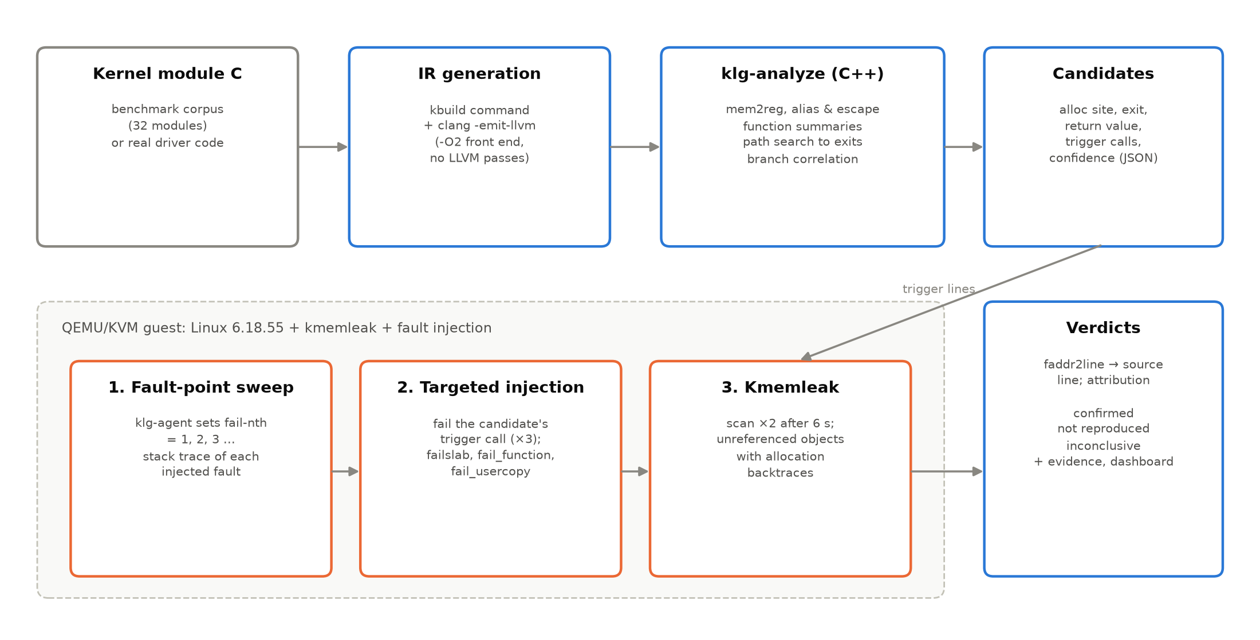
Figure 3.1: Architecture of KernelLeakGuard
Workflow.
1. Each module is compiled by kbuild; its exact compile command is re-run with -emit-llvm to obtain LLVM bitcode that sees the same headers, macros and configuration.
2. klg-analyze reports candidate leaks: allocation site, leaking exit, returned value, the trigger calls whose failure leads to the exit, and a confidence level.
3. Sweep run: in the VM, klg-agent executes each routine with fail-nth = 1, 2, 3 ... and records the stack trace of each injected fault, producing a map from fault number to source line.
4. Confirmation run: for every candidate, the fault number that hits its trigger line is injected three times; kmemleak is scanned and leaked objects are attributed to allocation sites through stack symbolisation (faddr2line).
5. Verdicts and evidence are written to JSON, evaluated against ground truth, and shown in the dashboard.

3.2 Module-wise Description

3.2.1 Static analyser (klg-analyze, C++/LLVM) - Om Gunjan Gupta
The analyser loads bitcode produced with clang's -O2 front end but no LLVM optimisation passes, so the IR keeps the program structure as written. A preparation step promotes stack variables to SSA registers (mem2reg), folds configuration stubs such as mem_alloc_profiling_enabled() that kmalloc()'s macro tests, and removes the resulting dead branches. Allocation sites are calls to the allocator functions of the API specification (kmalloc, kzalloc, kcalloc, kvmalloc, vmalloc, kmem_cache_alloc, kstrdup, kmemdup, kasprintf, memdup_user and their variants) or to module functions whose summary says they return fresh memory.
• Alias tracking: the allocated pointer is followed through casts, GEPs, PHIs and selects, and field-sensitively through local stack objects (structures and arrays) from which it is reloaded.
• Release and ownership transfer: kfree() and its relatives release the object; a store into non-local memory, returning the pointer, or passing it to a function that captures it transfers ownership and ends the function's responsibility.
• Function summaries: for each module function and each pointer parameter a monotone fixpoint computes whether it frees, captures or returns the parameter, and whether it provably publishes it (stores it into a list, hash table, global or another object, directly or through a module helper such as list_add_tail()). A second fixpoint marks functions that return new memory (allocation wrappers), but only when the new object is not published first: a helper that links the object into a list or returns a shared, reference-counted one is a lookup, and the caller does not own the result.
• Path search: a depth-first search from the allocation to every return, pruning the edge on which the allocation itself failed (a NULL check, or an IS_ERR() check when the value is an ERR_PTR error code) and edges that contradict an earlier decision on the same condition (branch correlation, seeded with the dominating conditions that guard the allocation). Values are resolved along the current path: a return of phi(object, NULL) hands the object over only on the paths that bring it into the phi, and a switch whose selector is a constant on the path (the cleanup-destination switch clang emits for a goto out of a scoped block) has a single feasible successor. Loops are unrolled twice; a second execution of the allocation creates a new instance while the earlier one stays reachable through memory.
• Reporting: the returned value on the path is resolved (constant errno, NULL, or a propagated error code) to classify error exits; the failing calls that guard the path become triggers; confidence is high when the function frees the object on another path and the leaking path returns an error.

3.2.2 Guest kernel and virtual machine - Abhishek Kumar Singh
Linux 6.18.55 LTS is built with clang from defconfig, the KVM guest fragment and the KernelLeakGuard fragment (vm/kernel.config.fragment): kmemleak without automatic scanning, fault injection with failslab, fail_function and fail_usercopy, ftrace-based kprobes and virtio-9p sharing. Several settings make kmemleak trustworthy by removing stale copies of pointers that would make a leaked object look referenced: thread stacks come from the page allocator (CONFIG_VMAP_STACK=n), kernel stacks are erased on return to user space (CONFIG_KSTACK_ERASE), kmemleak does not scan task stacks, and slab memory is zeroed on allocation and free (init_on_alloc=1 init_on_free=1). The guest boots from a busybox initramfs in about two seconds, mounts the host directory over 9p, configures fault injection through debugfs and runs the job script generated by the host.

3.2.3 Fault-injection agent (klg-agent, C) - Abhishek Kumar Singh
klg-agent is a statically linked C program that drives one kernel routine at a time. In sweep mode it writes N to /proc/thread-self/fail-nth, runs the routine (writing to the module's debugfs trigger file or loading the module with finit_module()), reads fail-nth back to learn whether the fault fired, and records the kernel log lines of the attempt. In repeat mode it injects a chosen fault several times and, when given the expected stack frame, verifies that the fault landed there and probes neighbouring N if fault numbering drifted between boots. A random mode enables probabilistic faults for the task only around the target system call, for the random baseline. With --filter the agent sets the fault-injection stack-trace filter (require-start / require-end) to the target module's code, so only the module's own fault points are counted; the module's layout comes from klg_modwatch, a helper kernel module that uses a module notifier to log every module's load address and function symbols. The same log lets the host resolve kmemleak backtraces of modules that were already unloaded. Before each attempt the agent writes a marker to the host, so that if the guest kernel crashes or hangs, the host records the faulting fault point, reboots the VM and resumes.

3.2.4 Verifier, evaluation and dashboard (Python) - Aarav Jain
The klg package builds modules and IR, runs the analyser, generates the guest job scripts, boots the VM, symbolises stack frames with the kernel's faddr2line script, plans the confirmation tests, schedules them in kmemleak rounds so that leaks can be attributed unambiguously, and computes verdicts and metrics. The Streamlit dashboard lists findings with verdicts, highlights the allocation, failing call and leaking exit in the source, shows the kmemleak backtraces, compares approaches, presents the real-kernel findings with their patches, can run the pipeline, and has a live page that boots the guest kernel and streams its console, so that a leak being caught by kmemleak can be watched as it happens.

3.2.5 Operating-system concepts used
Table 3.1: Operating-system concepts used in KernelLeakGuard
OS concept | Where it appears in the project
Memory management | Kernel slab allocator (kmalloc caches, kmem_cache), vmalloc, kvmalloc; ownership and release of kernel memory; kmemleak's mark-and-scan of memory
Error handling / fault tolerance | Early-exit paths, errno propagation, goto cleanup ladders; failslab, fail_function and fail_usercopy fault injection
Process management | Per-task fault injection state (fail-nth, make-it-fail), task stacks, kernel/user mode transitions, stack erasing on syscall return
Linux system programming | System calls (write, finit_module, delete_module, pread, pwrite), /proc and debugfs interfaces, /dev/kmsg log reading
Device management | Loadable kernel modules, misc devices, platform drivers with device-managed (devm) memory
Virtualisation | QEMU with KVM hardware acceleration, virtio-9p file sharing, initramfs boot
Synchronisation | Mutex-protected lists, RCU-deferred freeing (kfree_rcu, call_rcu), reference counting (kref)
Performance analysis | Analysis time, VM time, number of executions, precision/recall

3.3 Algorithms Used
Algorithm 1: Early-exit leak detection (per allocation site).
input : function F (SSA form), allocation call a, summaries S
output: leak candidates for a

Alias := closure of {a} over casts, GEPs, PHIs, selects, calls returning a parameter
Slots := stack fields a is stored into; Alias += loads from those fields
Events := { release(i) : i frees an alias (spec or summary) }
∪ { transfer(i) : i stores an alias to non-local memory,
returns it, or passes it to a capturing call }
D0 := branch outcomes that dominate block(a) outside loops around a

DFS(block, decisions D, triggers T):
for each instruction i in block:
if i = a again: reallocated := true # new instance, old one lives on
if i ∈ Events (and not superseded by reallocation): return # handled
if i is return: report(a, exit=i, value=resolve(retval, path), T); return
if block ends in "br c, s0, s1":
(key, value) := normalise(c) # strips !, unlikely(), zext
for each successor s with outcome v:
if contradicts(D, key, v) and not stale: continue # infeasible path
if key is "alias == NULL" and v is true and not reallocated: continue
if call f controls c and v means "f failed": T' := T + f
DFS(s, D + (key, v), T') # each block ≤ 2 times per path
else: DFS(each successor)

DFS(block(a) after a, D0, [])

Algorithm 2: Runtime verification of a candidate.
input : candidate C (alloc line, trigger lines, function), module M
Sweep (once per module, in VM):
for N = 1, 2, ...: set fail-nth := N; run M's routine
if fail-nth not consumed: break # all fault points visited
record stack trace of the injected fault → source lines (faddr2line)
Plan:
P := fault numbers whose stack contains a trigger line of C # exact
or whose frame is C.function with C's only allocation site # merged debug info
or silent faults that made the routine fail # __GFP_NOWARN
if P = ∅: verdict(C) := inconclusive
Confirm (one kmemleak round, ≤ 1 test per module, init-mode tests alone):
for N in P[0..2]: repeat 3 times: inject N, check fault hit the expected frame
wait 6 s; scan kmemleak twice; attribute each unreferenced object by backtrace
Verdict:
confirmed if an object allocated at C.alloc line leaked (or, for unloaded
modules, an object of C's allocation size leaked in an isolated round)
not reproduced if the predicted failure was injected but nothing leaked
inconclusive otherwise

3.4 Dataset Details
No public dataset of kernel error-path leaks with runnable triggers and exact ground truth exists, so we built a benchmark corpus of 32 kernel modules: 17 containing known leaks (klg_l01-l17) and 15 leak-free modules (klg_s01-s15), several of them fixed versions of a leaky module. The patterns follow bug classes reported for Linux (wrong goto label, missing release after copy_from_user failure, leaks in loops, through wrappers, after registration failures). Every allocation site carries a ground-truth comment GT:LEAK or GT:SAFE.
Table 3.2: Benchmark corpus (dataset)
Module | Pattern | Run mode | Leak / safe sites
l01_two_alloc | the canonical early-exit leak (init mode) | init | 1 / 1
l02_goto_ladder | goto cleanup ladder with a wrong label | trigger | 1 / 2
l03_reg_fail | leak on a non-allocation error | trigger | 1 / 0
l04_loop_partial | partial allocation in a loop | trigger | 1 / 0
l05_usercopy | leak when copy_from_user() fails (a very common real-world pattern) | trigger | 1 / 0
l06_wrapper_alloc | interprocedural: the object comes from an allocation wrapper | trigger | 1 / 2
l07_wrapper_free | interprocedural: the normal path releases through a wrapper | trigger | 1 / 1
l08_kstrdup | leak of memory returned by kstrdup() when kmemdup() fails | trigger | 1 / 1
l09_kcalloc | array allocations: the index table leaks when the value table cannot | trigger | 1 / 1
l10_vmalloc | vmalloc'd firmware image leaked when the header allocation fails | trigger | 1 / 1
l11_kmem_cache | object from a dedicated slab cache leaked on a later failure | trigger | 1 / 1
l12_multi_exit | several error exits, only one of them is wrong | trigger | 1 / 3
l13_init_misc | module init leaks its table when misc_register() fails (init mode) | init | 1 / 0
l14_cond_alloc | conditionally allocated histogram leaked when calibration fails | trigger | 1 / 1
l15_ida | device object leaked when ID allocation fails | trigger | 1 / 0
l16_nested_owner | nested ownership: a buffer owned by a heap object | trigger | 1 / 1
l17_local_struct | pointers kept in a stack-allocated structure | trigger | 1 / 1
s01_two_alloc_ok | fixed version of L01 (init mode): every exit releases what it owns | init | 0 / 2
s02_goto_ok | correct goto cleanup ladder (fixed version of L02) | trigger | 0 / 3
s03_list_owner | ownership transfer to a global list | trigger | 0 / 1
s04_param_owner | ownership transfer to the caller through a parameter's field | trigger | 0 / 1
s05_factory | factory function returning freshly allocated memory; the caller | trigger | 0 / 3
s06_devm | device-managed allocations (init mode) | init | 0 / 2
s07_free_wrapper_ok | release wrapper used consistently on all paths (fixed L07) | trigger | 0 / 2
s08_local_struct_ok | pointers kept in a stack-allocated structure, released correctly | trigger | 0 / 2
s09_loop_cleanup | loop allocation with a correct rollback loop (fixed L04) | trigger | 0 / 1
s10_correlated | allocation and release guarded by the same condition | trigger | 0 / 1
s11_register_owner | ownership handed to a registry function before a later failure | trigger | 0 / 1
s12_kvfree | allocator families paired with their matching release functions: | trigger | 0 / 3
s13_rcu_free | deferred release through RCU on the error path | trigger | 0 / 2
s14_kref | reference-counted object released through kref_put() and a release | trigger | 0 / 1
s15_single_alloc | a single allocation whose only early exit is its own failure | trigger | 0 / 1

Table 3.3: Dataset information
Attribute | Description | Type
Dataset source | Written for this project (corpus/), GPL-2.0 kernel test modules | C source
Number of records | 59 annotated allocation sites in 32 modules (17 leaking, 42 safe) | integer
Module | kernel module name | string
Allocation site | source line of the allocation call | integer
Label | GT:LEAK or GT:SAFE | categorical
Run mode | trigger (debugfs file) or init (module_init) | categorical

3.5 Tools and Technologies
Table 3.4: Tools and technologies
Area | Tools
Static analysis | C++17, LLVM/Clang 21.1.8 (IR, PassBuilder, DominatorTree, LoopInfo, JSON)
Kernel | Linux 6.18.55 LTS built with LLVM=1; kmemleak; failslab, fail_function, fail_usercopy; ftrace kprobes; KSTACK_ERASE
Virtualisation | QEMU 10 with KVM on WSL2 (Windows 11), virtio-9p, busybox initramfs
Runtime agent | C (static glibc), /proc/thread-self/fail-nth, /dev/kmsg
Orchestration | Python 3 (klg package), kernel scripts/faddr2line, binutils
Presentation | Streamlit, Altair, pandas, matplotlib, python-docx, python-pptx
Version control | Git

Module division among team members.
Table 3.5: Module division
Member | Register No. | Modules
Om Gunjan Gupta | 24BIT0316 | Static analyser: IR preparation, alias/escape analysis, function summaries, path search, trigger identification, ablation options
Abhishek Kumar Singh | 24BIT0309 | Guest kernel configuration and build, initramfs and QEMU launcher, klg-agent fault-injection driver, kmemleak protocol
Aarav Jain | 24BIT0023 | Benchmark corpus and ground truth, Python orchestrator (symbolisation, test planning, verdicts), evaluation, dashboard

CHAPTER 4: RESULTS AND DISCUSSION

4.1 Experimental Setup
Table 4.1: Experimental setup
Component | Configuration
Host | Laptop, AMD Ryzen 7 250 (8 cores / 16 threads), 15 GB RAM, Windows 11
Linux environment | WSL2, Ubuntu 26.04 LTS (kernel 6.18 WSL), /dev/kvm available
Guest VM | QEMU/KVM, 2 vCPUs, 2 GB RAM, Linux 6.18.55 (custom configuration)
Compiler | Clang/LLVM 21.1.8 for kernel, modules, IR and analyser
Verification parameters | 3 executions per test, up to 3 fault points per candidate, kmemleak settle time 6 s, 2 scans per round
Baselines | static/naive (all refinements off); cppcheck 2.19 with a kmalloc/kfree library model; dynamic exhaustive single-fault injection; dynamic random injection (10%, 50 executions per module)

Each complete run builds the corpus and IR, runs six analyser configurations, and boots the VM three times: the baseline run (exhaustive and random fault injection for the dynamic-only baselines), the mapping run (KernelLeakGuard's module-filtered fault-point sweep) and the confirmation run. Metrics are computed per allocation site: an approach reports a site when it reports at least one leak allocated there. The approach 'KernelLeakGuard (complete)' is the tool's full output: confirmed static warnings plus leaks exposed by its own mapping sweep; its cost counts every execution of the mapping and confirmation runs.

4.2 Results
Table 4.2 summarises detection quality; Figure 4.1 plots precision and recall.
Table 4.2: Detection results on the benchmark (per allocation site)
Approach | TP | FP | FN | Precision | Recall | F1
Static, naive | 16 | 11 | 1 | 0.59 | 0.94 | 0.73
Static, KernelLeakGuard | 16 | 1 | 1 | 0.94 | 0.94 | 0.94
Hybrid (confirmed warnings) | 15 | 0 | 2 | 1.00 | 0.88 | 0.94
KernelLeakGuard (complete) | 16 | 0 | 1 | 1.00 | 0.94 | 0.97
Dynamic, exhaustive FI | 16 | 0 | 1 | 1.00 | 0.94 | 0.97
Dynamic, random FI | 14 | 0 | 3 | 1.00 | 0.82 | 0.90
cppcheck 2.19 | 6 | 1 | 11 | 0.86 | 0.35 | 0.50

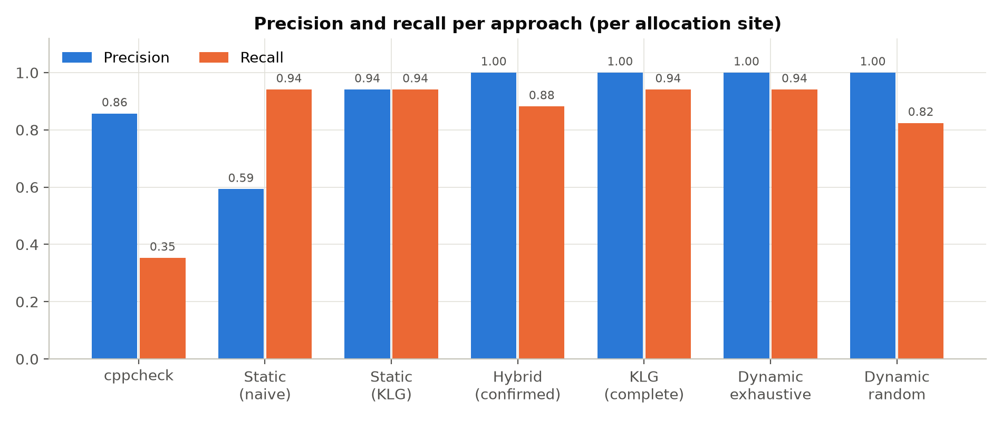
Figure 4.1: Precision and recall per approach
The static analyser reports 17 warnings on 17 allocation sites, finding 16 of the 17 leaking sites with 1 false alarm. The naive analysis that only looks for a missing kfree() finds the same leaks but raises 11 false alarms, most of them ownership transfers (list insertion, caller-owned structures, RCU and kref release, factories). Runtime verification confirmed 15 warnings with kmemleak evidence, refuted 1 and left 1 inconclusive; the hybrid approach therefore reaches precision 1.00: every reported leak is backed by a reproduction. The mapping sweep additionally exposed klg_l16_nested_owner:32, which the static analysis misses by design (Section 4.6), so the complete tool finds 16 leaks. cppcheck, a widely used C static analyser given a model of kmalloc/kfree, finds 6 with 1 false alarm(s): kernel-specific patterns such as error codes from other calls, copy_from_user failures, wrappers and slab caches are outside its model.
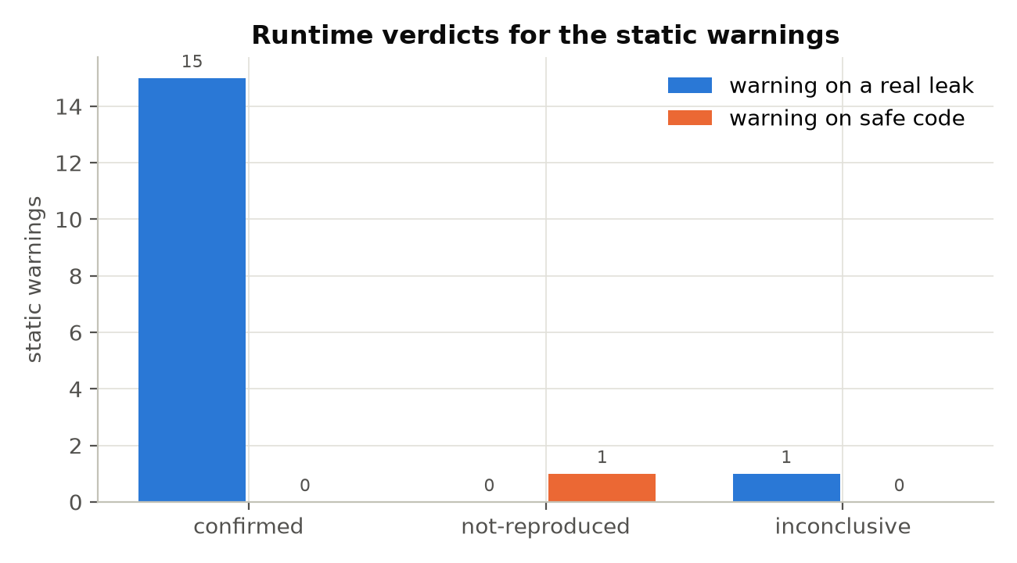
Figure 4.2: Runtime verdicts for the static warnings
Figure 4.2 shows what happened to each warning. All confirmed warnings are real leaks. The static false positive on klg_s09 (a correct rollback loop that the path search cannot prove safe because it does not reason about the loop counter) was refuted: the predicted allocation failures were injected and kmemleak found nothing.

4.2.1 Ablation study
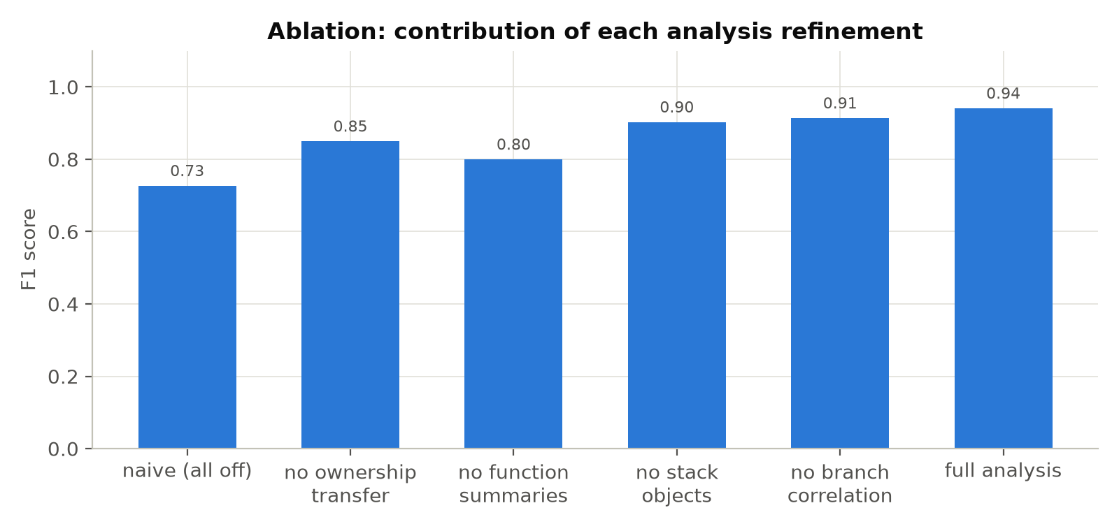
Figure 4.3: F1 score with each analysis refinement disabled
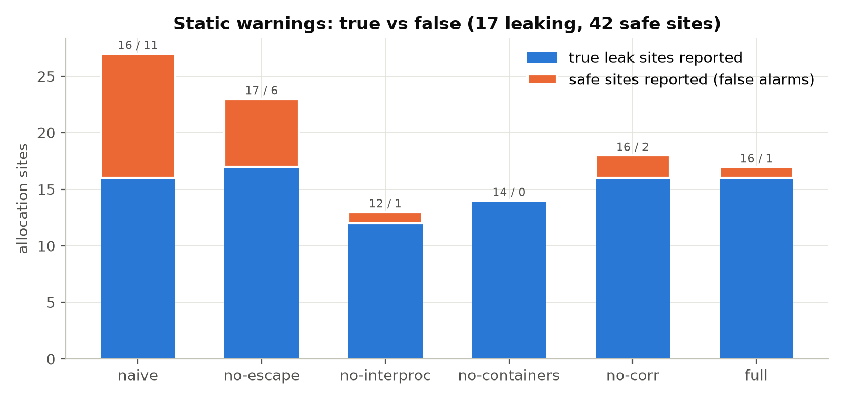
Figure 4.4: True and false static reports per configuration
Table 4.3: Ablation of the static analyser
Configuration | TP | FP | FN | Precision | Recall | F1 | Time (ms)
all refinements off | 16 | 11 | 1 | 0.59 | 0.94 | 0.73 | 21
no ownership transfer | 17 | 6 | 0 | 0.74 | 1.00 | 0.85 | 22
no function summaries | 12 | 1 | 5 | 0.92 | 0.71 | 0.80 | 22
no stack objects | 14 | 0 | 3 | 1.00 | 0.82 | 0.90 | 22
no branch correlation | 16 | 2 | 1 | 0.89 | 0.94 | 0.91 | 23
full analysis | 16 | 1 | 1 | 0.94 | 0.94 | 0.94 | 24

Each refinement matters. Without ownership-transfer analysis precision drops to 0.74, because objects handed to lists, callers or release callbacks look leaked. Without function summaries the analyser misses leaks through allocation and release wrappers and treats every module call as capturing (recall 0.71). Without stack-object tracking, pointers kept in local arrays and structures are treated as escaped (recall 0.82). Branch correlation removes the infeasible path in klg_s10, where allocation and release are guarded by the same condition.

4.2.2 Case study: a confirmed leak
klg_l02 jumps to the wrong cleanup label when kasprintf() fails, skipping the release of the transmit buffer:
28 rx = kmalloc(RX_SIZE, GFP_KERNEL); /* GT:SAFE */
29 if (!rx)
30 return -ENOMEM;
31
32 tx = kmalloc(TX_SIZE, GFP_KERNEL); /* GT:LEAK */
33 if (!tx) {
34 ret = -ENOMEM;
35 goto err_rx;
36 }
37
38 name = kasprintf(GFP_KERNEL, "sensor%d", 0); /* GT:SAFE */
39 if (!name) {
40 ret = -ENOMEM;
41 goto err_rx; /* BUG: should be err_tx */
42 }
43
44 ret = sensor_program(rx, tx, name);
45 kfree(name);
46 if (ret)
47 goto err_tx;
48 pr_debug("sensor ready\n");
49 /* success also unwinds: the buffers are scratch space */
50 err_tx:
51 kfree(tx);
52 err_rx:
53 kfree(rx);
54 return ret;
55 }
56
57 KLG_TRIGGER(sensor_setup);
58 KLG_SIMPLE_MODULE("KLG L02: goto ladder jumps past a cleanup label");

The analyser reports: memory from kmalloc() at line 32 in sensor_setup() is not released when the function returns -ENOMEM at line 54; trigger: kasprintf (line 38); confidence high. During the sweep, fault number 5 failed the call at sensor_setup+0x5f/0xb0. In the confirmation run that fault was injected 3 times and kmemleak reported 3 unreferenced objects allocated at line 32:
unreferenced object (size 512):
backtrace:
__kmalloc_cache_noprof+0x1b5/0x420
sensor_setup+0x3f/0xb0 [klg_l02_goto_ladder]
klg_trigger_write+0x12/0x30 [klg_l02_goto_ladder]
full_proxy_write+0x5c/0xb0
vfs_write+0x136/0x450
ksys_write+0x79/0x100
do_syscall_64+0xc8/0x260
entry_SYSCALL_64_after_hwframe+0x77/0x7f

Verdict: confirmed (leak at klg_l02_goto_ladder.c:32 after failing sensor_setup+0x5f/0xb0). Suggested fix: jump to err_tx instead of err_rx.

4.2.3 Test cases and results
Each benchmark module is a system-level test case: the expected outcome comes from the ground-truth annotations, and the test passes when the static result and the runtime verdict agree with it. A leaky module passes when its leak is reported and confirmed; a safe module passes when no leak is confirmed.
Table 4.4: System test cases (one per benchmark module)
ID | Module | Expected | Static | Runtime verdict(s) | Result
TC01 | l01_two_alloc | leak at 14 | flagged 14 | confirmed | Pass
TC02 | l02_goto_ladder | leak at 32 | flagged 32 | confirmed | Pass
TC03 | l03_reg_fail | leak at 33 | flagged 33 | confirmed | Pass
TC04 | l04_loop_partial | leak at 19 | flagged 19 | confirmed | Pass
TC05 | l05_usercopy | leak at 20 | flagged 20 | confirmed | Pass
TC06 | l06_wrapper_alloc | leak at 37 | flagged 37 | confirmed | Pass
TC07 | l07_wrapper_free | leak at 27 | flagged 27 | confirmed | Pass
TC08 | l08_kstrdup | leak at 16 | flagged 16 | confirmed | Pass
TC09 | l09_kcalloc | leak at 17 | flagged 17 | confirmed | Pass
TC10 | l10_vmalloc | leak at 22 | flagged 22 | confirmed | Pass
TC11 | l11_kmem_cache | leak at 22 | flagged 22 | confirmed | Pass
TC12 | l12_multi_exit | leak at 14 | flagged 14 | confirmed | Pass
TC13 | l13_init_misc | leak at 42 | flagged 42 | confirmed | Pass
TC14 | l14_cond_alloc | leak at 29 | flagged 29 | confirmed | Pass
TC15 | l15_ida | leak at 21 | flagged 21 | inconclusive | Fail
TC16 | l16_nested_owner | leak at 32 | no warning | — | Fail
TC17 | l17_local_struct | leak at 21 | flagged 21 | confirmed | Pass
TC18 | s01_two_alloc_ok | no leak | no warning | — | Pass
TC19 | s02_goto_ok | no leak | no warning | — | Pass
TC20 | s03_list_owner | no leak | no warning | — | Pass
TC21 | s04_param_owner | no leak | no warning | — | Pass
TC22 | s05_factory | no leak | no warning | — | Pass
TC23 | s06_devm | no leak | no warning | — | Pass
TC24 | s07_free_wrapper_ok | no leak | no warning | — | Pass
TC25 | s08_local_struct_ok | no leak | no warning | — | Pass
TC26 | s09_loop_cleanup | no leak | flagged 20 | not-reproduced | Pass
TC27 | s10_correlated | no leak | no warning | — | Pass
TC28 | s11_register_owner | no leak | no warning | — | Pass
TC29 | s12_kvfree | no leak | no warning | — | Pass
TC30 | s13_rcu_free | no leak | no warning | — | Pass
TC31 | s14_kref | no leak | no warning | — | Pass
TC32 | s15_single_alloc | no leak | no warning | — | Pass

30 of 32 system test cases pass. The failing cases are the known limitations discussed in Section 4.6: l15_ida (inconclusive); l16_nested_owner (not reported).
In addition, 32 automated unit and regression tests (tests/test_klg.py) check log parsing, kmemleak parsing, size matching, fault-point matching, test scheduling, ground-truth parsing and the analyser's behaviour on individual modules (including each ablation option):
Table 4.5: Unit and regression tests
Test | Result
findings filters | OK
pages render | OK
run button starts and finishes | OK
alloc size reported | OK
branch correlation | OK
detects wrong goto label | OK
error propagation exit | OK
fixed version is clean | OK
interprocedural wrapper | OK
local struct container | OK
loop leak | OK
managed memory ignored | OK
ownership transfer | OK
agent log | OK
crash site from begin marker | OK
kmemleak | OK
size compatible | OK
symbol map resolves unloaded module | OK
corpus annotations | OK
init mode detection | OK
exact line match | OK
function fallback needs single site | OK
schedule isolates init tests | OK
silent fault fallback | OK
cleanup branch in loop is resolved | OK
cleanup switch default is infeasible | OK
ownership transferred only on success | OK
phi return null path leaks | OK
publishing helper is a lookup | OK
fragment mapping complete | OK
load order dependencies first | OK
modname | OK

4.2.4 Fix patches
For every confirmed leak KernelLeakGuard generates a patch: it inserts the release statement the function already uses for the object on another path (or the deallocator matching the allocator) at the start of the error branch, only when that branch is reached exclusively from the failing call; leaks of allocations made in a loop receive a rollback loop. Each patch is validated three ways: the patched module compiles, klg-analyze no longer reports the leak, and in the VM a module-filtered sweep exercises every fault point of the patched module with kmemleak and SLUB debugging (slub_debug=FZPU, which detects double frees and memory corruption) active. 14 of 15 patches pass all three checks. The remaining 1 patch(es) (the loop rollback for klg_l04) removes the leak at runtime, with every fault point of the module exercised, but the analyser still reports the site because it cannot reason about the loop counter — the same limitation as the klg_s09 warning.
Table 4.6: Generated fix patches and their validation
Module | Release inserted | Compiles | Static clean | Faults exercised | Runtime clean | Status
l01_two_alloc | reuses the release at line 24 | yes | yes | 4 | yes | validated
l02_goto_ladder | reuses the release at line 51 | yes | yes | 6 | yes | validated
l03_reg_fail | reuses the release at line 44 | yes | yes | 3 | yes | validated
l04_loop_partial | rollback loop over desc[0..i-1]; reuses the release at line 27; static warning remains (loop-counter limitation) | yes | no | 8 | yes | runtime-validated
l05_usercopy | reuses the release at line 29 | yes | yes | 3 | yes | validated
l06_wrapper_alloc | reuses the release at line 48 | yes | yes | 4 | yes | validated
l07_wrapper_free | reuses the release at line 38 | yes | yes | 4 | yes | validated
l08_kstrdup | reuses the release at line 26 | yes | yes | 4 | yes | validated
l09_kcalloc | reuses the release at line 32 | yes | yes | 4 | yes | validated
l10_vmalloc | reuses the release at line 34 | yes | yes | 10 | yes | validated
l11_kmem_cache | reuses the release at line 34 | yes | yes | 4 | yes | validated
l12_multi_exit | reuses the release at line 20 | yes | yes | 8 | yes | validated
l13_init_misc | kfree() matches kzalloc() | yes | yes | 42 | yes | validated
l14_cond_alloc | reuses the release at line 42 | yes | yes | 5 | yes | validated
l17_local_struct | reuses the release at line 32 | yes | yes | 4 | yes | validated

Example: the generated patch for klg_l02.
--- a/corpus/klg_l02_goto_ladder.c
+++ b/corpus/klg_l02_goto_ladder.c
@@ -38,6 +38,7 @@
name = kasprintf(GFP_KERNEL, "sensor%d", 0); /* GT:SAFE */
if (!name) {
ret = -ENOMEM;
+ kfree(tx);
goto err_rx; /* BUG: should be err_tx */
}

4.3 Performance Metrics
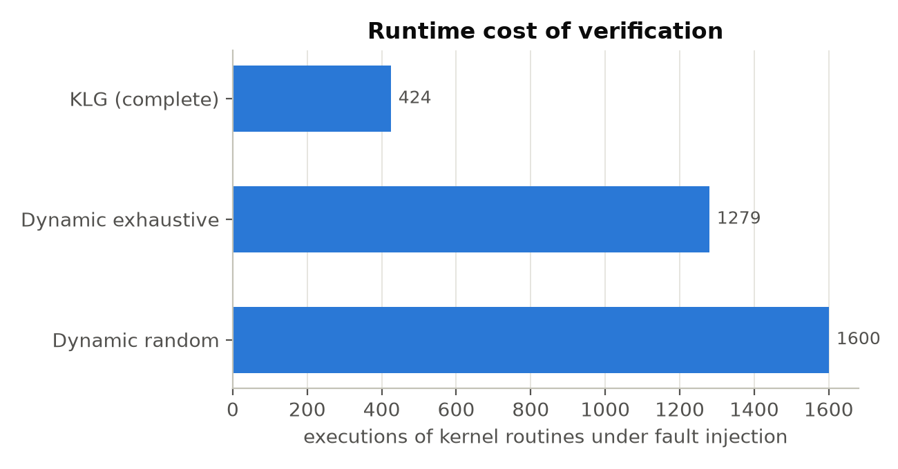
Figure 4.5: Executions of kernel routines needed for verification
Table 4.7: Performance of the pipeline
Metric | Value
Functions analysed / allocation sites | 200 / 57
Static analysis time, all 32 modules | 24 ms (0.7 ms per module)
Mapping VM run (module-filtered fault-point sweep) | 80 s
Confirmation VM run | 122 s
Baseline VM run (exhaustive + random fault injection) | 146 s
kmemleak rounds in confirmation | 10
Executions: KernelLeakGuard (sweep + confirmation) | 424 (303 + 121)
Executions: exhaustive fault injection | 1279
Executions: random fault injection | 1600

The complete pipeline was run 3 times from scratch (new VM boots, new fault-point sweeps) with the analyser of the benchmark evaluation, and once more with the final analyser, whose run gives the main results above (its static results find the same sites; it drops two low-confidence warnings on impossible paths). The hybrid confirmed between 14 and 15 leaks with 0 false positives in every run. The variation comes from the vmalloc leak in klg_l10: kmemleak tracks a vmalloc area with a minimum reference count of two (the kernel's own vm_struct legitimately points to it), so a single extra stale copy of its address hides the leak in that scan. The dynamic baselines vary for the same reason and because random injection does not reach the same fault points every time. A false positive never occurred.
Table 4.8: Results across independent runs (fresh VM boots)
Run | Hybrid TP / FP / FN | KLG complete TP / FP / FN | Exhaustive TP / FP / FN | Random TP / FP / FN
Run 1 | 15 / 0 / 2 | 16 / 0 / 1 | 15 / 0 / 2 | 14 / 0 / 3
Run 2 | 15 / 0 / 2 | 16 / 0 / 1 | 15 / 0 / 2 | 14 / 0 / 3
Run 3 | 14 / 0 / 3 | 16 / 0 / 1 | 15 / 0 / 2 | 13 / 0 / 4
Final (main results) | 15 / 0 / 2 | 16 / 0 / 1 | 16 / 0 / 1 | 14 / 0 / 3

4.4 Evaluation on Real Kernel Code
To check the approach beyond our own benchmark, KernelLeakGuard was run on 39 real modules of Linux 6.18.55 that initialise without hardware (virtual network devices, block and SCSI simulators, device-mapper targets, file systems, sound and input drivers; vm/real_modules.fragment). Each module's IR is built from all of its C files with the exact kbuild flags and linked with llvm-link; dependencies (udp_tunnel, ip6_udp_tunnel, configfs, zsmalloc, crc_t10dif, crc_itu_t, nls_ucs2_utils) are loaded first. The static analysis covered 6376 functions with 518 allocation sites and reported 11 warnings in 1.8 s.
Real code exposed false-positive patterns that are absent from the benchmark, and each was fixed in the analyser by a general rule, not by naming kernel functions. (1) Kernel lookup and factory helpers return an ERR_PTR error code (checked with IS_ERR()) instead of NULL; the IS_ERR() edge is now pruned like the NULL edge. (2) Helpers such as hfs_bnode_find(), find_build_dev_info() or add_fsync_inode() link the new object into a hash table or list before returning it, so the caller does not own it; such helpers are now lookups, not allocators. (3) clang emits a cleanup-destination switch when a goto leaves a scoped block; its default edge cannot execute, but the path search followed it and reached the return without the cleanup. Conditions are now evaluated on the values their operands have along the path, which also handles error codes kept in a variable (snd_aloop's err < 0 at a shared unlock label). Investigating a missed seeded leak (Section 4.5) also uncovered a false negative: a single return of phi(object, NULL) was treated as returning the object on every path, hiding leaks on the NULL-returning error path. The table shows the warnings after each step; no step changed any benchmark result in any of the six analyser variants, and every warning removed by the ownership rule was checked by hand in the kernel source.
Table 4.9: Effect of each precision refinement on real kernel code
Analyser refinement | Static warnings (39 modules)
initial MLEE-style analysis | 115
IS_ERR()/ERR_PTR modelled like the NULL check | 64
phi returns resolved per path (fixes a false negative; no real-code change) | 64
ownership: helpers that publish the object are lookups, not allocators | 42
conditions on values that are constant on the path resolved (clang cleanup destinations, error codes kept in a variable) | 11

The runtime stage was run on all 39 modules (affs, bonding, brd, cramfs, dm_delay, dm_dust, dm_flakey, dummy, erofs, exfat, f2fs, geneve, hfs, hfsplus, ipvlan, jfs, mac80211_hwsim, macvlan, minix, netdevsim, nilfs2, nlmon, ntfs3, null_blk, omfs, qnx4, romfs, scsi_debug, snd_aloop, snd_dummy, squashfs, team, tun, udf, ufs, uinput, veth, vxlan, zram). Hardware virtualization was unavailable in WSL during this run (Windows virtualization-based security), so the guest ran under QEMU software emulation, which is correct but 10-20x slower. For each module the mapping run failed every fault point of its initialisation reachable from the module's own code (library modules without an initialisation routine have none), with kmemleak checked after each module, and every static warning was given a targeted confirmation test.
Table 4.10: Real kernel modules run in the VM
Module | Functions | Alloc. sites | Warnings | Faults injected | Runtime verdicts | Guest crashes
affs | 104 | 5 | 0 | 74 | — | 0
bonding | 434 | 16 | 0 | 1106 | — | 0
brd | 14 | 1 | 0 | 1500 | — | 0
cramfs | 21 | 3 | 0 | 5 | — | 0
dm_delay | 18 | 1 | 0 | 0 | — | 0
dm_dust | 21 | 2 | 0 | 0 | — | 0
dm_flakey | 18 | 1 | 0 | 0 | — | 0
dummy | 10 | 1 | 0 | 286 | — | 0
erofs | 191 | 29 | 1 | 567 | 1 inconclusive | 0
exfat | 202 | 9 | 0 | 146 | — | 0
f2fs | 1012 | 77 | 3 | 1096 | 3 inconclusive | 0
geneve | 58 | 1 | 0 | 5 | — | 0
hfs | 135 | 9 | 0 | 72 | — | 0
hfsplus | 201 | 22 | 0 | 152 | — | 0
ipvlan | 84 | 2 | 0 | 7 | — | 0
jfs | 320 | 18 | 0 | 179 | — | 0
mac80211_hwsim | 155 | 4 | 0 | 1440 | — | 0
macvlan | 80 | 3 | 0 | 3 | — | 0
minix | 108 | 3 | 0 | 74 | — | 0
netdevsim | 264 | 33 | 0 | 81 | — | 0
nilfs2 | 692 | 29 | 0 | 325 | — | 0
nlmon | 9 | 0 | 0 | 0 | — | 0
ntfs3 | 439 | 105 | 5 | 78 | 5 inconclusive | 0
null_blk | 148 | 8 | 0 | 752 | — | 10
omfs | 57 | 4 | 0 | 0 | — | 0
qnx4 | 25 | 3 | 0 | 72 | — | 0
romfs | 22 | 2 | 0 | 72 | — | 0
scsi_debug | 273 | 20 | 0 | 2 | — | 0
snd_aloop | 75 | 2 | 0 | 95 | — | 0
snd_dummy | 45 | 2 | 0 | 838 | — | 5
squashfs | 90 | 36 | 0 | 72 | — | 0
team | 155 | 7 | 0 | 15 | — | 0
tun | 121 | 5 | 0 | 47 | — | 0
udf | 204 | 17 | 0 | 74 | — | 0
ufs | 124 | 11 | 2 | 73 | 2 inconclusive | 0
uinput | 38 | 5 | 0 | 0 | — | 0
veth | 76 | 1 | 0 | 0 | — | 0
vxlan | 227 | 12 | 0 | 11 | — | 0
zram | 106 | 9 | 0 | 372 | — | 0

Manual review. Of the 11 warning(s) in these modules, 9 are false positives, 2 are real bugs; all 11 were read in the kernel source, and the real bugs are described below. The false positives share causes the analyser does not model: release decisions on values held in memory (in->index, *raw_super), on pointer identity (free new unless e == new, name != s_name_buf), on the relation between two loop counters, and ownership handed to asynchronous work. Before the refinements above, the same review had found every high-confidence warning to be a false positive, which is what motivated them. No warning was confirmed at runtime, so none became a false report; the two real bugs lie in mount-time code that module initialisation does not reach.
Runtime verdicts. Of the 11 warnings, 11 were inconclusive. 9 inconclusive verdicts mean that no fault point of module initialisation reaches the warning's failing call: the code runs only on other entry points (file system mount, ioctl, netlink, block I/O), which the runtime stage does not drive yet. Driving those entry points (for example with mount images or syzkaller-style system call programs) is the main extension needed for real code.
Leaks found by the sweep. Exercising 9779 fault points of module initialisation left 10 unreferenced allocation site(s): erofs zdata.c:466 (3 objects); f2fs extent_cache.c:1240 (3 objects); f2fs node.c:3519 (3 objects); f2fs segment.c:5866 (3 objects); f2fs super.c:5488 (3 objects); f2fs sysfs.c:1939 (26 objects); f2fs sysfs.c:1944 (4 objects); f2fs xattr.c:836 (3 objects); hfsplus attributes.c:21 (5 objects); nilfs2 super.c:1365 (3 objects).
Root cause of the erofs report: a leak in the SLUB allocator. The unreferenced objects are complete slab caches (a struct kmem_cache, its per-node structures and its kstrdup'd name, e.g. "erofs_pcluster-1"). We bisected erofs's initialisation with the fault-probe helper (one kmemleak scan per batch of fault points, then per fault point): 5 of 9 batches leaked, and the trigger is fail-nth 85 of erofs init: kmalloc in create_unique_id(), inlined into sysfs_slab_add(), while creating the erofs_pcluster-1 cache. The mechanism, confirmed with the full kernel log in the guest, is: sysfs_slab_add() returns before kobject_init_and_add() when create_unique_id() fails, so the cache's kobject is never initialised; do_kmem_cache_create() treats sysfs failure as non-fatal and keeps the cache; kmem_cache_destroy() unlinks the cache and calls kobject_put() on the uninitialised kobject: WARN, refcount underflow, kmem_cache_release() never runs; the struct kmem_cache, its per-node structures and its name stay allocated and unreferenced. The kernel's own warning at destruction time shows the path:
kobject: '(null)': is not initialized, yet kobject_put() is being called.
z_erofs_destroy_pcluster_pool+0x16/0xc0 [erofs]
z_erofs_exit_subsystem+0x1a/0x20 [erofs]
cleanup_module+0x1f/0x140 [erofs]
__se_sys_delete_module+0x289/0x310
do_syscall_64+0xc8/0x260
entry_SYSCALL_64_after_hwframe+0x77/0x7f
refcount_t: underflow; use-after-free.

erofs is only the messenger: any kernel code that creates a mergeable slab cache can leak it this way under allocation failure, and the sweep of all modules indeed reported the same leak in erofs, f2fs, hfsplus and nilfs2. The code is unchanged in mainline 7.3 and linux-next (next-20261020) as of 2026-10-20. Our fix (patches/0001-mm-slub-release-cache-whose-sysfs-kobject-was-never-initialised.patch) makes sysfs_slab_release() release a cache whose kobject was never initialised directly instead of calling kobject_put(). Re-running the same 9 batches on a guest kernel built with the patch exercised the failing sysfs registration 167 times and left 0 unreferenced objects and 0 kobject warnings (stock kernel: 20 objects). The fix is validated in the VM but has not been submitted upstream; the mailing lists should be searched for a pending fix before it is.
A regression in f2fs found by the sweep. The other leak reported by the sweep is in f2fs: kobject_init_and_add() requires kobject_put() even when it fails (the kobject name is already allocated); f2fs_init_sysfs() jumps past kobject_put(&f2fs_feat) when adding "features" fails and past kobject_put(&f2fs_tune) when adding "tuning" fails; initialisation fails, the module is freed, and the kstrdup'd kobject names are left unreferenced. The code was introduced in 2026-04 by commit b635f2ecdb5a ("f2fs: fix uninitialized kobject put in f2fs_init_sysfs()"): the rewrite stopped putting an uninitialised f2fs_tune but also stopped putting the kobject whose own kobject_init_and_add() failed; backported to stable (present in 6.18.55); it is unchanged in mainline 7.3 as of 2026-10-20. Our patch (patches/0003-f2fs-put-kobjects-when-kobject_init_and_add-fails-in-f2fs_init_sysfs.patch) puts each kobject from its own failure path and still never puts the uninitialised one. On the fault points 369-429 of f2fs init the stock module leaked 25 "features" names, 4 "tuning" names and the patched module 0. The leaked names are allocated inside the kobject core, outside the module, so only the runtime stage can find this kind of leak.
A leak found statically in ntfs3. Of the remaining static warnings, the high-confidence one in ntfs3's log replay is a genuine leak: for an InitializeFileRecordSegment log record whose MFT record cannot be read (mi_get() fails), do_action() allocates a struct mft_inode with kzalloc(); mi_format_new() can fail (mi_init()'s buffer allocation, or ntfs_get_bh() after mi->mrec was allocated) and does not free mi; do_action() then returns the error without mi_put(): the mft_inode (and mi->mrec) leak; on success the object is released by mi_put() at the out label. The code is unchanged in mainline 7.3 and linux-next (next-20261020); a web search found no existing report or fix. Our fix (patches/0002-fs-ntfs3-free-mft_inode-when-mi_format_new-fails-in-do_action.patch) calls mi_put(mi) before returning; built against the guest kernel it compiles, and re-analysing the patched module removes exactly this warning (5 warnings before, 4 after, none new). It is not confirmed at runtime, which needs an NTFS image with a dirty log that replays InitializeFileRecordSegment for an unreadable record, so we report it as a source-confirmed static finding.
A known but unfixed leak in ufs. The second real bug among the static warnings: free_full_branch() reads an indirect block with ubh_bread(), which kmallocs a struct ufs_buffer_head; it ends with ubh_bforget(ubh), which bforget()s the buffers but, unlike ubh_brelse(), does not kfree() the ufs_buffer_head; one ufs_buffer_head leaks for every indirect block freed when a file is truncated or deleted. The code is unchanged in mainline 7.3; the leak was reported with a fix in 2018 ("ufs: Fix memory leak in the unlink path", Luis Henriques) that is not in mainline, so KernelLeakGuard independently rediscovered it. Our patch (patches/0004-ufs-free-the-ufs_buffer_head-in-ubh_bforget.patch) adds the kfree(); it compiles and re-analysis removes exactly this warning (2 warnings before, 1 after, none new). It is not confirmed at runtime, which needs a mounted UFS image and a truncate.
Kernel crashes and hangs found. During the sweep the guest had 10 crashes while loading null_blk; 5 hangs while loading snd_dummy. Every null_blk crash is the same page fault in bdev_release() reading freed module memory (below); the crash-recovery mechanism resumed the sweep after each one and stopped the module's sweep after repeated crashes. The snd_dummy hangs (no progress for 15 minutes at certain fault points of its initialisation) were not analysed; to save time under software emulation its sweep was stopped after these hangs instead of the usual ten.
BUG: unable to handle page fault for address: ffffffffa0242650
Oops: Oops: 0000 [#1] SMP NOPTI
RIP: 0010:bdev_release+0x129/0x170
blkdev_release+0x11/0x20
__fput+0xfe/0x280
task_work_run+0x8b/0xb0
exit_to_user_mode_loop+0xaa/0xc0
do_syscall_64+0x1dc/0x260
entry_SYSCALL_64_after_hwframe+0x77/0x7f

Root cause of the null_blk crash. Probing fault points 739-745 one at a time on a freshly booted guest crashed it at 739, 741, 743, 745, so no earlier state is needed. With a verbose console the trigger is fail-nth 739 of null_blk init: kmalloc in configfs_register_subsystem(), after null_init() has added its disk. The mechanism: add_disk() -> disk_scan_partitions() opens the whole disk (taking a module reference through disk->fops->owner) and drops it with fput(); called from a user task (finit_module), the final __fput() is deferred to task_work; configfs_register_subsystem() then fails; null_init() destroys its device and returns the error, and the module loader frees the module; on return to user space the deferred __fput() runs bdev_release(), whose module_put(disk->fops->owner) reads the freed module's block_device_operations. The crash stack confirms the deferred release (blkdev_release+0x11/0x20 <- __fput+0xfe/0x280 <- task_work_run+0x8b/0xb0 <- exit_to_user_mode_loop+0xaa/0xc0). Any module that adds a disk and then fails its initialisation is exposed; the code is unchanged in mainline 7.3 (disk_scan_partitions() still uses fput(); null_init() still registers configfs after creating devices). We did not validate a fix: releasing the scan file synchronously (__fput_sync()) is documented as reserved for kernel threads; the fix belongs to the block / module-loader maintainers.

4.5 Seeded Leaks in Real Kernel Code
The current real modules contain few early-exit leaks on code the runtime stage can execute, so to evaluate the complete detect-confirm-fix loop on real kernel code we re-introduce leaks into real kernel sources and build the module out of tree against the guest kernel, unchanged apart from that change. Where possible the leak is a real historical bug: the release added by an upstream leak fix is removed again, so the code is exactly what Linux shipped before that fix and the fix is the upstream patch. Otherwise one release statement is removed as a careless patch would; such bugs are ours and clearly marked. A warning counts as detected only if it is new compared with the unmodified module, and the fix (re-inserting the statement) must compile, clear the warning and leave kmemleak clean on a VM re-run.
Table 4.11: Early-exit leaks re-introduced into real kernel modules
Module | Removed at | Removed statement | Origin | Detected | Confirmed (VM) | Fixed
bonding | bond_main.c:6509 | free_netdev(bond_dev); | real bug (fixed by 8d6184e4881b, 2010) | yes | yes | yes
null_blk | main.c:812 | kfree(dev); | seeded by us | yes | yes | yes

bonding, bond_create() — upstream commit 8d6184e4881b "bonding: fix device leak on error in bond_create()" (2010-02-27). A real bug that shipped in Linux until 2010: when register_netdevice() fails, bond_create() returns without free_netdev(), leaking the net_device allocated by alloc_netdev_mq(). Upstream commit 8d6184e4881b added the release; removing it from Linux 6.18.55 restores the original bug. bonding_init() calls bond_create() for each of max_bonds (default 1) at module load and propagates its error, so failing an allocation inside register_netdevice() with fail-nth makes initialisation fail and leaves the net_device unreferenced.
KernelLeakGuard reported the allocation at line 6497 (alloc_netdev_mqs) leaking at the exit on line 6510 (returning error from register_netdevice, confidence medium); the unmodified module has no such warning.
In the guest VM the module-filtered sweep mapped the failing call, and the targeted test (leak at bond_main.c:6497 after failing bond_create+0x66/0xa0) made module initialisation fail; kmemleak then reported the object as unreferenced, with the allocation backtrace pointing back into the module's init path (module frames symbolised through klg_modwatch):
unreferenced object:
__kvmalloc_node_noprof+0x30f/0x5c0
alloc_netdev_mqs+0x86/0x580
do_one_initcall+0x119/0x300
do_init_module+0x60/0x250
__se_sys_finit_module+0x27f/0x370
do_syscall_64+0xc8/0x260
entry_SYSCALL_64_after_hwframe+0x77/0x7f
bond_create+0x44/0x0 [bonding]

Re-inserting the removed statement (the generated fix) compiles, clears the static warning and leaves kmemleak with nothing to report on the VM re-run; the guest did not crash (0 crashes).
null_blk, null_alloc_dev(). null_alloc_dev() allocates the struct nullb_device with kzalloc() and frees it with kfree(dev) when badblocks_init() fails. Removing that call leaks the nullb_device: dev is a local variable that has not been published anywhere yet, and NULL is returned. null_init() calls null_alloc_dev() at module load; when it returns NULL, init fails with -ENOMEM and the module is unloaded, so failing the allocation inside badblocks_init() with fail-nth leaves the object unreferenced.
KernelLeakGuard reported the allocation at line 799 (kzalloc) leaking at the exit on line 813 (returning NULL, confidence medium); the unmodified module has no such warning.
In the guest VM the module-filtered sweep mapped the failing call, and the targeted test (leak at main.c:799 after failing null_alloc_dev+0x63/0x210) made module initialisation fail; kmemleak then reported the object as unreferenced, with the allocation backtrace pointing back into the module's init path (module frames symbolised through klg_modwatch):
unreferenced object:
__kmalloc_cache_noprof+0x1b5/0x420
do_one_initcall+0x119/0x300
do_init_module+0x60/0x250
__se_sys_finit_module+0x27f/0x370
do_syscall_64+0xc8/0x260
entry_SYSCALL_64_after_hwframe+0x77/0x7f
null_alloc_dev+0x1c/0x0 [null_blk]
init_module+0xd7/0x0 [null_blk]

Re-inserting the removed statement (the generated fix) compiles, clears the static warning and leaves kmemleak with nothing to report on the VM re-run; the guest did not crash (0 crashes).
Choosing seeds. A seed is only useful when kmemleak can observe the leak, which rules out most candidates, and we report the rejected ones. In brd, removing brd_free_device() leaves the object linked in the global brd_devices list: it stays reachable, so this is a stale-entry bug, not an unreferenced leak. The analyser initially flagged it, and its ownership rule (Section 4.4) now correctly treats brd_find_or_alloc_device() as a lookup. In zram (zram_add()) and scsi_debug the object is first stored in an IDR or passed to a registering helper, so the analyser conservatively treats it as escaped and does not warn: these are honest misses of the escape analysis on code where ownership is handed over and then taken back. A historical scsi_debug fix (e6d773f93a49, a device name leaked when device_register() fails) was not used because the leaked name is allocated inside the driver core, outside the module the static stage analyses. The null_blk seed also revealed two analyser gaps, both fixed generally: the phi-return false negative (Section 4.4) and the missing model of badblocks_init(), which only initialises the struct badblocks it is given.

4.6 Analysis
Static versus hybrid. Runtime verification removed all static false positives (1 in this run) and attached reproduction steps and kmemleak backtraces to every confirmed report. The cost is a modest loss of recall: warnings whose failure cannot be injected stay inconclusive rather than confirmed. In the corpus this happens for klg_l15, where ida_alloc() never allocates for small identifiers (they are stored inline in the XArray), so its failure cannot be provoked; reporting it as inconclusive is the honest outcome, and the warning is still shown to the developer.
Hybrid versus dynamic-only. Exhaustive fault injection runs every routine once per fault point (1279 executions, dominated by module loading, which has hundreds of fault points) and random injection uses a fixed budget. KernelLeakGuard restricts its sweep with the kernel's fault-injection stack-trace filter (require-start/require-end set to the module's code, taken from klg_modwatch's log), so fail-nth counts only fault points reached from the module itself; together with the targeted confirmation it needs 424 executions in total and finds 16 leaks, against 16 for the exhaustive baseline. Leaks in module initialisation code are reported by kmemleak with raw addresses because the module is unloaded after its failed initialisation; klg_modwatch, a helper module that logs each module's load address and symbols, turns them back into exact source lines. Dynamic tools report only a backtrace, whereas KernelLeakGuard's report names the leaking exit, the returned error, the failing call and a validated fix.
Trustworthy kmemleak results. kmemleak decides that an object is referenced if any scanned memory contains a value equal to its address, so a stale copy of a pointer hides a real leak. During development the leak in klg_l17 (a pointer kept in a local structure) was confirmed in some runs and missed in others. We traced two sources of stale copies: reused kernel stacks, and reused slab objects that still contained an old SLUB freelist link pointing to the leaked buffer (kmalloc does not clear memory). The guest therefore allocates thread stacks from the page allocator, erases kernel stacks on return to user space, disables kmemleak's task-stack scanning (all tested routines have returned before a scan) and boots with init_on_alloc=1 init_on_free=1 so that slab memory is zeroed. This made the klg_l17 verdict stable. vmalloc'd memory remains less stable (see the repeated runs in Section 4.3): such leaks can still be hidden in an individual scan, which is why a missing confirmation is reported as 'not reproduced', never as 'safe'.
Limitations. The analyser does not track ownership through fields of other heap objects, so the nested-buffer leak in klg_l16 is missed by design; field-sensitive heap ownership (as in K-MELD) is future work. Path-insensitivity on loop counters causes the klg_s09 warning, which the runtime stage then refutes. The benchmark is written by us; results on it demonstrate the mechanism but do not predict performance on the whole kernel.
Comparison with MLEE. MLEE analyses the whole kernel and found 120 new leaks; KernelLeakGuard analyses modules with a smaller MLEE-style analysis. Its contribution is the verification loop: MLEE's reports require manual confirmation, while KernelLeakGuard confirms or refutes each warning automatically with kernel evidence.

CHAPTER 5: CONCLUSION AND FUTURE WORK

5.1 Conclusion
KernelLeakGuard detects memory leaks on Linux kernel early-exit paths with an LLVM-based static analyser and verifies every warning by injecting the predicted failure in a QEMU/KVM guest and checking kmemleak. The project applies core operating-system concepts (kernel memory management, error handling, system calls, per-task kernel state, kernel modules and virtualisation) to a practical systems problem. On a benchmark of 32 modules the static analyser achieves F1 0.94 against 0.73 for a naive missing-kfree analysis, and runtime verification confirms 15 leaks with kernel evidence, refutes the remaining false positive and reaches precision 1.00. The complete tool finds 16 of 17 leaks with no false positive using 424 executions, compared with 16 leaks and 1279 executions for exhaustive fault injection, and generates validated fix patches for 14 of 15 confirmed leaks.
On 39 real Linux modules the static analyser reported 11 warnings after general precision refinements (115 before), and the runtime stage confirmed none of them, so no false report reached the developer. 2 of 2 leaks re-introduced into real module code, including a real historical bug, were detected, confirmed in the VM with kmemleak evidence and fixed end to end. Exercising the initialisation of real modules under fault injection also found three kernel defects that we root-caused and checked against mainline: a slab-cache leak in the SLUB allocator when sysfs registration fails and a kobject-name leak in f2fs introduced by a 2026 fix (both fixes validated in the VM), and a use-after-free of module memory when a module's initialisation fails after it added a disk. The static analyser also found leaks in ntfs3's log replay and in ufs's truncation that are still present in mainline; our fixes remove the warnings. The runtime half is therefore useful beyond confirming static warnings.
Key findings: ownership-transfer analysis is the single most important refinement for precision; predicting the failing call and filtering fault injection to the module's own code make runtime verification cheaper and more precise than blind fault injection; and kmemleak evidence is trustworthy only when stale pointer copies on reused stacks and in reused slab memory are eliminated.

5.2 Future Work
• Field-sensitive heap ownership to detect nested leaks such as klg_l16.
• Track error codes stored in variables (value correlation, e.g. err < 0 at a shared cleanup label) and release through list iteration: remaining false-positive causes on real kernel code (Section 4.4).
• Drive non-initialisation entry points (file-system images to mount, ioctl and netlink programs, syzkaller-style system-call sequences) so that warnings outside module initialisation become testable.
• Run the runtime stage with hardware acceleration (KVM) instead of software emulation, which makes the real-module run 10-20x faster and allows repeated runs.
• Report the SLUB slab-cache leak, the f2fs regression, the ntfs3 log-replay leak and the ufs leak upstream with their patches, and the null_blk / block-layer use-after-free to the block maintainers, after checking the mailing lists for pending fixes; confirm the ntfs3 leak at runtime with a crafted image.
• Reproducing known MLEE-reported leaks on the corresponding historical kernel versions.
• Value-range reasoning about loop counters to avoid rollback-loop false positives.
• Patches for shared error labels (goto ladders used by several paths), which are currently left for manual review.
• Integration into kernel continuous-integration systems such as KernelCI.
Real-world deployment scope. The command-line tool and dashboard can be run by driver developers before submitting patches, and the verifier's evidence (failing call, fault number, kmemleak backtrace) is directly usable in a bug report.

REFERENCES
Wang, Wenwen. “MLEE: Effective Detection of Memory Leaks on Early-Exit Paths in OS Kernels.” 2021 USENIX Annual Technical Conference (USENIX ATC 21), USENIX Association, 2021, www.usenix.org/conference/atc21/presentation/wang-wenwen.
Saha, Suman, et al. “Hector: Detecting Resource-Release Omission Faults in Error-Handling Code for Systems Software.” 2013 43rd Annual IEEE/IFIP International Conference on Dependable Systems and Networks (DSN), IEEE, 2013.
Emamdoost, Navid, et al. “Detecting Kernel Memory Leaks in Specialized Modules with Ownership Reasoning.” Proceedings of the Network and Distributed System Security Symposium (NDSS), 2021.
Wu, Qiushi, et al. “Understanding and Detecting Disordered Error Handling with Precise Function Pairing.” 30th USENIX Security Symposium (USENIX Security 21), 2021.
Jiang, Zu-Ming, et al. “Fuzzing Error Handling Code Using Context-Sensitive Software Fault Injection.” 29th USENIX Security Symposium (USENIX Security 20), 2020.
Lawall, Julia, and Gilles Muller. “Coccinelle: 10 Years of Automated Evolution in the Linux Kernel.” 2018 USENIX Annual Technical Conference (USENIX ATC 18), 2018.
Palix, Nicolas, et al. “Faults in Linux 2.6.” ACM Transactions on Computer Systems, vol. 32, no. 2, 2014.
Engler, Dawson, et al. “Bugs as Deviant Behavior: A General Approach to Inferring Errors in Systems Code.” Proceedings of the 18th ACM Symposium on Operating Systems Principles (SOSP), 2001.
Xie, Yichen, and Alex Aiken. “Context- and Path-Sensitive Memory Leak Detection.” Proceedings of ESEC/FSE 2005, ACM, 2005.
Cherem, Sigmund, Lonnie Princehouse, and Radu Rugina. “Practical Memory Leak Detection Using Guarded Value-Flow Analysis.” Proceedings of the ACM SIGPLAN Conference on Programming Language Design and Implementation (PLDI), 2007.
Sui, Yulei, Ding Ye, and Jingling Xue. “Static Memory Leak Detection Using Full-Sparse Value-Flow Analysis.” Proceedings of the International Symposium on Software Testing and Analysis (ISSTA), ACM, 2012.
Rubio-González, Cindy, et al. “Error Propagation Analysis for File Systems.” Proceedings of the ACM SIGPLAN Conference on Programming Language Design and Implementation (PLDI), 2009.
Lattner, Chris, and Vikram Adve. “LLVM: A Compilation Framework for Lifelong Program Analysis & Transformation.” International Symposium on Code Generation and Optimization (CGO), IEEE, 2004.
Nethercote, Nicholas, and Julian Seward. “Valgrind: A Framework for Heavyweight Dynamic Binary Instrumentation.” Proceedings of the ACM SIGPLAN Conference on Programming Language Design and Implementation (PLDI), 2007.
Serebryany, Konstantin, et al. “AddressSanitizer: A Fast Address Sanity Checker.” 2012 USENIX Annual Technical Conference (USENIX ATC 12), 2012.
Bellard, Fabrice. “QEMU, a Fast and Portable Dynamic Translator.” Proceedings of the USENIX Annual Technical Conference, FREENIX Track, 2005.
Bonwick, Jeff. “The Slab Allocator: An Object-Caching Kernel Memory Allocator.” Proceedings of the USENIX Summer 1994 Technical Conference, 1994.
Google. “syzkaller: An Unsupervised Coverage-Guided Kernel Fuzzer.” GitHub, github.com/google/syzkaller. Accessed 12 Oct. 2026.
The Linux Kernel Documentation. “Kernel Memory Leak Detector.” kernel.org, docs.kernel.org/dev-tools/kmemleak.html. Accessed 12 Oct. 2026.
The Linux Kernel Documentation. “Fault Injection Capabilities Infrastructure.” kernel.org, docs.kernel.org/fault-injection/fault-injection.html. Accessed 12 Oct. 2026.
Love, Robert. Linux Kernel Development. 3rd ed., Addison-Wesley, 2010.
Silberschatz, Abraham, Peter B. Galvin, and Greg Gagne. Operating System Concepts. 10th ed., Wiley, 2018.
Marjamäki, Daniel. “Cppcheck: A Tool for Static C/C++ Code Analysis.” cppcheck.sourceforge.io. Accessed 13 Oct. 2026.

APPENDIX: SOURCE CODE
The complete source code is in the project repository (KernelLeakGuard/). Layout:
Table A.1: Repository structure
Path | Contents | Lines
analyzer/src | klg-analyze static analyser (C++) | 1740
runtime | klg-agent fault-injection driver (C) | 701
vm | kernel/initramfs build, QEMU launcher, guest init | 131
corpus | benchmark modules and harness (C) | 1589
klg | orchestrator, verifier, evaluation (Python) | 2479
dashboard | Streamlit dashboard (Python) | 562

Key excerpt: the path search of the static analyser (analyzer/src/Analyzer.cpp).
void dfs(BasicBlock *BB, BasicBlock::iterator It) {
size_t NPending = Pending.size();
dfsBlock(BB, It);
Pending.resize(NPending);
}

