

School of Computer Science Engineering and Information Systems
Department of Information Technology
Fall 2026-27
Operating Systems Lab BITE303P
PROJECT DESIGN & PROGRESS REPORT (REVIEW-I)
KernelLeakGuard: Detecting and Verifying Linux Kernel Memory Leaks

Submitted by
Om Gunjan Gupta 24BIT0316
Abhishek Kumar Singh 24BIT0309
Aarav Jain 24BIT0023

Under the Guidance of
Dr. ARIVUSELVAN K
Associate Professor, SCORE
VIT, Vellore.

Fall 2026-27

PROJECT DESIGN & PROGRESS REPORT (REVIEW-I)

1. Project at a Glance
KernelLeakGuard finds memory leaks on the error exits of Linux kernel code and proves them inside a real running kernel. In one sentence: a static analyser points at the suspicious exit and the failing call that leads there; a virtual machine makes exactly that call fail; the kernel's leak detector, kmemleak, says whether memory was really lost. This report describes the design, how the work is split, the algorithms, how far the implementation has come by Review-I, screenshots of the working prototype, and the problems we ran into.
Table 1.1: Summary of progress
Item | Status at Review-I
Problem, objectives, literature | Done (see the proposal)
Architecture and module design | Done
Static analyser | Working on the benchmark; refinements continue
Kernel, virtual machine, fault injection | Working
Runtime verification and verdicts | Working end to end
Benchmark modules with known answers | Done (32 modules)
Baselines, fix patches, dashboard, real modules | In progress for Review-II

2. System Architecture
The system has two halves that talk through files. On the host (Ubuntu in WSL2) the static analyser reads the compiled modules and writes a list of suspected leaks. In the guest (our own Linux 6.18 kernel inside QEMU) the agent loads each module and injects failures, and kmemleak reports what was lost. The Python orchestrator on the host connects the two: it prepares the guest's job, boots the virtual machine, reads the guest's logs back, and turns them into verdicts.
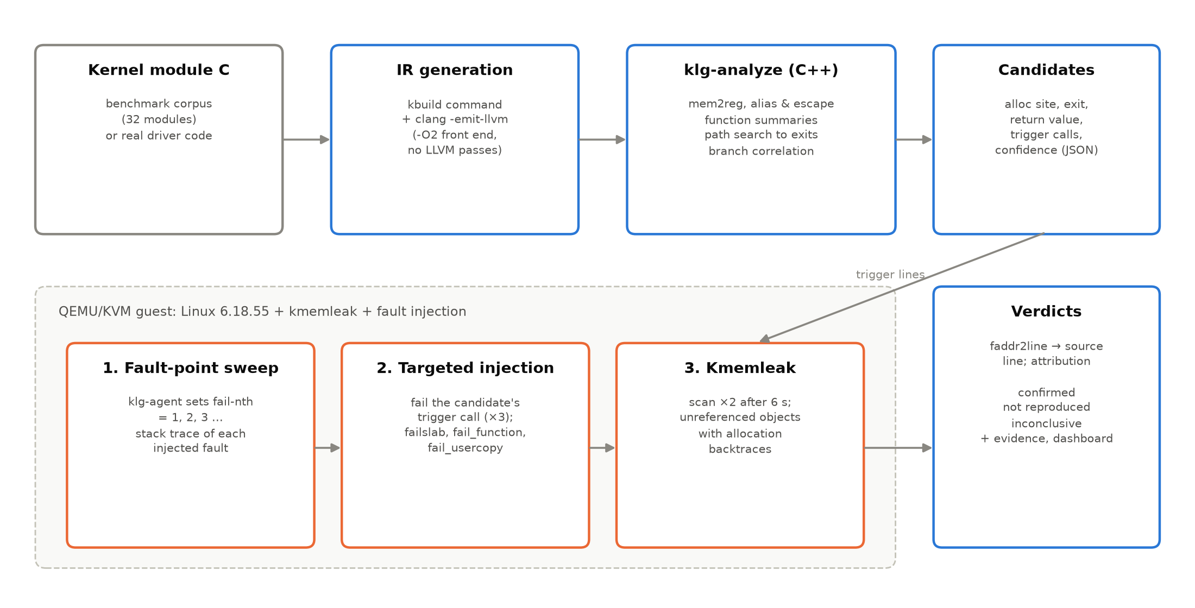
Figure 2.1: System architecture
The main pieces, in the order the data flows:
• Build: each module is compiled twice — normally (for the VM) and into LLVM IR (for the analyser), with exactly the kernel's own compiler flags.
• klg-analyze (C++): finds leak candidates and writes them as JSON.
• klg (Python): plans which failure to inject for each candidate and writes a shell script for the guest.
• QEMU guest: boots our kernel, runs the script, loads modules, injects failures, runs kmemleak, writes logs to a shared folder.
• Verifier: reads the logs, matches leaked objects to source lines and decides each verdict.
• Reports: command-line summary now; dashboard and documents for Review-II.

3. Module Design
We split the work into four modules with clear inputs and outputs, so each of us could work and test independently.
Table 3.1: Modules
Module | Owner | Input | Output
Static analyser (analyzer/) | Om Gunjan Gupta | LLVM IR of a module | candidates.json: allocation, leaking exit, failing call, error code
Kernel and VM (vm/, runtime/) | Abhishek Kumar Singh | Kernel source, modules, guest job script | Booted guest; agent logs; kmemleak reports
Verifier and orchestrator (klg/) | Aarav Jain | candidates.json, guest logs | Verdicts with evidence (verification.json)
Benchmark and evaluation (corpus/, klg/evaluate.py) | Aarav Jain | Modules with GT:LEAK / GT:SAFE marks | Precision, recall, comparison tables

3.1 Static analyser
Written in C++ on top of the LLVM 21 libraries. It first simplifies the IR (turns stack variables into plain values), then for each allocation call it collects every value that is a copy of the pointer (aliases), notes where the pointer is freed, returned or stored somewhere outside the function (ownership hand-over), and searches the paths to every return. Small summaries of helper functions (does this function free its argument? return new memory?) let it follow memory across function calls.

3.2 Kernel, virtual machine and agent
We build Linux 6.18.55 with clang and switch on kmemleak, the fault-injection framework (failslab, fail_function, fail_usercopy) and a few settings that keep kmemleak accurate. QEMU boots it with a tiny BusyBox file system and shares a host folder with it. The agent (klg-agent, written in C) loads a module or calls a test trigger while /proc/self/fail-nth makes the chosen allocation fail, and prints markers that the host can parse. A helper module, klg_modwatch, logs where modules are loaded so that stack traces can be turned back into source lines even after a module was unloaded.

3.3 Verifier
The Python verifier first runs a mapping pass (fail allocation 1, 2, 3, ... and record where each failure happened), then picks for each candidate the failure number that hits its trigger, runs those confirmation tests three times, and compares kmemleak's report with the candidate's allocation site.

3.4 Benchmark
32 small kernel modules written by us: 17 leaking allocation sites and 42 safe ones. Each allocation line carries a comment /* GT:LEAK */ or /* GT:SAFE */, which is the ground truth for scoring. The safe modules contain the tricky patterns that fool naive tools: memory handed to a list, freed through a wrapper, freed in a loop, or reference counted.

3.5 Data formats
We do not need a database; all stages exchange JSON files, which are easy to inspect. A shortened candidate written by the analyser looks like this:
{
"function": "sensor_setup",
"allocator": "kmalloc",
"alloc": {"file": "klg_l02_goto_ladder.c", "line": 32},
"exit": {"file": "klg_l02_goto_ladder.c", "line": 54},
"return_value": "-ENOMEM",
"triggers": [{"callee": "kasprintf", "line": 38, "kind": "alloc"}],
"confidence": "high",
"category": "missing-release-on-error-path"
}

4. Algorithms and Flowcharts

4.1 Finding leaks (static analysis)
for each allocation call A in function F:
aliases = every value that is a copy of A's result
events = places where an alias is freed, returned, or stored outside F
depth-first search over the paths from A to every return of F:
skip the edge where A itself failed (A == NULL or IS_ERR(A))
skip branches that contradict an earlier decision on the same condition
stop the path at a free / hand-over event (no leak on this path)
at a return: report "A leaks here",
with the failing call that chose this path (trigger)

In plain words: start where memory is taken, walk every possible way out of the function, and complain about any way out that neither frees the memory nor gives it to someone else. The “skip” rules remove paths that cannot really happen.

4.2 Proving leaks (runtime verification)
mapping: for n = 1, 2, 3, ...:
load the module with fail-nth = n (only failures inside the module count)
record which source line the n-th failure hit; stop when nothing fails
confirm: for each candidate:
pick n whose failure hits the candidate's trigger
run 3 times with fail-nth = n; then kmemleak scan
verdict: object from the candidate's line leaked -> confirmed
path ran, nothing leaked -> not reproduced
trigger could not be failed -> inconclusive

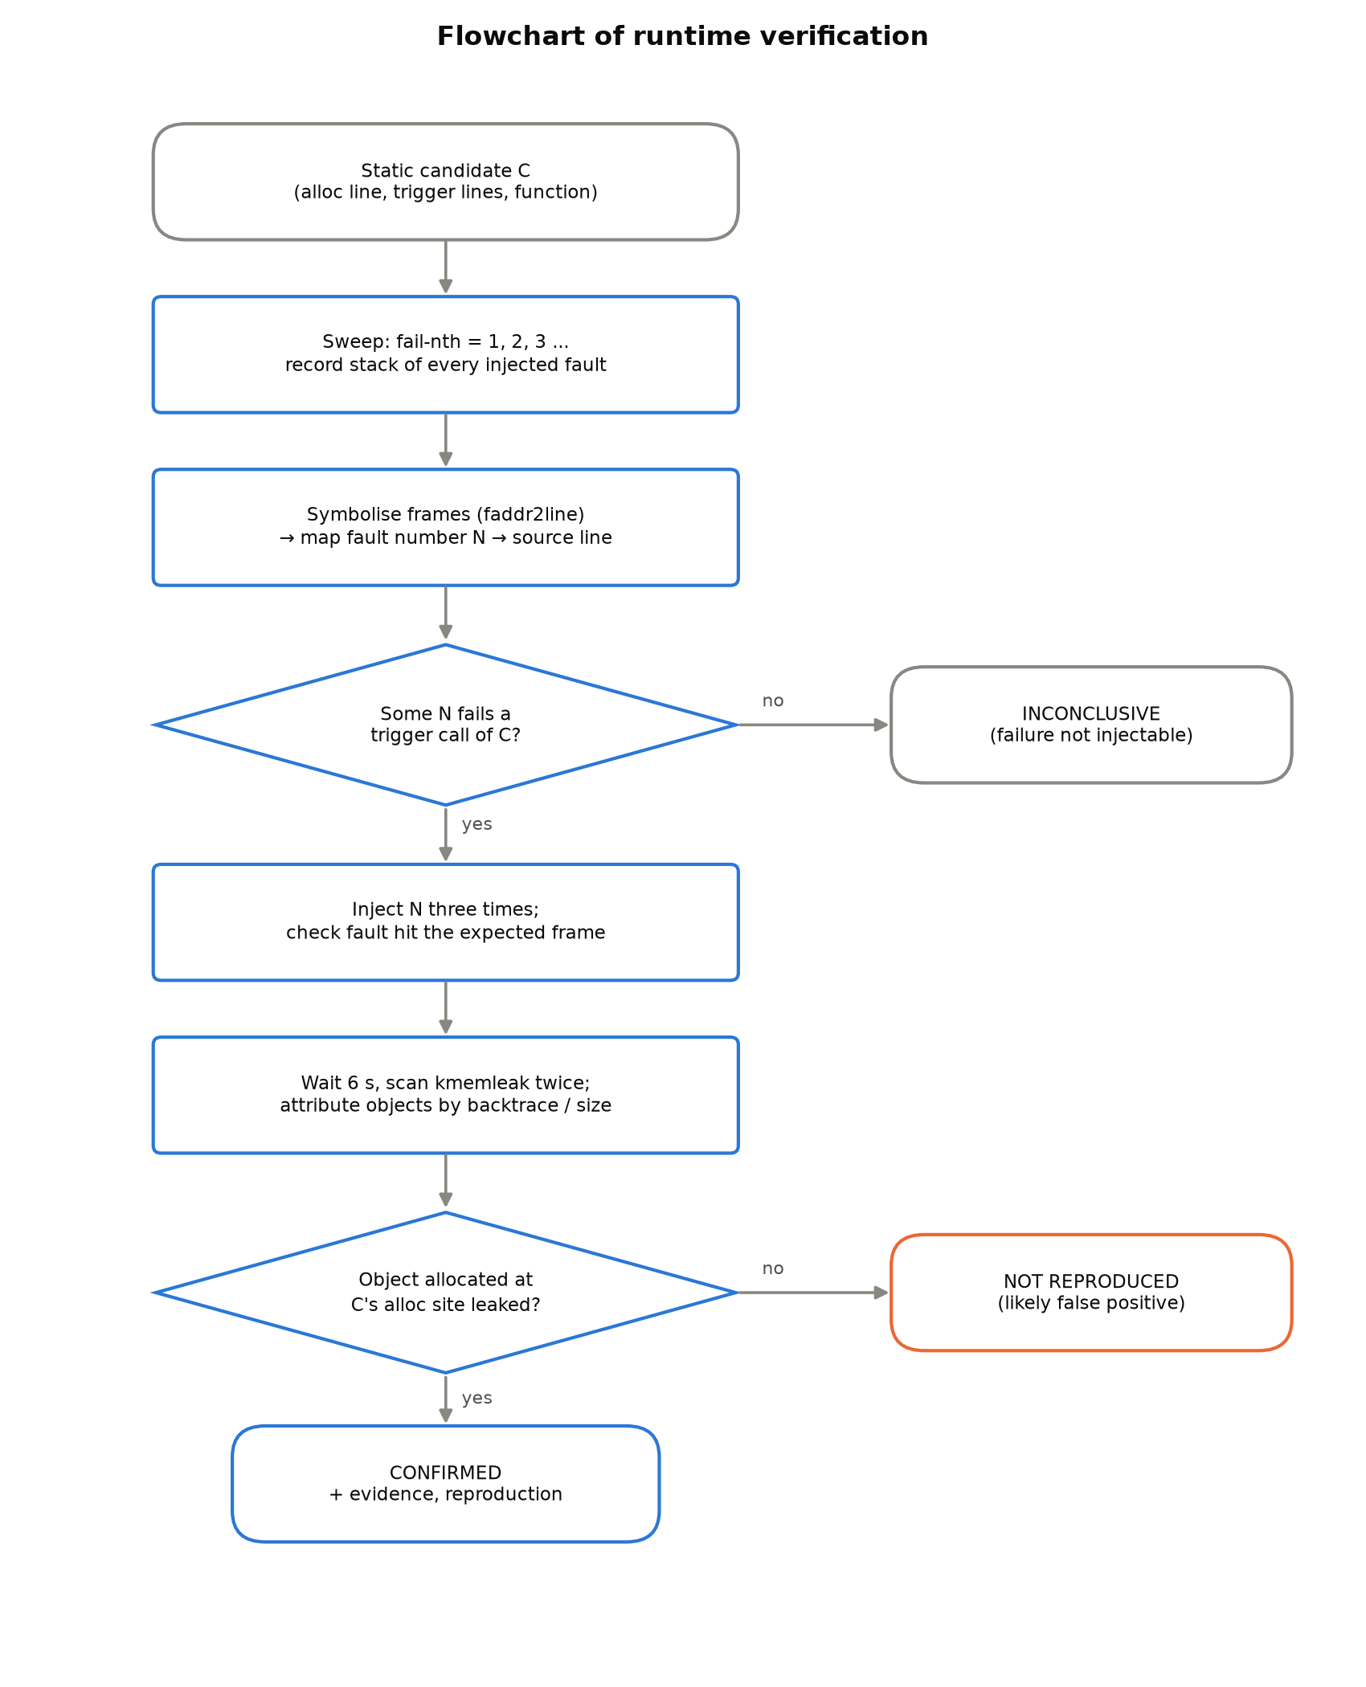
Figure 4.1: Flowchart of the runtime verification

5. Implementation Progress
By Review-I the core of the tool runs from start to finish on the benchmark: it compiles the modules, finds candidates, boots the kernel, injects the predicted failures and produces verdicts with kmemleak evidence. We estimate the project at about two thirds complete.
Table 5.1: Implementation status
Part | Status | Notes
Kernel build with kmemleak + fault injection | Done | Linux 6.18.55, clang
QEMU guest, init script, shared folder | Done | BusyBox, 9p share
klg-agent (sweep / repeat modes) | Done | fail-nth with module filter
klg_modwatch symbol logging | Done | for unloaded modules
Benchmark: 32 modules with ground truth | Done | 17 leaks, 42 safe sites
Static analyser: aliases, paths, triggers | Done | C++/LLVM
Ownership hand-over, summaries, branch correlation | Done | reduces false alarms
Mapping and confirmation runs, verdicts | Done | end to end
Baselines (exhaustive, random, cppcheck) | In progress | Review-II
Fix patch generation and validation | In progress | Review-II
Dashboard | Prototype | findings page works
Real kernel modules | Planned | Review-II
Report, manual, presentation | In progress | Review-II

6. Screenshots of the Working Prototype
The screenshots below were taken from the running system.
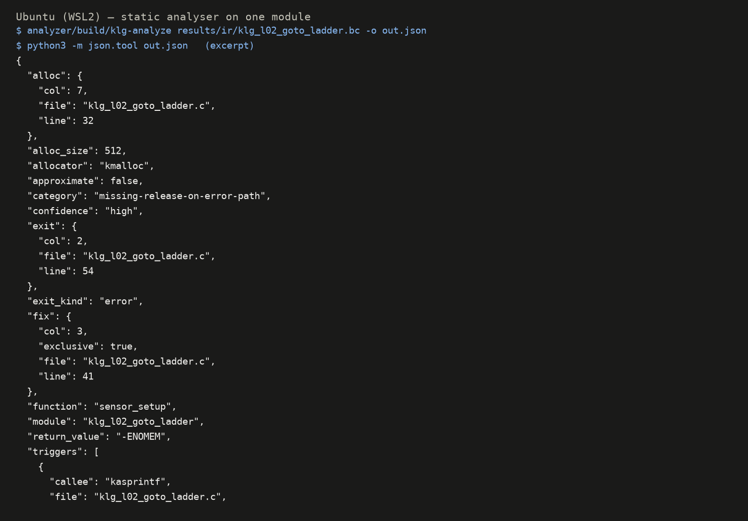
Figure 6.1: The static analyser's report for one benchmark module
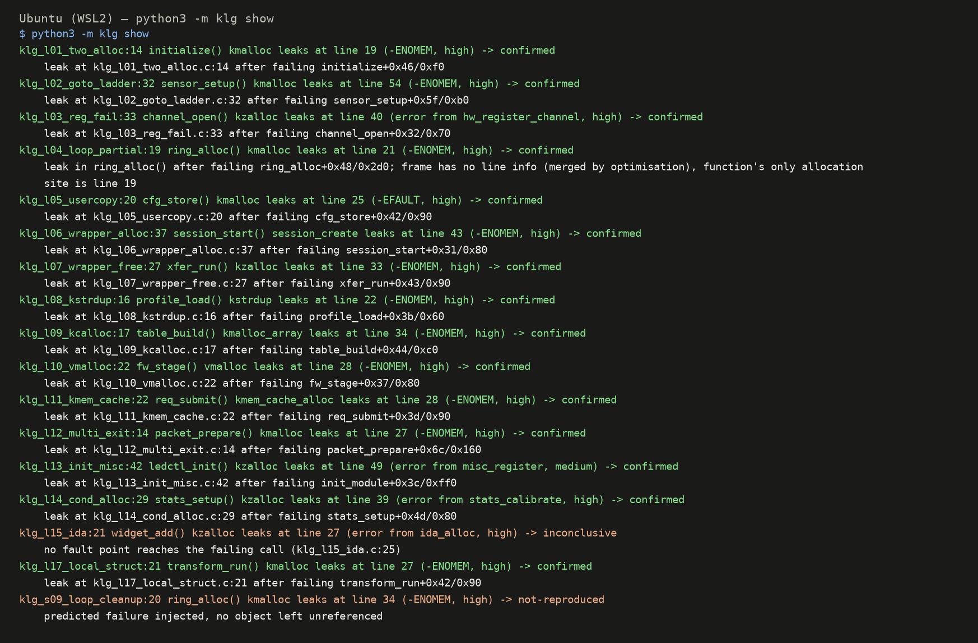
Figure 6.2: Findings and verdicts on the command line (python3 -m klg show)
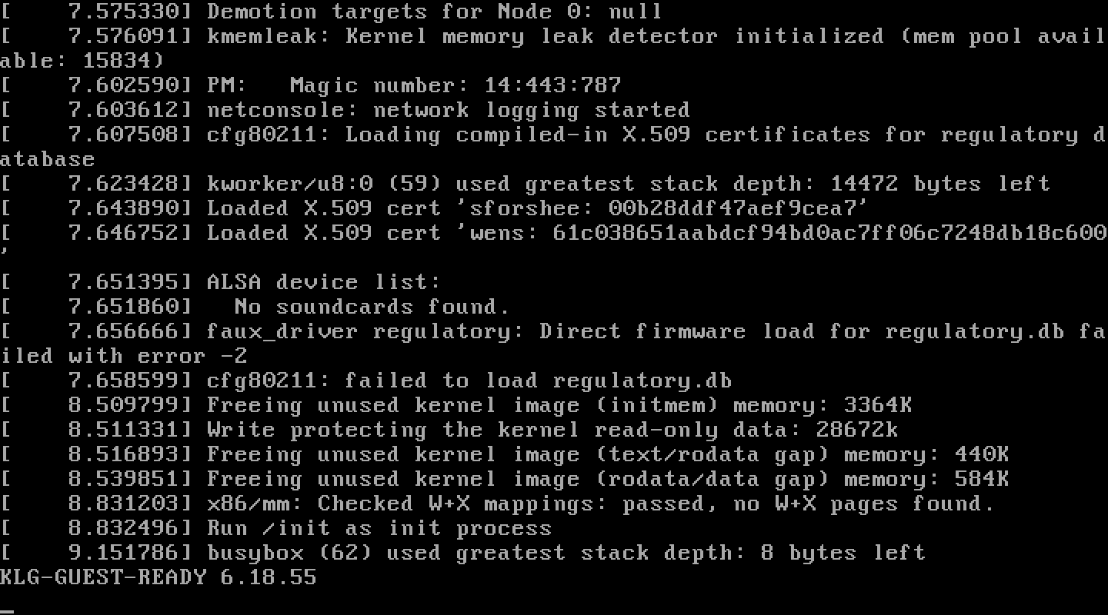
Figure 6.3: Our Linux 6.18.55 kernel booting inside the QEMU virtual machine
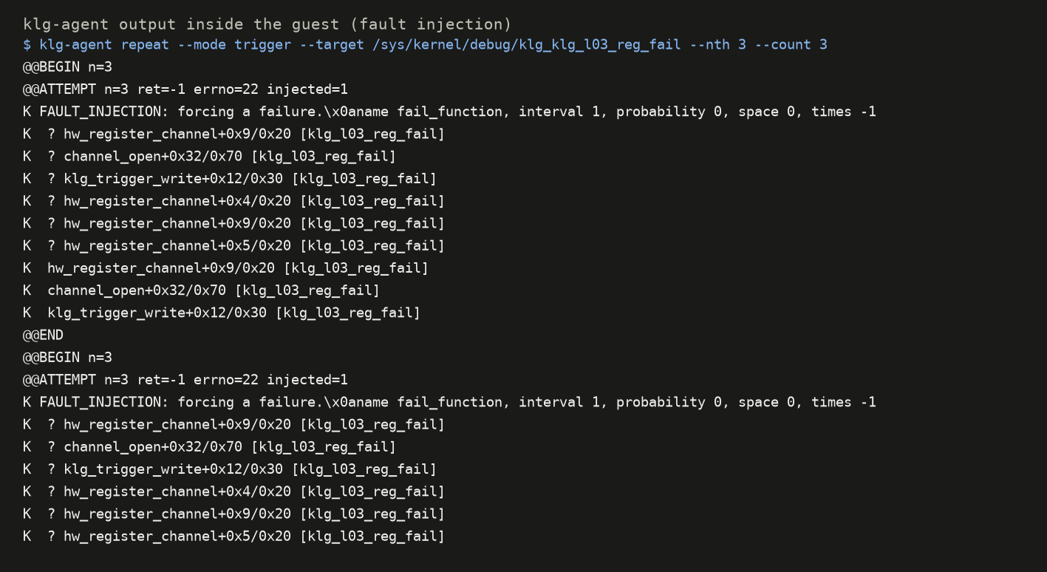
Figure 6.4: The agent injecting a failure inside the guest
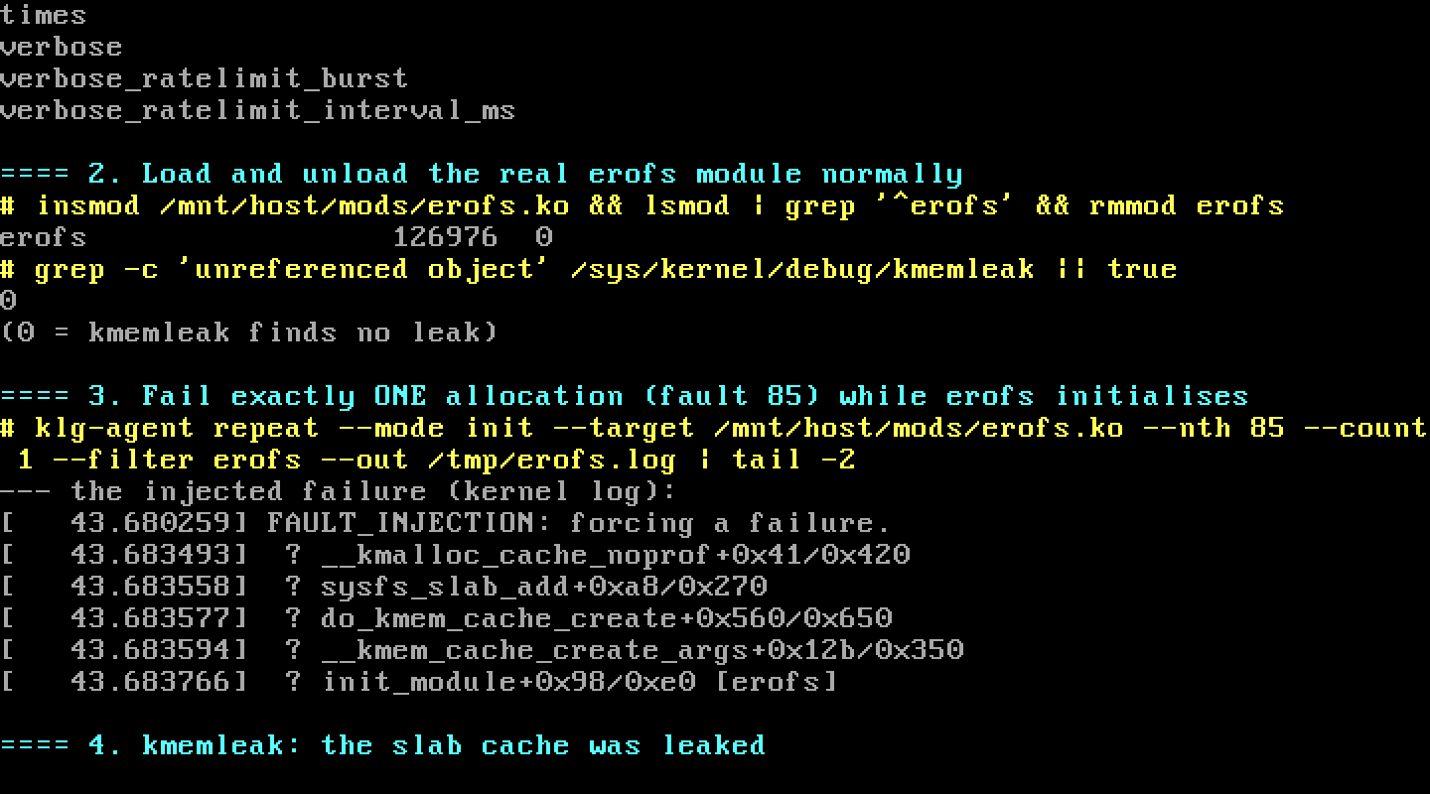
Figure 6.5: A failure injected while a real module (erofs) loads
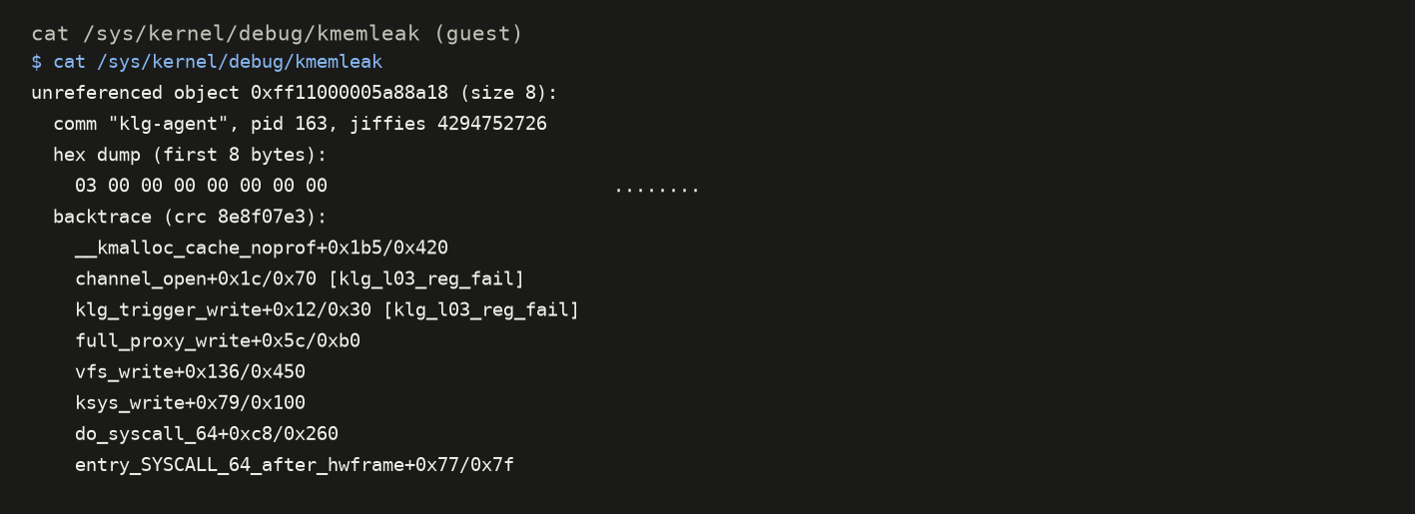
Figure 6.6: kmemleak reporting the leaked object, with its call stack
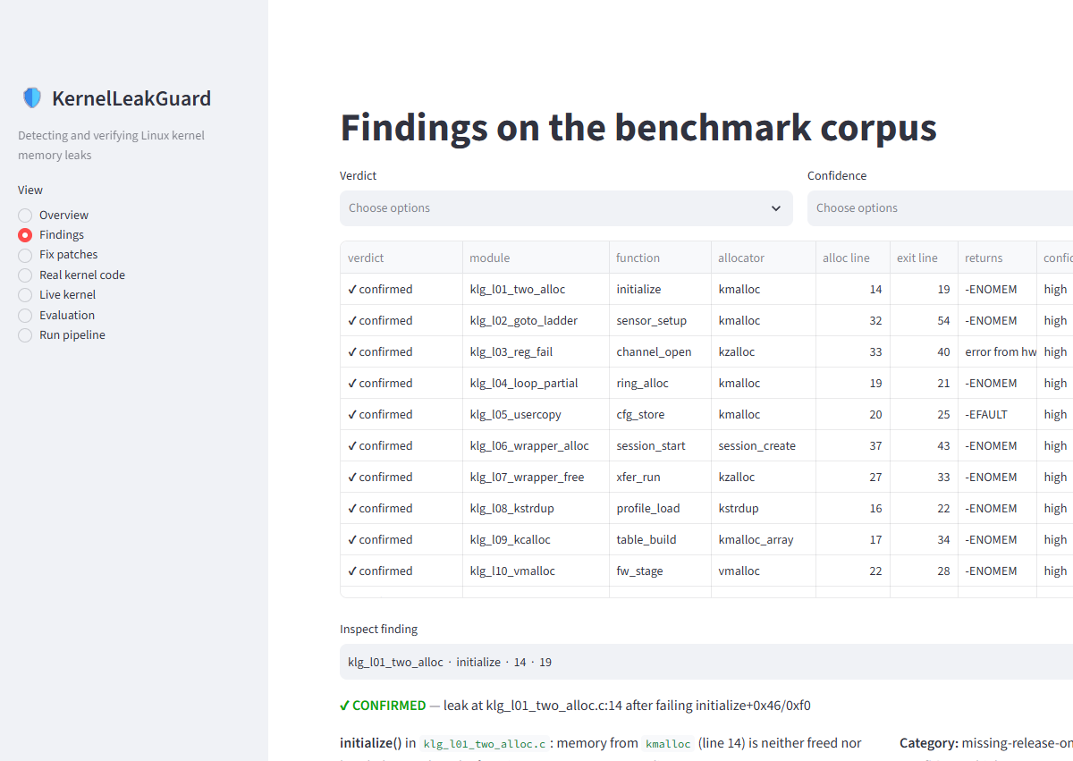
Figure 6.7: Dashboard prototype: the list of findings with verdicts

7. Challenges Faced
Not everything worked the first time. These were the hardest problems and how we solved them.
Table 7.1: Challenges and solutions
Challenge | What happened | How we solved it
Fault injection ignored | Failing a function by name did nothing for our calls. | The kernel's probe mechanism had to be built in its ftrace-based mode; with the other mode the injection never matched our task.
Leaks hidden from kmemleak | A real leak was found in some runs and missed in others. | Old copies of pointers on reused stacks and in reused memory made kmemleak think the memory was still used. We clear stacks and zero memory on allocation and free.
Module gone before the scan | When a module fails to load, Linux removes it before kmemleak reports, so stack traces showed only raw addresses. | We wrote klg_modwatch, a tiny module that logs every module's addresses and symbols.
Random injection crashed the guest | PID 1 also got failures and the kernel panicked. | Restrict injection to the agent's own task before turning it on.
Too many false alarms | Helpers that return error codes instead of NULL looked like leaks. | We model IS_ERR() like a NULL check and let runtime checks refute the rest.
Stack traces to source lines | The kernel's faddr2line script broke with clang builds. | We call it in the mode that works with LLVM builds.
Slow virtual machine | Windows security features blocked hardware virtualization (KVM) inside WSL2. | QEMU falls back to software emulation; the tool only fails the calls the analyser points at, which keeps runs short.

8. Plan for Review-II
• Run the baselines (fail every allocation, random failures, cppcheck) and compare.
• Generate fix patches and check them by compiling, re-analysing and re-testing.
• Finish the dashboard and write the user manual and final report.
• Try the tool on real Linux modules that need no hardware.
• Repeat the experiments several times to check that results are stable.

9. References
[1] Wang, W. “MLEE: Effective Detection of Memory Leaks on Early-Exit Paths in OS Kernels.” USENIX Annual Technical Conference (ATC), 2021, pp. 31–45.
[2] Linux kernel documentation: “Kernel Memory Leak Detector (kmemleak).” https://docs.kernel.org/dev-tools/kmemleak.html
[3] Linux kernel documentation: “Fault injection capabilities infrastructure.” https://docs.kernel.org/fault-injection/fault-injection.html
[4] Google. “syzkaller: an unsupervised coverage-guided kernel fuzzer.” https://github.com/google/syzkaller
[5] Emamdoost, N., Wu, Q., Lu, K., McCamant, S. “Detecting Kernel Memory Leaks in Specialized Modules with Ownership Reasoning (K-MELD).” NDSS, 2021.
[6] Lattner, C., Adve, V. “LLVM: A Compilation Framework for Lifelong Program Analysis and Transformation.” CGO, 2004.
[7] Bellard, F. “QEMU, a Fast and Portable Dynamic Translator.” USENIX ATC, 2005.
[8] Cppcheck: a tool for static C/C++ code analysis. https://cppcheck.sourceforge.io/
[9] Silberschatz, A., Galvin, P. B., Gagne, G. Operating System Concepts, 10th ed. Wiley, 2018.
[10] Corbet, J., Rubini, A., Kroah-Hartman, G. Linux Device Drivers, 3rd ed. O’Reilly, 2005.

