KernelLeakGuard
User Manual
Hybrid static analysis and runtime verification of memory leaks on Linux kernel early-exit paths

BITE303P Operating Systems Lab, Fall 2026-27, VIT Vellore
Om Gunjan Gupta (24BIT0316) · Abhishek Kumar Singh (24BIT0309) · Aarav Jain (24BIT0023)
Guide: Dr. Arivuselvan K

CHAPTER 1: INTRODUCTION
KernelLeakGuard finds memory leaks on the error paths of Linux kernel modules and checks each finding by reproducing the failure inside a virtual machine. This manual explains how to install it, run it, read its results and analyse your own module.
What you get for every finding:
• the function, the allocation (file and line) and the leaking return with its error code;
• the call whose failure leads to the leak (for example a second kmalloc() or copy_from_user());
• a verdict from the virtual machine: confirmed (kmemleak saw the leak), not reproduced (the failure was injected and nothing leaked) or inconclusive (the failure could not be injected);
• the evidence: fault number, stack frame, kmemleak backtrace.
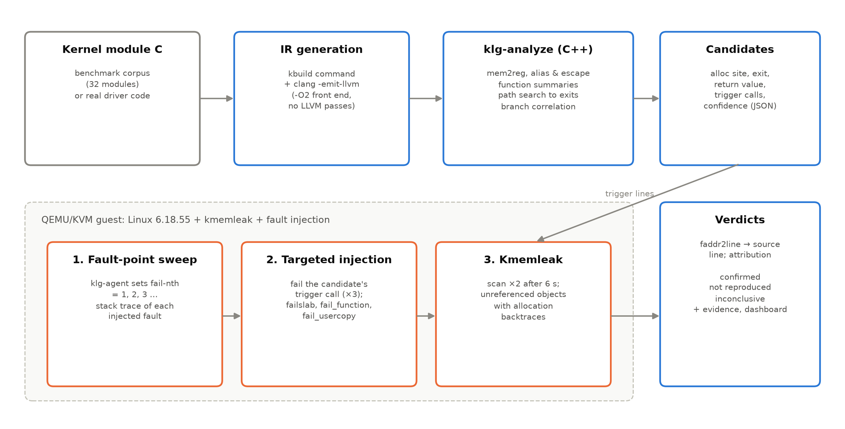
Figure 1.1: How the pieces fit together

CHAPTER 2: SYSTEM REQUIREMENTS
Table 2.1: Requirements
Item | Requirement
Operating system | Windows 10/11 with WSL2 (Ubuntu 24.04 or newer), or native Linux x86-64
Virtualisation | KVM available (/dev/kvm); on Windows 11 WSL2 provides it
CPU / RAM | 4+ cores recommended, 8 GB RAM (the guest VM uses 2 GB)
Disk | about 25 GB (kernel source and build)
Network | only for the first download of packages and kernel source

CHAPTER 3: INSTALLATION

3.1 Install WSL2 and Ubuntu (Windows only)
Open PowerShell as administrator and run wsl --install -d Ubuntu, restart, then open the Ubuntu app from the Start menu and choose a user name and password.

3.2 Install packages
In the Ubuntu terminal:
sudo apt update
sudo apt install -y build-essential clang llvm llvm-dev lld libclang-dev \
qemu-system-x86 flex bison bc libelf-dev libssl-dev dwarves cpio busybox-static \
python3-venv python3-pip git curl xz-utils rsync kmod
sudo usermod -aG kvm $USER

Close the terminal and run wsl --shutdown in Windows PowerShell so the group change takes effect. Check with ls -l /dev/kvm and id (the kvm group must be listed).

3.3 Get the project and build the components
cd ~
git clone <repository-url> KernelLeakGuard # or copy the project folder here
cd KernelLeakGuard
./vm/build_kernel.sh # downloads and builds Linux 6.18.55 (10-20 min the first time)
./vm/build_initramfs.sh # guest root filesystem with klg-agent
make -C analyzer # static analyser -> analyzer/build/klg-analyze
./scripts/setup_venv.sh # Python packages for dashboard and documents

Keep the project inside the Linux file system (for example /home/<user>), not under /mnt/c: the kernel build needs a case-sensitive file system and runs much faster there. From Windows the folder is reachable at \\wsl$\Ubuntu\home\<user>\KernelLeakGuard.

CHAPTER 4: RUNNING KERNELLEAKGUARD

4.1 The complete pipeline
python3 -m klg all

This builds the 32 benchmark modules and their LLVM IR, runs the analyser in six configurations, boots the VM twice (fault-point sweep, then confirmation) and prints the evaluation. It takes about 3-4 minutes. Expected output (numbers may vary slightly):
[klg] built 32 modules and their LLVM IR in 23.2s
[klg] static (full): 19 warnings in 32 modules
...
[klg] runtime verification: {'confirmed': 15, 'inconclusive': 3, 'not-reproduced': 1}
| Approach | TP | FP | FN | Precision | Recall | F1 |
| static/full | 16 | 1 | 1 | 0.94 | 0.94 | 0.94 |
| hybrid | 15 | 0 | 2 | 1.00 | 0.88 | 0.94 |
| klg/combined | 16 | 0 | 1 | 1.00 | 0.94 | 0.97 |

4.2 Individual steps
Table 4.1: Command reference
Command | What it does
python3 -m klg build | build corpus modules, LLVM bitcode, klg-agent and initramfs
python3 -m klg analyze [--all-variants] | static analysis (full, or also the ablation variants)
python3 -m klg verify [--skip-sweep] | runtime verification in the VM (reuse the last sweep with --skip-sweep)
python3 -m klg evaluate | precision/recall against the ground truth, triage table
python3 -m klg show | one line per finding with its verdict and reason
python3 -m klg fix | generate fix patches for confirmed leaks and validate them (compile, re-analyse, VM re-run); patches in results/fixes/patches
python3 -m klg real [--only m1,m2] | analyse the real Linux modules of vm/real_modules.fragment and verify their initialisation in the VM (results/real)
python3 -m klg seed [--only name] | reintroduce a known leak into a real kernel module (seeds/) and run detect -> confirm -> fix on it (results/seeded)
.venv/bin/python -m klg.figures | regenerate the charts in docs/figures
scripts/repeat_runs.sh N | run the pipeline N times to check reproducibility

4.3 The dashboard
.venv/bin/streamlit run dashboard/app.py

Open http://localhost:8501 in a Windows browser. Tabs:
• Overview: counts of warnings and verdicts, static vs hybrid precision, pipeline summary.
• Findings: filterable table of all findings. Selecting one shows the source with the allocation (blue), the failing call (orange) and the leaking exit (red), the suggested fix, and the runtime tests with kmemleak backtraces.
• Evaluation: comparison table and precision/recall chart; triage of warnings.
• Run pipeline: runs any step and streams its output into the page.

CHAPTER 5: READING THE RESULTS
Table 5.1: Verdicts
Verdict | Meaning | What to do
confirmed | The predicted failure was injected and kmemleak reported an object allocated at the reported line as unreferenced. | Fix the bug; the evidence shows how to reproduce it.
not reproduced | The failure was injected but nothing leaked; the static warning is most likely a false positive (e.g. a correct rollback loop). | Review briefly; usually no action.
inconclusive | No injectable failure leads to the path, or the failure cannot happen in the test state. | Review the warning manually.

Table 5.2: Fields of a static finding (results/static/full/<module>.json)
Field | Meaning
alloc | file and line of the allocation that leaks
exit / return_value | the return statement on the leaking path and the value it returns
triggers | calls whose failure leads onto the path (the last one is the primary)
confidence | high: the function frees the object elsewhere but not on this error path; medium: ownership is transferred elsewhere, or never released; low: other cases
category | missing-release-on-error-path, ownership-not-transferred-on-error-path, never-released, missing-release-on-other-path

Output files: results/static/<variant>/*.json (findings), results/runtime/verification.json (verdicts and evidence), results/runtime/sweep|confirm/out/ (raw agent logs, kmemleak reports, guest console), results/evaluation.json (metrics).

CHAPTER 6: ANALYSING YOUR OWN MODULE
1. Put the module source into a directory with a Kbuild file (obj-m += mymod.o) and build it against the guest kernel:
make -C ~/klg-build/linux-6.18.55 O=$HOME/klg-build/kbuild LLVM=1 M=$PWD modules

2. Generate bitcode and analyse it:
python3 -c "from klg import build; from pathlib import Path; print(build.emit_ir(Path('mymod.o').resolve(), Path('.')))"
analyzer/build/klg-analyze mymod.bc -o mymod.json
python3 -m json.tool mymod.json | less

3. For runtime verification, copy the module into corpus/ (or another directory passed to the verifier). Code that runs in module_init is verified automatically (init mode). For other code, expose the routine through a debugfs file with the harness macros in corpus/klg_harness.h (KLG_TRIGGER(fn)), then run python3 -m klg all.
4. Unknown allocators or release functions can be added without recompiling via klg-analyze --spec extra.json, for example {"allocators": ["my_alloc"], "deallocators": {"my_free": 0}}.

CHAPTER 7: TROUBLESHOOTING
Table 7.1: Troubleshooting
Problem | Solution
/dev/kvm not accessible | Add yourself to the kvm group (sudo usermod -aG kvm $USER) and restart WSL; without KVM the VM falls back to slow emulation.
Module build: unresolved symbols | Run ./vm/build_kernel.sh first (it creates Module.symvers).
VM run failed | Read results/runtime/<run>/console.log and out/job.log; a kernel panic message there shows what went wrong.
All verdicts inconclusive | Check that scripts/faddr2line works: ~/klg-build/linux-6.18.55/scripts/faddr2line corpus/<m>.ko <func>+0x10
Commands fail from Windows PowerShell | Run them inside the Ubuntu terminal, or with wsl -d Ubuntu --cd ~/KernelLeakGuard -- <command>.
Dashboard not reachable | Use http://localhost:8501; if the port is busy add --server.port 8502.

