How to export the data file and head file from xml

Export the data files and head files from xmls

1. Launch the ECGViewer

..\ ECGToolkit\apps\ECGViewer\bin\Debug\ECGViewer.exe

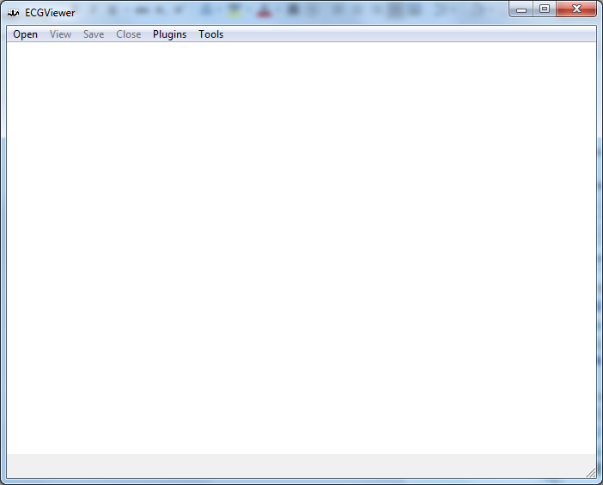

1. Load the Plugin for Muse

Clicking “Plugins->File”

Browsing the MuseXML plugin

..\ECGToolkit\libs\ECGConversion\MUSEXML\bin\Release

Open “ECGCpluginMUSEXML.dll”

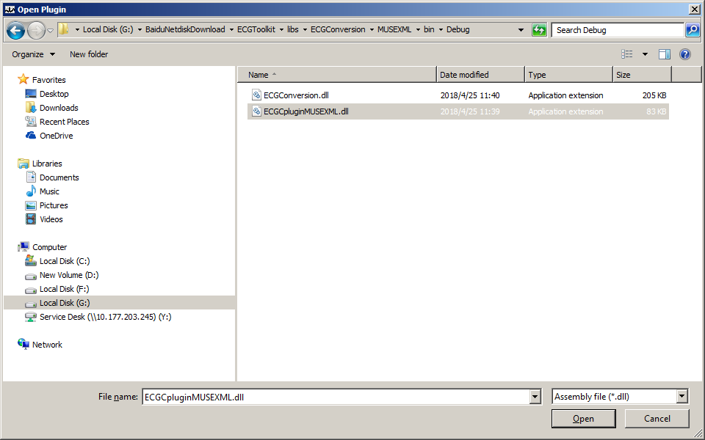

1. Click the menu to export the data files

Select “ExportMuseDataToCSV”

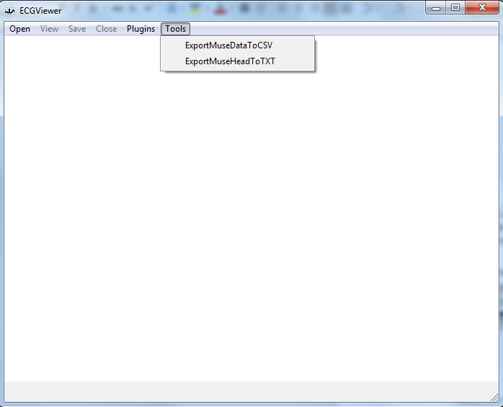

Then a dialog will shown to browse the muse file directory.

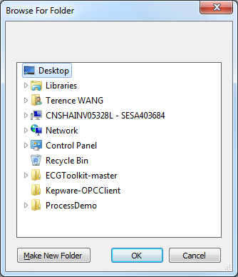

Browse the muse data folder in this dialog.

When the Directory selected and ok button clicked, there is a configuration dialog pop up. Click OK, and Keep the default setting in it.

Then the export will be started.

The exported file will be under the same directory of Muse file

Note: during the export process, do not make any action on this software. When the process done there will be a message box shown.

1. Click the menu to export the head files

Select “ExportMuseHeadToTxt”



Then a dialog will shown to browse the muse file directory.



Browse the muse data folder in this dialog.

When the Directory selected and ok button clicked, there is a configuration dialog pop up. Click OK, and Keep the default setting in it.

Then the export will be started.

The exported file will be under the same directory of Muse file

Note: during the export process, do not make any action on this software. When the process done there will be a message box shown.