## IoT “Internet Of Things”

## “What is IoT?”

When you Google “what is IoT,” many of the answers are unnecessarily technical. Case in point:

*“The Internet of Things (IoT) is a system of interrelated computing devices, mechanical and digital machines, objects, animals or people that are provided with unique identifiers and the ability to transfer data over a network without requiring human-to-human or human-to-computer interaction.”*

*– An unnecessarily technical explanation of IoT*

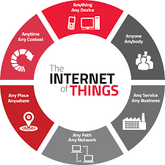

You're not alone if you just read that and thought, “ok, so what?”. Most people don’t want to nor need to dive into the nitty-gritty of IoT. In this chapter, we’ll provide you with a simple explanation of the Internet of Things and what it means for you.

Before we jump in, note that “The Internet of Things” and “IoT” can and will be used interchangeably. And a quick tip to sound knowledgeable: avoid saying “the IoT”.

### **A Simple, Non-Technical Explanation of the Internet of Things**

How are you reading this ebook right now? It might be on desktop, on mobile, maybe a tablet, but whatever device you’re using, it’s most likely connected to the internet.

An internet connection is a wonderful thing, it give us all sorts of benefits that just weren’t possible before. If you’re old enough, think of your cell phone before it was a smartphone. You could call and you could text, sure, but now you can read any book, watch any movie, or listen to any song all in the palm of your hand.

The point is that connecting things to the internet yields many amazing benefits. We’ve all seen these benefits with our smartphones, laptops, and tablets, but this is true for everything else too. And yes, we do mean everything.

The Internet of Things is actually a pretty simple concept, **it means taking all the physical places and things in the world and connecting them to the internet**.

Confusion arises not because the concept is so narrow and tightly defined, but rather because it’s so broad and loosely defined. It can be hard to nail down the concept in your head when there are so many examples and possibilities in IoT.

To help clarify, it’s important to understand the benefits of connecting things to the internet. Why would we even want to connect everything to the internet?

### **Why IoT Matters**

When something is connected to the internet, that means that it can send information or receive information, or both. This ability to send and/or receive information makes things “smart."

Let’s use **smart**phones again as an example. Right now you can listen to just about any song in the world, but it’s not because your phone actually has every song in the world stored on it. It’s because every song in the world is stored somewhere else, but your phone can send information (asking for that song) and then receive information (streaming that song on your phone).

To be smart, a thing doesn't need to have super storage or a super computer inside of it - it just needs access to it. All a thing has to do is connect to super storage or to a super computer. In the Internet of Things, all the things that are being connected to the internet can be put into three categories:

1. Things that collect information and then send it.
2. Things that receive information and then act on it.
3. Things that do both.

And all three of these have enormous benefits that compound on each other.

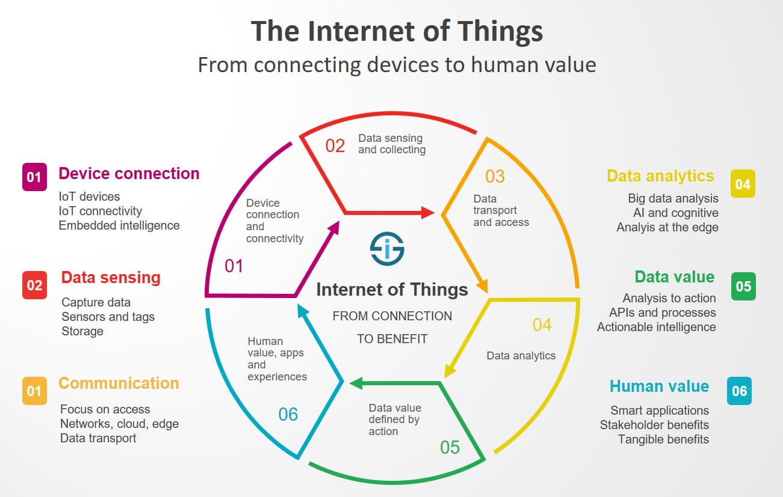

#### **1. Collecting and Sending Information**

Sensors could be temperature sensors, motion sensors, moisture sensors, air quality sensors, light sensors, you name it. These sensors, along with a connection, allow us to automatically collect information from the environment which, in turn, allows us to make more intelligent decisions.

On a farm, automatically getting information about the soil moisture can tell farmers exactly when their crops need to be watered. Instead of watering too much (which can be an expensive over-use of irrigation systems) or watering too little (which can be an expensive loss of crops), the farmer can ensure that crops get exactly the right amount of water. This enables farmers to increase their crop yield while decreasing their associated expenses.

Just as our sight, hearing, smell, touch, and taste allow us, humans, to make sense of the world, sensors allow machines (and the humans monitoring the machines) to make sense of the world.

#### **2. Receiving and Acting on Information**

We’re all very familiar with machines getting information and then acting. Your printer receives a document and it prints it. Your car receives a signal from your car keys and the doors open. The examples are endless.

Whether it’s a simple as sending the command “turn on” or as complex as sending a 3D model to a 3D printer, we know that we can tell machines what to do from far away. So what?

The real power of the Internet of Things arises when things can do both of the above. Things that collect information and send it, but also receive information and act on it.

#### **3. Doing Both: The Goal of an IoT System**

Let’s quickly go back to the farming example. The sensors can collect information about the soil moisture to tell the farmer how much to water the crops, but you don’t actually need the farmer. Instead, the irrigation system can automatically turn on as needed, based on how much moisture is in the soil.

You can take it a step further too. If the irrigation system receives information about the weather from its internet connection, it can also know when it’s going to rain and decide not to water the crops today because they’ll be watered by the rain anyways.

And it doesn’t stop there! All this information about the soil moisture, how much the irrigation system is watering the crops, and how well the crops actually grow can be collected and sent to supercomputers that run amazing algorithms that can make sense of all this information.

And that’s just one kind of sensor. Add in other sensors like light, air quality, and temperature, and these algorithms can learn much, much more. With dozens, hundreds, thousands of farms all collecting this information, these algorithms can create incredible insights into how to make crops grow the best, helping to feed the world.

And agriculture is just one of many applications of IoT…